***Programming Project I - Small Sample Examples***

*Individual Route Planning Tool*

*DA 2024/2025 Instructors Team*

*Departamento de Engenharia Informática (DEI)/Departamento de Ciências de Computadores (DCC)*

*Faculdade de Eng. da Univ. do Porto (FEUP)/Faculdade de Ciências da Univ. do Porto (FCUP)*

*Spring 2025*

***Due Date: March 30, 2025, at 23:59 (PT time)***

**Description:**

This document includes a set of simple examples that you can use to validate your algorithm implementation. In Figure 1, you can find a diagram of a Graph with 8 nodes representing specific locations of Porto. Dashed edges correspond to walking only segments whereas full edges correspond to segments where you can drive and walk. Each edge has walking and/or driving time.

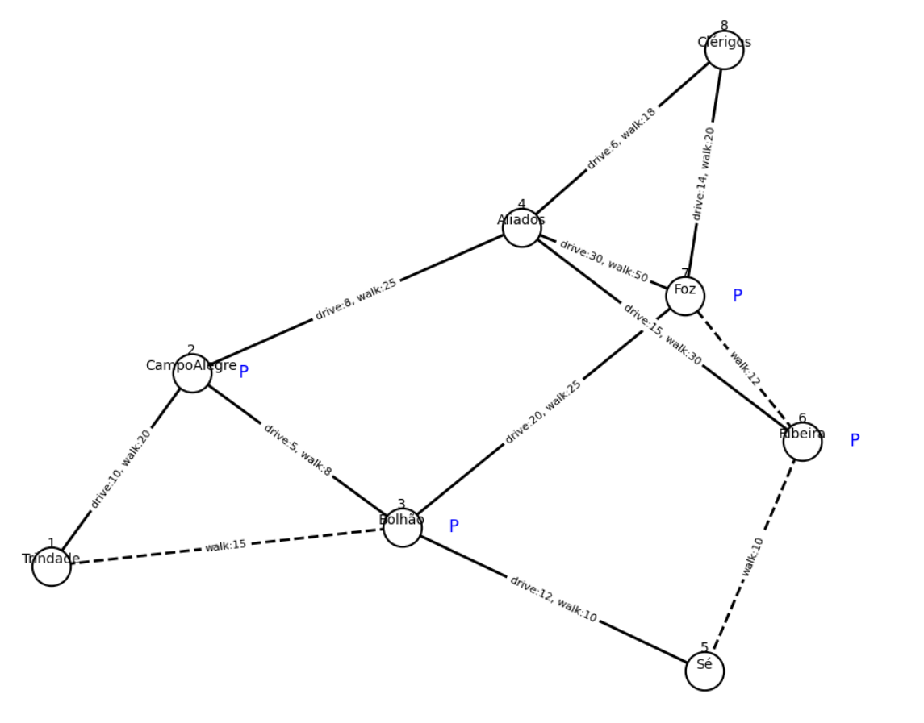

**Figure 1.** Example of a Graph with 8 nodes.

For this graph, we now indicate the correct output(s) for each specific routing problem.

**Important Note**

The purpose of this document is to provide some basic case examples. There may be other extraordinary cases that you should consider, taking into account the project description.

# **Best Route and Alternative Independent Route**

**Input:**

**Mode:driving**

**Source:3**

**Destination:8**

**Output:**

**Source:3**

**Destination:8**

**BestDrivingRoute:3,2,4,8(19)**

**AlternativeDrivingRoute:3,7,8(34)**

## **2. Best Route and Alternative Independent Route - Error/Not found Case**

**Input:**

**Mode:driving**

**Source:8**

**Destination:1**

**Output:**

**Source:8**

**Destination:1**

**BestDrivingRoute:8,4,2,1(24)**

**AlternativeDrivingRoute:none**

**Note:** This is a test case to remember that you should handle error/not found cases.

# **3. Restricted Route Planning - Excluding Nodes**

**Input:**

**Mode:driving**

**Source:5**

**Destination:4**

**AvoidNodes:2**

**AvoidSegments:**

**IncludeNode:**

**Output:**

**Source:5**

**Destination:4**

**RestrictedDrivingRoute:5,3,7,8,4(52)**

**Note**: If node 2 was not excluded, the fastest route would be [5, 3, 2, 4] Time: 25

# **4. Restricted Route Planning - Excluding Segments**

**Input:**

**Mode:driving**

**Source:5**

**Destination:4**

**AvoidNodes:**

**AvoidSegments:(3,2),(7,8)**

**IncludeNode:**

**Output:**

**Source:5**

**Destination:4**

**RestrictedDrivingRoute:5,3,7,4(62)**

# **5. Restricted Route Planning - Excluding Nodes and/or Segments**

**Input:**

**Mode:driving**

**Source:5**

**Destination:4**

**AvoidNodes:2**

**AvoidSegments:(4,7)**

**IncludeNode:**

**Output:**

**Source:5**

**Destination:4**

**RestrictedDrivingRoute:5,3,7,8,4(52)**

## **6. Restricted Route Planning - Including a single specific node**

**Input:**

**Mode:driving**

**Source:5**

**Destination:4**

**AvoidNodes:**

**AvoidSegments:**

**IncludeNode:7**

**Output:**

**Source:5**

**Destination:4**

**RestrictedDrivingRoute:5,3,7,8,4(52)**

**Note:** Other possible route would be [5, 3, 7, 4] (time: 62) but it is not the fastest.

# **7. Environmentally-Friendly Route Planning** **(driving and walking)**

**Input:**

**Mode:driving-walking**

**Source:8**

**Destination:5**

**MaxWalkTime:18**

**AvoidNodes:**

**AvoidSegments:**

**Output:**

**Source:8**

**Destination:5**

**DrivingRoute:8,4,2,3(19)**

**ParkingNode:3**

**WalkingRoute:3,5(10)**

**TotalTime:29**

**Note:** Other possible driving route would be [8, 4, 2] (time: 14) and walking route would be [2,3,5] (time: 18) with parking node = 2. However, this option has a total time of 32 minutes, which is not better than the current best option with 29 minutes.

See extra example (last page) for the case where overall travel time is equal for two routes.

## **8. Display feedback if no suitable route is found that satisfies the requirements (state what parameters have not been satisfied)**

**Input:**

**Mode:driving-walking**

**Source:8**

**Destination:5**

**MaxWalkTime:5**

**AvoidNodes:**

**AvoidSegments:**

**Output:**

**Source:8**

**Destination:5**

**DrivingRoute:**

**ParkingNode:**

**WalkingRoute:**

**TotalTime:**

**Message:*No possible route with max. walking time of 5 minutes.***

# **9. Approximate Solution**

**Input:**

**Mode:driving-walking**

**Source:8**

**Destination:5**

**MaxWalkTime:5**

**AvoidNodes:**

**AvoidSegments:**

**Output:**

**Source:8**

**Destination:5**

**DrivingRoute1:8,4,2,3(19)**

**ParkingNode1:3**

**WalkingRoute1:3,5(10)**

**TotalTime1:29**

**DrivingRoute2:8,4,2(14)**

**ParkingNode2:2**

**WalkingRoute2:2,3,5(18)**

**TotalTime2:32**

# **[Extra Example] Environmentally-Friendly Route Planning** **(driving and walking)**

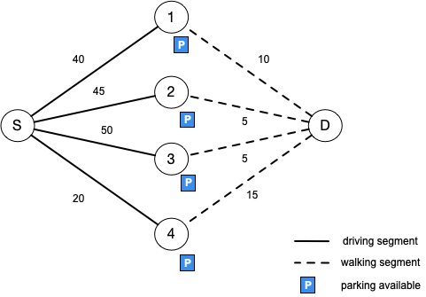

In the simplified graph below, the best (and only) route from S to D with the maximum walking time of 10 minutes would be the route S-1-D with a total time of 50 minutes. Route S-4-D does not meet the restriction of maximum walking time. Route S-3-D is longer than the best route. Also, the route S-2-D has the same total travel time as S-1-D but the latter one has a higher walking time, and hence is more environmentally-friendly. So, for routes with the same total time, we want to select the one that has the longest walking time. If more than one exists we pick any of them.