# Introduction

## Overview of the software

The Low-Level Features software is a MATLAB code that provides users with a set of tools for analyzing and extracting low-level features from images. Low-level features are image characteristics that are not related to semantic content, such as color, texture, and shape.

The software is particularly useful for researchers, students, and professionals in fields such as computer vision, image processing, and machine learning who need to extract features from images for further analysis or classification.

The software provides a graphical user interface (GUI) that allows users to easily load images, select the type of feature to extract, and configure various parameters.

## Purpose and scope of the user manual

The purpose of this user manual is to provide users with clear instructions on how to use the Low-Level Features software to extract low-level features from images. The scope of this manual is to help users understand how to navigate the graphical user interface (GUI), load images, select the type of feature to extract, and configure various parameters.

This manual is intended for users who may not have extensive knowledge of MATLAB or image processing, but who need to use the Low-Level Features software to extract features from images for further analysis or classification.

By following the instructions in this manual, users will be able to easily use the software to extract features from their images, and generate output files that can be further analyzed using MATLAB or other software tools.

This manual provides step-by-step instructions, along with screenshots and examples, to help users understand how to use the software effectively. It also includes information on common issues and troubleshooting tips to help users resolve any problems they may encounter.

Overall, the purpose of this user manual is to provide users with a comprehensive guide to using the Low-Level Features software, helping them to achieve their goals efficiently and effectively.

# Installation

Download the Low-Level Features software from the GitHub repository: https://github.com/PauloJFSFRodrigues/lowlevel-features

Extract the downloaded zip file to a location of your choice.

Open MATLAB and navigate to the folder where you extracted the Low-Level Features software.

Add the software to your MATLAB path by right-clicking on the folder and selecting "Add to Path" > "Selected Folders and Subfolders".

You should now be able to use the software by opening the MATLAB command window and typing "lowlevel_features" to launch the graphical user interface (GUI).

Note: The Low-Level Features software requires MATLAB version R2016b or later to run and image toolbox. If you do not have MATLAB installed on your computer, you will need to install it before using the software.

Once you have installed the software, you can begin using it to extract low-level features from your images. Refer to the user manual for more information on how to use the software.

# Getting Started

## Opening the GUI

Open MATLAB and navigate to the folder where you extracted the Low-Level Features software.

Locate the file "PI_GUI.m" in the main folder.

Double-click on the "PI_GUI.m" file to open it in the MATLAB editor.

Run the "PI_GUI.m" file by clicking the "Run" button in the MATLAB editor or by typing "PI_GUI" in the MATLAB command window.

The GUI should now appear on your screen, displaying options for loading images, selecting features to extract, and configuring parameters.

## Main window layout and interface

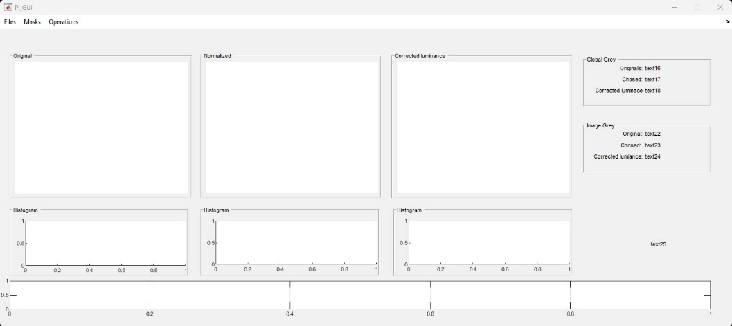

## Explanation of each section of the GUI

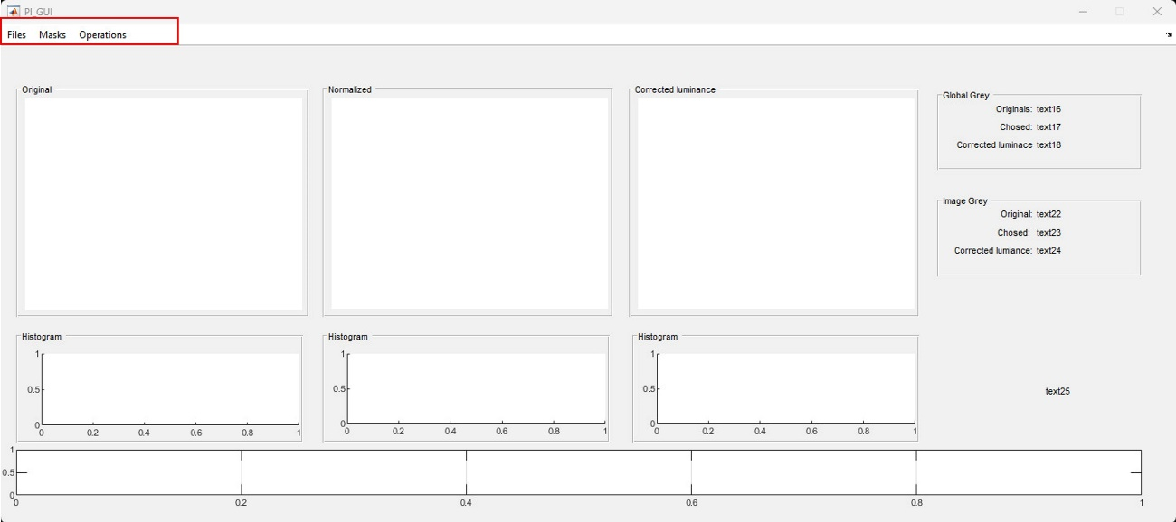

This area highlighted in red is the main menu, from there you will have access to all features of the software.

### Files

By clicking on “Files” you open a menu from where you could Load Images, Save Project, Save Images or Close the app.

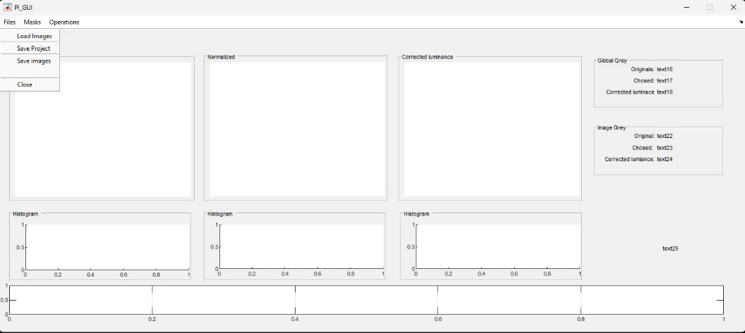

The option “Load Images” will allow to select one or multiple images from a path. You can repeat the process until you have loaded all images you need. You can maintain the original paths in other to maintain the organization of you experiment. If you do so, when you save the processed images they will organized in folders has the originals images are. If you have more than one image a top bar will be visible allowing to browse the images.

“Save Project” allows you to save all in a file to continue all procedures in a later time or to create backups for the steps you are happy with.

“Close” will close the app and clean the workspace.

### Masks

By clicking on “Masks” you will open the menu masks where you can find the options: “Load and apply mask” and “Create and apply mask”.

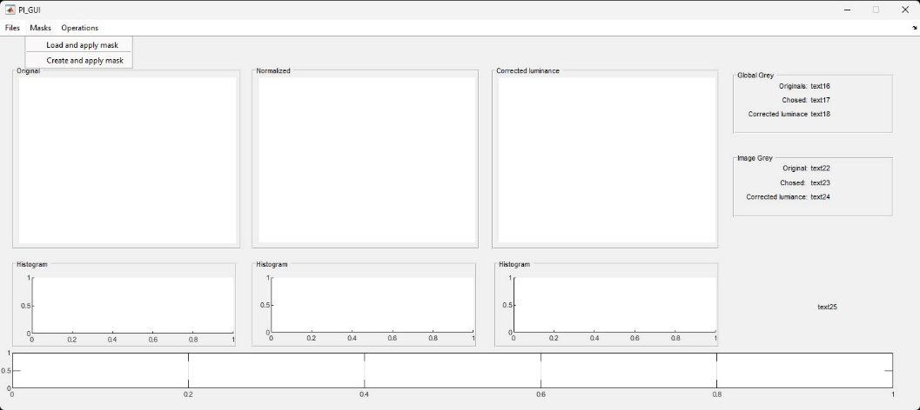

“Load and apply mask” allow to load a mask you made outside this app. Mask, in the context of this app is a file with the same size of the image you are using with zeros and ones, where one means that’s an area of interest to be used for the calculations needed.

“Create and apply mask” will attempt to make a mask that removes the background from the area of interest.

### Operations

By clicking operations you will open the menu and have access to “Chose normalized image”, “Adjust luminance”, “Correct mask”, “Centre and resizing”, “Crop”, and “Cut image”.

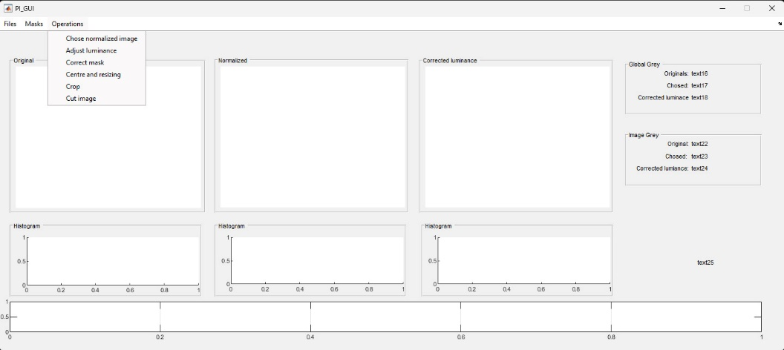

The “Chose normalized image” opens a window that permits to select the method of transformation of image if needed.

“Adjust luminance” will do the calculations and try to transform all images in order to have the same luminance. A chart of the deviations will be presented. The data is available at imada.STATS.std, imada.STATS.stdstd, imada.STATS.mstd, imada.STATS.zim.

“Correct mask” opens an app that will help you correct errors in the mask.

“Centre and resizing” opens an app that allows to chose a point as centre of the image. It will browse all images and the identified point will be the centre for those images.

“Crop” will crop the image.

“Cut the image” will allow to cut out the image.

## How to use the software

# Input Data

## How to input data into the software

The data feed to the software are images in rgb or b&w. you load them in the “Load image” menu.

## File formats accepted by the software

The software will accept images in .png, .jpg, .tif, .bmp

# Output Data

Output data will be created as you save the images and will be save as an excel file.

You will be prompted to define a directory to store the data. You can chose the location you prefer.