**- DIRECTORY -**

dir

**- CHANGE DIRECTORY -**

cd

**- BUSCAR AS COISAS NECESSARIAS PARA INSTALAR O LARAVEL -**

composer global require laravel/installer

**- CRIAR O PROJECTO “blog” É O NOME -**

composer create-project --prefer-dist laravel/laravel:^7.0 blog

**- CRIAR SV -**

php artisan serve

**- INSTALAR AUTENTICAÇÃO -**

composer require laravel/ui:^2.4 1º

php artisan ui vue --auth 2º

npm install 3º

npm run dev 4º

**- CRIAR A BASE DE DADOS -**

ABRIR ".env" , mudar DB_DATABASE

**- EXECUTAR OS CREATES NA BASE DE DADOS -**

php artisan migrate

**- LIMPAR CACHE -**

composer dump-autoload

php artisan optimize:clear

**- CRIAR CONTROLADOR -**

php artisan make:controller HelloWordlController

**- ORDEM -**

Page Request --> routes/web.php --> app/Http/Controllers --> resources/view

Route::get( '/hello-world', 'HelloWorldController@index');

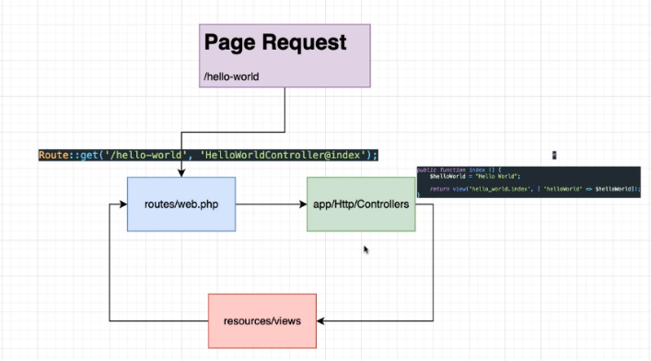--------------------------------------------------------------------------------------------------------------------------------------------------------------------------------

public function index()  
{  
 $helloWorld = "Hello World";  
 $name = "Paulo Oliveira";  
  
 return view('hello_world.index',  
 [  
 'helloWorld' => $helloWorld,  
 'name' => $name,  
 ]  
 );  
}

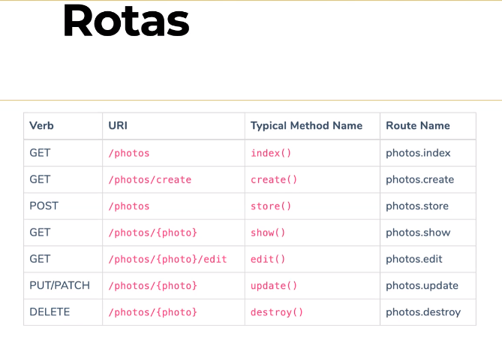

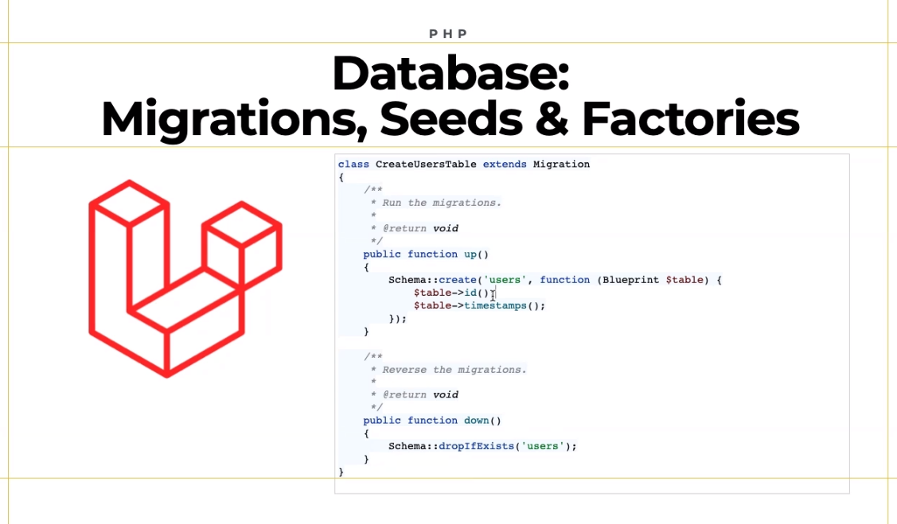

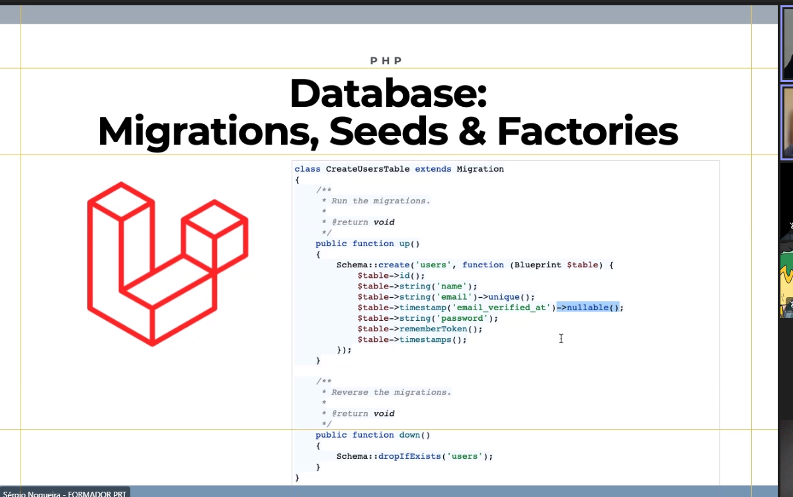

php artisan make:migration create_table_posts --create=posts

https://laravel.com/docs/7.x/migrations

php artisan make:seeder UsersTableSeeder

php artisan make:seeder PostsTableSeeder

php artisan migrate:fresh –seed MONTAR E REFRESH A BASE DE DADOS E FAZER AS SEEDS

<https://github.com/fzaninotto/Faker> - FAKERS

php artisan make:factory PostFactory

php artisan make:model Post

php artisan make:model Post -a