Project Summary: Kinetic Toy Model

General Idea
- Inspired by the ASTHERISC paper’s reviewer 2, we decided to look at the thermodynamic toy model in the form of a kinetic model in order to elucidate whether or not the results given by ASTHERISC are of any relevance in kinetic models.
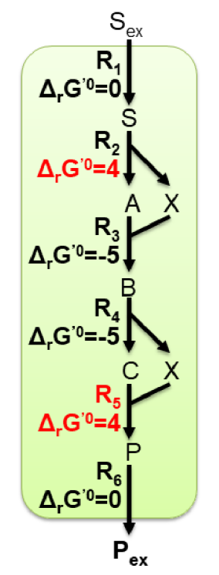
- The „single“ toy model looks like this:
- The „community“ toy model looks like this (here, you can already see the solution given by ASTHERISC for a maximal MDF; the major idea is that the highest MDF community advantage is possible due to a high X concentration in strain 2 and a low X concentration in strain 1):
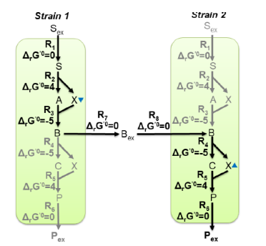

Methods
- The basic kinetic model was made by Giulia using COPASI (where the metabolite X was renamed to Z). It includes (as strains 1 and 2) a „community“ and (as strain 3) a „single“ toy model representation.
- The kinetic laws (which are the same for all strains) look as follows:
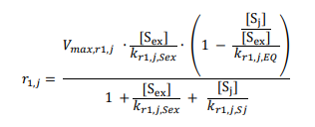

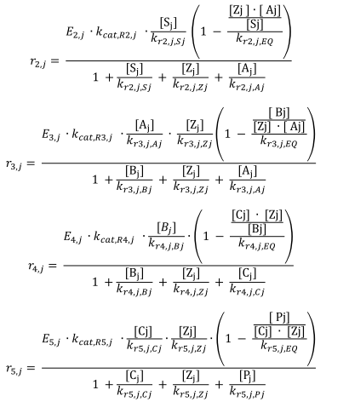
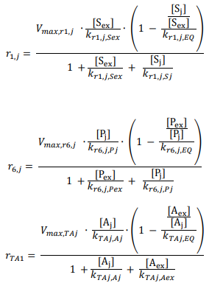

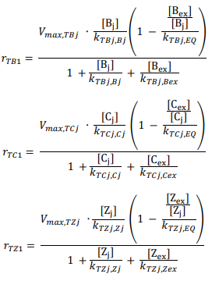
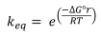
- The k_{eq} value is calculated as follow for each reaction:
- The parameters were set as follows:
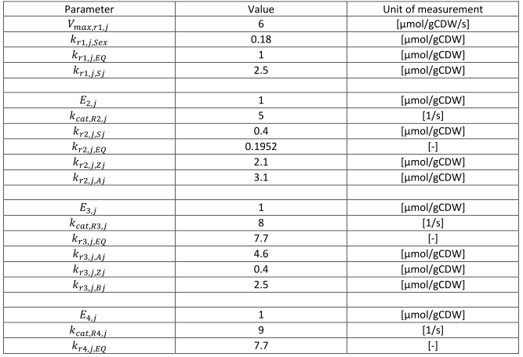

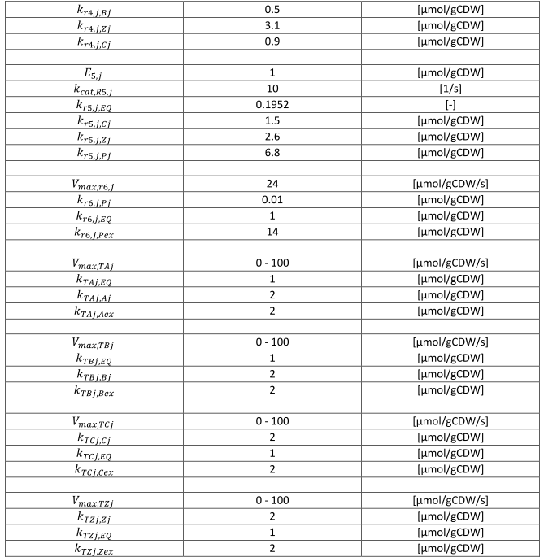
Results
- Initial parameters steady-state analysis: With the parameters given above, the model ‚s community has a flux of ca. 0.75, the single strain a flux of ca. 0.66. Z1 has a concentration of ca. 0.74, Z2 of ca. 0.72, which does not follow ASTHERISC‘s result. One issue with steady-state analyses (as given by COPASI as function): Multiple steady-states are possible. Therefore, we switched to time courses from the given initial conditions.
- Sampling with time courses: We performed a sampling of the model, where the V_{max} parameters were, in each sampling round, each multiplied with a random value from 1/10 to 10, and all other parameters (except of enzyme concentrations of k_{EQ} values) with a value from 1/100 to 100. Each time step had a set „duration“ of 5 and 50 „step“s.
By looking at the last 2 timepoints, it was tested if a sample run reached a non-oscillatory steady-state: If any value of the last timepoint didn’t match its corresponding values of the last two time steps, the sample run was rejected and didn’t occur in the final results.
Programmatically, the sampling was done using COPASI’s unneccessarily complicated Python API.
Here are the main statstics of the results with a sampling of 50‘000 runs (RELATIVE_METABOLITE_COMPARISON stands for Z2/Z1):
~RELATIVE_METABOLITE_COMPARISON~
Min: 0.019301700931076436
Max: 7.513820865334038
Median: 1.115859078077461
Num positive: 45325
Num negative: 0
Num >1.0: 25059
Num <=1.0: 20266
~RELATIVE_COMMUNITY_FLUX_ADVANTAGE~
Min: 0.5535859988781067
Max: 2.2404010213518752
Median: 1.016685208555007
Num positive: 45325
Num negative: 0
Num >1.0: 44648
Num <=1.0: 677
~dG_R2_1~
Min: -8.445695365286669
Max: -5.598550938312741e-05
Median: -0.004916798442782699
Num positive: 0
Num negative: 45325
Num >1.0: 0
Num <=1.0: 45325
~dG_R2_3~
Min: -8.48914641883178
Max: -5.58387879898703e-05
Median: -0.004762266741108689
Num positive: 0
Num negative: 45325
Num >1.0: 0
Num <=1.0: 45325
~dG_R3_1~
Min: -28.107573019219036
Max: -0.0032031347957772738
Median: -9.1764487598538
Num positive: 0
Num negative: 45325
Num >1.0: 0
Num <=1.0: 45325
~dG_R3_3~
Min: -27.756644766860468
Max: -0.002774979590491
Median: -9.249237754629316
Num positive: 0
Num negative: 45325
Num >1.0: 0
Num <=1.0: 45325
~dG_R4_2~
Min: -20.754943656871575
Max: -6.180613106199218e-05
Median: -0.08605385404039989
Num positive: 0
Num negative: 45325
Num >1.0: 0
Num <=1.0: 45325
~dG_R4_3~
Min: -20.70163005250518
Max: -6.122947459452632e-05
Median: -0.08547616078723763
Num positive: 0
Num negative: 45325
Num >1.0: 0
Num <=1.0: 45325
~dG_R5_2~
Min: -33.07461655699386
Max: -0.015370367948838393
Median: -15.752699134460958
Num positive: 0
Num negative: 45325
Num >1.0: 0
Num <=1.0: 45325
~dG_R5_3~
Min: -20.70163005250518
Max: -6.122947459452632e-05
Median: -0.08547616078723763
Num positive: 0
Num negative: 45325
Num >1.0: 0
Num <=1.0: 45325
~A1~
Min: 0.16220254536475665
Max: 0.8921304610941724
Median: 0.8865154847808578
Num positive: 45325
Num negative: 0
Num >1.0: 0
Num <=1.0: 45325
~A3~
Min: 0.04185064626100696
Max: 0.8916722396735239
Median: 0.5903422661112412
Num positive: 45325
Num negative: 0
Num >1.0: 0
Num <=1.0: 45325
~B1~
Min: 7.043810440389198e-05
Max: 5.954150797577083
Median: 0.14163787456658342
Num positive: 45325
Num negative: 0
Num >1.0: 4830
Num <=1.0: 40495
~B2~
Min: 7.039706887580954e-05
Max: 5.954150382654007
Median: 0.1416376722256088
Num positive: 45325
Num negative: 0
Num >1.0: 4830
Num <=1.0: 40495
~B3~
Min: 8.115487949069674e-05
Max: 5.94667930522798
Median: 0.13790289249610801
Num positive: 45325
Num negative: 0
Num >1.0: 4029
Num <=1.0: 41296
~C1~
Min: 0.017184666109611342
Max: 6.691292260433027
Median: 0.9773934032416643
Num positive: 45325
Num negative: 0
Num >1.0: 22142
Num <=1.0: 23183
~C3~
Min: 0.00025749585852901643
Max: 6.628451040772883
Median: 0.7132545160819517
Num positive: 45325
Num negative: 0
Num >1.0: 17013
Num <=1.0: 28312
~P2~
Min: 1.0033804612319704e-05
Max: 2.1421001700606968
Median: 0.00029510719995772526
Num positive: 45325
Num negative: 0
Num >1.0: 1
Num <=1.0: 45324
~P3~
Min: 1.0033336147311045e-05
Max: 0.9888350339220142
Median: 0.00028454082200702897
Num positive: 45325
Num negative: 0
Num >1.0: 0
Num <=1.0: 45325
~S1~
Min: 0.14154834962152749
Max: 3.9991697395741297
Median: 3.9642222426391927
Num positive: 45325
Num negative: 0
Num >1.0: 45269
Num <=1.0: 56
~S3~
Min: 0.14256246274867476
Max: 3.9991715908915273
Median: 3.9657130335111095
Num positive: 45325
Num negative: 0
Num >1.0: 45276
Num <=1.0: 49
~Z1~
Min: 0.16220254536475665
Max: 0.8921304610941724
Median: 0.8865154847808577
Num positive: 45325
Num negative: 0
Num >1.0: 0
Num <=1.0: 45325
~Z2~
Min: 0.01718466610961135
Max: 6.691292260432997
Median: 0.9773934032416637
Num positive: 45325
Num negative: 0
Num >1.0: 22142
Num <=1.0: 23183
~Z3~
Min: 0.20706124910806853
Max: 6.746022325628551
Median: 1.3023114710118484
Num positive: 45325
Num negative: 0
Num >1.0: 35988
Num <=1.0: 9337
~MDF_Total~
Min: 5.58387879898703e-05
Max: 1.4943918049862965
Median: 0.004122324075654049
Num positive: 45325
Num negative: 0
Num >1.0: 4
Num <=1.0: 45321
~MDF_Community~
Min: 5.598550938312741e-05
Max: 1.5186370468273664
Median: 0.004256029071717293
Num positive: 45325
Num negative: 0
Num >1.0: 5
Num <=1.0: 45320
~MDF_Single~
Min: 5.58387879898703e-05
Max: 1.4943918049862965
Median: 0.004129759449222448
Num positive: 45325
Num negative: 0
Num >1.0: 4
Num <=1.0: 45321
~MDF_Advantage~
Min: -0.16606589519281467
Max: 0.4989181240819347
Median: 4.018578928799074e-05
Num positive: 41504
Num negative: 3821
Num >1.0: 0
Num <=1.0: 45325

- Distributon of relative metabolite concentration (Z2/Z1); Most are over 1.0, although many are also under 1.0:
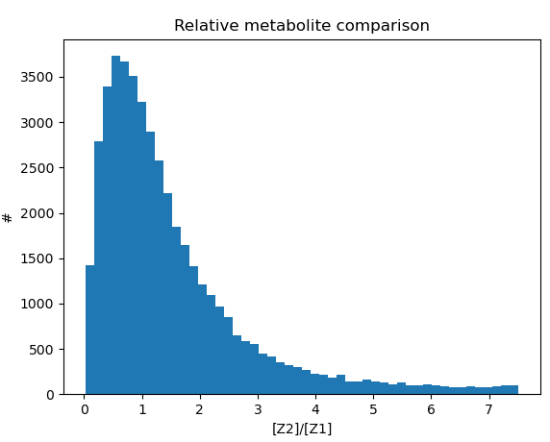
- Distribution of community flux advantage; Most of the times, but not always, the community has a flux advantage:
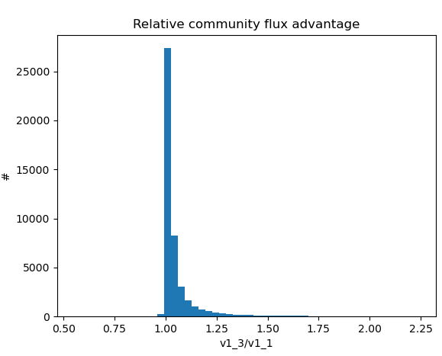
- Metabolite comparison vs. community flux advantage; In order, for the community, to achieve a high flux advantage, the metabolite Z2/Z1 ratio must be high, as predicted by ASTHERISC:
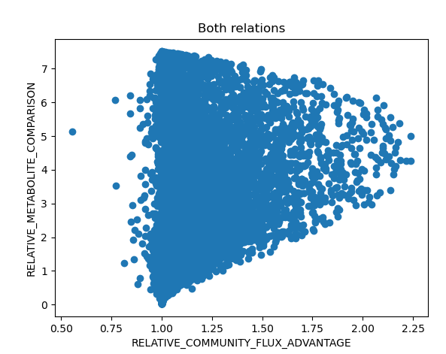
- MDF advantage (of community) distribution; Most of the times, the distribution is sublime
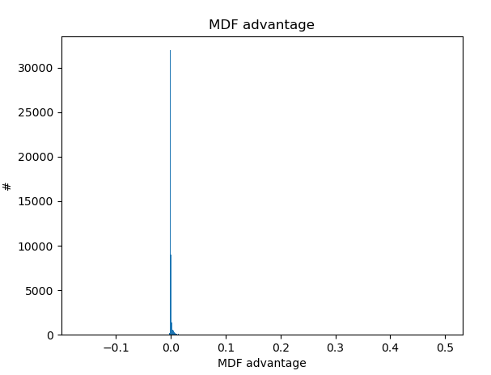
- Flux advantage vs. Community MDF advantage; There is no correlation between the MDF and the flux advantages
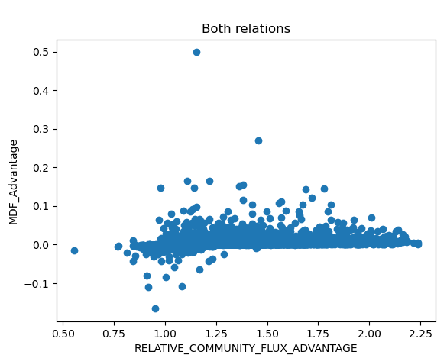
- MDF of community vs. MDF of single solution; Most of the times, the community MDF advantage is sublime, and the single solution can be advantegeous, too:
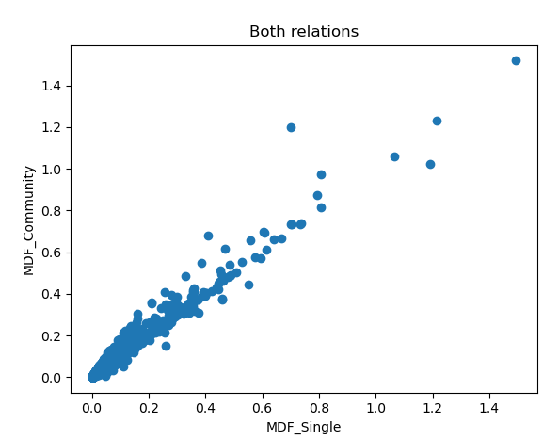
- Metabolite comparison vs. MDF community advantage; Again, so significant correlation occurs
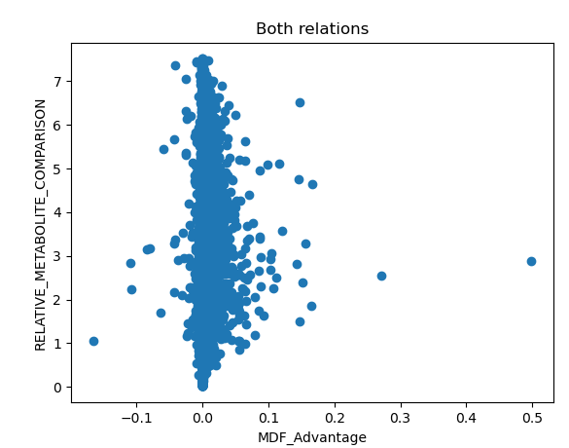

Main conclusions
- Regarding ASTHERISC’s predictions: Depending on the actual kinetic parameters, ASTHERISC only shows a potential for a flux advantage, since the kinetic paramters can cause a community not to have a flux advantage. But ASTHERISC suceeds in predicting neccessary metabolite concentration separations between strains, as shown by the need for a high Z2/Z1 ratio for a high flux advantage.
- Regarding the value of the MDF: In „vivo“, typically no high MDF occurs as the high MDF „draws away“ educts and forms products, which in turn leads to a lower MDF, so that in the end, the overall pathway’s MDF tends to be at slightly above 0 (as shown by the MDF statistics). Furthermore, the MDF in a kinetic model tells us nothing about the actual fluxes. Nevertheless, a positive MDF is neccesasry for a pathway in order to be able to run. ASTHERISC can predict this, too, disregarding kinetic influences on the pathway.

