1. Model map
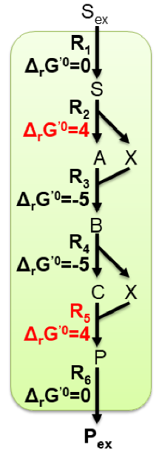
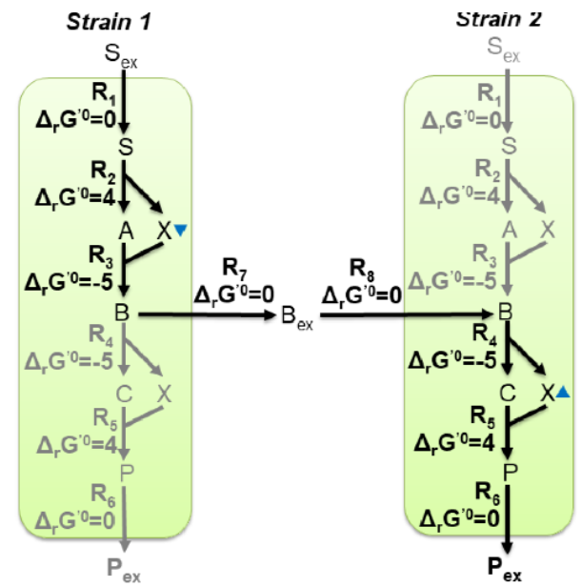
2. Model equations
RTB
RTB
CS1
CS2
SS1
Note: The equations are identical for each compartment

3. Standard initial concentrations
- 4 for S_{ex} (fixed)
- 1e-6 for all others (not fixed)

