In [316]:
import numpy as np
import pandas as pd
import itertools
import matplotlib.pyplot as plt
import seaborn as sns
from sklearn.metrics import confusion_matrix, make_scorer, accuracy_score, roc_curve, roc_auc_score
from sklearn.model_selection import train_test_split, KFold, cross_val_score
from sklearn.tree import DecisionTreeClassifier
from sklearn.neighbors import KNeighborsClassifier
from sklearn.svm import SVC
from sklearn.gaussian_process import GaussianProcessClassifier
from sklearn.ensemble import RandomForestClassifier, AdaBoostClassifier,GradientBoostingClassifier
from sklearn.naive_bayes import GaussianNB
sns.set()
dataset = pd.read_csv('./Datasets/diabetes.csv')
dataset.head()
Out[316]:
 | Pregnancies | Glucose | BloodPressure | SkinThickness | Insulin | BMI | DiabetesPedigreeFunction | Age | Outcome
0 | 6 | 148 | 72 | 35 | 0 | 33.6 | 0.627 | 50 | 1
1 | 1 | 85 | 66 | 29 | 0 | 26.6 | 0.351 | 31 | 0
2 | 8 | 183 | 64 | 0 | 0 | 23.3 | 0.672 | 32 | 1
3 | 1 | 89 | 66 | 23 | 94 | 28.1 | 0.167 | 21 | 0
4 | 0 | 137 | 40 | 35 | 168 | 43.1 | 2.288 | 33 | 1
In [317]:
dataset.info(verbose=True)
<class 'pandas.core.frame.DataFrame'>
RangeIndex: 768 entries, 0 to 767
Data columns (total 9 columns):
# Column Non-Null Count Dtype
--- ------ -------------- -----
0 Pregnancies 768 non-null int64
1 Glucose 768 non-null int64
2 BloodPressure 768 non-null int64
3 SkinThickness 768 non-null int64
4 Insulin 768 non-null int64
5 BMI 768 non-null float64
6 DiabetesPedigreeFunction 768 non-null float64
7 Age 768 non-null int64
8 Outcome 768 non-null int64
dtypes: float64(2), int64(7)
memory usage: 54.1 KB
In [318]:
dataset.describe().T
Out[318]:
 | count | mean | std | min | 25% | 50% | 75% | max
Pregnancies | 768.0 | 3.845052 | 3.369578 | 0.000 | 1.00000 | 3.0000 | 6.00000 | 17.00
Glucose | 768.0 | 120.894531 | 31.972618 | 0.000 | 99.00000 | 117.0000 | 140.25000 | 199.00
BloodPressure | 768.0 | 69.105469 | 19.355807 | 0.000 | 62.00000 | 72.0000 | 80.00000 | 122.00
SkinThickness | 768.0 | 20.536458 | 15.952218 | 0.000 | 0.00000 | 23.0000 | 32.00000 | 99.00
Insulin | 768.0 | 79.799479 | 115.244002 | 0.000 | 0.00000 | 30.5000 | 127.25000 | 846.00
BMI | 768.0 | 31.992578 | 7.884160 | 0.000 | 27.30000 | 32.0000 | 36.60000 | 67.10
DiabetesPedigreeFunction | 768.0 | 0.471876 | 0.331329 | 0.078 | 0.24375 | 0.3725 | 0.62625 | 2.42
Age | 768.0 | 33.240885 | 11.760232 | 21.000 | 24.00000 | 29.0000 | 41.00000 | 81.00
Outcome | 768.0 | 0.348958 | 0.476951 | 0.000 | 0.00000 | 0.0000 | 1.00000 | 1.00
In [319]:
print(dataset.isnull().sum())
Pregnancies 0
Glucose 0
BloodPressure 0
SkinThickness 0
Insulin 0
BMI 0
DiabetesPedigreeFunction 0
Age 0
Outcome 0
dtype: int64
In [320]:
dataset[['Glucose','BloodPressure','SkinThickness','Insulin','BMI']] = dataset[['Glucose','BloodPressure','SkinThickness','Insulin','BMI']].replace(0,np.NaN)
In [321]:
print(dataset.isnull().sum())
Pregnancies 0
Glucose 5
BloodPressure 35
SkinThickness 227
Insulin 374
BMI 11
DiabetesPedigreeFunction 0
Age 0
Outcome 0
dtype: int64
In [322]:
p = dataset.hist(figsize = (20,20))
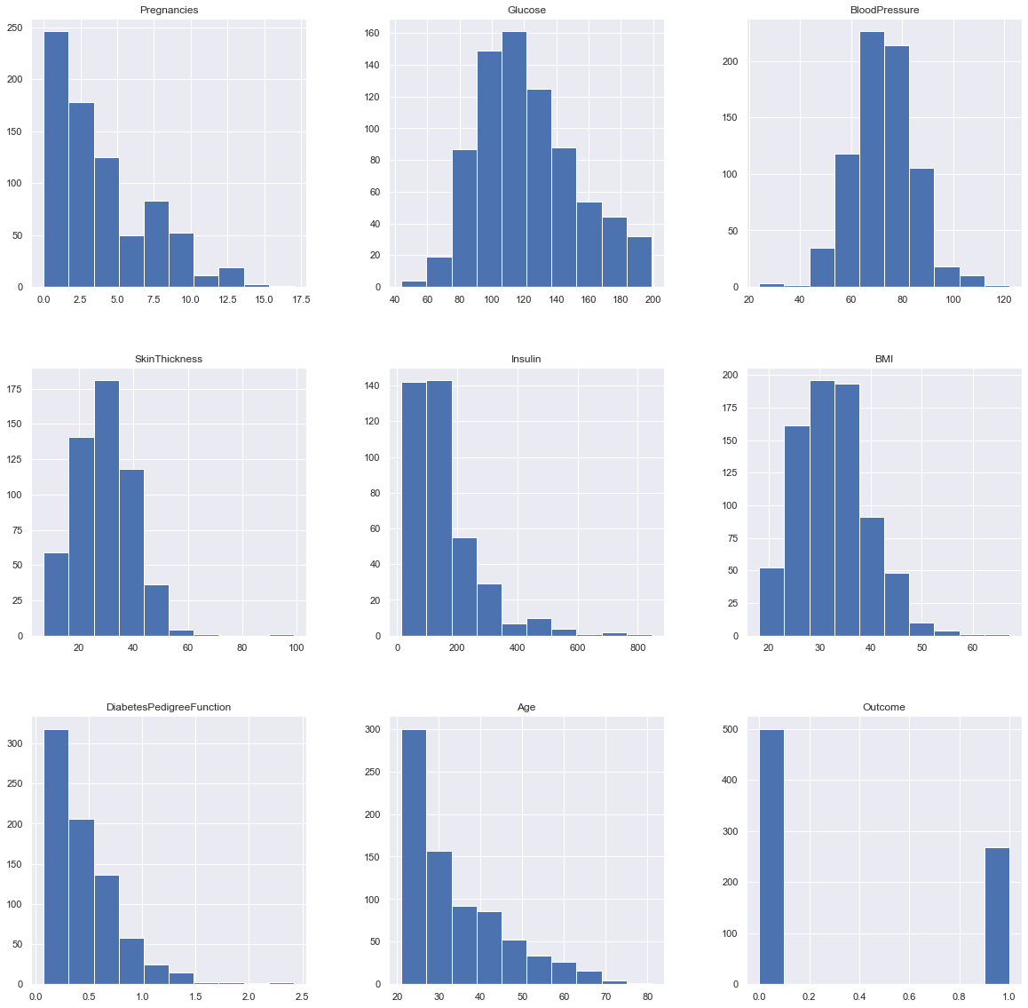
In [323]:
# after analyzing the data distribution, we can choose proper methods to replace nan columns to meanningful value.

dataset['Glucose'].fillna(dataset['Glucose'].mean(), inplace = True)
dataset['BloodPressure'].fillna(dataset['BloodPressure'].mean(), inplace = True)
dataset['SkinThickness'].fillna(dataset['SkinThickness'].median(), inplace = True)
dataset['Insulin'].fillna(dataset['Insulin'].median(), inplace = True)
dataset['BMI'].fillna(dataset['BMI'].median(), inplace = True)
In [324]:
dataset.describe().T
Out[324]:
 | count | mean | std | min | 25% | 50% | 75% | max
Pregnancies | 768.0 | 3.845052 | 3.369578 | 0.000 | 1.00000 | 3.000000 | 6.00000 | 17.00
Glucose | 768.0 | 121.686763 | 30.435949 | 44.000 | 99.75000 | 117.000000 | 140.25000 | 199.00
BloodPressure | 768.0 | 72.405184 | 12.096346 | 24.000 | 64.00000 | 72.202592 | 80.00000 | 122.00
SkinThickness | 768.0 | 29.108073 | 8.791221 | 7.000 | 25.00000 | 29.000000 | 32.00000 | 99.00
Insulin | 768.0 | 140.671875 | 86.383060 | 14.000 | 121.50000 | 125.000000 | 127.25000 | 846.00
BMI | 768.0 | 32.455208 | 6.875177 | 18.200 | 27.50000 | 32.300000 | 36.60000 | 67.10
DiabetesPedigreeFunction | 768.0 | 0.471876 | 0.331329 | 0.078 | 0.24375 | 0.372500 | 0.62625 | 2.42
Age | 768.0 | 33.240885 | 11.760232 | 21.000 | 24.00000 | 29.000000 | 41.00000 | 81.00
Outcome | 768.0 | 0.348958 | 0.476951 | 0.000 | 0.00000 | 0.000000 | 1.00000 | 1.00
In [325]:
# Plot again after all NAN are removed.
In [326]:
p = dataset.hist(figsize = (20,20))
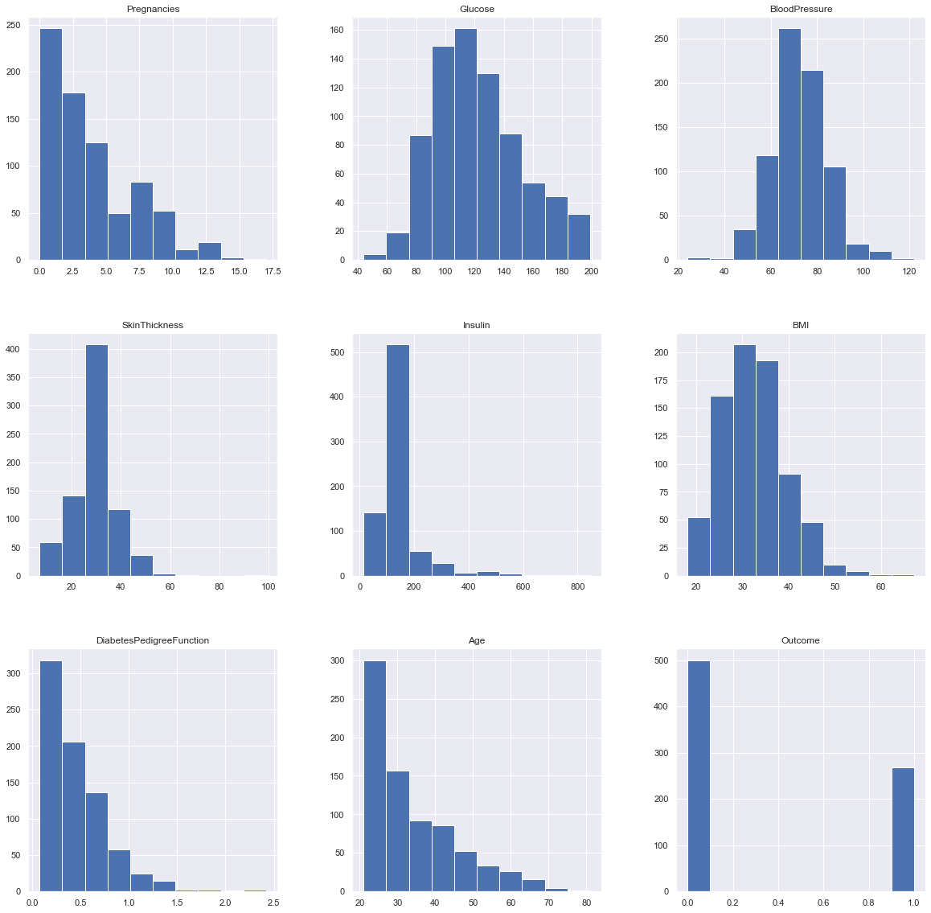
In [327]:
#

positive = dataset.loc[dataset['Outcome'] == 1]
negative = dataset.loc[dataset['Outcome'] == 0]
number_positive_each_age = positive.groupby('Age')['Outcome'].count()
number_negative_each_age = negative.groupby('Age')['Outcome'].count()
result = pd.DataFrame(dict(positive = number_positive_each_age, negative = number_negative_each_age)).reset_index().fillna(0).set_index('Age')
result.plot.bar(figsize=[20,20])
plt.xticks(rotation=360)
plt.title('Variation of Outcome for ages')
plt.ylabel('Count')
plt.xlabel('Age');
plt.show()
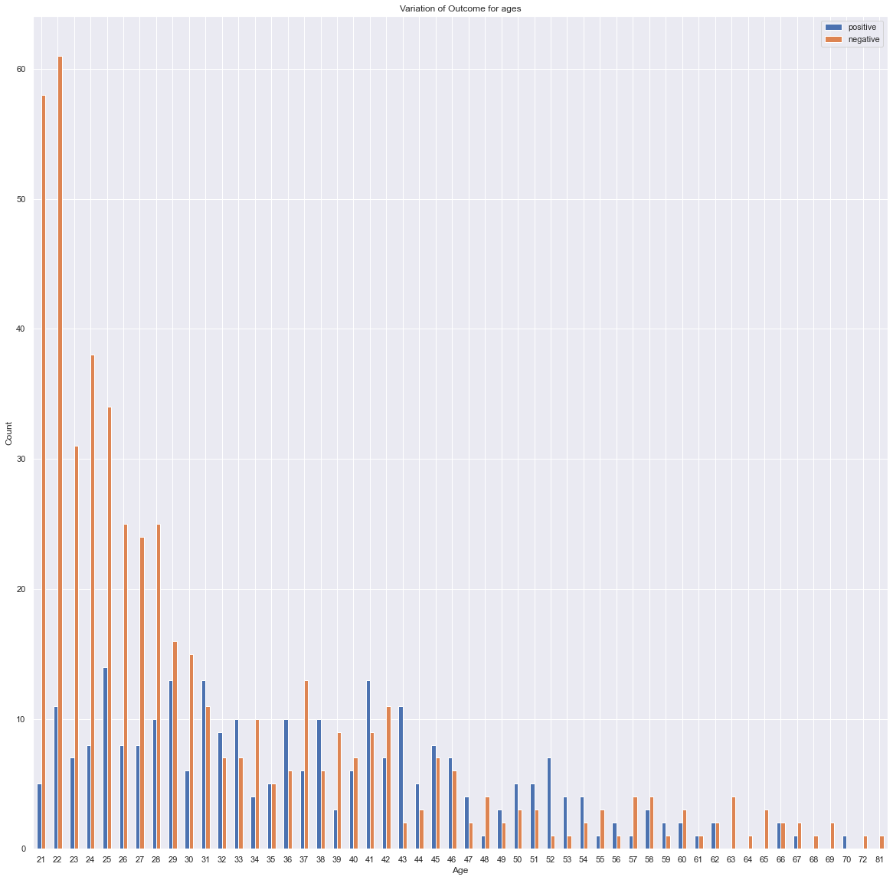
In [328]:
#heatmap
plt.figure(figsize=(12,10)) # on this line I just set the size of figure to 12 by 10.
p=sns.heatmap(dataset.corr(), annot=True,cmap ='YlOrBr')
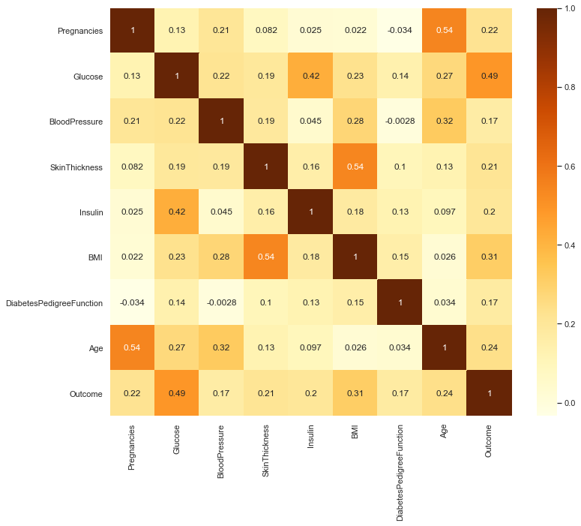

Analysis:¶

The value of Correlation Coefficient can be between -1 to +1. 1 means that they are highly correlated and 0 means no correlation. According to the heatmap, we can clearly see the correlations between each attributes.¶
In [329]:
dataset.corr()
Out[329]:
 | Pregnancies | Glucose | BloodPressure | SkinThickness | Insulin | BMI | DiabetesPedigreeFunction | Age | Outcome
Pregnancies | 1.000000 | 0.127911 | 0.208522 | 0.081770 | 0.025047 | 0.021559 | -0.033523 | 0.544341 | 0.221898
Glucose | 0.127911 | 1.000000 | 0.218367 | 0.192686 | 0.419064 | 0.231128 | 0.137060 | 0.266534 | 0.492928
BloodPressure | 0.208522 | 0.218367 | 1.000000 | 0.191853 | 0.045087 | 0.281199 | -0.002763 | 0.324595 | 0.166074
SkinThickness | 0.081770 | 0.192686 | 0.191853 | 1.000000 | 0.155610 | 0.543205 | 0.102188 | 0.126107 | 0.214873
Insulin | 0.025047 | 0.419064 | 0.045087 | 0.155610 | 1.000000 | 0.180241 | 0.126503 | 0.097101 | 0.203790
BMI | 0.021559 | 0.231128 | 0.281199 | 0.543205 | 0.180241 | 1.000000 | 0.153438 | 0.025597 | 0.312038
DiabetesPedigreeFunction | -0.033523 | 0.137060 | -0.002763 | 0.102188 | 0.126503 | 0.153438 | 1.000000 | 0.033561 | 0.173844
Age | 0.544341 | 0.266534 | 0.324595 | 0.126107 | 0.097101 | 0.025597 | 0.033561 | 1.000000 | 0.238356
Outcome | 0.221898 | 0.492928 | 0.166074 | 0.214873 | 0.203790 | 0.312038 | 0.173844 | 0.238356 | 1.000000
In [330]:
def plotHistogram(values,label,feature,title):
sns.set_style("whitegrid")
plotOne = sns.FacetGrid(values, hue=label,aspect=2)
plotOne.map(sns.histplot,feature,kde=False)
plotOne.set(xlim=(0, values[feature].max()))
plotOne.add_legend()
plotOne.set_axis_labels(feature, 'Proportion')
plotOne.fig.suptitle(title)
plt.show()

attributes = dataset.columns.values
for i in attributes[: -1]:
plotHistogram(dataset,"Outcome",i, i + ' vs Diagnosis (Blue = Healthy; Orange = Diabetes)')
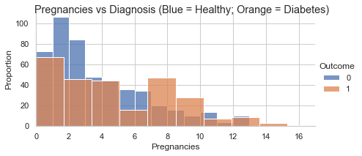
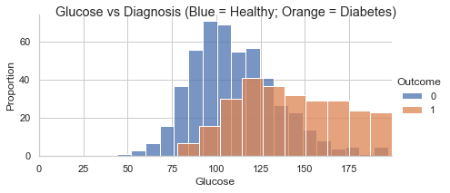
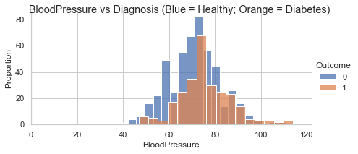
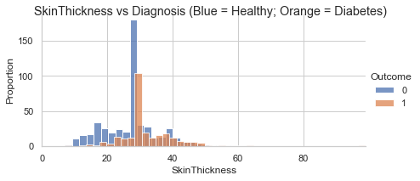
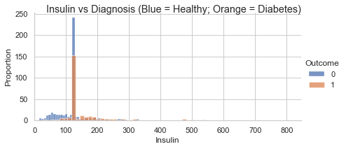
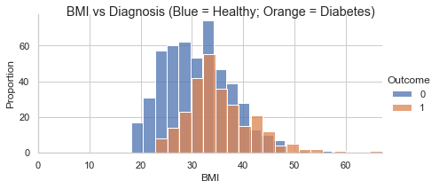
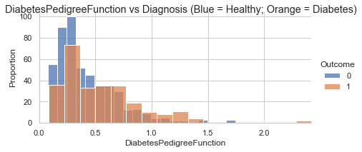
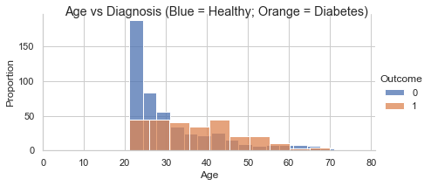
In [1]:
def show_used_models():
print('Decision Tree = DecisionTreeClassifier')
print('SVC = Support Vector Machine SVC')
print('KNN = KNeighborsClassifier')
print('GradientBoosting = GradientBoostingClassifier')
print('Gaussian NB = GaussianNB')
print('Random Forest = RandomForestClassifier')
print('Ada Boost = AdaBoostClassifier')
print('GradientBoosting = GradientBoostingClassifier \n\n')
In [332]:
# modelling
X = dataset.iloc[:, :-1]
y = dataset.iloc[:, -1]

X_train, X_test, y_train, y_test = train_test_split(X, y, test_size=0.3)
models = []
model_names = []
results = []
models.append(('Decision Tree', DecisionTreeClassifier()))
models.append(('SVC', SVC()))
models.append(('KNN', KNeighborsClassifier()))
models.append(('GradientBoosting', GradientBoostingClassifier()))
models.append(('Gaussian NB', GaussianNB()))
models.append(('Random Forest', RandomForestClassifier()))
models.append(('Ada Boost', AdaBoostClassifier()))

for name, model in models:
model.fit(X_train, y_train)
kfold = KFold(n_splits=10)
accuracy_results = cross_val_score(model, X_train,y_train, cv=kfold, scoring='accuracy')
results.append(accuracy_results)
model_names.append(name)
accuracyMessage = "%s: %f (%f)" % (name, accuracy_results.mean(), accuracy_results.std())
print(accuracyMessage)

Decision Tree: 0.677918 (0.051998)
SVC: 0.739693 (0.073575)
KNN: 0.707827 (0.070016)
GradientBoosting: 0.750559 (0.061796)
Gaussian NB: 0.769357 (0.055614)
Random Forest: 0.743291 (0.056324)
Ada Boost: 0.720825 (0.072511)
In [333]:
# boxplot for each model
fig = plt.figure(figsize=[20,20])
fig.suptitle('Algorithm Comparison: Accuracy')
ax = fig.add_subplot(111)
plt.boxplot(results)
ax.set_xticklabels(model_names)
ax.set_ylabel('Cross-Validation: Accuracy Score')
plt.show()
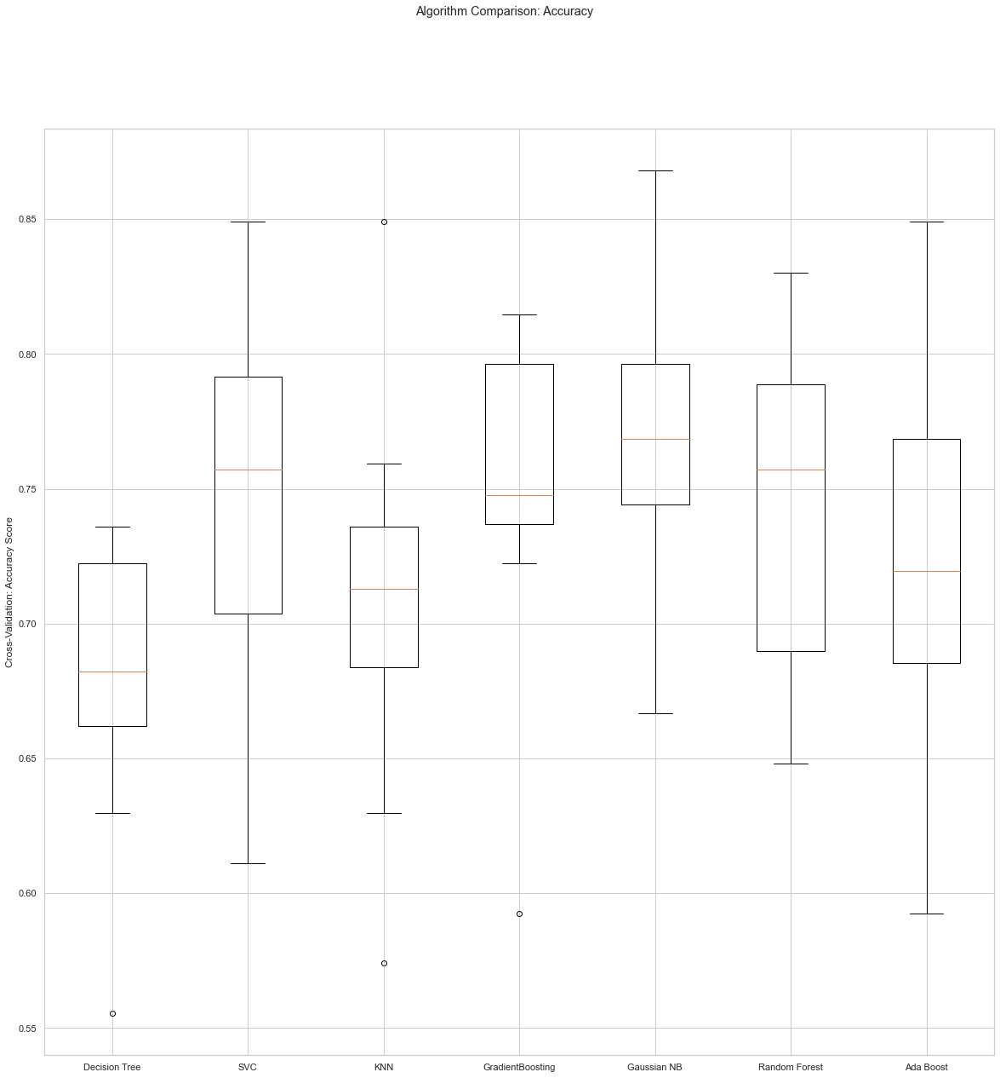
In [334]:
show_used_models()
results = {}
for name, clf in models:

scores = cross_val_score(clf, X_train, y_train, cv=5)
results[name] = scores
for name, scores in results.items():
print("%20s | Accuracy: %0.2f%% (+/- %0.2f%%)" % (name, 100*scores.mean(), 100*scores.std() * 2))
Decision Tree = DecisionTreeClassifier
SVC = Support Vector Machine SVC
KNN = KNeighborsClassifier
GradientBoosting = GradientBoostingClassifier
Gaussian NB = GaussianNB
Random Forest = RandomForestClassifier
Ada Boost = AdaBoostClassifier
GradientBoosting = GradientBoostingClassifier

Decision Tree | Accuracy: 68.53% (+/- 5.50%)
SVC | Accuracy: 74.50% (+/- 8.48%)
KNN | Accuracy: 72.07% (+/- 8.25%)
GradientBoosting | Accuracy: 73.74% (+/- 9.99%)
Gaussian NB | Accuracy: 76.36% (+/- 4.05%)
Random Forest | Accuracy: 73.18% (+/- 7.40%)
Ada Boost | Accuracy: 70.96% (+/- 9.97%)
In [335]:
def plot_confusion_matrix(cm, classes,
normalize=False,
title='Confusion matrix',
cmap=plt.cm.Blues):
plt.imshow(cm, interpolation='nearest', cmap=cmap)
plt.title(title)
plt.colorbar()
tick_marks = np.arange(len(classes))
plt.xticks(tick_marks, classes, rotation=45)
plt.yticks(tick_marks, classes)
fmt = '.2f' if normalize else 'd'
thresh = cm.max() / 2.
for i, j in itertools.product(range(cm.shape[0]), range(cm.shape[1])):
plt.text(j, i, format(cm[i, j], fmt),
horizontalalignment="center",
color="white" if cm[i, j] > thresh else "black")
plt.tight_layout()
plt.ylabel('True label')
plt.xlabel('Predicted label')
In [336]:
# according to the analysis above, we picked the top 3 high accuracy model to explore more
candidate_models = [('random forest', RandomForestClassifier()), ('GradientBoosting',GradientBoostingClassifier()), ('AdaBoost',AdaBoostClassifier())]
for name, model in candidate_models:
model.fit(X_train, y_train)
kfold = KFold(n_splits=10)
accuracy = cross_val_score(model, X_train, y_train, cv=kfold, scoring='accuracy')
mean = accuracy.mean()
stdev = accuracy.std()
prediction = model.predict(X_test)
cnf_matrix = confusion_matrix(y_test, prediction)
plot_confusion_matrix(cnf_matrix, classes={0:'Healthy', 1:'Diabetes'},title='Confusion matrix for '+ name)
plt.show()
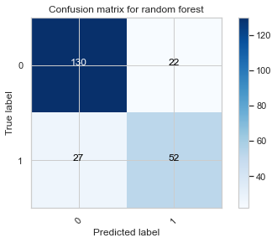
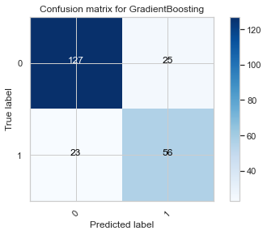
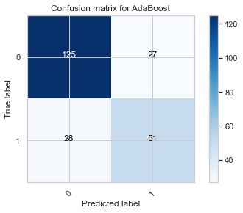
In [337]:
# ROC
def no_skill_prediction():
ns_probs = [0 for _ in range(len(y_test))]
ns_auc = roc_auc_score(y_test, ns_probs)
print('No Skill: ROC AUC=%.3f' % (ns_auc))
ns_fpr, ns_tpr, _ = roc_curve(y_test, ns_probs)
plt.plot(ns_fpr, ns_tpr, linestyle='--', label='No Skill')

def graph_roc_auc(model, name):
# predict probabilities
lr_probs = model.predict_proba(X_test)
lr_probs = lr_probs[:, 1]
# calculate score
lr_auc = roc_auc_score(y_test, lr_probs)
# print score
print(name + ': ROC AUC=%.3f' % (lr_auc))
# calculate roc curves
lr_fpr, lr_tpr, _ = roc_curve(y_test, lr_probs)
# plot the roc curve for the model
plt.plot(lr_fpr, lr_tpr, marker='.', label=name)
# axis labels
plt.xlabel('False Positive Rate')
plt.ylabel('True Positive Rate')
# show the legend
plt.legend()
In [338]:
no_skill_prediction()
for name, model in (candidate_models):
graph_roc_auc(model, name)
plt.title('ROC AUC comparison')
No Skill: ROC AUC=0.500
random forest: ROC AUC=0.837
GradientBoosting: ROC AUC=0.851
AdaBoost: ROC AUC=0.818
Out[338]:
Text(0.5, 1.0, 'ROC AUC comparison')
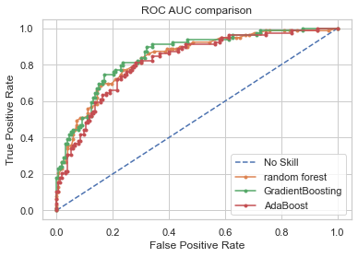
In [339]:
for name, model in candidate_models:
model.fit(X_train, y_train)
print('Accuracy of ' + name + ': {:.2f}'.format(model.score(X_test, y_test)))

columns = dataset.columns.values
coefficients = model.feature_importances_
absCoefficients = abs(coefficients)
fullList = pd.concat((pd.DataFrame(columns, columns = ['Variable']), pd.DataFrame(absCoefficients, columns = ['absCoefficient'])), axis = 1).sort_values(by='absCoefficient', ascending = False)
print('DecisionTreeClassifier - Feature Importance:')
print('\n',fullList,'\n')
Accuracy of random forest: 0.79
DecisionTreeClassifier - Feature Importance:

Variable absCoefficient
1 Glucose 0.261964
5 BMI 0.160252
7 Age 0.129872
6 DiabetesPedigreeFunction 0.122828
0 Pregnancies 0.087502
4 Insulin 0.085999
2 BloodPressure 0.083820
3 SkinThickness 0.067764
8 Outcome NaN

Accuracy of GradientBoosting: 0.79
DecisionTreeClassifier - Feature Importance:

Variable absCoefficient
1 Glucose 0.388823
5 BMI 0.202975
7 Age 0.103672
6 DiabetesPedigreeFunction 0.099697
0 Pregnancies 0.073492
4 Insulin 0.073369
2 BloodPressure 0.043211
3 SkinThickness 0.014761
8 Outcome NaN

Accuracy of AdaBoost: 0.76
DecisionTreeClassifier - Feature Importance:

Variable absCoefficient
5 BMI 0.24
1 Glucose 0.18
2 BloodPressure 0.14
6 DiabetesPedigreeFunction 0.14
4 Insulin 0.10
7 Age 0.10
3 SkinThickness 0.06
0 Pregnancies 0.04
8 Outcome NaN

After analyzing the three models, we are able to predict diabetes from medical records with an accuracy of approximately 76%. This was done by focusing on important features such as Glucose levels and BMI.
In [340]:
dataset
Out[340]:
 | Pregnancies | Glucose | BloodPressure | SkinThickness | Insulin | BMI | DiabetesPedigreeFunction | Age | Outcome
0 | 6 | 148.0 | 72.0 | 35.0 | 125.0 | 33.6 | 0.627 | 50 | 1
1 | 1 | 85.0 | 66.0 | 29.0 | 125.0 | 26.6 | 0.351 | 31 | 0
2 | 8 | 183.0 | 64.0 | 29.0 | 125.0 | 23.3 | 0.672 | 32 | 1
3 | 1 | 89.0 | 66.0 | 23.0 | 94.0 | 28.1 | 0.167 | 21 | 0
4 | 0 | 137.0 | 40.0 | 35.0 | 168.0 | 43.1 | 2.288 | 33 | 1
... | ... | ... | ... | ... | ... | ... | ... | ... | ...
763 | 10 | 101.0 | 76.0 | 48.0 | 180.0 | 32.9 | 0.171 | 63 | 0
764 | 2 | 122.0 | 70.0 | 27.0 | 125.0 | 36.8 | 0.340 | 27 | 0
765 | 5 | 121.0 | 72.0 | 23.0 | 112.0 | 26.2 | 0.245 | 30 | 0
766 | 1 | 126.0 | 60.0 | 29.0 | 125.0 | 30.1 | 0.349 | 47 | 1
767 | 1 | 93.0 | 70.0 | 31.0 | 125.0 | 30.4 | 0.315 | 23 | 0
768 rows × 9 columns
In [341]:
columns = ['Pregnancies', 'BloodPressure', 'DiabetesPedigreeFunction','Age', 'SkinThickness', 'Insulin']

dataset = dataset.drop(columns, axis=1)
In [342]:
dataset
Out[342]:
 | Glucose | BMI | Outcome
0 | 148.0 | 33.6 | 1
1 | 85.0 | 26.6 | 0
2 | 183.0 | 23.3 | 1
3 | 89.0 | 28.1 | 0
4 | 137.0 | 43.1 | 1
... | ... | ... | ...
763 | 101.0 | 32.9 | 0
764 | 122.0 | 36.8 | 0
765 | 121.0 | 26.2 | 0
766 | 126.0 | 30.1 | 1
767 | 93.0 | 30.4 | 0
768 rows × 3 columns
In [362]:
X = dataset.iloc[:, :-1]
y = dataset.iloc[:, -1]
X_train, X_test, y_train, y_test = train_test_split(X, y, test_size=0.2, random_state=1)

clf = GradientBoostingClassifier()
clf.fit(X_train, y_train)
print('Accuracy of GradientBoostingClassifier in Reduced Feature Space: {:.2f}'.format(clf.score(X_test, y_test)))
columns = dataset.columns
coefficients = clf.feature_importances_
absCoefficients = abs(coefficients)
fullList = pd.concat((pd.DataFrame(columns, columns = ['Variable']), pd.DataFrame(absCoefficients, columns = ['absCoefficient'])), axis = 1).sort_values(by='absCoefficient', ascending = False)
print('\n GradientBoostingClassifier - Feature Importance:')
print('\n',fullList,'\n')
Accuracy of GradientBoostingClassifier in Reduced Feature Space: 0.75

GradientBoostingClassifier - Feature Importance:

Variable absCoefficient
0 Glucose 0.622474
1 BMI 0.377526
2 Outcome NaN

