Arduino Home Automation featuring TP-Link 702n and ENC28J60

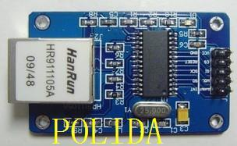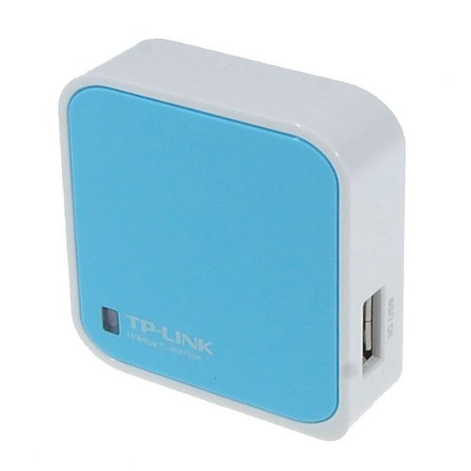

By Paul Richards and Manuel Tijerino

Overview:

An Ipad can be used to control irrigation systems, lights, house temperature, and even water plants. It can also be used to read temperature sensors, humidity sensors even sump pumps. Inexpensive wireless sensor and control nodes can be created using a TP-Link 702n ($22) and an ENC28J60 ($5.00) and DIY Arduino pcbs ($7.00). X-10 (with a DIY arduino control) can also be used to controlled power to lights.

The system is started with an existing wireless router. TP-Link modules are placed in repeater mode so that ENC28J60 (connected to DIY arduinos) can communicate with the system wirelessly.

Here are the required steps:

1. Place a TP-Link 702n in repeater mode
2. Create a DIY Arduino Web-Server that can be written to ($7.00). Connect it directly to your wireless router
3. Create a DIY Arduino Web-Client and connect it to the TP-Link 702n
4. Command the Web-Client using an Ipad or notebook computer  
     
   This project is located on github: <https://github.com/Pualware/ArduinoHomeAutomation>

Configure a TP-Link in Repeater Mode

1. Set your PC Lan IP4 properties so that it is on the same subnet as the TP-Link 702n (note: the default IP address of a TP-Link 702n is 192.168.0.254)  
   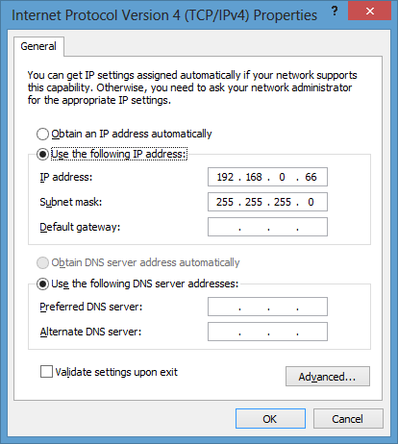
2. Acces TP-Link 702n located at <http://192.168.0.254> from laptop via ethernet cable (note: username is admin, and password is admin). Select Repeater and press the Next button  
   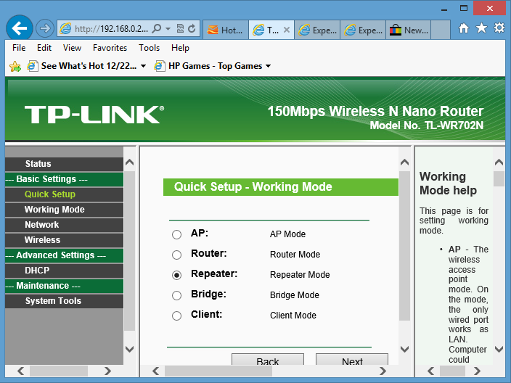
3. Select Survey and select your network, then select the same Security Options as your network and enter the correct password. Then press Next.  
   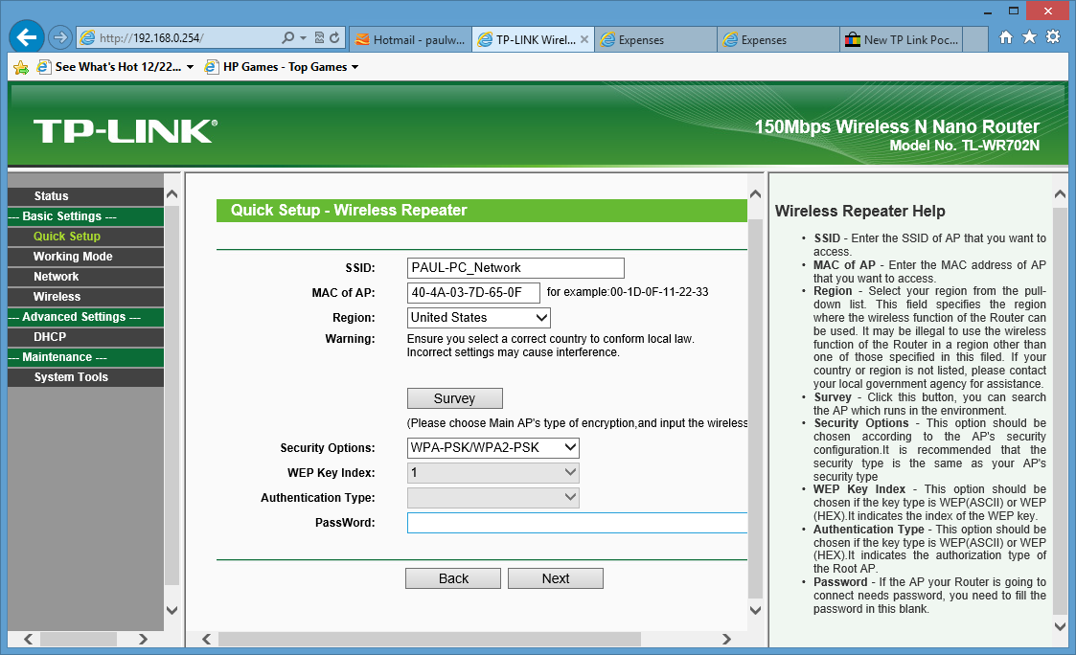
4. The default setting for DHCP in Repeater mode is disabled. You will need DHCP enabled for your client nodes so enable DHCP in DHCP Settings:

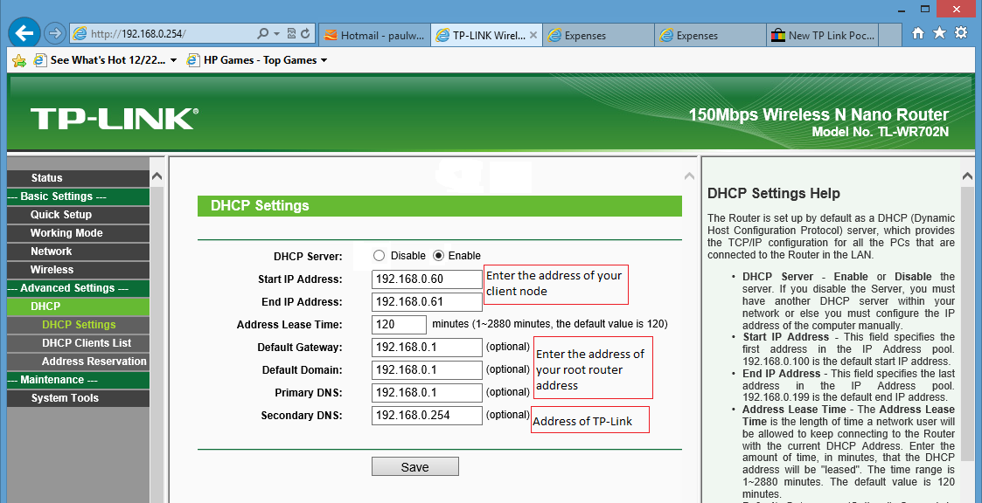  
  
Your tp-link is now setup. To verify that it works. Turn off your wireless laptop connection and connect an Ethernet cable directly from your laptop to the 702n. You should be able to get to the internet via the tp-link. Change your pc lan properties for TCP/IPV4 to optain IP Address automatically. The Tp-Link will assign the pc the address 192.168.0.60.

You can verify that the pc has the correct ip address by running ipconfig. In windows 8 press the windows key and the “r” this will bring up the Run dialog box. Enter “cmd” and then change directory to c:\windows\system32 from there you run ipconfig and should see:

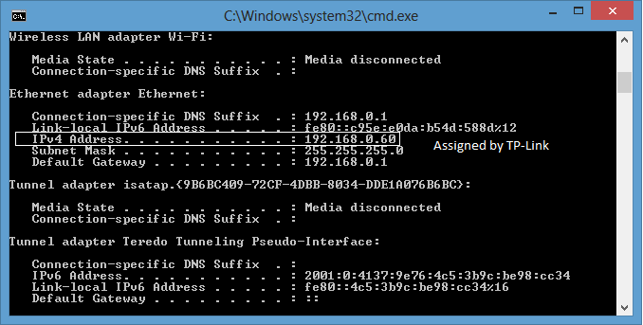

The system is now ready for the TP-Link 702n to be directly connected to the DIYArduino Client

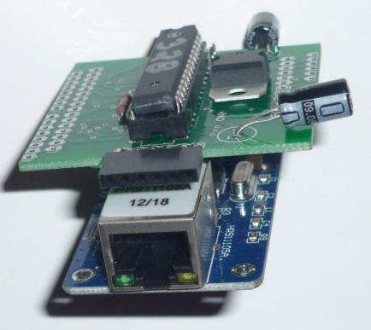

Connect the 2102 usb to serial adapter to the DIYArduino Client and flash the unit using the Arduino IDE. Use the client sketch found at Github to flash the unit.

From the Arduino IDE, start the serial monitor. Assuming your DIY Arduino webServer is connected and you have already entered the command: <http://192.168.0.50/discoverKingTiger1>. You should see a display like this in the Serial Monitor:

[webClient]

access Ethernet controller ok

IP: 192.168.0.61

GW: 192.168.0.1

DNS: 192.168.0.1

SRV: 192.168.0.50

0:0:0:0:0:0:100:0:0:100:0:0:0:0:0:0:0:0:0:0

This means that the client has been assigned the address of 192.168.0.61 by the 702n. The gateway is established to the root modem/router. The DNS name server is established to the root modem/router and the DIY web-server located at 192.168.0.50 is visible to the client device. Further, all the port values were read from the web-server for this device named “KingTiger1”

Commands recognized by the DIY Arduino Web-Server are:

1. discover  
    This command lets the web server know that a device exists on the network. It must be followed by a unique device name for example:  
   discoverKingTiger1  
    For example this lets the web server know that a device by the name of KingTiger1 exists.
2. show  
    This command lists all the devices currently connected. Here is an example output:

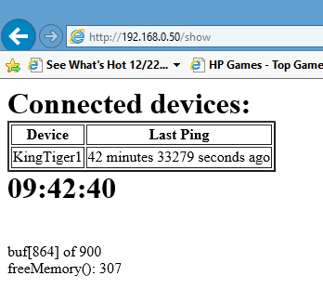

1. write  
    This command is used to write to ports on the specified device.  
    For example:  
    writeKingTiger1:19:1:5:100:3:200  
    writes the value 1 to port 19, the value 100 to port 5 and the value 200 to port 3
2. read  
    This command is used to read all the ports on the specified device.  
    For example:  
    readKingTiger1  
    Tells the web-server to echo the value for all ports on the device KingTiger1.

Sketches for the web server and web-client, as well as the schematics to build the DIY Arduino components will be located on Github:

<https://github.com/Pualware/ArduinoHomeAutomation>