Bay Coding Club

Robotics

Lesson Plan

By: Paul Richards 1/8/2021

Legos and robotics

What could be better than adding electronics to legos?

Legos has released a variety of motors:

Like power functions:

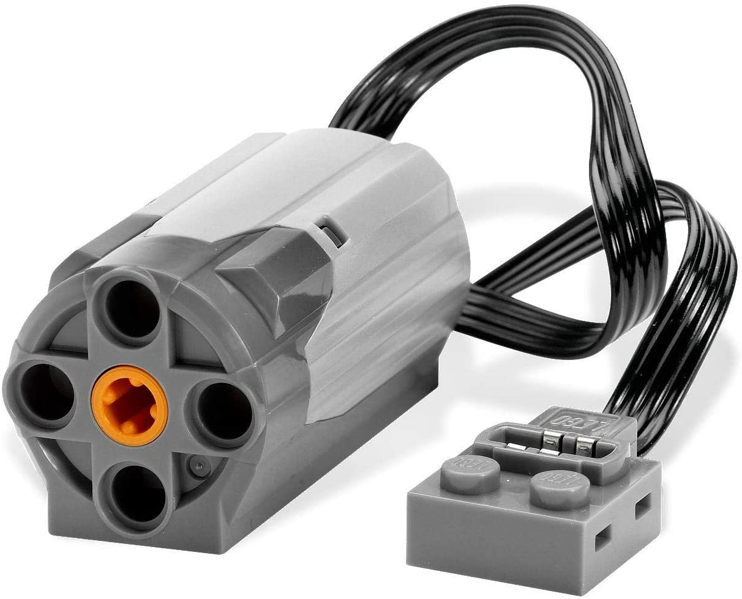

And NXT:

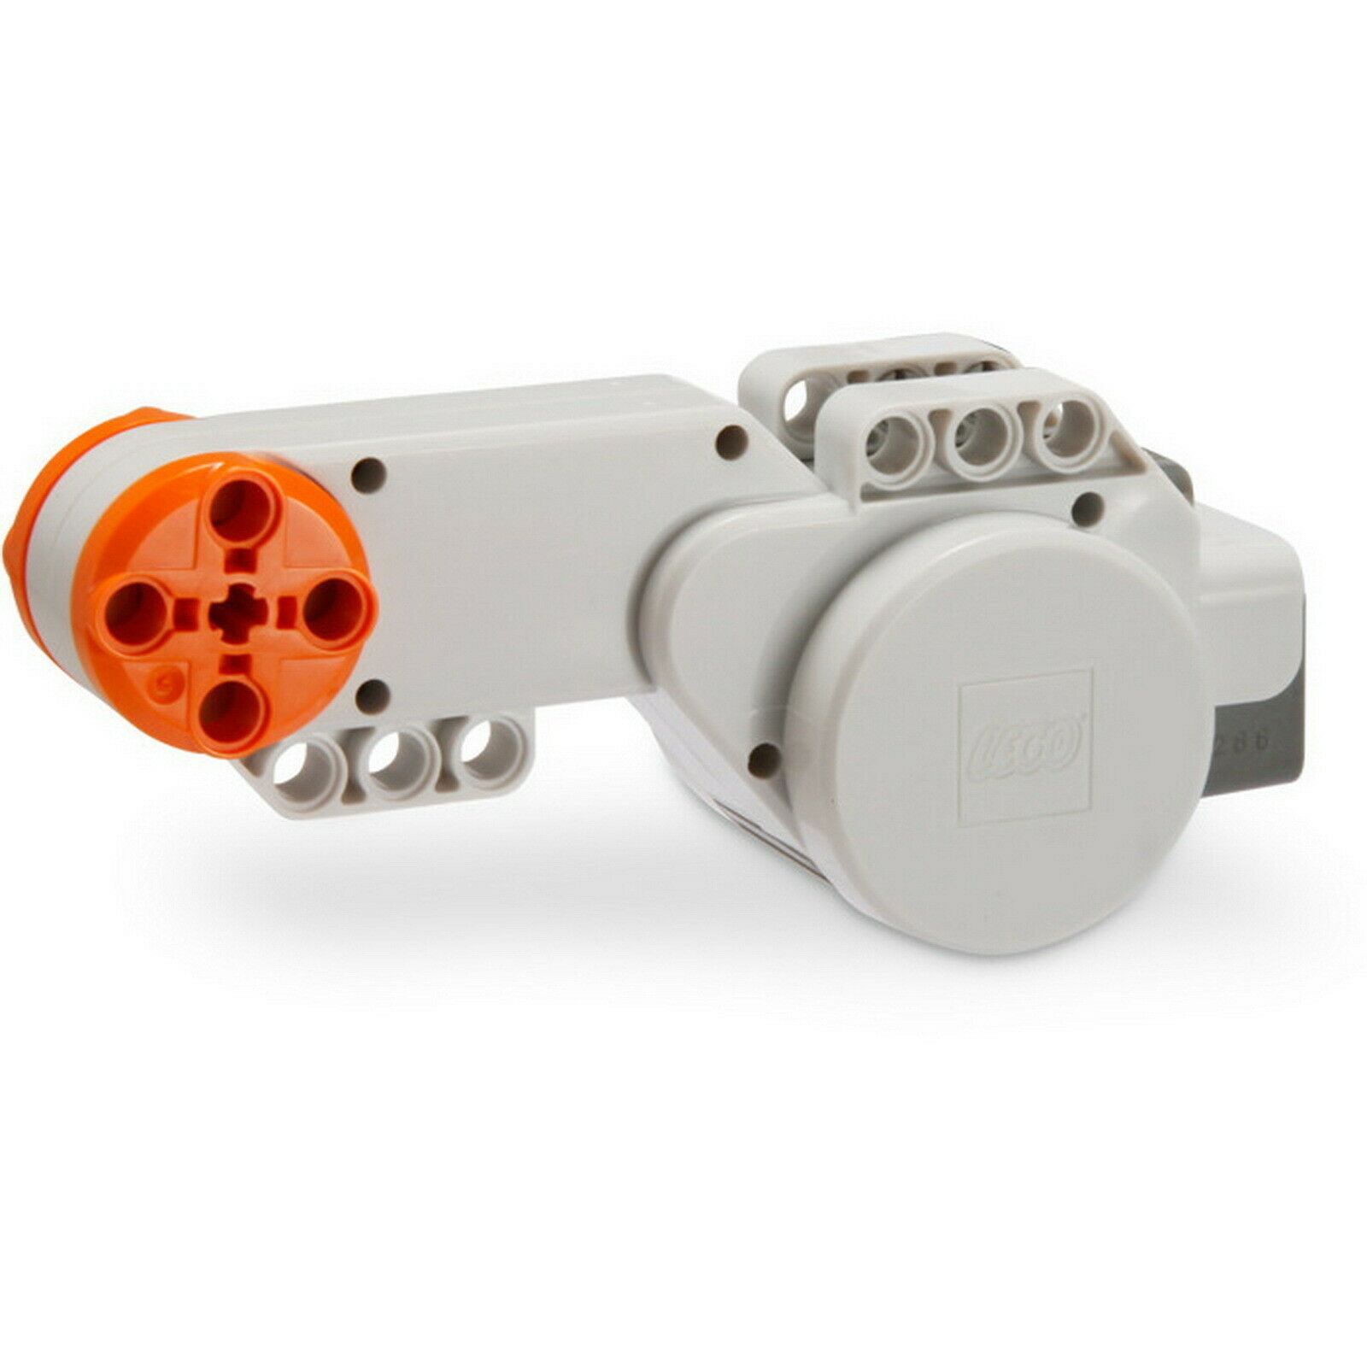

But the remote control features are limited to infra-red:

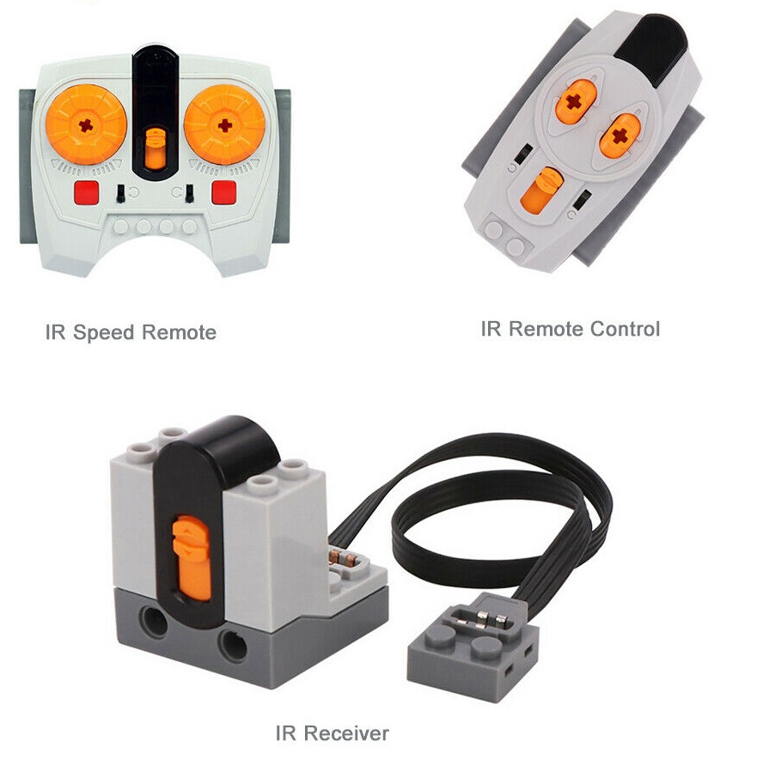

And the mindstorm brick:

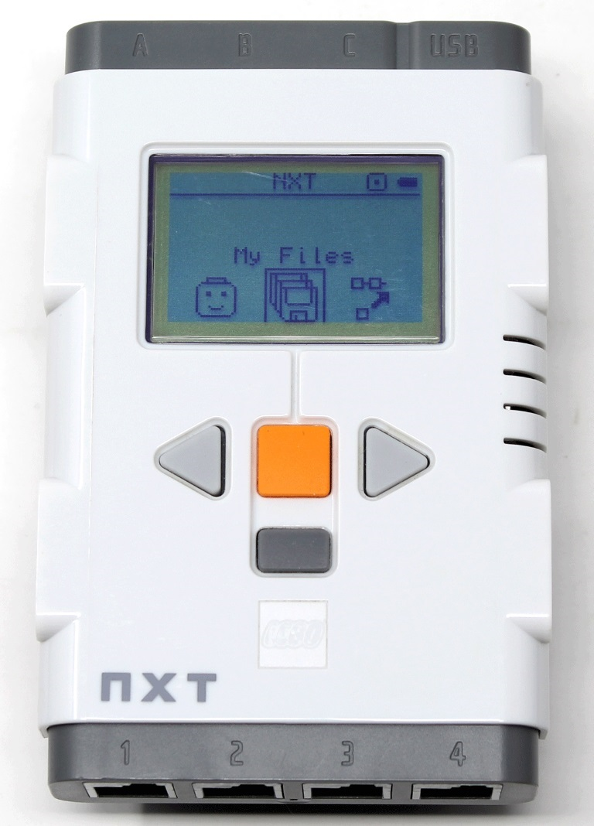

This course will leverage the large number of lego projects currently available online with the new user-friendly microcontroller: micro-bit.

Micro-bit was developed in the UK with young students in mind. Using an intuitive blockly development environment and a rich set of examples, students can easily build working robots.

Our first project will be a mecanum vehicle (which can drive sideways), and then we will build a spider and walking biped. Finally we will add infra-red receive and transmit to our models and explore adding our own custom components.

Project 1: Microbit Development Environment

We start with the micro-bit development environment, because it gives students a foundation they can build on for all subsequent projects. It also gives a chance to make sure all parts are on order for the subsequent projects.

Project 2: Mecanum Vehicle

That is all