How to configure and use the Water Sensor Data Logger

By Paul Richards

[paulware@hotmail.com](mailto:paulware@hotmail.com)

February 8, 2014

This system will log date, soil humidity, stream sensing, and rain sensing to an sd card each minute.

It currently runs on 5 volts and looks like this:

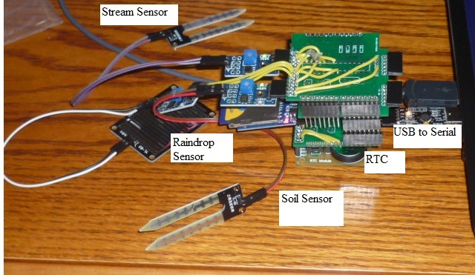

5 volts is preferred at the moment so that it can be easily interacted with by a laptop over the usb port.

I future version will run on 3.3V.

Total Parts cost:

|  |  |  |  |
| --- | --- | --- | --- |
| Name | Description | Price | Supplier |
| DS1302 | Real Time Clock | $2.23 | Ebay |
| SD Card Module | Interface to SD Card | $0.99 | Ebay |
| I2C interface to SD Card | Allows control of card | $5 | Me |
| Soil Sensor | Provides soil humidity | $1.54 | Ebay |
| Stream Sensor | Provides water detection | $1.54 | Ebay |
| Raindrop detection | Senses rain | $1.96 | Ebay |
| CP2102 | Usb to serial converter for laptop to communicate | $3.00 | Ebay |
| DIY Arduino for overall control | Interfaces with all the components | $8.74 | Me |
| Total Cost |  | **$25** |  |

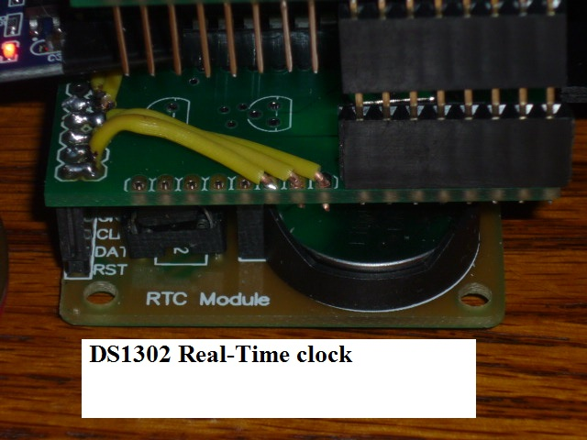

This DS1302 has an operating voltage of 2-5V. It uses a 2302 watch battery and has a rather obscure protocol for interaction. I used a library from <http://quadpoint.org/projects/arduino-ds1302> by Matt Sparks to control it. 3 wires are used for control (Chip Enable, Data pin, and Clock). You can find these on ebay for $2.23. Search on “Clock Module DS1302 with Battery”.

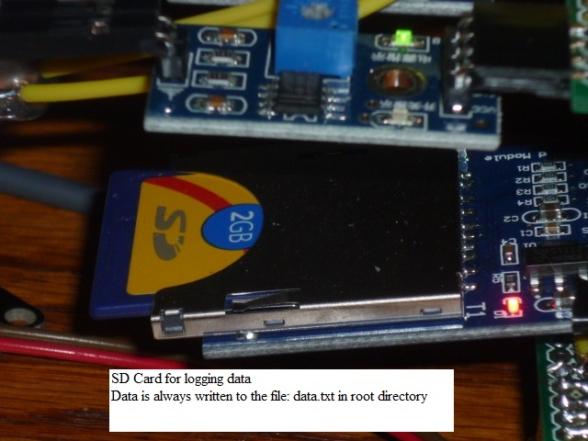

The SD card can also be found on ebay for $0.99. Search for “SD Card Module Slot Socket Reader”. Its 2 operating voltages are 3.3V and 5.0V.

I created my own I2C interface for this module which requires 2 atmega 328 chips, which increases the price about $5. The card can be read and written to by a windows machine.



Three water sensors are used:

1. Soil sensor which has an analog output
2. Raindrop sensor which has a digital output
3. Stream sensor which has a digital output

The Soil and Stream sensors are actually identical, but utilized differently. The soil sensor is attached by its analog output and the stream sensor is attached by its digital output.

The soil/stream sensors are found on ebay for $1.54. Search for “Soil Humidity Moisture Detection”

The raindrop sensors are found on ebay for $1.96. Search for “Rain Weather Module”

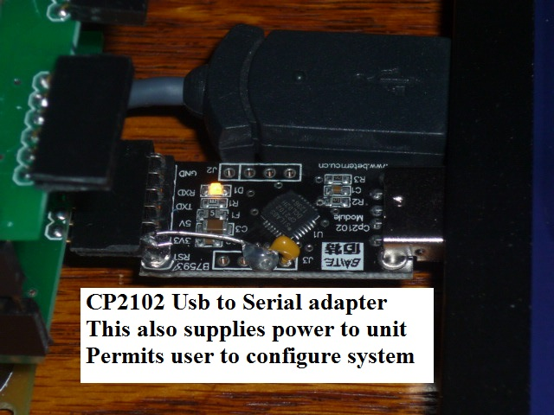

The CP2102 is used to communicate from the laptop to the device. They also send power to the device from the laptop. This allows you to interface with a menu that allows you to set date, clear data, and view the data.

A specific pin sequence is required: RST, 3V3, 5V, TX, RX, GND, which I don’t see on ebay anymore. But you can search for CP2102 module to get a rough idea. They are about $3.

Windows needs a driver to use this CP2102 they are located here: <http://www.silabs.com/products/mcu/pages/usbtouartbridgevcpdrivers.aspx>.

Miscellaneous parts:

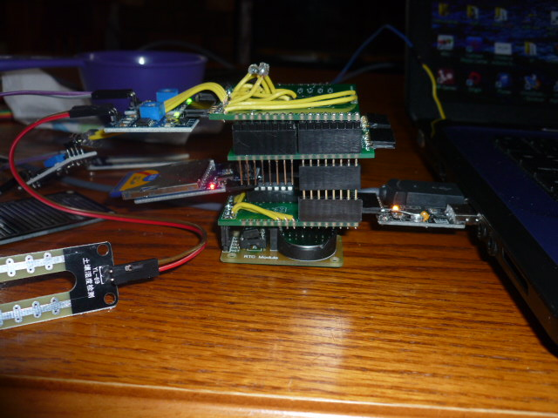

I create a DIY Arduino to control the entire thing this, plus a top pcb which is about $8.74

Shipping within the United states is about $3.50.

Outside the United States is about $10.00.

Please deposit shipping cost in my paypal account:

[paulware@hotmail.com](mailto:paulware@hotmail.com)

To have this shipped. Also specify the mailing address.

All my products have my full support. If you any questions or comments, contact me at [paulware@hotmail.com](mailto:paulware@hotmail.com)

Thanks!

Paul