SORN – Level Design Document – Level 1
1. Level Overview
- Level Name: The Wall
- Game: SORN
- Level Type: (Tutorial/Combat)
- Player Count: 1
- Estimated Playtime: 5-8 minutes
- Difficulty Tier: (Early)
- Primary Player Fantasy: Infiltrate “The Wall” and execute the Commander

2. Narrative & Context
Story Purpose:
- This level exists because our narrative has taken us to this desert wasteland with direct orders to infiltrate a location called “The Wall” and eliminate a target called the “Commander of the Wall.” The outer part of the wall, which is a desert, nests a security checkpoint players will go through as a tutorial area before infiltrating the Wall
Narrative Beats:
- Beat 1: “Getting Online” which is our stationary tutorial
- Beat 2: Clearing out the security checkpoint to get comfortable with the controls
- Beat 3: Infiltrating the wall via a side vent, and entering room 1
- Beat 4: Defeating enemies in sector 1, and progressing to sector 2
- Beat 5: Defeating the enemies in sector 2, and progressing to the boss room
- Beat 6: Engage in boss fight with the commander and defeat him
- Beat 7: Escape down the hatch and exit through the front door (previously locked) and escape in your hub ship (cutscene)
World Lore Elements: Decals showing what PMC I am attacking

3. Player Goals & Objectives
Primary Objectives: Defeating the Commander of the Wall
Secondary/Optional Objectives:
- Complete the tutorial
- Clear out enemies at security checkpoint
- Clear out sector 1
- Clear out sector 2
Fail Conditions: Losing all health results in death, resetting player to previous checkpoint
Success Conditions: Progressing to the next beat is possible (doors unlock)

4. Level Flow & Structure
Entry Point: Drop in via hub ship
Critical Path Summary:
- Complete tutorial
- Clear security checkpoint
- Clear out sectors 1 and 2
- Defeat the boss
Exit Point: Through the initially locked front door

5. Gameplay Mechanics Used
Core Mechanics Highlighted: Target lock on
New Mechanics Introduced (if any):
- Boost
- Dash
- Fire right weapon
- Fire left weapon
- Fire rockets
- Reload
- Heal
- Jump
Mechanics Reinforced: Target lock on, rockets

6. Combat Design
Combat Style: Open arena, chokepoints, ambushes, vertical combat,
Enemy Types: Turret, drones, hermit, laser turret, opposing mech
Enemy Placement Philosophy: Enemies are placed strategically for balance as well as breadcrumbing
Encounter Progression:
- Encounter 1: Checkpoint enemies flow from front to back leading to the vent in the wall
- Encounter 2: Strategically placed enemies flow from right to left, breadcrumbing the player to the door. Additionally, enemies are placed keeping in mind variety and balance
- Encounter 3: Enemies flow from front to back and are also placed on the side of the players, enabling 360-degree combat. Verticality is introduced via jump pads allowing for further traversal
- Encounter 4: Boss fight combines everything learned into a fight against another mech
Difficulty Ramp: More enemies faced as level progresses, as well as variety

7. Exploration & Navigation
Traversal Mechanics:
- Jumping
- Upward thrusting
- Boosting state
- Dash
Landmarks & Wayfinding: Objective markers with distance
Secrets / Optional Paths: None
Risk vs Reward Elements: Limited amount of rockets and heals per level

8. Level Layout (Top-Down Description)
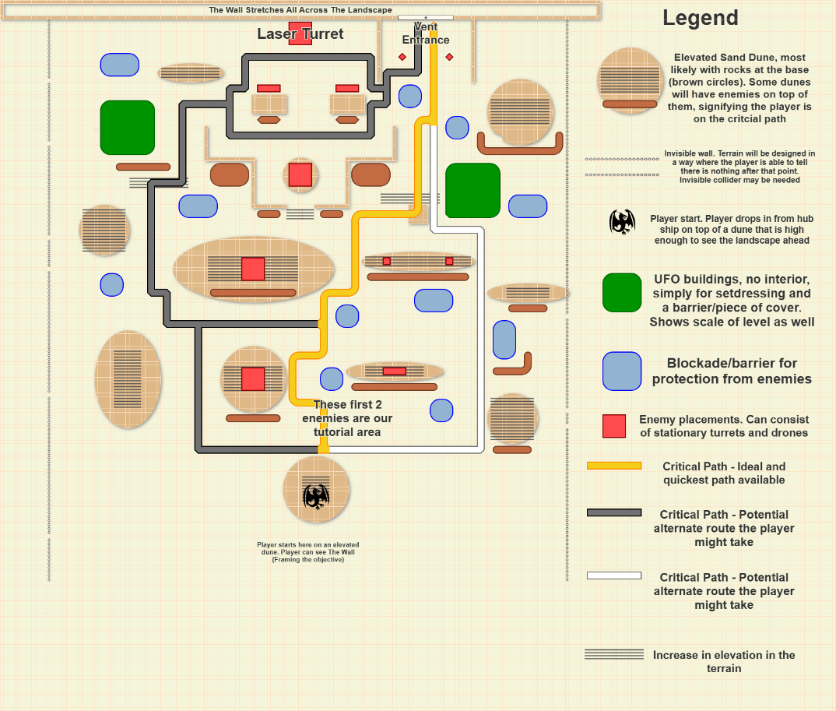
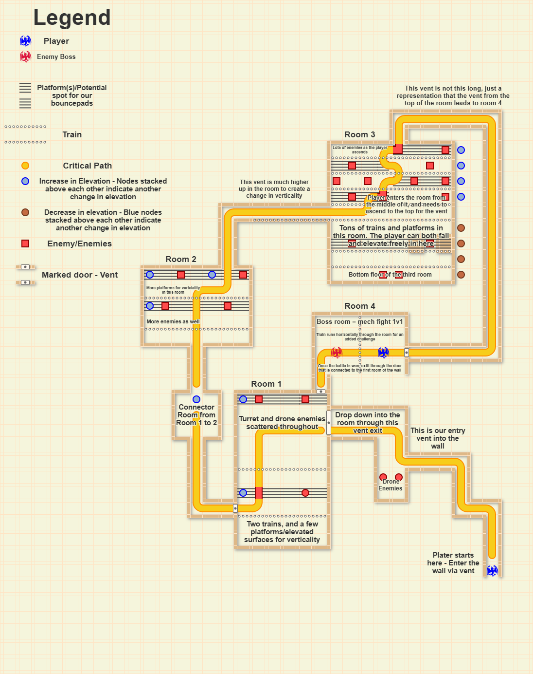

9. Environmental Storytelling
Visual Themes: Art style not finalized
- Set Dressing Goals: Spaces should feel lived in, but props should also be placed with logical reasoning. Additionally, all props/pieces of cover should be placed strategically to allow for balanced engagements, encourage aggressive gameplay, provide proper sightlines, and verticality where needed while maintaining visual interest and cohesion
Implied Events:
Play space is currently occupied by opposing faction, and is an operational shipping facility using trains to transport cargo throughout the wall

10. Art & Audio Direction
Art:
- Biome / Environment Type: Desert and Industrial monolith play space
- Color Palette: Brown, gray, navy blue, green, military colors
- Key Visual References: Miro board
Audio:
- Ambient Sounds: Whooshing of our mech while in boosted state
- Combat Audio Cues: Hit markers, explosions
- Music State Changes: Different parts of the level have different soundtracks

11. Technical Considerations
Performance Targets: Perfect 60 FPS
Streaming / Level Partitioning: Level streaming is used to load/unload levels not needed. Additionally, it is used so we can work in the same level at the same time in engine
Blueprint / System Dependencies: Enemy BP, Mech BP, Train BP and splines
Known Risks: Different designers working on same levels can cause creative differences, or result in a level that is not cohesive

12. Player Experience Goals
Intended Emotions: Exhilaration and satisfaction
Pacing Notes: Tutorial is tame, but once the player approaches the checkpoint the pace increases substantially. Downtime exists between encounters but only for brief stints.
Moments to Remember: Final boss fight vs the Commander of the Wall

13. Metrics & Testing Notes
Time to Complete: 5-8 minutes
Death Hotspots: Laser turret guarding the entrance to the wall
Player Confusion Points:
- Understanding that players can only progress when their current objective is complete
- There is no backtracking
- All mechanics in tutorial should be spoon fed and applied in the level at some point
Iteration Notes: Images, design process, and thought process should be presented in the #level chat and explained thoroughly. This includes intentions, concepts, future changes, and any assets/systems that need to be made or implemented for the next iteration

14. Open Questions / To-Do

