Automatic Cat Feeder.
A consumer device to help alive the chore of owning pets.

Dispensing Unit: Investigation into the physical design of the food dispensing unit.

Author: Matthew Smith
Team Member: Chris Ranc
Team Member: Shabab Siddiq
Submission Date: 11-7-2017
Table of contents

Overview:
As a Computer Engineering project, one extremely important aspect of a physical design that carries the most risk is the actual method of dispensing food. As a dispensing unit, the design must be able to hold several days worth of food and be able to dispense without jamming or crushing the food. This design needs to be free of obstructions that would restrict food flow as well. Since the food will be gravity fed, we will also need to ensure that the assembly is not too top heavy such that it’d fall over with little effort.

Risk Specification

Market Requirements | Engineering Requirement | Justification
 | A. An automatic feeder should be able to hold a multi-day supply of pet food. | In order to justify an automatic feeder, the user must not need to tend to the feeder often.
 | B. Portion control for the feeder must be reliable and reasonably precise. | In order for the feeder to suit the needs of a diverse group of pets, the portions need to be controllable to accommodate size and health restrictions.
 | C. Dispensing mechanism must be reliable enough to not jam or crush food too often. | It’s important that the unit does not jam because it’s designed to be trusted to feed while the owner is away for a reasonable time. A jam could mean a day without being fed.

Risk investigation:

Survey of existing systems/components:

In order to have a cohesive system, the container must taper into a hopper that then feeds into the chosen dispensing mechanism. This means the hopper must be designed around the dispensing mechanism. As this mechanism carries the responsibility of both reliably and precisely dispensing food, it will be the primary focus of this investigation. Many future aspects of the design will be dependent on how food is dispensed from the unit, making this the lynch pin in the design.

When beginning to design and search for solutions, it’s often a good idea to look at solutions that already exist on the market for inspiration as well as learning based on others’ past decisions, productive or otherwise. A very common consumer item that was designed to specifically dispense dry goods is the cereal dispenser. These are often seen in hotels to provide varying kinds of cereal to patrons. These devices are manually controlled by a knob in the front that rotates a four-paddle assembly that allows cereal to fall into a “V” shaped area, then the assembly rotates to drop the cereal down into a bowl below. This is a very common design due to the simplicity and the use cases associated with it. This design is particularly good at dumping larger servings into the bowl with the goal of filling it, but does not provide much room for precise control. This design also has a tendency to bind while rotating and in turn, pulverizing the dry food caught up. An illustration of this can be seen in Figure 1 in the appendix. This is often solved by the intelligent human operator rotating the assembly in the reverse direction then back in the original direction to clear the bind. With the intelligent user being replaced by an electric motor, the possible binding risks long term reliability on the design.

Another possible method seen in other dry goods dispensers is the simple trap door design. This idea can take many forms and orientations to allow food to spill out. This design is also very simple to implement. Similar to the paddle-based design, this method has trouble with precise dispensing. Unlike the paddle-based design, binding is rarely an issue due to the nature of an opening and closing door. It is possible that the door used in conjunction with a secondary dispensing method would allow to reduce the force of food stacked above the mechanism and by relation, reduce or remove possible binding. This possibility will need to be investigated further as well.

A third design possibility is not often seen in the context of moving dry food but is very common in automation applications such as injection molding, where a precise amount of material must be fed and injected into a mold. This design uses a a screw embedded into a tube that would allow for food to fall into the tube and the screw would rotate and push it along. The screw would be installed on an axle that could be easily driven by a motor. Since the screw would only allow small amounts of food to fall between threads and pushed forward by the screw rotating, thus advancing the food to the drop point. This allows for the speed and the amount of food dispensed to be controlled with a far greater amount of precision. The downside to the screw based dispenser mechanism is that great care will be involved in designing the screw and hopper, particularly the angle of attach on the threads and the taper of the hopper. Any sort of binding could be greatly mitigated with a proper design, compared to the nature of the paddle dispenser that has far less room for improvement compared to the screw design.

Concepts considered and chosen:

First and foremost, the final design should be able to reliably portion and control the output of the pet food. Due to this, the most important design decision will be based on the mechanism that controls this. From research into feed methods, the screw design beats out other considered methods by a long shot in it’s ability to portion food in a semi controlled resolution compared to how the paddles and doors mostly dump the food.

Another point to consider is the durability of the design. For the paddle design, if a bind is encountered, a greater amount of torque would be needed for the paddle to overcome the bind compared to the screw. The screw can also be designed in such a way that the binding point would be far smaller. Another property of the mitigated screw design is that with a shallow angle of attack on the screw allows for food to be pushed back into the next gap between threads rather than getting stuck right away. Overall, the screw design, while being the more difficult design, can do the job of the dispensing mechanism the best out of other possible designs.

Risk Mitigation Design

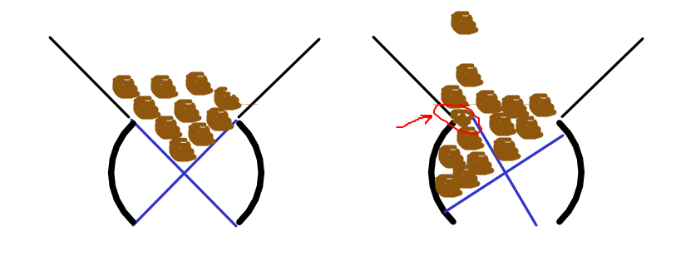
Appendix

