**Q: Study** the complete Software Development Life Cycle (SDLC) and analyze various activities conducted as a part of various phases. For each SDLC phase, **identify** the objectives and **summaries** outcomes.

For this assignment, you will be applying Agile Process Model.

Answer:

* SDLC (Software Development Life cycle):

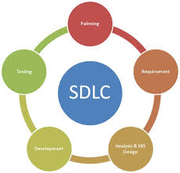

* SDLC is used for develop the software. There are some Phases of SLDC.

Requirement gathering, Analysis, design, development, testing, implementation, maintain.

These phases for developing the software and we can say that this is life cycle of software development.

For developing a best software we have to understand SDLC. And then we start the developing a software.

For the software development first we have to getting the requirement from the user. Then we have to analysis this requirement and design the model of required requirement. Then we have to develop the actual product and test this product.

* Agile Process Model:

This is best model compare to all model like water fall v-model etc.

In this model first we have initial requirement stage. After this stage we all the stages we have own stage iteration.

In the every stage it have performs iteration.

The best advantage of agile model is ability to respond to the changing the requirement of the project.

The most of company we have use that agile process model. It’s also called method.

Why iteration perform on every stage..??

* We know that in this model, every stage has perform the iteration because if the project is larger and the requirement are change on short time so we have need iteration because we have to change the design, model etc. that’s why this model gives iteration on every stage.

If any time requirement will change the iteration of stages are update this requirement.

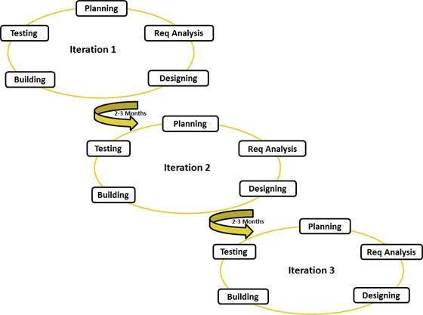

[Fig: Agile Process model (iteration)]