**Project Idea - Bondi Beach Image Design**

**Name:** Pauric Carroll

**Date:** June 26th

**Image 1.1: User's View Of The App**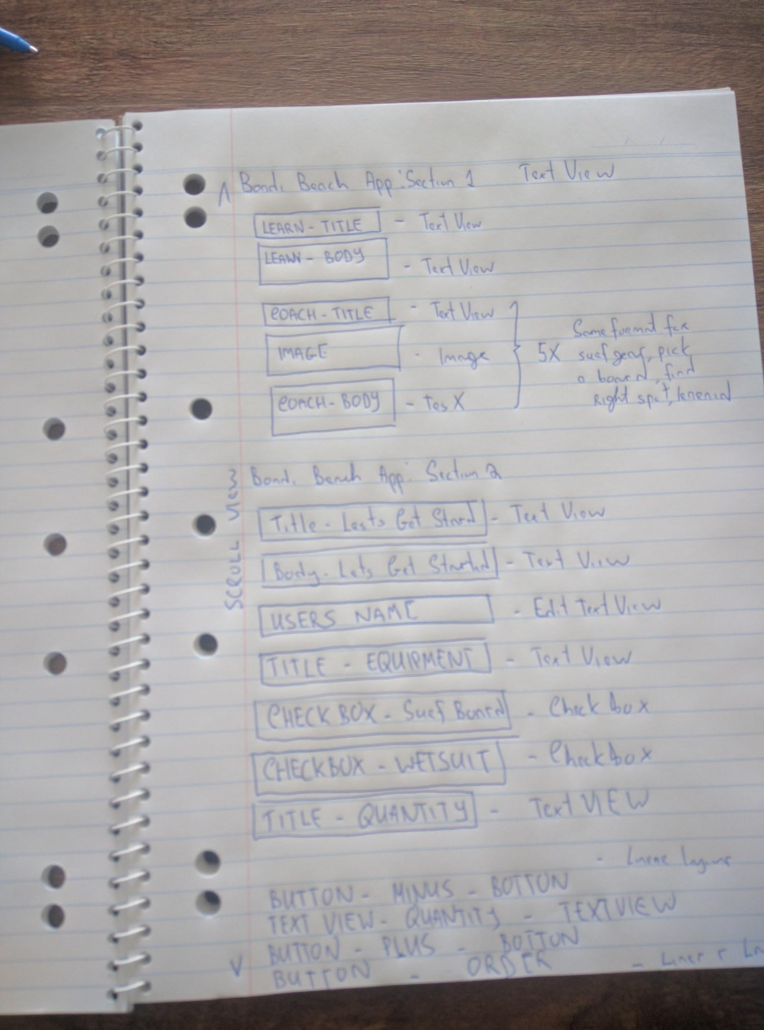

**Image1.2: View Layout of the App t**