# Task -SQL

The main aim is to find the respondent has answered all the questions and the answers given through the survey link should be stored into the database.

I have used the following link: -

<https://surveyinterface-v2.opinionsample.com/#/surveys/ab320070-bbad-0134-bb62-0a6b3886cf3d/screens/page_1?publisher_user_id=07b59010-86d2-0131-c9a9-0a424708edaa&panel_user_id=PANEL_USER_TEST_22fd1640-d94b-0137-0d5b-029188bc54b8&panel_user_id_kind=PANEL_USER_KIND_TEST&pparam_offer_click_id=OFFER_CLICK_TEST_22fd1640-d94b-0137-0d5b-029188bc54b8&pparam_provider_user_id=%5Bprovider_user_uuid%5D&is_test&survey_id=ab320070-bbad-0134-bb62-0a6b3886cf3d&screen_id=page_1>

Hence, by analysing the above link following parameter values can be deducted : -

**survey_id** = “ab320070-bbad-0134-bb62-0a6b3886cf3d”

**panel_user_id** = “PANEL_USER_TEST_22fd1640-d94b-0137-0d5b-029188bc54b”

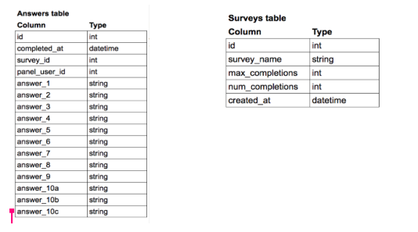

Taking the reference of both the tables we can see that the relevant answers in a survey can be obtained by using survey_id and panel_user_id.

The query to obtain the respective results is as follow: -

Select a.*

from Answers a, Surveys s

where a.survey_id = s.survey_id

and a.survey_id = “ab320070-bbad-0134-bb62-0a6b3886cf3d”

and a.panel_user_id = “PANEL_USER_TEST_22fd1640-d94b-0137-0d5b-029188bc54b”