**Paul Carlos T. Lima I MX – Statistical Theory**

**Dataset and Problem**

This study is conducted to examine the average time spent on cell phones by male and female participants per week (in terms of hours). Fifty male and fifty female student’s participants are chosen from Midwestern universities and the hours per week spent chatting on cell phones. The data and result we gained and used for this study displays the findings in hours.

The objective is to determine whether there is a significant difference in the mean time spent on cell phones per week between male and female college students.  
  
  
**Checking of Assumptions**

**Assumption #1:** **You have one dependent variable that is measured at the continuous level.**  
  
 The dependent variable called TimeonPhone which is the “Mean time spent on cell phones per week (in terms of hours). This dependent variable is continuous level.

**Assumption #2:** **You have one independent variable that consists of two categorical, independent groups.**

The independent variable is gender which is categorized into independent groups: male, female.

**Assumption #3:**  **Independence of observations.**

There is no relationship between the observations in each group of the independent variable and among the group themselves. Meaning observations are assumed that they are independent of each other, the result of one individual within the groups does not affect the outcome of the other individuals of that same group.

**Assumption #4:**  **No Significant Outliers.**

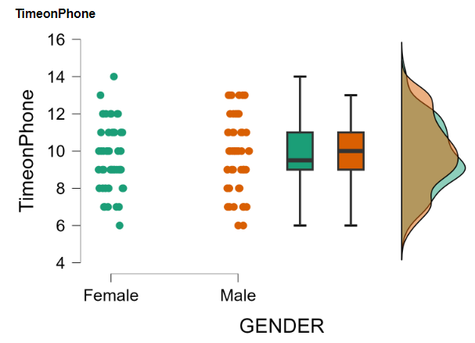

Determined by visually inspecting the boxplots, there were no significant outliers in the gender groups in terms of TimeonPhone.

**Assumption #5:**  **Normality or Normal Distribution.**

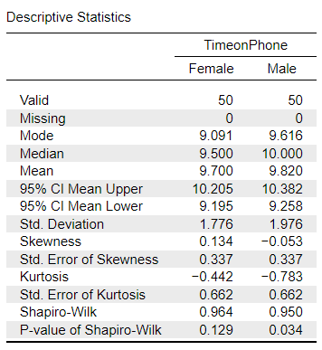

The Time spent on cell phones by both male and female college students per week (TimeonPhone) are approximately normally distributed for each of the gender groups, as assessed by Shapiro-Wilk’s test, p > 0.05.  
  
**Assumptions #6:**  **Homogeneity of Variances.**

Since the p value is 0.508 < 0.05 which is the significan level. Thus, as determined through Levene’s test of homogeneity of variances, there’s homogeneity of variances for the dependent variable across all gender groups.

**NULL AND ALTERNATIVE HYPOTHESIS**

**For Null Hypothesis:**

H_0 : μ_male = μ_female (The mean time spent on cell phones is the same for male and female students.)  
  
**For Alternative Hypothesis:**

H_0 : μ_male ≠ μ_female (There is significant difference in the mean time spent on cell phones between male and female students.)  
  
**COMPUTATION:**  
**Hypothesis Test (Independent Samples T-Test – Welch’s):**

**Report**

The p value of the test is 0.750 which is greater than 0.05. Thus based on the p-value, there is no significant difference in the mean time spent on cell phones between male and female college students. Since the p-value is greater than 0.05, the researcher should accept the null hypothesis because the p-value is significantly greater than 0.05. In the sample given, there’s no statistical evidence that could suggest a difference in the mean time spent on cellular devices between male and female student(TimeonPhone). Based on the descriptive statistics, we have on average the female spends about 9.700 hours on cell phones per week, while males tend to spend around 9.820 hours. Through Shapiro-Wilk test we can conclude that the time spent on cell phones is approximately normally distributed for both male and female groups. Through 95% confidence interval for mean we can conclude that the mean time spent for females is estimated between 9.195 and 10.205 hours, while males is estimated to be between 9.258 and 10.382 hours. In the 95% confidence interval for mean difference, we can say that the mean time spent on cell phones between male and female groups is between -0.866 and 0.626 hours. The need for larger sample sizes and more testing with the time spent on cell phones might be needed to get precise estimates, but it also has downsides such as the time and cost of getting those samples. Hence, since all the assumptions did pass, we can ensure the validity of the results and conclusions drawn from this report.