**Paul Carlos T. Lima I  
FA7 – Statistical Theory**

**Comparison of its Conditional and Critical Recall of Eye Movements**

**Assumption Checks**

**Assumption 1.** The dependent variable (CriticalRecall) is measured at the continuous level.

**Assumption 2.** The independent variable (Condition) contains of two category of independent groups which are Fixed and Horizontal.

**Assumption 3.** Each participant is present to only one group.

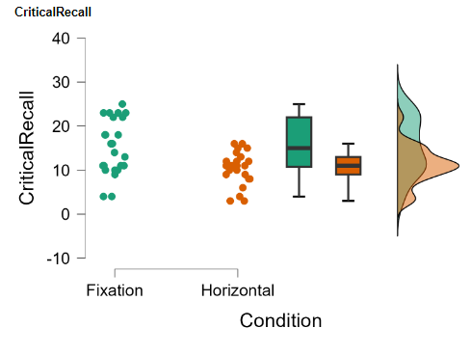

**Assumption 4.** **Outliers.**

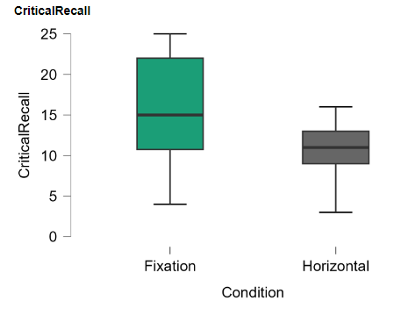

There are no significant outliers in the two groups of independent variable (Condition) in terms of the dependent variable (Critical Recalld), as assessed by visual inspection of boxplots.

**Assumption 5. Normality.** The dependent variable (CriticalRecall) for each group (Condition) is normally distributed (*p > 0.05*), as assessed by Shapiro-Wilk test.

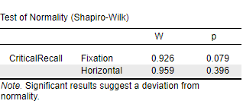

**Assumption 5. Homogeneity of variances.** There is no equality of variances between groups (Fixed, Horizontal) on their number of Recalled words after the memory retrieval task (CriticalRecall), as assessed by Levene’s test of equality of variances since (p < 0.05).

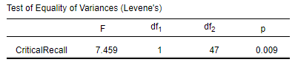

**Computation**

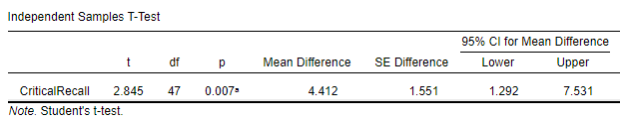

This table shows the output for the independent samples t-test. The results suggest that there is a statistically significant difference between the "Horizontal" and "Fixation" conditions in terms of their impact on "CriticalRecall." The "Horizontal" condition is associated with higher mean recall scores compared to the "Fixation" condition, with a mean difference of 4.412 units. This difference is statistically significant at the 0.05 significance level, as indicated by the p-value of 0.007. The 95% confidence interval provides a range of values within which we can reasonably expect the true mean difference to lie.

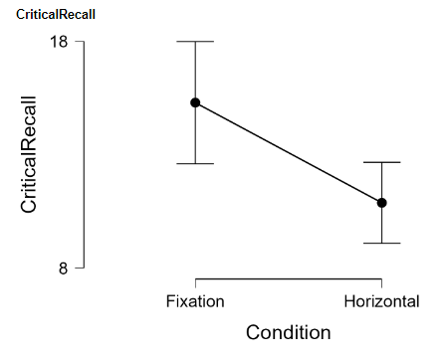

**Short Report**

In conclusion, these findings suggest that performing horizontal eye movements during the memory retrieval task significantly enhances "CriticalRecall" compared to maintaining a fixed gaze on a central point. The evidence supports the hypothesis that horizontal eye movements have a positive effect on memory retrieval in this experimental setting.