**Paul Carlos T. Lima I FA9 – Statistical Theory**

**Data and Data Description**  
  
Participants in the study were asked to speed date a group of possible partners and then rate how much they would like to spend on a genuine date at the conclusion of the end of the day. The dating partners' personalities and looks were exaggerated. Another possible moderator that was looked at was gender. Three independent variables—looks (attractive, average, ugly), personality (high charisma, some charisma, no charisma), and gender (male versus female).

**Check Assumptions**

**Assumption 1. The continuous dependent variable are the participants of the speed dates**

**Assumption 2. The two between-subjects factors (categorical independent variables) are,  
  
Looks**, has three levels **– att**ractive**, av**erage**, and ug**ly **Personality**, has three levels **– high** charisma**, some** charisma**,** and **none** charisma

**Assumption 3. The within-subjects factor (categorical independent variable) with two levels is,**

**Gender** which this factor has two levels that is**, male** and **female.  
  
Assumption 4. There should be no significant outliers in any cell of the design  
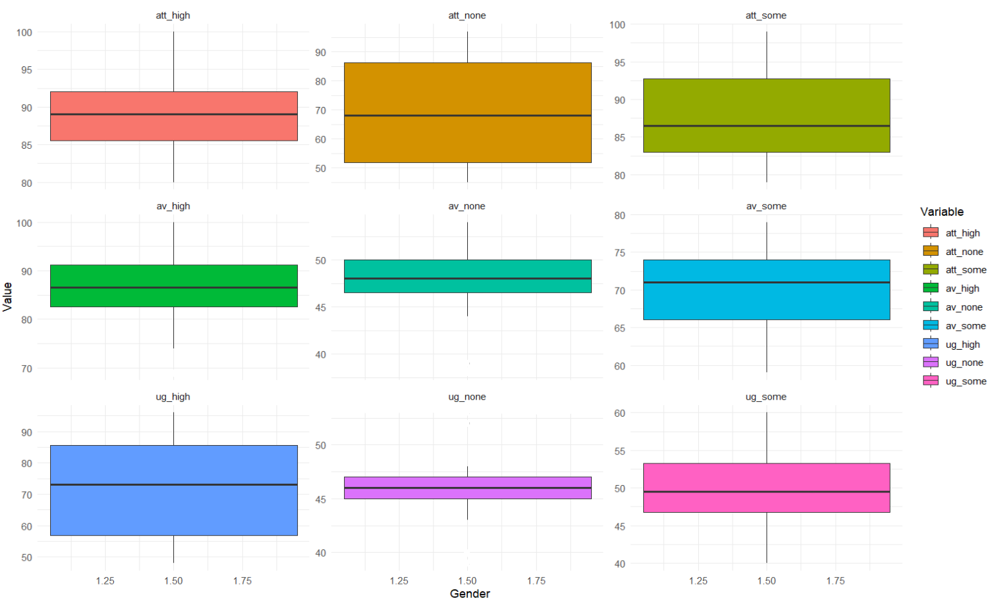**

Based on the boxplots created in R there seems to be no extreme outliers in the data.

**Assumption 5. The dependent variable should be approximately normally distributed for each cell design**

Variable shapiro_pvalue

*<chr>* *<dbl>*

1 att_high 0.216

2 att_none 0.06236

3 att_some 0.155

4 av_high 0.236

5 av_none 0.0599

6 av_some 0.770

7 ug_high 0.0849

8 ug_none 0.124

9 ug_some 0.905

The values are normally distributed (p > 0.05) for each cell, as assessed by Shapiro-Wilk’s test of normality. **Assumption 6. The variance of your dependent variable should be equal between the groups of between-subjects factors.**

Levene's Test for Homogeneity of Variance (center = median)

Df F value Pr(>F)

group 1 0.4937 0.4913

18

Levene's Test for Homogeneity of Variance (center = median)

Df F value Pr(>F)

group 1 0.0504 0.8248

18

Levene's Test for Homogeneity of Variance (center = median)

Df F value Pr(>F)

group 1 0.0048 0.9457

18

Levene's Test for Homogeneity of Variance (center = median)

Df F value Pr(>F)

group 1 0.4524 0.5098

18

Levene's Test for Homogeneity of Variance (center = median)

Df F value Pr(>F)

group 1 1.8161 0.1945

18

Levene's Test for Homogeneity of Variance (center = median)

Df F value Pr(>F)

group 1 0.1192 0.7339

18

Levene's Test for Homogeneity of Variance (center = median)

Df F value Pr(>F)

group 1 1.9904 0.1753

18

Levene's Test for Homogeneity of Variance (center = median)

Df F value Pr(>F)

group 1 0.0213 0.8855

18

Levene's Test for Homogeneity of Variance (center = median)

Df F value Pr(>F)

group 1 0.1393 0.7134

18

**There was homogeneity of variances, as assessed by Levene’s test of homogeneity of variance (p > 0.05)  
  
  
Assumption 7. The variance of the diofference between groups should be equal**

Mauchly's Test for Sphericity`

Effect W p p<.05

3 Looks 0.960 0.708

4 Gender:Looks 0.960 0.708

5 Personality 0.929 0.536

6 Gender:Personality 0.929 0.536

7 Looks:Personality 0.613 0.534

8 Gender:Looks:Personality 0.613 0.534

$`Sphericity Corrections`

Effect GGe p[GG] p[GG]<.05 HFe

3 Looks 0.962 0.000000000000000000000000762 * 1.074

4 Gender:Looks 0.962 0.000000000000148702643589779 * 1.074

5 Personality 0.934 0.000000000000000000000205662 * 1.038

6 Gender:Personality 0.934 0.000000000009442425658493532 * 1.038

7 Looks:Personality 0.799 0.000000000000090035984243933 * 0.992

8 Gender:Looks:Personality 0.799 0.000000000147042182668051506 * 0.992

p[HF] p[HF]<.05

3 0.0000000000000000000000000959 *

4 0.0000000000000523418671863051 *

5 0.0000000000000000000000076894 *

6 0.0000000000019749859639075176 *

7 0.0000000000000001426883124759 *

8 0.0000000000013378764445001671 *

**Data Computations:**

ANOVA

Effect DFn DFd SSn SSd F

1 (Intercept) 1 18 846249.8 760 20036.89968

2 Gender 1 18 0.2 760 0.00474

3 Looks 2 36 20779.6 883 423.73252

5 Personality 2 36 23233.6 1274 328.24977

4 Gender:Looks 2 36 3944.1 883 80.42699

6 Gender:Personality 2 36 4420.1 1274 62.44868

7 Looks:Personality 4 72 4055.3 1993 36.63253

8 Gender:Looks:Personality 4 72 2669.7 1993 24.11596

p p<.05 ges

1 0.0000000000000000000000000000701 * 0.9942319

2 0.9458958475568546298006822325988 0.0000407

3 0.0000000000000000000000000959481 * 0.8088849

5 0.0000000000000000000000076894298 * 0.8255493

4 0.0000000000000523418671863051214 * 0.4454748

6 0.0000000000019749859639075176266 * 0.4737685

7 0.0000000000000001101308132536972 * 0.4523510

8 0.0000000000011078009545646184235 * 0.3522328

$aov

Call:

aov(formula = formula(aov_formula), data = data)

Grand Mean: 68.6

First Test: id

Terms:

Gender Residuals

Sum of Squares 0 760

Deg. of Freedom 1 18

Residual standard error: 6.5

Estimated effects are balanced

Second Test: id:Looks

Terms:

Looks Gender:Looks Residuals

Sum of Squares 20780 3944 883

Deg. of Freedom 2 2 36

Residual standard error: 4.95

Estimated effects may be unbalanced

Third Test: id:Personality

Terms:

Personality Gender:Personality Residuals

Sum of Squares 23234 4420 1274

Deg. of Freedom 2 2 36

Residual standard error: 5.95

Estimated effects may be unbalanced

Fourth Test: id:Looks:Personality

Terms:

Looks:Personality Gender:Looks:Personality Residuals

Sum of Squares 4055 2670 1993

Deg. of Freedom 4 4 72

Residual standard error: 5.26

Estimated effects may be unbalanced  
  
  
The ANOVA results indicate that appearance and personality have different main effects. The main influence of gender is not statistically significant. Each interaction has statistical importance.

**Report:**

**In the study, it is known that both looks and personality significantly influenced participants’ ratings of their willingness to go on a genuine date. While gender alone did not have a significant maineffect, depending on the looks and personality of the participant added a bit of complexity to the relationship. The three-way interactions says the importance of considering the combinations of effects between gender, looks, and personality on dating preferences.**