Task3 - Working of VPC
Connectivity of VPC

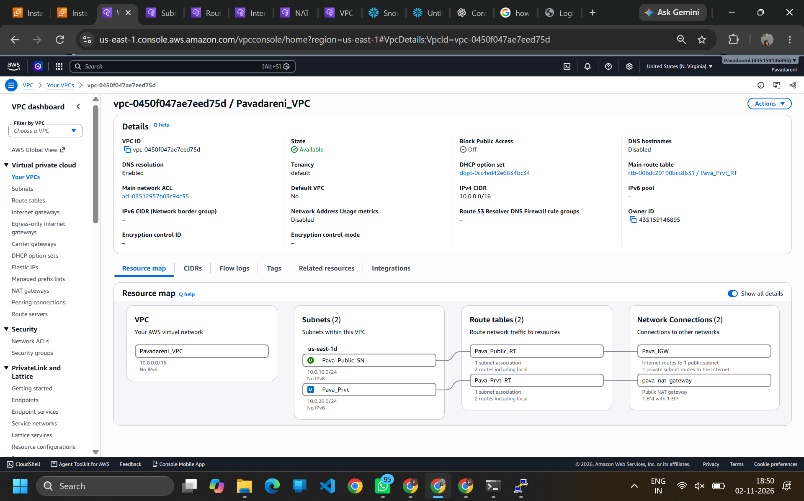
Subnet
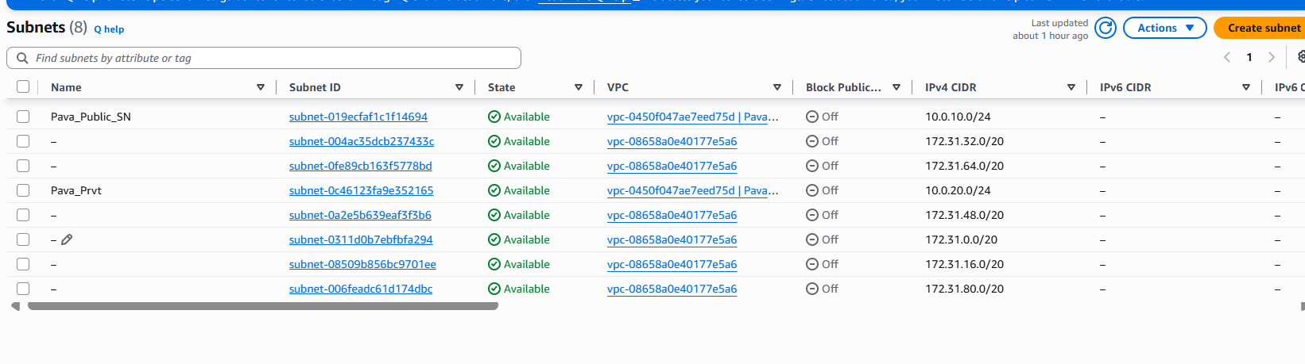
IGW
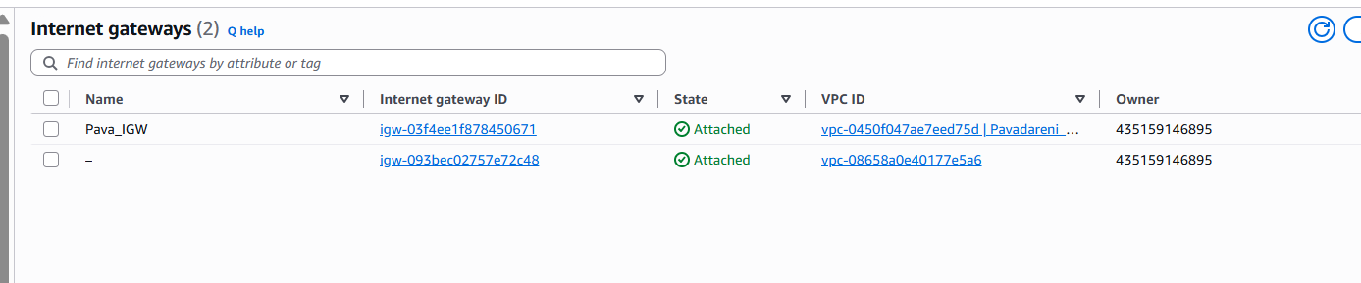

Route table

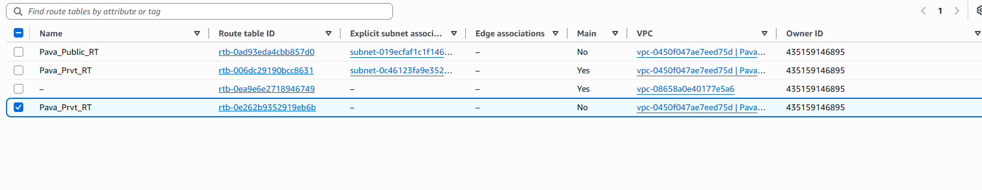
NAT Gateway
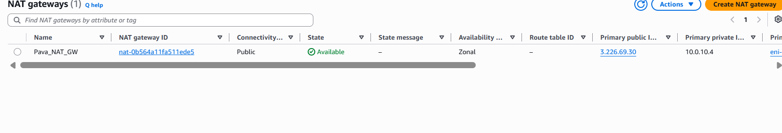
Security Group

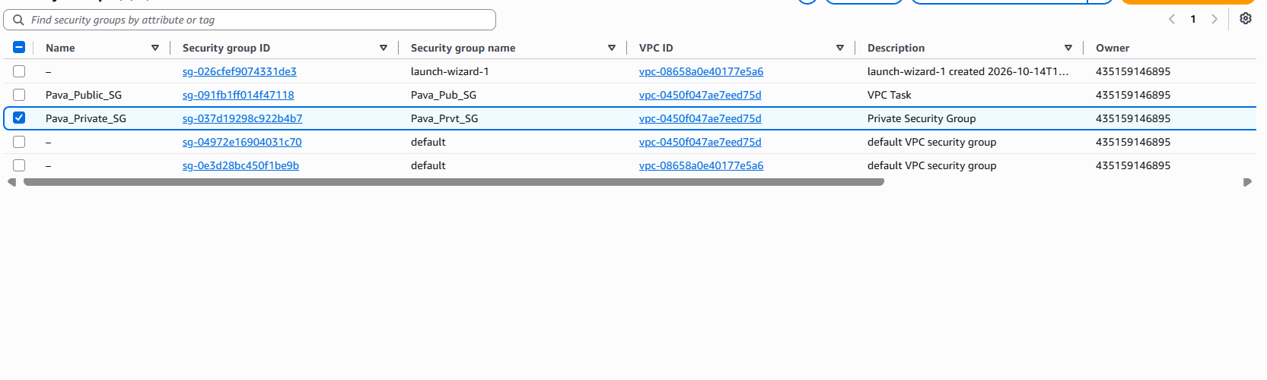

Home Page
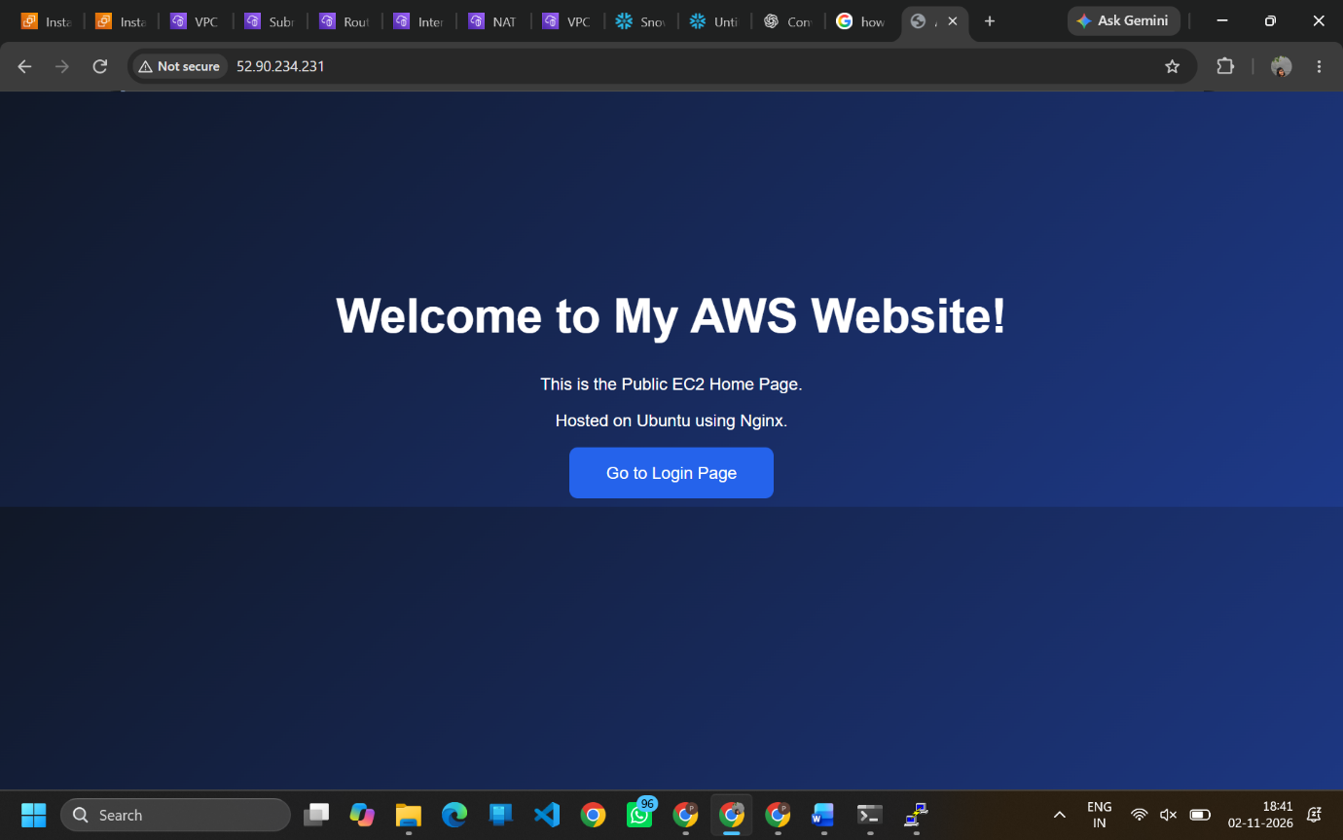

Login Page


