04-11-2026
SNOWFLAKE PRATICES
DB NAME = PAVA_SALES_DB
SCHEMA = RAW
WAREHOUSE_NAME = PAVA_SALES_WH

DESCRIBE TABLE PAVA_SALES_DB.RAW.PRODUCTS;
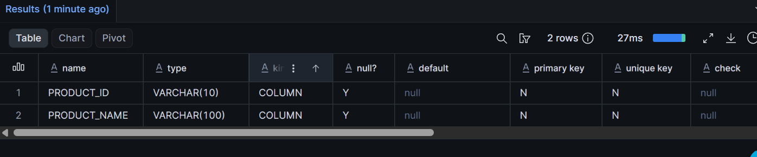

DESCRIBE TABLE PAVA_SALES_DB.RAW.ORDERS;
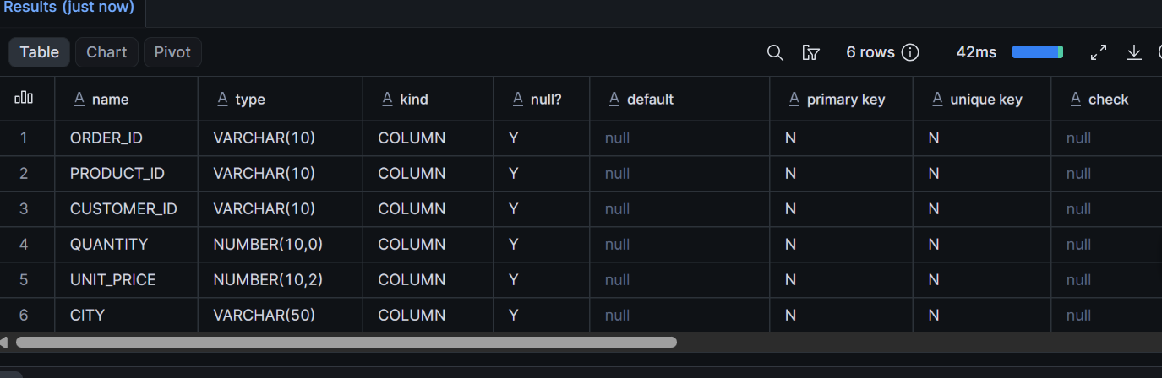
DESCRIBE TABLE PAVA_SALES_DB.RAW.CUSTOMERS;
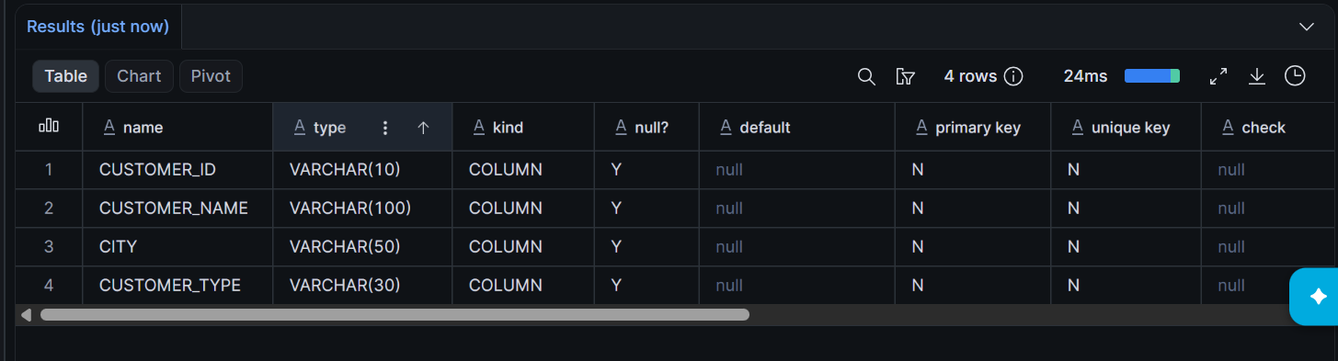

LIST @PAVA_SALES_DB.RAW.SALES_STAGE;
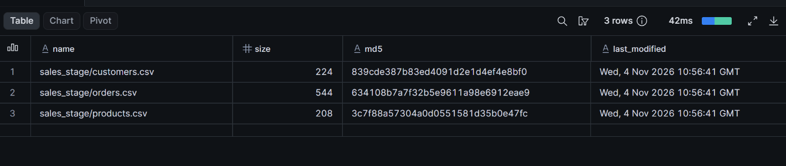

COPY INTO PAVA_SALES_DB.RAW.CUSTOMERS
FROM @PAVA_SALES_DB.RAW.SALES_STAGE/customers.csv
FILE_FORMAT = (
FORMAT_NAME = PAVA_SALES_DB.RAW.SALES_CSV_FORMAT
)
ON_ERROR = 'ABORT_STATEMENT';

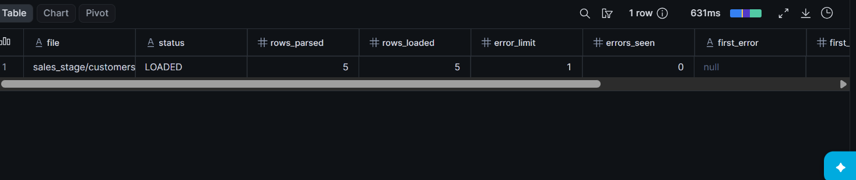
ERROR SPOTTED
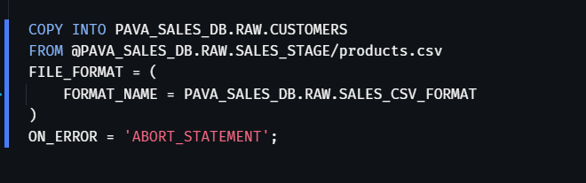
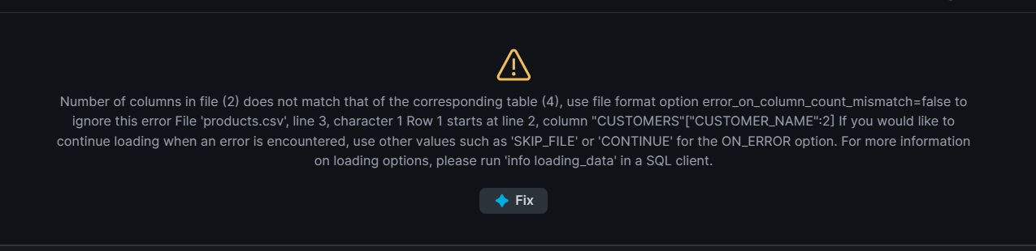
REASON TRYING TO IMPORT IN WRONG TABLE

COPY INTO PAVA_SALES_DB.RAW.PRODUCTS
FROM @PAVA_SALES_DB.RAW.SALES_STAGE/products.csv
FILE_FORMAT = (
FORMAT_NAME = PAVA_SALES_DB.RAW.SALES_CSV_FORMAT
)
ON_ERROR = 'ABORT_STATEMENT';

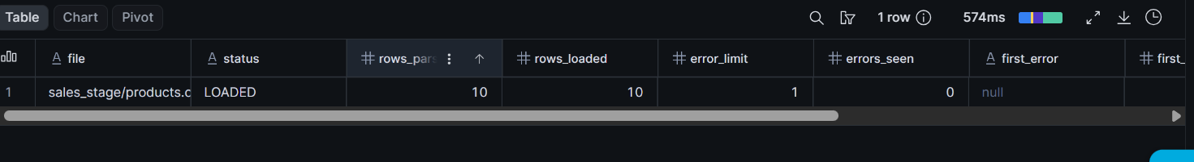

COPY INTO PAVA_SALES_DB.RAW.ORDERS
FROM @PAVA_SALES_DB.RAW.SALES_STAGE/orders.csv
FILE_FORMAT = (
FORMAT_NAME = PAVA_SALES_DB.RAW.SALES_CSV_FORMAT
)
ON_ERROR = 'ABORT_STATEMENT';

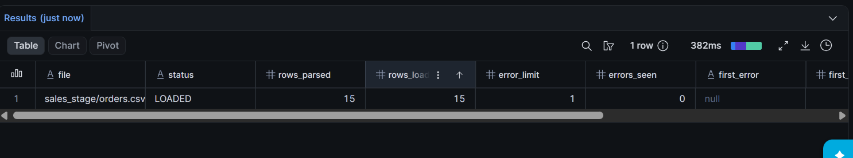

SELECT * FROM CUSTOMERS;
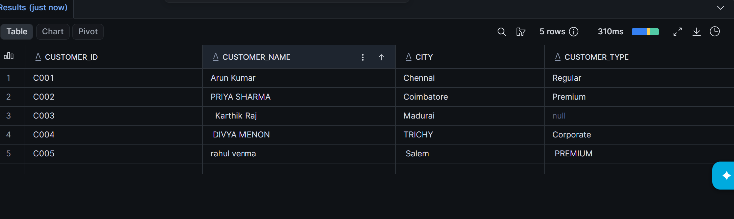
SELECT * FROM ORDERS;
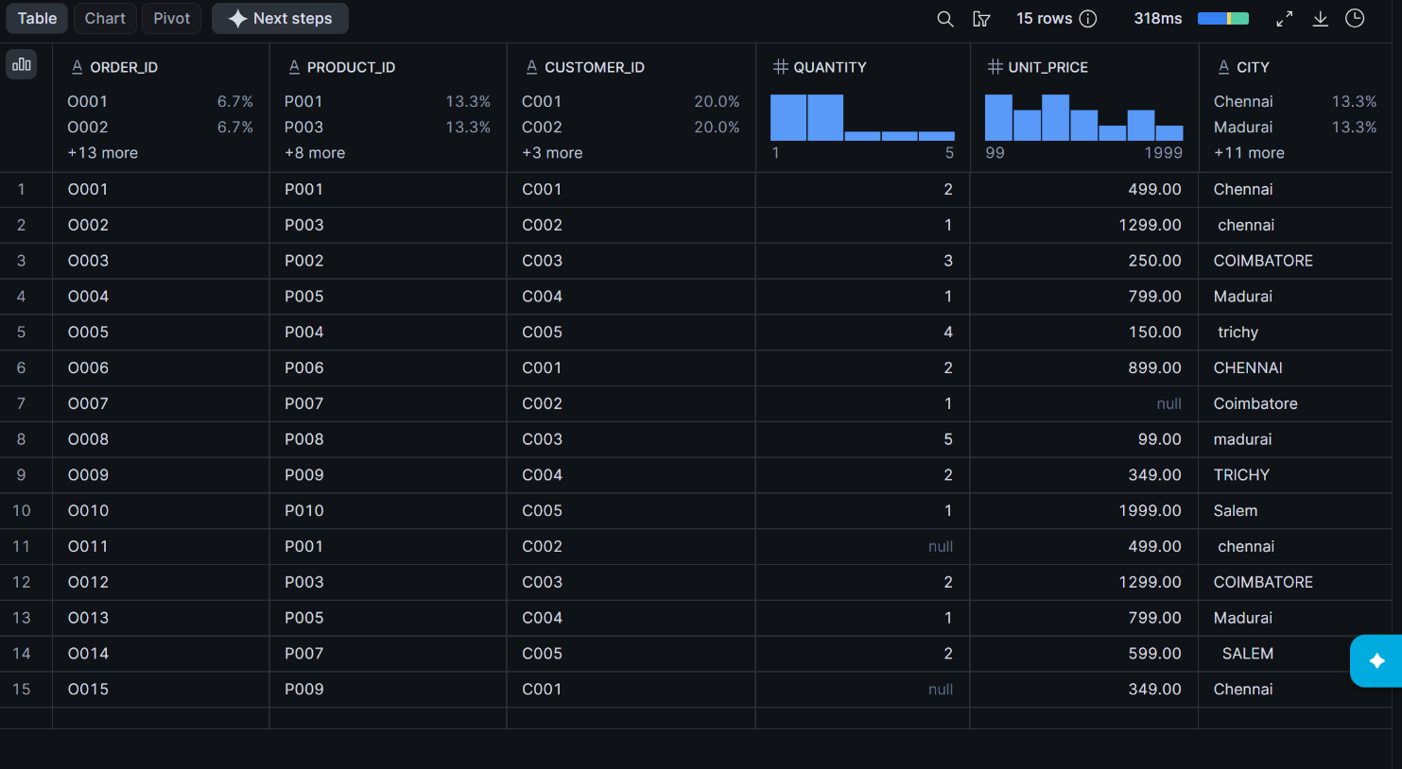

SELECT * FROM PRODUCTS;
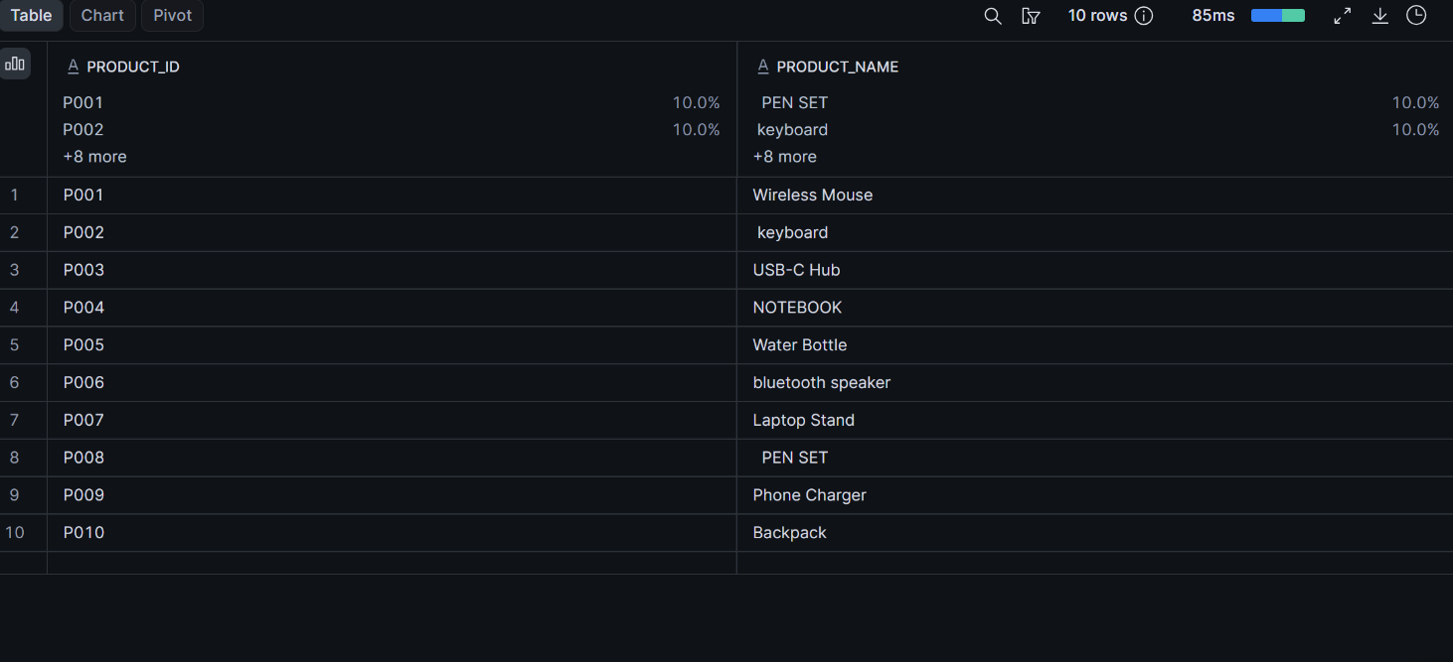

DATA TRANSFORMATION
TRIM() – removes leading and trailing spaces.
UPPER() – converts text into uppercase.
COALESCE() – replaces NULL values with a default value.

Clean table for Customer
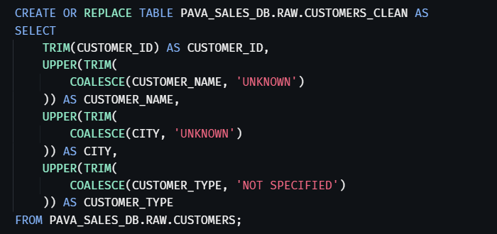

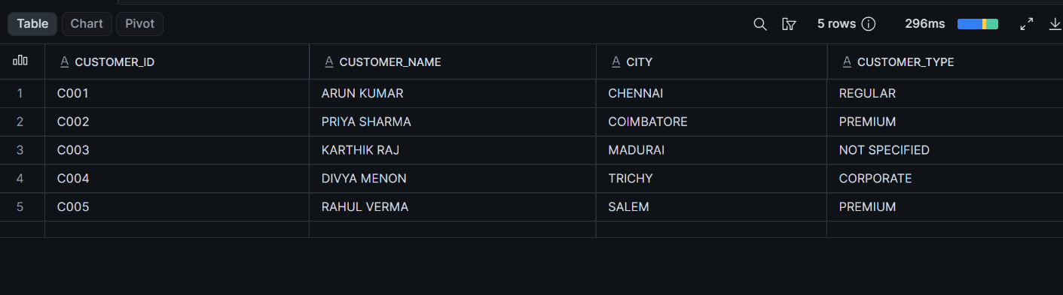

Clean table for Product
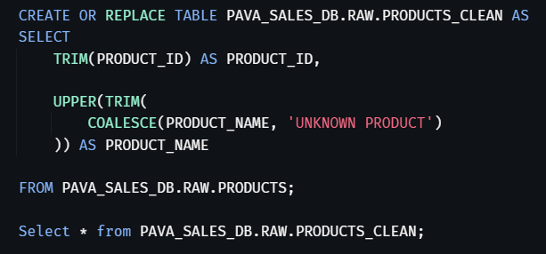

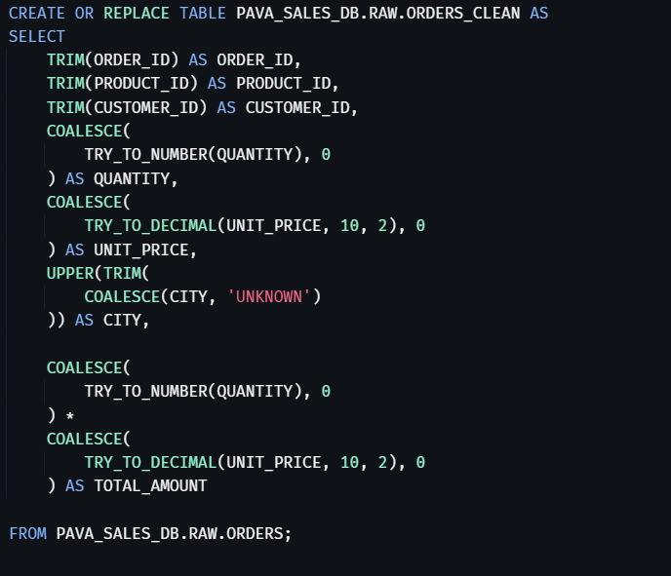

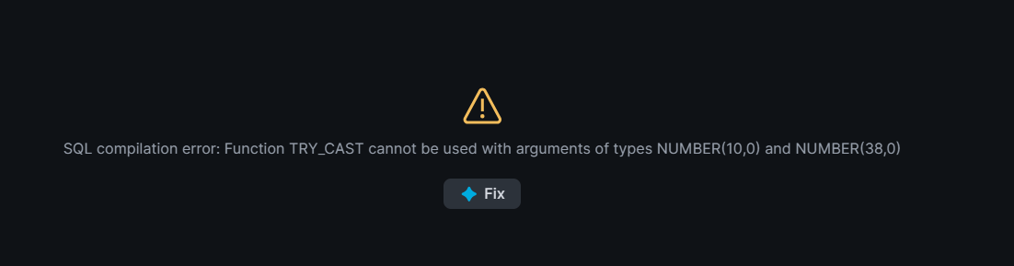
CLEAN TABLE FOR ORDERS
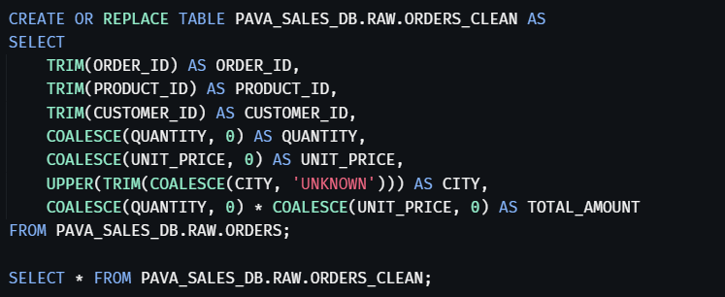

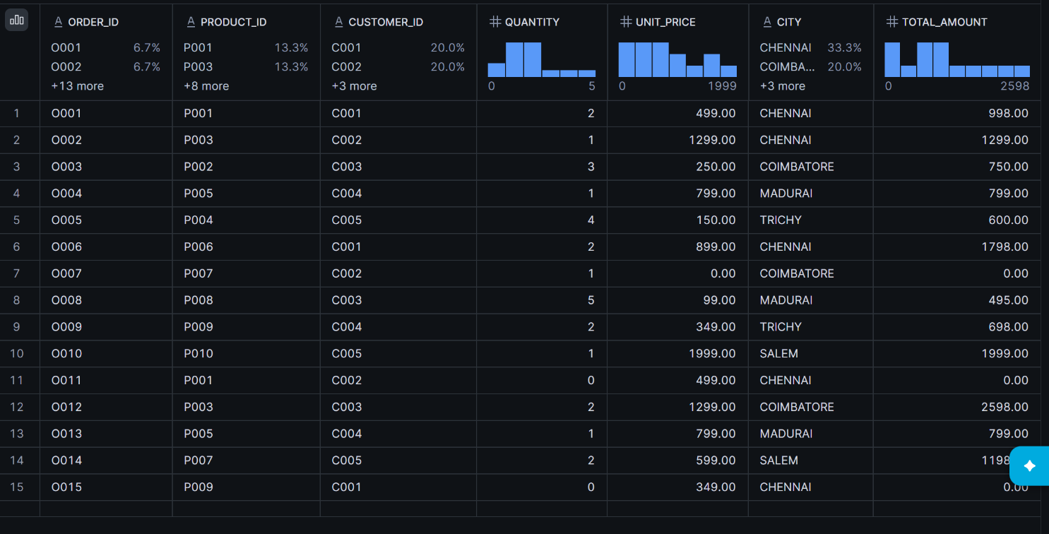
2) Display orders from a particular location
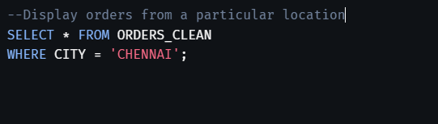

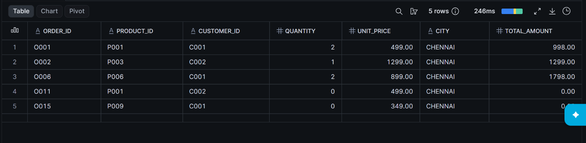
3) Calculate total amount
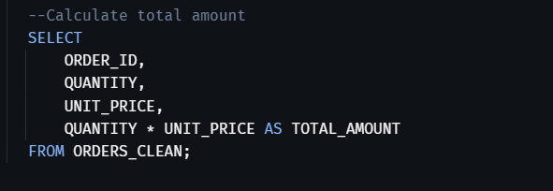
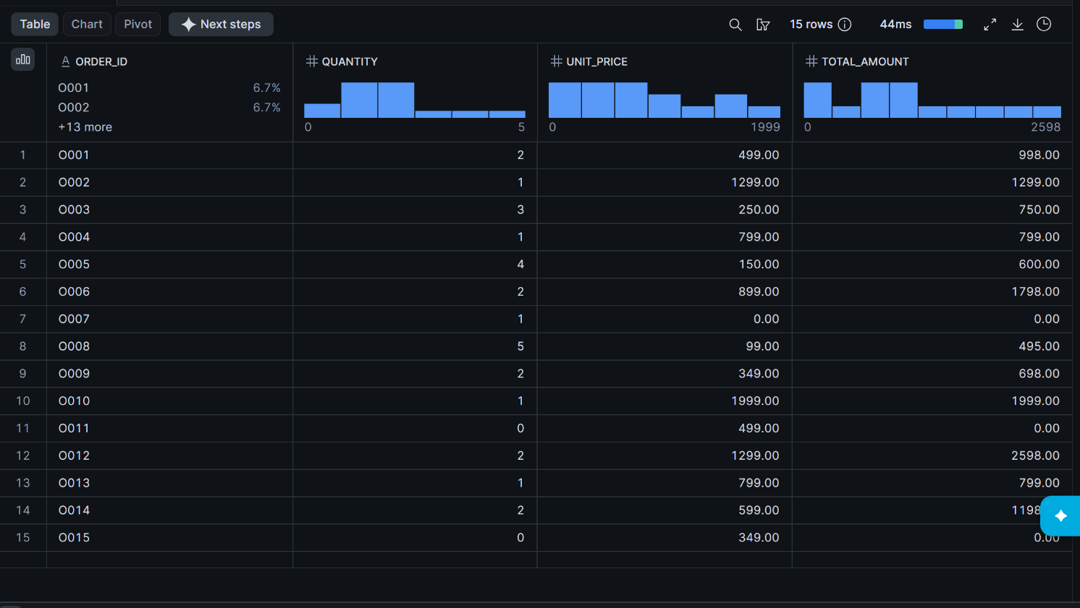
4) Product-wise sales
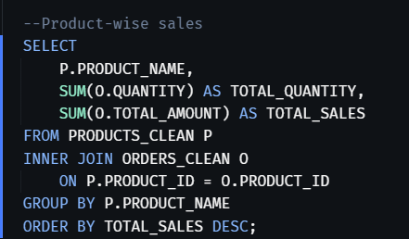
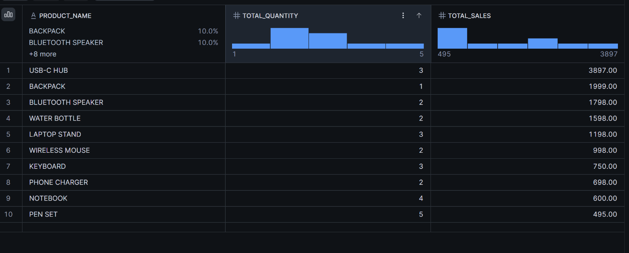

5) Join Orders and Customers

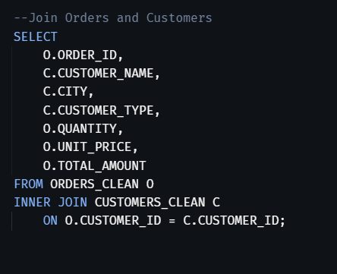
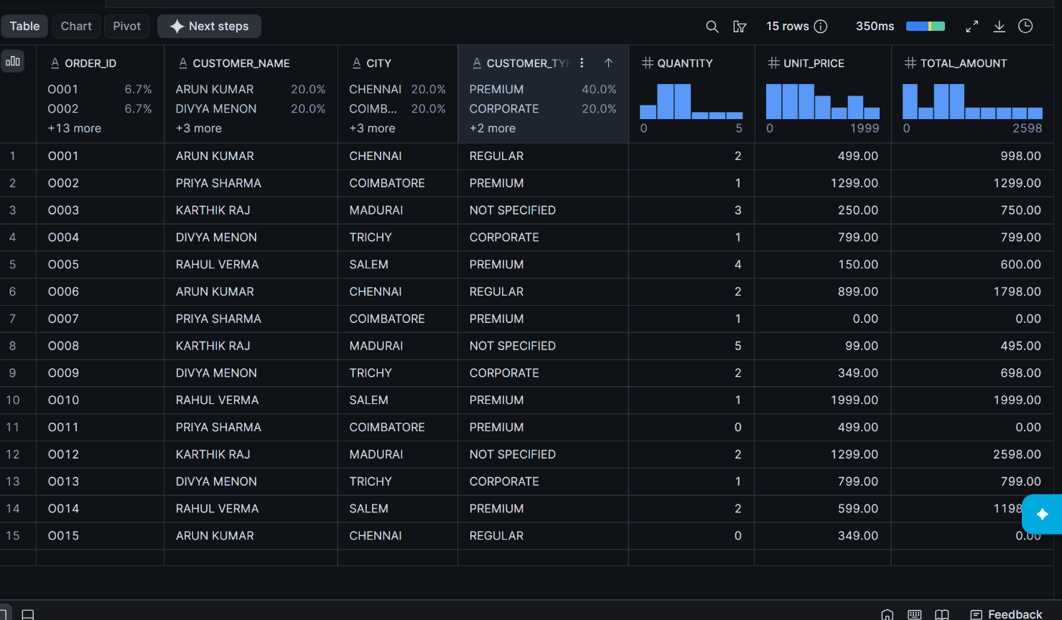

6) Total sales by customer
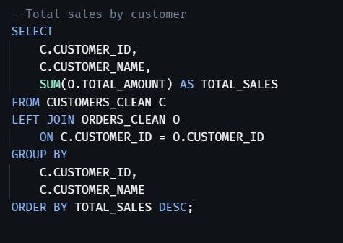

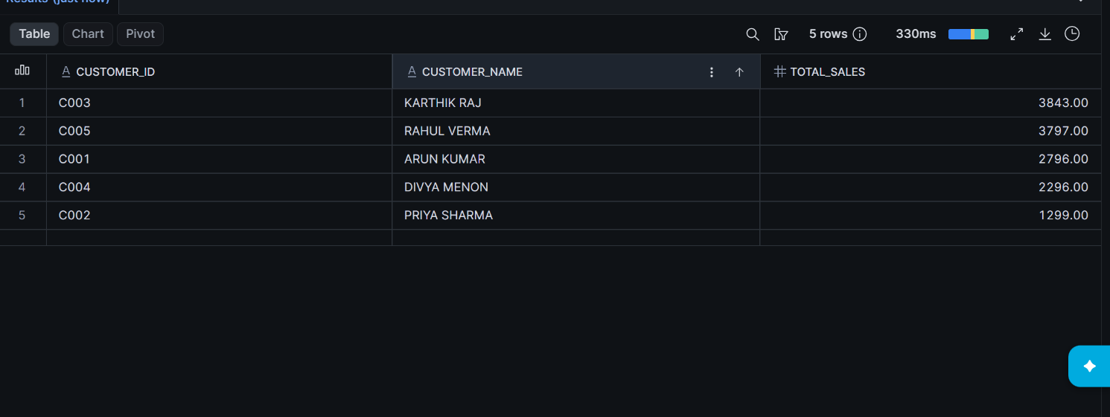

DELETION


