05-11-2026
Connection of PowerBI and Snowflake
Creating Warehouse, Database, Schema
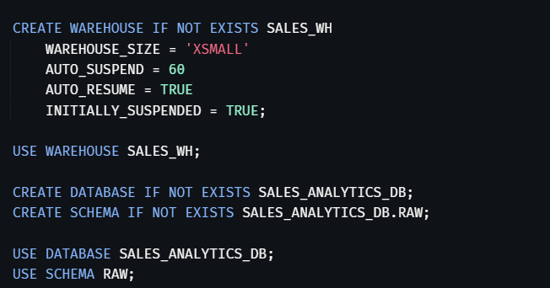
Creating Table
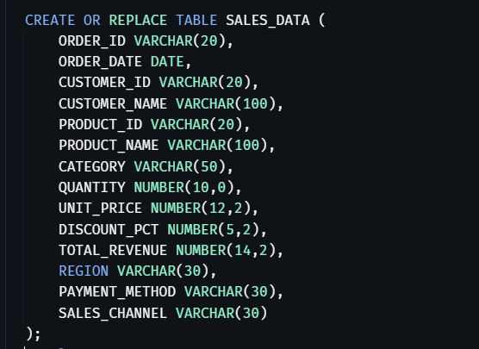
Creating file format and stages
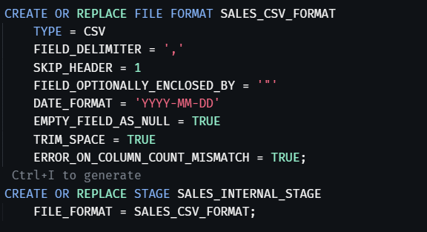
Load staged CSV data into the table
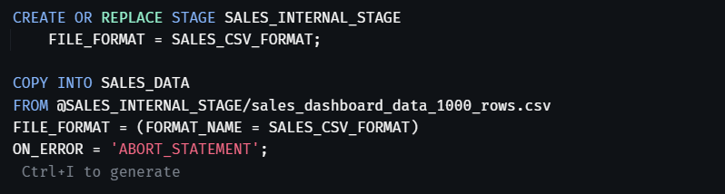
Validate the load


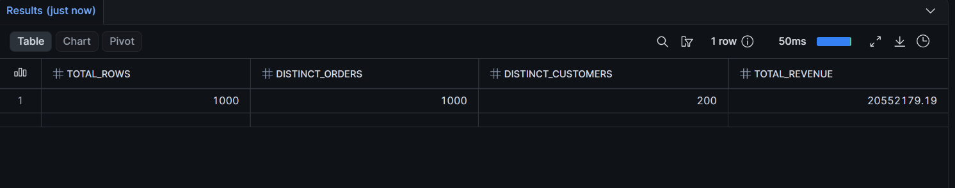

KPI query
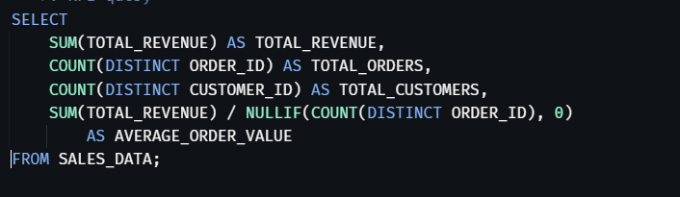
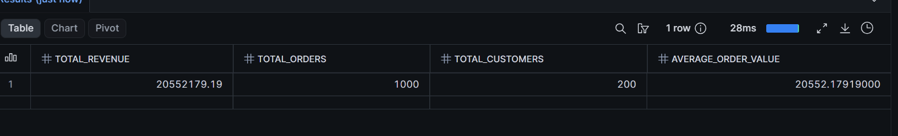

POWERBI

Cards
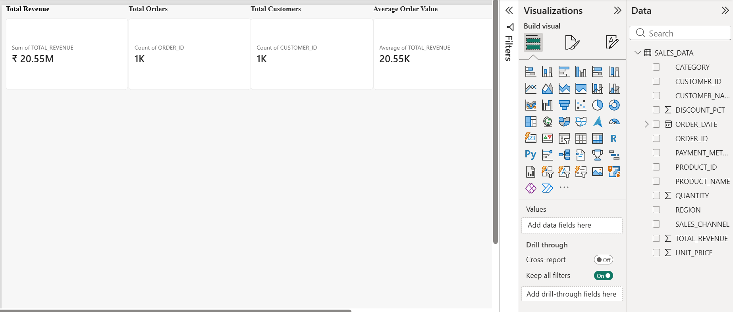

The Complete Dashboard


