Combinations of Quaries -Dataset-1
Quary – 1
select name, course, python_marks from student_marks;
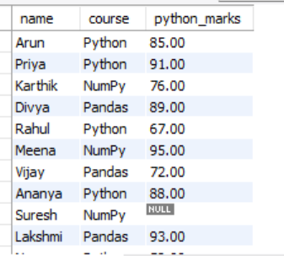
Quary-2
select * from student_marks
where python_marks >= 80 and numpy_marks >= 80;
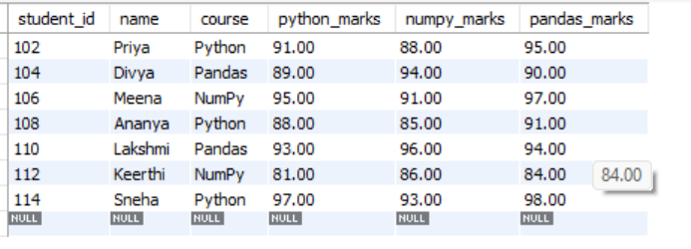
Quary-3
select name, course, pandas_marks from student_marks
where pandas_marks >= 95 or python_marks >= 95
order by pandas_marks desc;
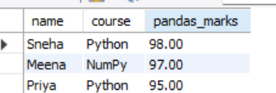
Quary-4
select * from student_marks
where python_marks between 70 and 90 and course in ('python', 'pandas');
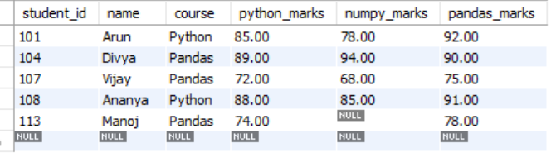
Quary-5
select * from student_marks
where python_marks is NULL or numpy_marks is NULL or pandas_marks is NULL;
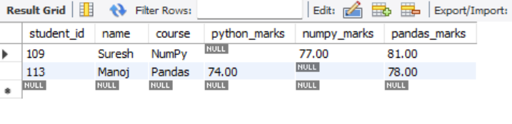
Quary-6
select count(*) as total_students, avg(python_marks) as avg_python,
max(numpy_marks) as highest_numpy, min(pandas_marks) as lowest_pandas
from student_marks;
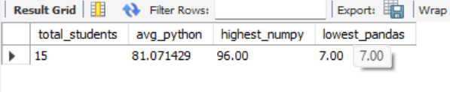

Quary-7
select course, count(*) as total_students, avg(python_marks) as avg_python_marks from student_marks
group by course having avg(python_marks) >= 80;
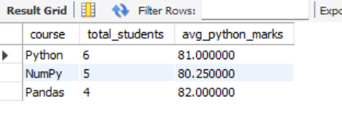
Quary-8
select name, python_marks,
case
when python_marks >= 90 then 'excellent'
when python_marks >= 75 then 'good'
when python_marks >= 60 then 'average'
when python_marks is null then 'not available'
else 'needs improvement'
end as performance
from student_marks;
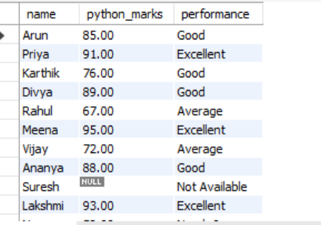
Quary-9
select name, python_marks from student_marks
where python_marks > (
select avg(python_marks) from student_marks
);
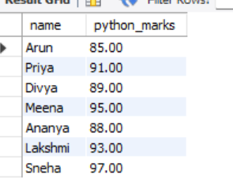
Quary-10
select name, python_marks from student_marks
where python_marks = (
select max(python_marks) from student_marks
);
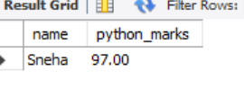

Quary-11
SELECT s.name, s.course, s.python_marks FROM student_marks s
WHERE s.python_marks > (
SELECT AVG(s2.python_marks) FROM student_marks s2
WHERE s2.course = s.course
);
