Combination of Quaries-Dataset 1 and Dataset 2
Quary-1
SELECT
m.student_id,
m.name,
m.course,
m.python_marks,
m.numpy_marks,
m.pandas_marks,
a.attendance_percentage,
a.assignments_completed,
a.exam_status
FROM student_marks m
INNER JOIN student_attendance a
ON m.student_id = a.student_id;
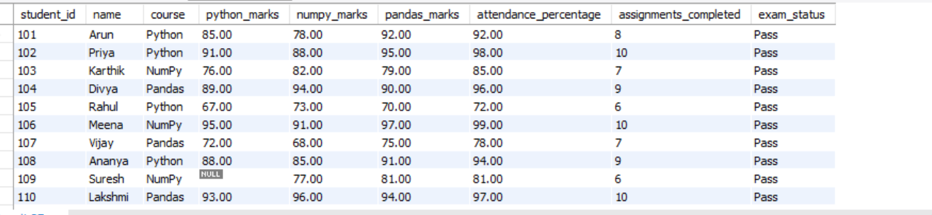

Quary-2
select
m.student_id,
m.name,
m.course,
a.attendance_percentage,
a.assignments_completed,
a.exam_status
from student_marks m
left join student_attendance a
on m.student_id = a.student_id;
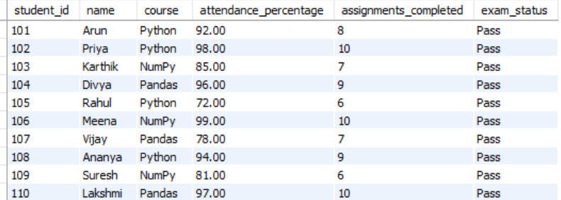

Quary-3
select
m.name,
m.python_marks,
a.attendance_percentage,
a.exam_status
from student_marks m
inner join student_attendance a
on m.student_id = a.student_id
where a.exam_status = 'pass'
and a.attendance_percentage >= 90
and m.python_marks >= 80
order by m.python_marks desc;
