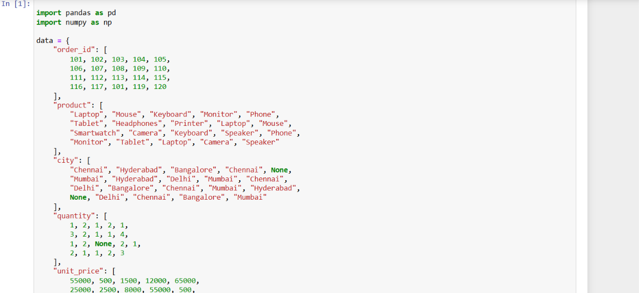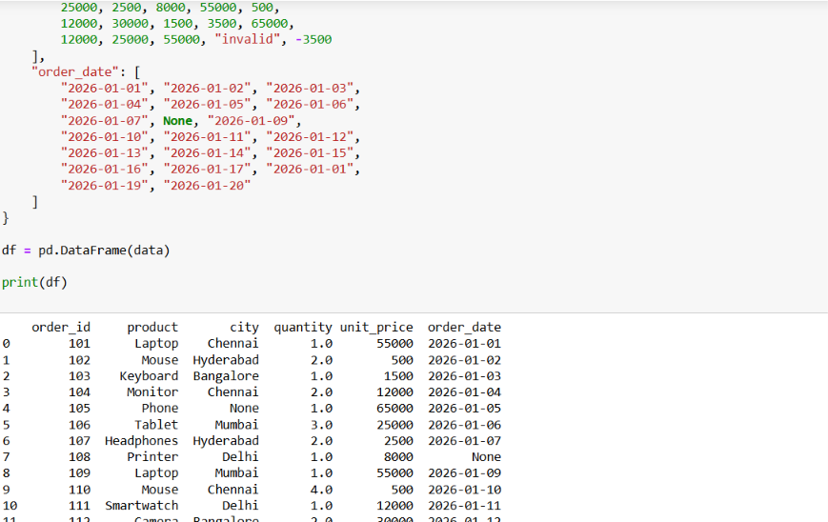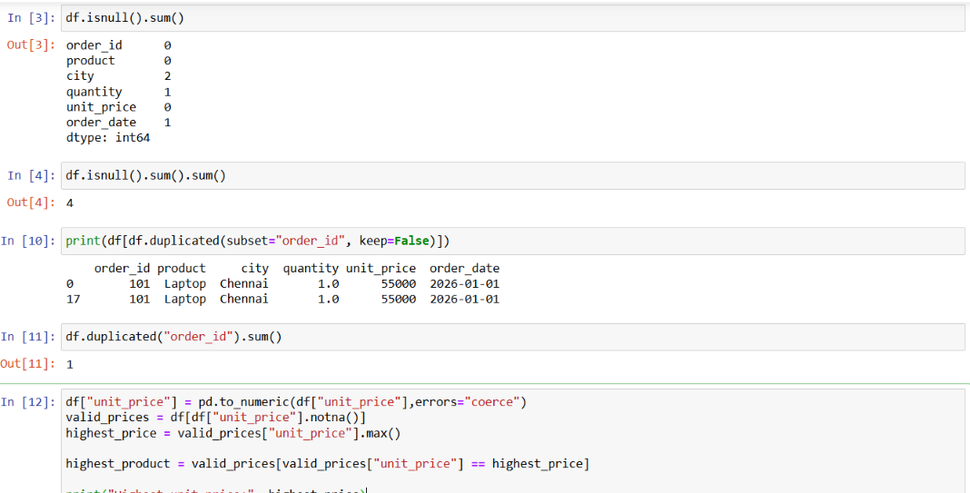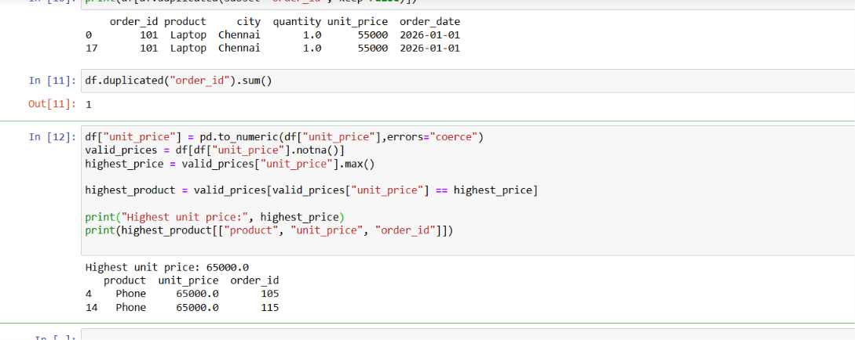

E-commerce Dataset Analysis: Errors, Causes and Solutions

1. Identify missing values in every column
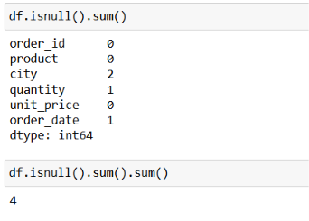
Possible error / issue | Cause | Solution
Missing values are not detected in blank-looking cells. | A cell may contain an empty string or spaces rather than NaN. | Standardize blanks: df.replace(r"^\s*$", np.nan, regex=True), then run df.isnull().sum().
"invalid" is not counted as missing. | It is text, not a null value, although it cannot be used as a price. | Convert numeric data: df["unit_price"] = pd.to_numeric(df["unit_price"], errors="coerce"). Count missing values again.
Missing values are filled inappropriately. | The same fill value is applied to every column. | Choose a strategy by column. Investigate missing IDs; use "Unknown" for city only if suitable; use mean/median only when justified.
Missing values remain after cleaning. | Only the original data was checked, or conversions created new NaN values. | Run df.isnull().sum() after conversions and cleaning.

2. Find repeated order_id values
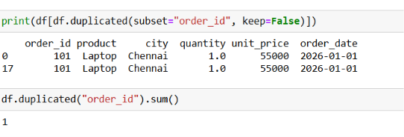
Possible error / issue | Cause | Solution
Duplicates are missed. | The check uses whole rows instead of only order_id. | Use df.duplicated(subset="order_id", keep=False) to show all rows sharing an ID.
Valid records are deleted. | One order may legitimately contain multiple product lines. | Confirm the data model before deleting. Verify repeated records against business rules.
The wrong duplicate is kept. | The first row may be incomplete or incorrect. | Compare product, quantity, timestamps and other fields; document which record should be retained.
Equivalent IDs appear different. | IDs may contain spaces or inconsistent types, e.g. 101 and "101 ". | Normalize IDs: df["order_id"] = df["order_id"].astype("string").str.strip().
Duplicate count is misunderstood. | duplicated() defaults to keep="first", marking later occurrences only. | Use keep=False to display every row in duplicate groups; .sum() counts later repeated rows.

3. Find the highest available unit_price
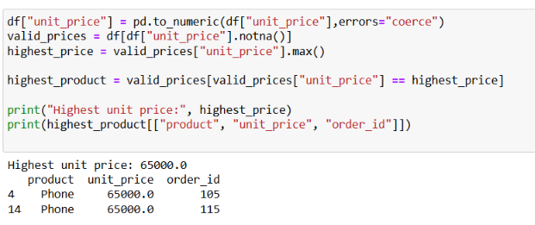
Possible error / issue | Cause | Solution
TypeError or incorrect maximum. | unit_price mixes numbers and strings such as "invalid". | Use pd.to_numeric(df["unit_price"], errors="coerce") before calculations.
Invalid text is treated as a price. | Non-numeric text has not been converted. | Use errors="coerce" and inspect rows where unit_price is NaN.
A negative price is included. | Data-entry error or refund/adjustment stored as a product price. | Validate the record. Exclude negative prices from ordinary product-price analysis; handle refunds separately.
Tied maximum prices are missed. | Code returns only one row, e.g. with idxmax(). | Find the maximum, then filter unit_price == highest_price to return all tied products.
Wrong field is used. | quantity or revenue is used instead of unit_price. | Use df["unit_price"].max() for highest unit price; quantity * unit_price is revenue.

4. Group revenue by city
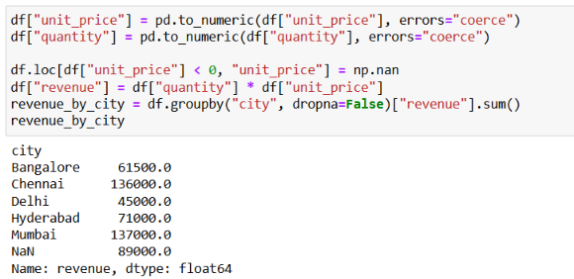
Possible error / issue | Cause | Solution
Revenue is missing or understated. | Quantity or price is missing or invalid. | Recover values from a trusted source where possible; otherwise exclude unresolved rows or report their impact.
Revenue is negative. | Negative price/quantity or a refund recorded as a sale. | Validate records and separate refunds/returns from ordinary sales.
Some city revenue is absent. | Missing city values are dropped by groupby by default. | Use groupby("city", dropna=False) to retain a missing-city group, or use "Unknown" if appropriate.
Same city appears in multiple groups. | Different capitalization or spaces, e.g. "Chennai" and " chennai ". | Normalize: df["city"] = df["city"].astype("string").str.strip().str.title().
Revenue is counted twice. | Duplicate transaction rows are included. | Investigate repeated order IDs and confirm the correct row grain before deduplication.
Revenue is too high or inconsistent. | Mixed currencies/units or incorrect formula. | Standardize currency and units; confirm revenue = quantity * unit_price.

