AMA Front End Page Speed Analysis Report

**(AMA Stay and Trials)**

Nov 2024, Version 0.1

|  |
| --- |
| Notice |
| © 2024 Tata Consultancy Services Limited  This is a controlled document. Unauthorized access, copying, replication or usage for a purpose other than for which it is intended, are prohibited.  All trademarks that appear in the document have been used for identification purposes only and belong to their respective companies. |

<Retail>

<TCS Kolkata>

Document Release Note

Notice No.: NA

Customer: IHCL

Authors: Rana Majumdar, Pavadeppa M

**Document Details**

|  |  |  |
| --- | --- | --- |
| Name | Version No. | Description |
| AMA Front End Page Speed Analysis Report | 0.1 | Initial version |
|  |  |  |

**Revision Details**

|  |  |  |  |
| --- | --- | --- | --- |
| Action Taken  (add/del/change) | Previous Page Number | New Page Number | Revision Description |
| NA | NA | NA | NA |

Change Register serial numbers covered: NA

The documents or revised pages are subject to document control.

Please keep them up to date using the release notices from the distributor of the document.

These are confidential documents. Unauthorized access or copying is prohibited.

Approved by: NA Authorized by: NA

Date: NA Date: NA

About this Document

Purpose

The purpose of the document is to provide Page performance analysis and the constraints.

Intended Audience

The following are the intended audience of the document:

* IHCL
* TCS team

Table of **Contents**

1. Business Objective 7

2. Scope 7

3. Requirement Description 7

4. Architecture Reference Diagram (Integration Architecture) 8

5. Tools Used 9

6. Best Practice Index 9

7. Application Scope 9

8. Detail Analysis report 10

9. Evidence 11

10. Quick Insights on AMA 15

11. What’s been done for performance improvement 19

12. TCS Recommendation 19

List of Abbreviations/Acronyms

|  |  |
| --- | --- |
| Abbreviations/Acronyms | Expanded Form |
| FE | Front-end |
| IHCL | Indian Hotels Company Limited |
| AMA | AMA is IHCL business line which deals with Stay and Trials concepts involving Villa/Bungalow |
| UAT | User Acceptance Test |
| PROD | Production |
| Screen / Page | Screen and Page in the document mentioned and these are interchangeable and has same meaning. The viewport displayed in the browser |

# Business Objective

This document will provide competitive analysis between Taj and AMA with respect to SEO analysis on data like FCP, LCP, Performance, Accessibility, best practice and SEO. Based on this data team will have an understating where we stand in-terms of front data initial data.

# Scope

This document outlines the page speed analysis report. AMA project is re-skinning project, built on Taj

re-usable code base and same design patterns and architecture patterns followed as-is in Taj.

Though front end repo is independent same architecture, same sanity meta data, same sanity hotel document, shared backend, shared search engine Solr, shared 3rd party system Hudini, SynXis , loyalty systems.  In a nutshell because of same architecture hence same behaviour regarding page performance.

# Requirement Description

Application-level performance analysis is carried considering the landing page.

# Architecture Reference Diagram (Integration Architecture)

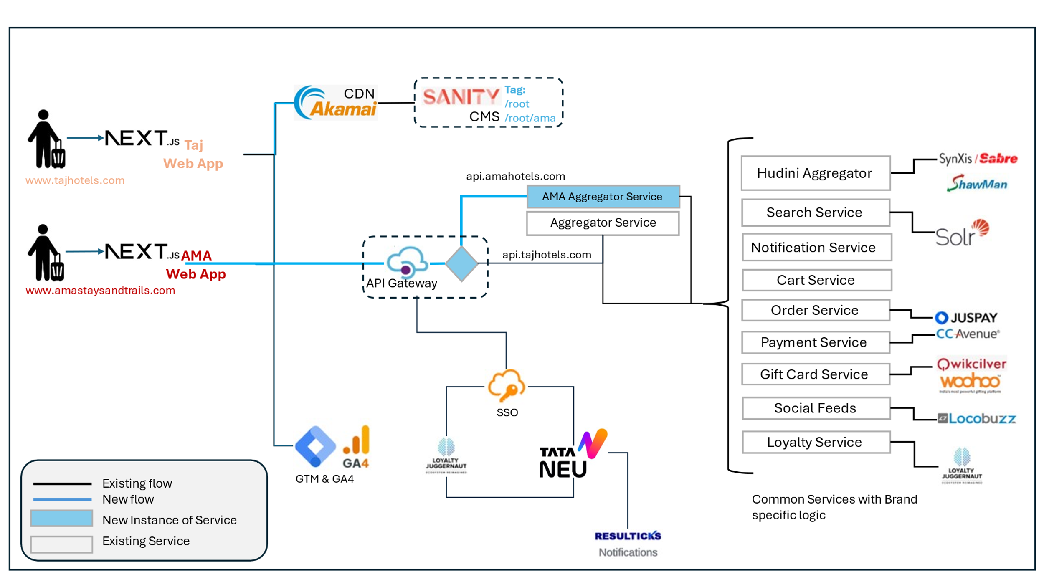

# Tools Used

This document will provide competitive analysis between Taj and AMA with respect to SEO analysis on data like FCP, LCP, Performance, Accessibility, best practice and SEO. Based on this data team will have an understating where we stand in-terms of front data initial data.

# Best Practice Index

Following are the best practice data available, provided by google which is mostly been used by all industry.

|  |  |
| --- | --- |
| Item | Good |
| FCP | [0, 1800ms] |
| LCP | [0, 2500ms] |
| CLS | [0, 0.1] |
| TTFB (experimental) | [0, 800ms] |

Source : <https://developers.google.com/speed/docs/insights/v5/about>

# Application Scope

Following applications are in-scope.

1. AMA :

UAT Environment

<https://web-uatv1.amastaysandtrails.com/en-in>

Without Akamai CDN cache layer

1. Taj :

Production Environment

<https://www.tajhotels.com/en-in>

With Akamai Edge CDN Cache

# Detail Analysis report

Following is the test report where both AMA & Taj been compared with live data. Reference data been captured from Google which is been followed by all solution providers.

|  |  |  |  |  |  |  |  |
| --- | --- | --- | --- | --- | --- | --- | --- |
| No# | Line Items | Category | AMA | | Taj | | References |
|  |  |  | Mobile | Desktop | Mobile | Desktop |  |
| 1 | FCP | UI | 1.4s | 0.5s | 1.2s | 0.3s | [0, 1800ms] |
| 2 | LCP | UI | 3.5s | 1.3s | 2.4s | 0.6s | [0, 2500ms] |
| 3 | CLS | UI | 0 | 0 | 0 | 0 | [0, 0.1] |
| 4 | TTFB | UI | 9.0s | 1.82s | 16.63s | 1.76s | [0, 800ms] |
| 5 | Speed Index | UI | 10.6s | 3.8s | 7.7s | 3.5s | [2000,4000ms] |

Reference Source : <https://developers.google.com/speed/docs/insights/v5/about>

# Evidence

Following are the evidences which is been captured once test was conducted and completed.

1. AMA – Evidence (Desktop) :

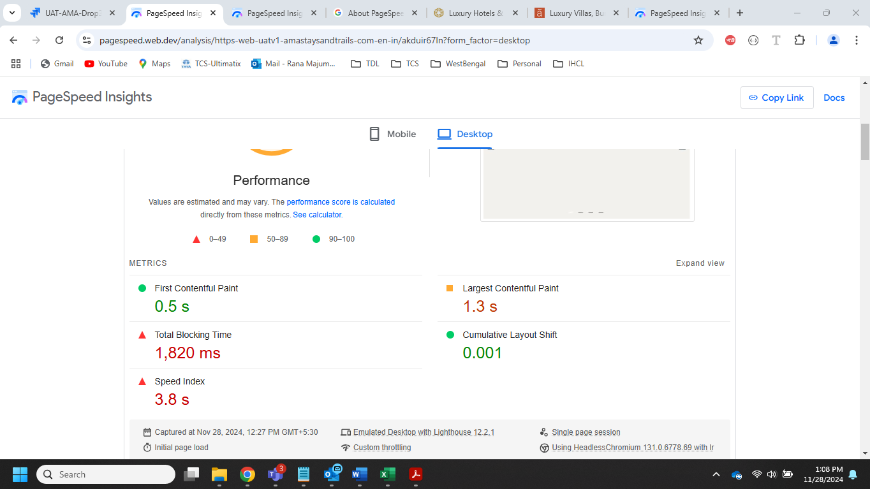

1. AMA – Evidence (Mobile) :

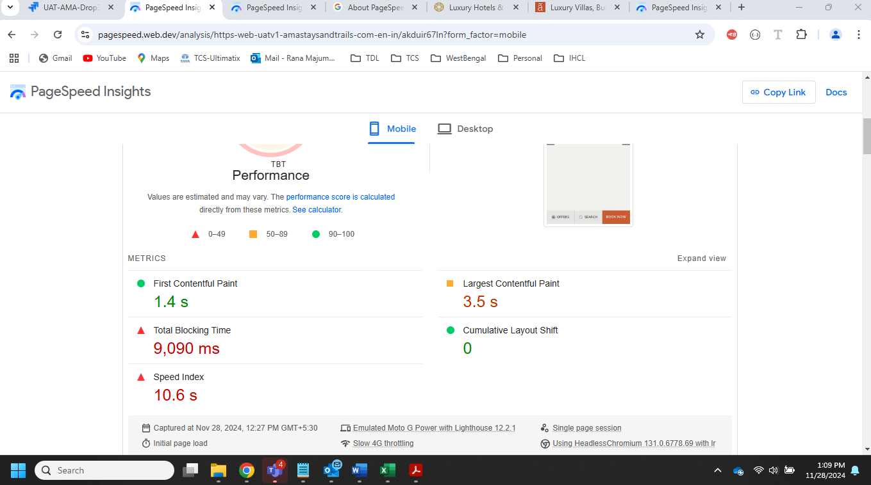

1. TAJ – Evidence (Desktop) :

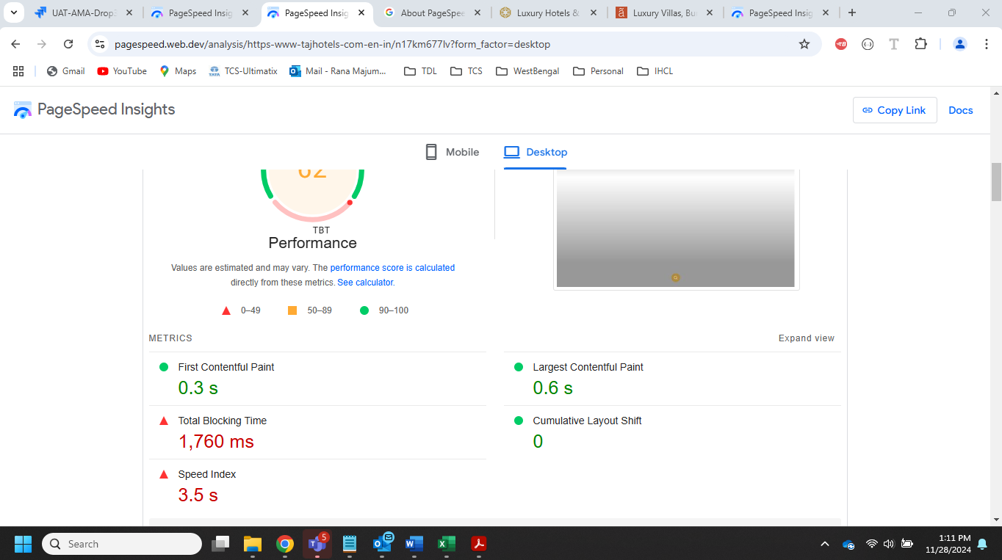

1. Taj – Evidence (Mobile) :

# Quick Insights on AMA

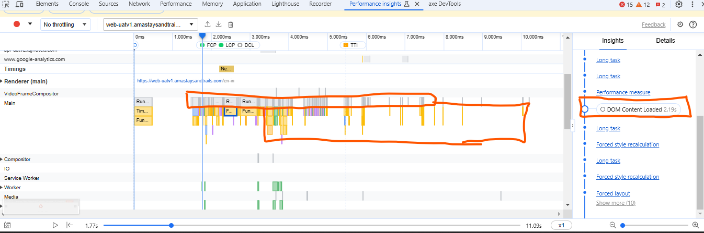

1. ReCAPTCHA and TDL is also taking huge amount of time.

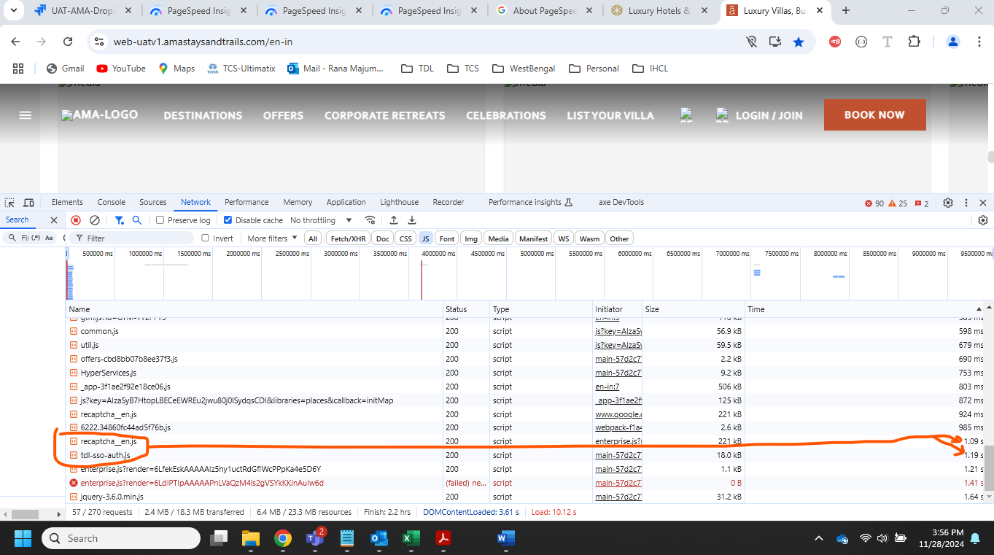

1. Some of the icons aren’t query parameter driven (Same like Taj)

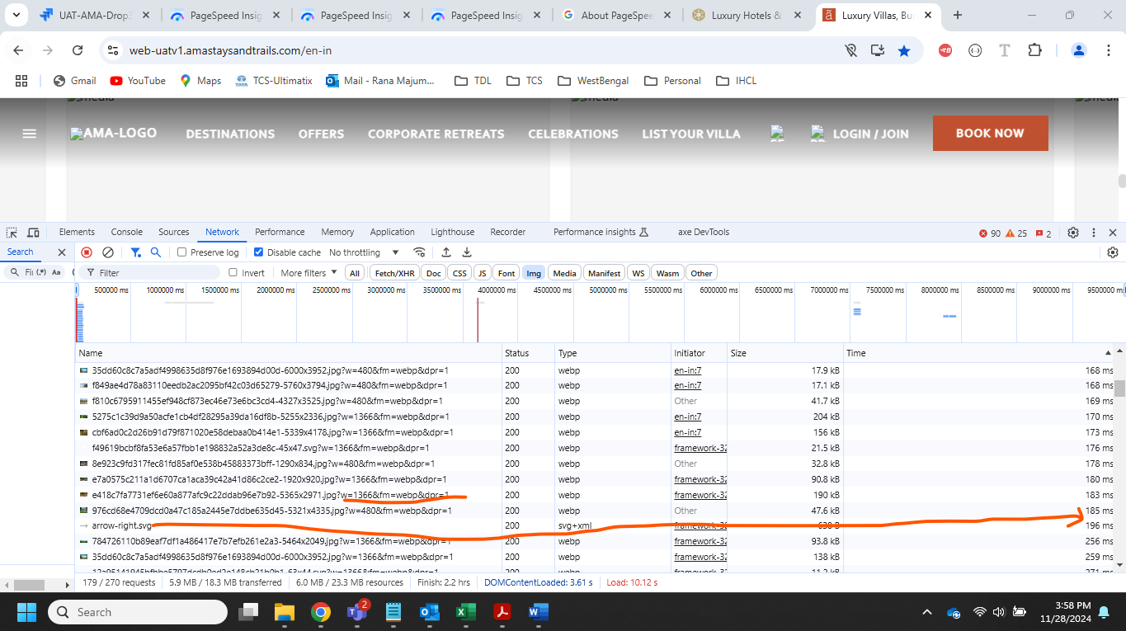

1. Some of the images are taking quite high time. Its primarily because of the size. If IHCL can reduce the size and share updated copy then speed would increase further.

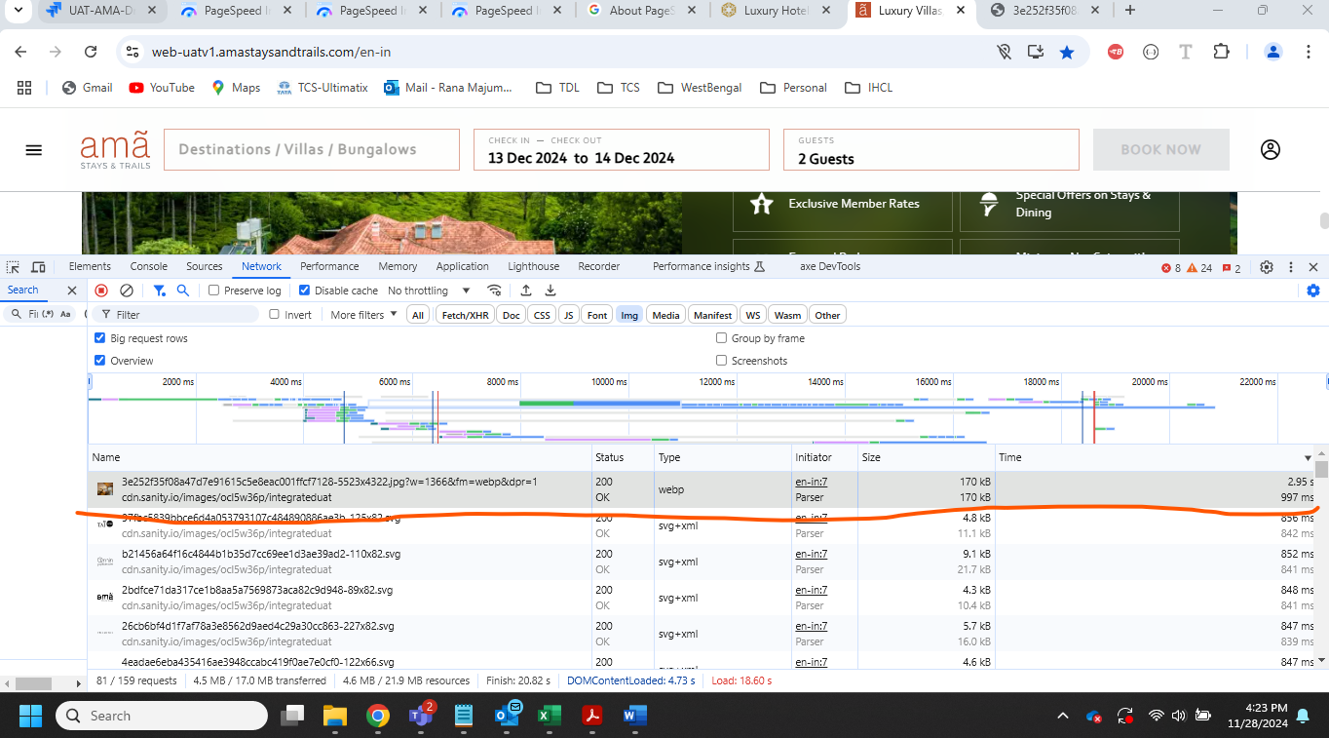

1. Initially Loaded Page Size is bloated

The ideal approach for the initial loading and rendering of a page is to render the**above-the-fold**and important content like which needs to be crawled for SEO, while rendering the remaining **below-the-fold content** on the client side. This ensures the page maintains high-performing Web Vitals. This would make Initial Load (TTFB) there by improving the web vitals subsequently. However, in AMA almost all page content is server side rendered making bigger size for initial load.

**Facts**

 In AMA, because of SEO requirements, almost all components of the pages are being server-side rendered. This has bloated the initial load page and negatively impacted the Web Vitals. Additionally, at the server level warnings being logged on the server regarding page size.

 Below are the facts and logs the AMA team communicated regarding page size warnings.

**Reference**: <https://nextjs.org/docs/messages/large-page-data>

 (Note for FE development AMA is using NextJS tech Stack)

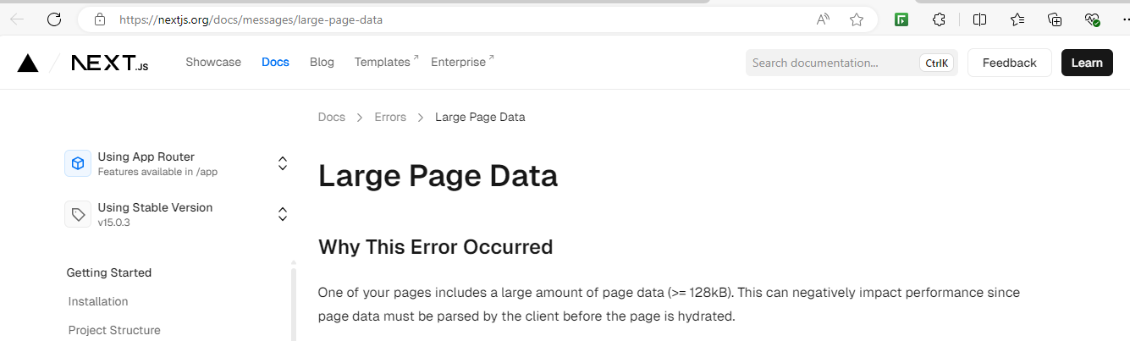

**Evidence**

|  |
| --- |
| 2024-11-27T07:52:27.3345584Z Warning: data for page "/[pid]/offers-and-promotions/[slug]" (path "/cottabetta-bungalow-coorg/offers-and-promotions/4d-offer") is **553 kB which exceeds the threshold of 128 kB, this amount of data can reduce performance.**  2024-11-27T07:52:27.3346117Z See more info here: <https://nextjs.org/docs/messages/large-page-data>  2024-11-27T07:52:42.5370676Z Warning: data for page "/[pid]/offers-and-promotions/[slug]" (path "/glenlorna-bungalow-coorg/offers-and-promotions/4d-offer") is**553 kB which exceeds the threshold of 128 kB, this amount of data can reduce performance.**  2024-11-27T07:52:42.5371169Z See more info here: <https://nextjs.org/docs/messages/large-page-data>  2024-11-27T07:53:04.0263494Z Warning: data for page "/[pid]/offers-and-promotions/[slug]" (path "/kumara-villa-kodaikanal/offers-and-promotions/4d-offer") is **553 kB which exceeds the threshold of 128 kB, this amount of data can reduce performance.**  2024-11-27T07:53:04.0264011Z See more info here: <https://nextjs.org/docs/messages/large-page-data> 2024-11-27T07:59:12.5221011Z Warning: data for page "/[pid]/offers-and-promotions/[slug]" (path "/sneh-villa-kodaikanal/offers-and-promotions/4d-offer") **is 553 kB which exceeds the threshold of 128 kB, this amount of data can reduce performance.** 2024-11-27T07:59:12.5221507Z See more info here: <https://nextjs.org/docs/messages/large-page-data>  2024-11-27T07:59:42.9421032Z Warning: data for page "/[pid]/offers-and-promotions/[slug]" (path "/taneerhulla-bungalow-coorg/offers-and-promotions/4d-offer") is**553 kB which exceeds the threshold of 128 kB, this amount of data can reduce performance.** |

# What’s been done for performance improvement

* gzip page serving
* Implementing optimization parameter of sanity image download
* Below the fold images lazy loading,
* Page (HTML), JavaScript, CSS, assets caching in Akamai edge layer
* Video downloading frame by frame using Akamai impolicy featured parameter

NOTE:

The caching Akamai layer and Video downloading optimisation is out of scope for this analysis as Akamai layer CUG environment is not publicly exposed and so not able to run PageSpeed tool on cached pages. The UAT environment is not having Akamai Edge Cache layer. It’s envisioned that, this would improve the points 12-20 when cache is considered like in Production.

# TCS Recommendation

* Explore the feasibility of Image assets caching at Akami cache layer. This has to be taken as MVP and idea to be vetted.
* Lazy load the **below-the -fold** components, currently this feature implementation is constrained by the dynamic rendering of the page component’s which is driven by the page structure and variants defined in the Sanity CMS and most of the page rendering at server side.