BOOK NEST (MERN Stack) - Project Documentary

1. Project Title
Book Nest Application using MERN Stack

2. Project Overview
The BookNest application is a web-based online bookstore developed using the MERN (MongoDB, Express.js, React.js, Node.js) stack. It allows users to browse an extensive collection of books, add them to a cart, complete purchases securely, and view their order history. Admins have dedicated access to manage book listings, monitor inventory, and oversee order processing.

3. Objective
To build a responsive, interactive, and scalable digital bookstore that delivers an enjoyable book-browsing and shopping experience for users, along with robust admin-side management — all built with the MERN stack.

4. Tech Stack
- Frontend:
  - React.js
  - React Router
  - Axios for API requests
  - Tailwind for styling
- Backend:
  - Node.js
  - Express.js
  - JWT for authentication
  - Multer for file uploads
- Database:
  - MySQL

5. Key Features
Admin:
- Authentication
- Book Management (Add, Update, Delete)
- Order Management
- Dashboard View
User:
- Secure Registration & Authentication
- Browse Books by Genre, Author, Popularity
- Search and Filter Books
- Cart Management
- Order Placement
- Order History
- Modern, Responsive UI

6. System Architecture

Client (React) <--> Express Server (Node.js) <--> MongoDB Database

7. Folder Structure (Simplified)
/client
/src
/components
/pages
App.js
/server
/routes
/models
/controllers
server.js

8. Challenges Faced
- Handling asynchronous data operations
- Managing protected routes and secure authentication
- Configuring deployment for full-stack integration

9. Outcomes & Learnings
- Full-stack development experience
- REST API implementation
- Scalable codebase architecture
- UI-state interaction
- Debugging & deployment

10. Future Enhancements
• Integration of secure payment gateways
• User reviews and star ratings for books
• Personalized recommendations and wishlists
• Admin analytics and sales reports
• Email or OTP-based verification for secure sign-ups

13. Screenshots
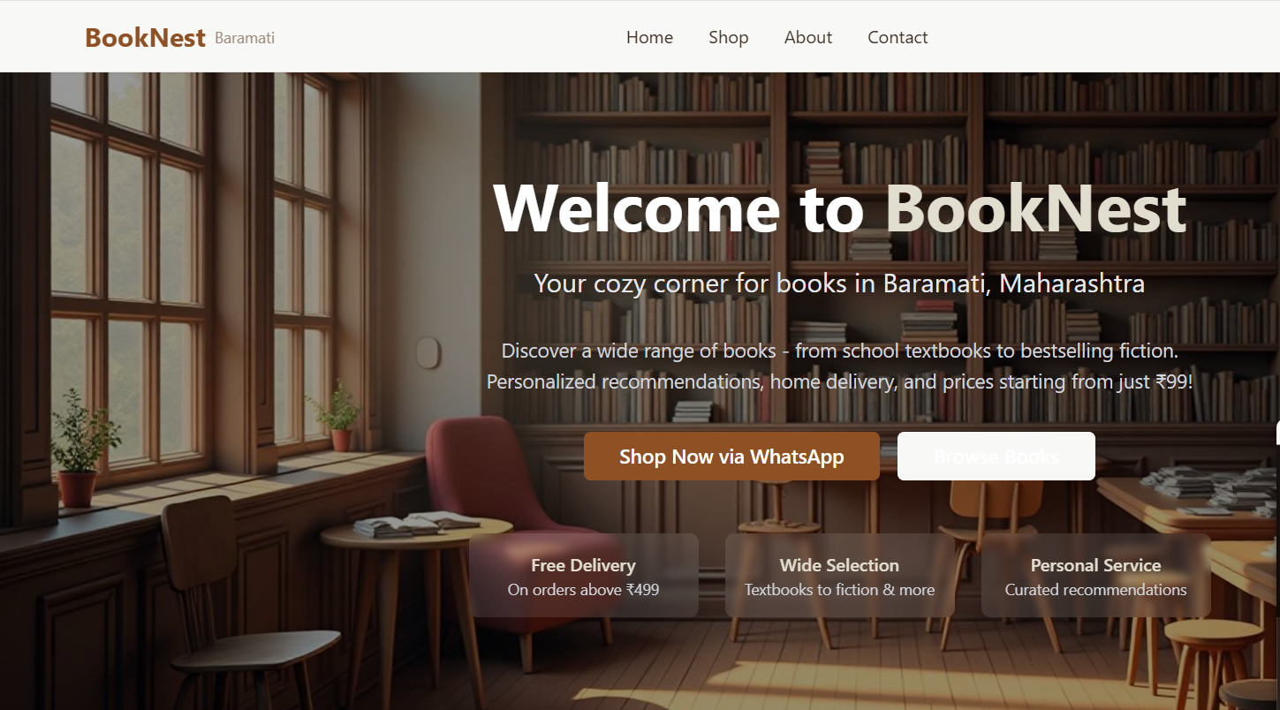
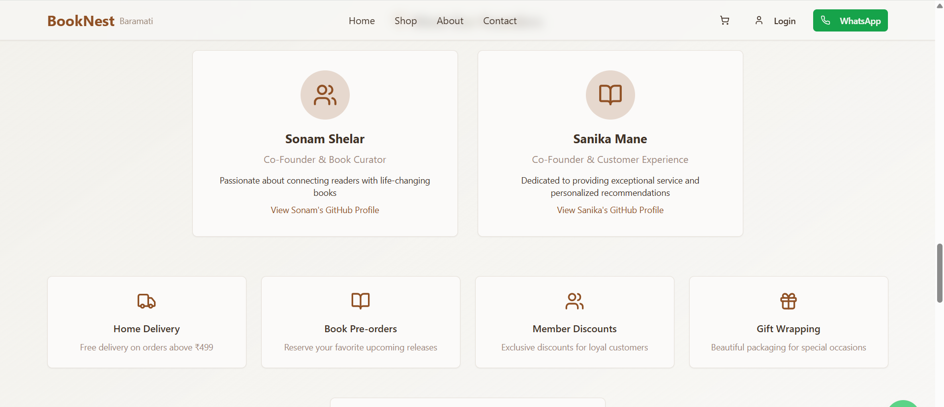

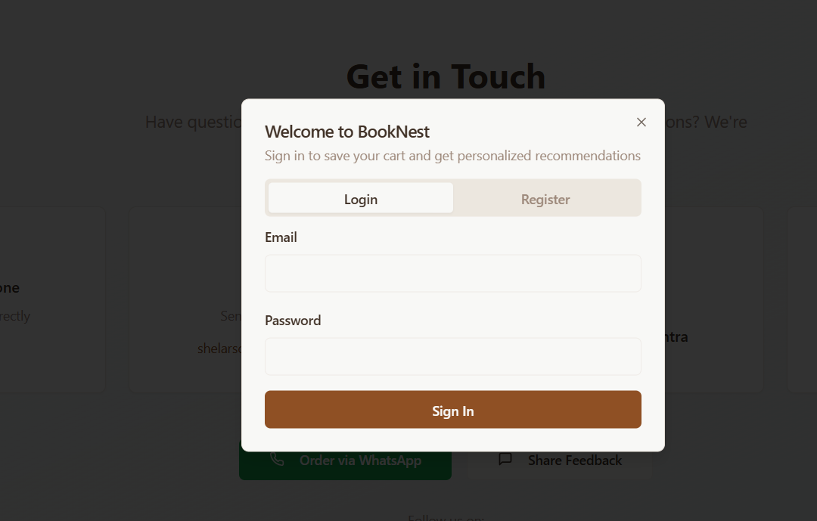

14. Conclusion
This project demonstrates the development of a fully functional online bookstore using the MERN stack. BookNest replicates real-world bookstore functionality in a digital environment, empowering readers to discover and purchase books easily while providing admins with powerful management tools. Completing this project enhanced full-stack development skills and laid the groundwork for future advanced features.

