**WORKSHOP ON BATTERIES AND CHARGING UNITS (ELE294)**

**LOVELY PROFESSIONAL UNIVERSITY**

PROJECT REPORT

ON

**OMNI EV BOT FOR INDUSTRIAL WAREHOUSING**

Submitted in partial fulfillment of the requirements for the award of degree of

**Bachelor of Technology**

**(Electrical and Electronics Engineering)**

Submitted to

**LOVELY PROFESSIONAL UNIVERSITY**

**PHAGWARA, PUNJAB**

### **SUBMITTED BY**

### POCHAMPALLI PAVAN (12308240)

### CHAVA SAI KIRAN (12308817)

### MARUPAKA VENKAT SAI (12308900)

### PENDOTA SAI TEJA (12315169)

### **SUBMITTED TO**: DR.AMIT KUMAR SINGH

**ABSTRACT**

The rapid growth of e-commerce and industrial logistics has necessitated smarter, more efficient warehousing solutions. The Omni EV Bot for Industrial Warehousing is an innovative robotic platform designed to automate material handling in confined warehouse environments. Leveraging omni-directional Mecanum wheels, this electric vehicle (EV) bot achieves seamless 360-degree movement, allowing it to navigate narrow aisles and perform precise maneuvers. The bot is powered by a rechargeable battery system and features a dual-mode operation—manual control via a mobile app (Blynk). A servo-driven lifting mechanism enhances its utility by enabling vertical material handling, making it ideal for shelving or transporting boxes. The system employs ESP8266 (NodeMCU) microcontrollers and wireless communication via ESP-NOW, reducing latency and enhancing reliability. This project addresses key challenges in warehouse automation, including space optimization, labor cost reduction, and operational safety, paving the way for scalable deployment in smart industrial facilities.

**INDEX**

|  |  |  |
| --- | --- | --- |
| **S.NO** | **TITLE** | **Page No** |
| 1. | INTRODUCTION | 4-6 |
| 2. | WORKING | 7-9 |
| 3. | SOFTWARE CODE | 10-13 |
| 4. | APPLICATIONS | 14-15 |
| 5. | FUTURE SCOPE | 16-17 |
| 6. | CONCLUSION | 18 |

1. **INTRODUCTION**

The industrial and warehousing sectors are experiencing a dramatic transformation due to the rise of automation, the Internet of Things (IoT), and electric mobility. Traditional warehouse operations that once relied heavily on manual labor are becoming increasingly inefficient in the face of growing demand, labor shortages, and the need for error-free, high-speed logistics. The future of warehousing lies in integrating intelligent robotics with clean energy solutions to ensure faster, safer, and more reliable operations. In this context, the Omni EV Bot for Industrial Warehousing offers a novel approach to material handling and warehouse automation, combining omni-directional mobility, electric propulsion, wireless control, and lifting capabilities in a compact and versatile robotic system.

Warehousing operations involve multiple repetitive tasks such as loading, unloading, sorting, stacking, and transporting goods. These processes are often time-consuming and labor-intensive. Errors in manual handling can result in damaged goods, workplace injuries, and operational inefficiencies. Automated Guided Vehicles (AGVs) and warehouse robots have emerged as effective solutions to these problems, but they often suffer from limitations such as poor maneuverability in tight spaces, high cost, or complex infrastructure requirements. This project addresses these gaps by designing an agile, cost-effective, and energy-efficient Omni-directional Electric Vehicle Bot specifically tailored for small to medium-sized warehouse environments.

At the core of the Omni EV Bot’s functionality is its Mecanum wheel drive system, which provides the robot with 360-degree movement capabilities. Unlike traditional two-wheel or four-wheel drive robots that can only move forward or backward (and must rotate to change direction), the Mecanum wheel design enables the bot to move in any direction without rotating its body. This includes lateral (sideways), diagonal, and rotational movements—all of which are critical for operating in narrow warehouse aisles and cluttered environments. This level of agility is particularly beneficial for high-density storage systems where conventional robots struggle with navigation.

The propulsion system of the Omni EV Bot is powered by electric motors, which make it an environmentally friendly alternative to fossil-fueled material handling equipment. The motors are controlled by an ESP8266 NodeMCU microcontroller, which also serves as the brain of the robot. Wireless control is implemented using ESP-NOW, a low-latency, peer-to-peer communication protocol provided by Espressif, allowing for quick and stable transmission of control signals from a joystick or smartphone application. Manual operation can be conducted through the Blynk IoT platform, where users can send movement commands over Wi-Fi and monitor parameters such as battery voltage or obstacle detection in real-time.

To enhance its functional utility, the bot incorporates a servo motor-driven lifting mechanism, which enables it to pick up, lift, and place small loads or containers. This feature replicates a key aspect of warehouse robotics—automated shelving and retrieval—and makes the bot useful in applications such as order picking, sorting, and inventory movement. The lifting platform is designed to be lightweight yet sturdy, ensuring it does not compromise the balance or agility of the robot while in motion.

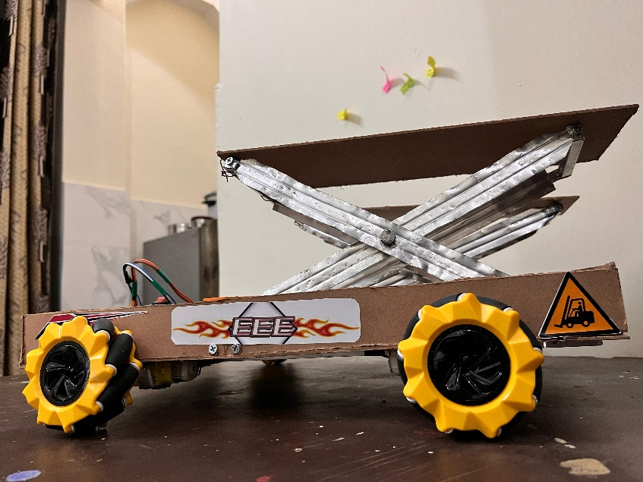

Fig1: EV Bot with Lift Mechanism

The Omni EV Bot was engineered to fulfill the core industrial warehousing needs of intelligent mobility and efficient material handling. The primary objective was to build a compact, energy-efficient, and robust electric vehicle platform capable of omni-directional movement using mecanum wheels. Emphasis was placed on real-time wireless control, effective platform lifting using gear motors, and seamless system integration using low-cost, off-the-shelf components. The bot’s structure and control logic were optimized for reliable indoor navigation and precision in lifting payloads, supporting tasks such as shelf-to-shelf movement and package positioning in small-to-medium-sized warehouses.

In conclusion, the Omni EV Bot for Industrial Warehousing is a step toward democratizing warehouse automation by providing a scalable and intelligent robotic solution that can be adapted to various industrial needs. It addresses the pressing demands of modern logistics by combining key technological innovations—omni-directional movement, wireless control, , and material handling—into a single, flexible platform. As warehouses continue to evolve into smart, interconnected ecosystems, such robots will play a pivotal role in reducing operational costs, increasing efficiency, and ensuring safe, sustainable logistics operations.

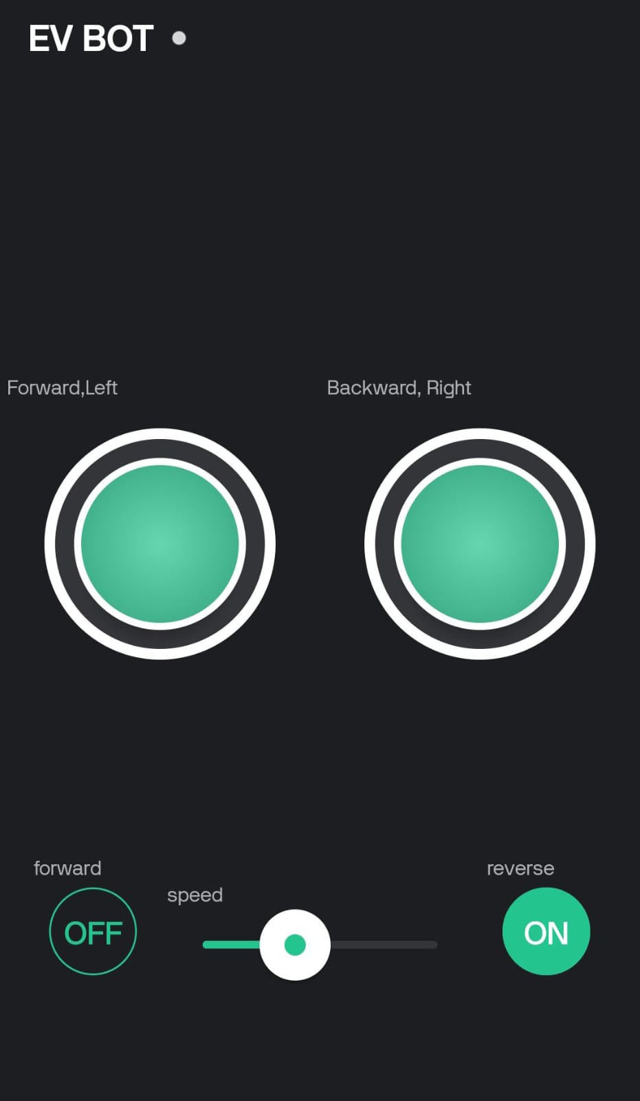

Fig2: Blynk APP for control

1. **WORKING**

The Omni EV Bot is designed to perform intelligent, flexible, and efficient movement and material handling tasks in an industrial warehouse environment. The system integrates mechanical, electrical, and embedded components, working together to perform omnidirectional mobility, platform lifting, and wireless control via the Blynk IoT application.

Using ESP8266 (NodeMCU) as the core controller, the bot receives directional and speed commands from the Blynk app through Wi-Fi. The commands are processed to drive mecanum wheels via an L298N motor driver, enabling forward, backward, lateral, and diagonal movement.

For lifting operations, gear motors are employed to raise or lower the platform, allowing the bot to handle object transportation within the warehouse. A Blynk-controlled interface offers intuitive control over the bot's movement and lifting mechanism, enhancing ease of operation.

Additionally, the bot integrates ultrasonic distance measurement to monitor obstacle proximity and support safe navigation. Power is supplied through a 12V battery pack, charged externally via a Battery Management System (BMS) for regulated and protected operation.

The Omni EV Bot offers a compact, scalable, and responsive solution for modern warehouse automation needs.

1. Power and Integration

The Omni EV Bot is powered by a 12V lithium-ion battery pack, which supplies power to the ESP8266 controller, motor driver, gear motors, and sensors.

Charging is done externally through a Battery Management System (BMS) that ensures safe charging, voltage regulation, and cell balancing.

The external DC charging port is connected to the BMS, allowing easy recharging without opening or removing the battery.

The system architecture is designed such that:

* Logic-level components (ESP8266, sensors) receive a stable 3.3V/5V via onboard voltage regulators.
* Motors and actuators receive direct 12V from the battery pack via the L298N motor driver.

This setup ensures efficient power distribution, safe charging cycles, and protection against overcurrent, overvoltage, or deep discharge conditions.

2. Wireless Communication Control

The bot uses ESP-NOW protocol to establish a wireless peer-to-peer connection between a joystick module (or smartphone with Blynk app) and the ESP8266 on the bot. Unlike typical Wi-Fi-based control that introduces latency, ESP-NOW provides low-latency communication ideal for real-time joystick data transfer. Joystick X and Y analog values are transmitted to the receiver ESP8266 on the bot, which interprets them as movement instructions.

If operating through the Blynk app, the bot receives control commands over Wi-Fi via buttons, sliders, or joystick widgets. Commands include directional movement, speed control, and lift actuation.

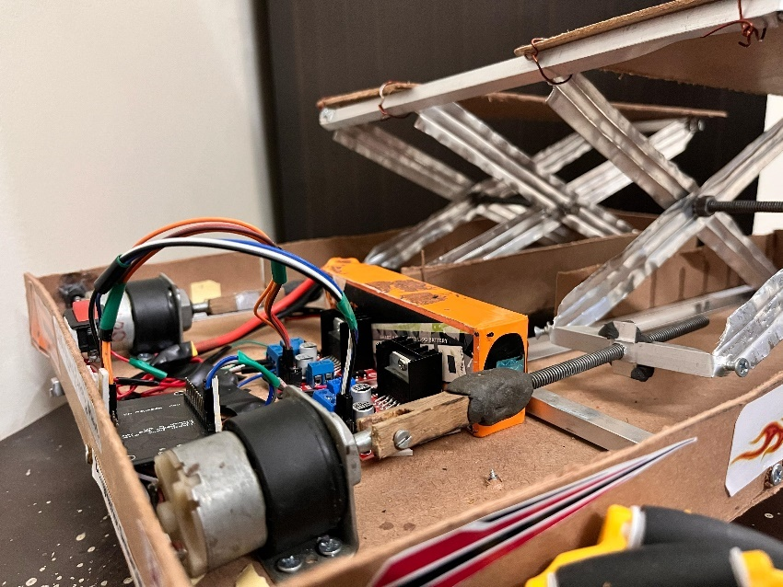

Fig3: Gear motors and motor drivers

3. Omni-Directional Mobility (Using Mecanum Wheels)

The bot is equipped with four Mecanum wheels, each driven by an individual DC gear motor controlled by the L298N dual H-bridge motor driver. By varying the direction and speed of each motor, the bot can achieve:

* Forward/Backward Motion: All wheels rotate in the same direction.
* Lateral (Sideways) Motion: Diagonally opposite wheels rotate in opposite directions.
* Rotation (Spin): Left and right wheels rotate in opposite directions.
* Diagonal Movement: A unique combination of wheel speeds.

The microcontroller calculates the required motor outputs based on joystick data or app commands and drives the motors accordingly. This gives the bot the freedom to navigate tight warehouse aisles, turn in place, or reposition precisely without large turning radii

4. Lifting Mechanism

The lifting mechanism is driven by one or more servo motors or stepper motors depending on the load requirement. When the user sends a lift-up or lift-down command, the microcontroller sends PWM signals to the servo to rotate to a specific angle, thereby raising or lowering the platform. This lifting platform is designed to handle lightweight warehouse items like small containers, boxes, or tools.

The lifting mechanism is placed centrally to ensure the load is balanced and does not interfere with movement. The lifting height and stability can be adjusted in software by modifying the servo angle limits or incorporating a mechanical gear system for better torque.

.

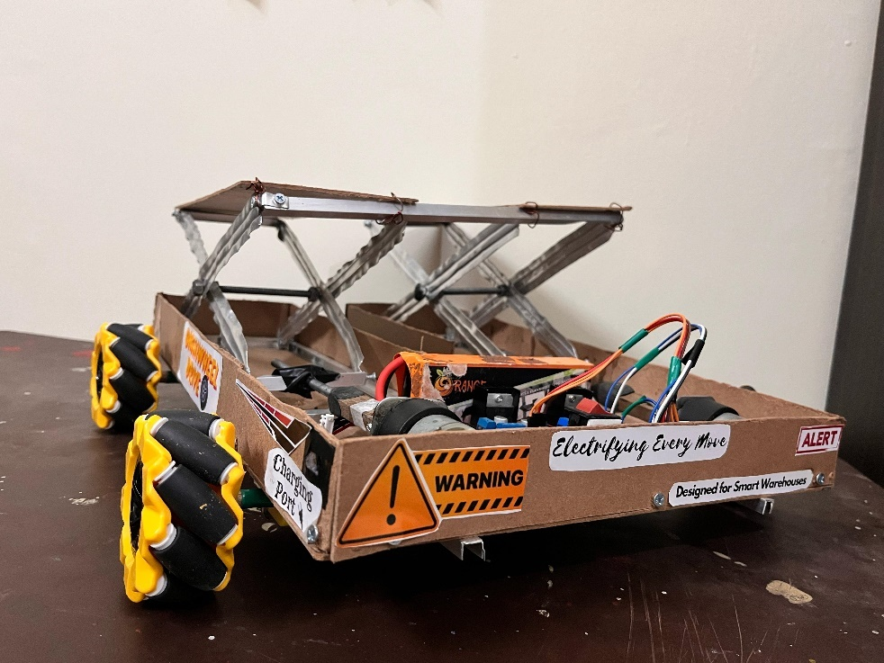

Fig4: EV Bot back side View

1. **SOFTWARE CODE**

// --- Blynk Credentials ---

#define BLYNK_TEMPLATE_ID "TMPL3-6ZOJMDP"

#define BLYNK_TEMPLATE_NAME "EV BOT"

#define BLYNK_AUTH_TOKEN "_DKfiu_a10BEKOfSrJ9xTtynnPLAc-zg"

#include <ESP8266WiFi.h>

#include <BlynkSimpleEsp8266.h>

#define BLYNK_PRINT Serial

char ssid[] = "Realme 8 5G";

char pass[] = "0987654321";

// --- Motor Control Pins ---

#define LEFT_FORWARD    D3    // IN3

#define LEFT_BACKWARD   D4    // IN4

#define RIGHT_FORWARD   D5    // IN1

#define RIGHT_BACKWARD  D6    // IN2

#define MOTOR_PWM       D0    // Common PWM for ENA/ENB

#define DIR_FORWARD     D1    // Direction logic forward

#define DIR_REVERSE     D2    // Direction logic reverse

// Variables

int speedValue = 0;

bool isForward = false;

bool isReverse = false;

// --- Blynk Functions ---

// Left side forward control (V2)

BLYNK_WRITE(V2) {

  int value = param.asInt();

  digitalWrite(LEFT_FORWARD, value);

  Serial.println(value ? "Left Motor Forward ON" : "Left Motor Forward OFF");

}

// Left side backward control (V3)

BLYNK_WRITE(V3) {

  int value = param.asInt();

  digitalWrite(LEFT_BACKWARD, value);

  Serial.println(value ? "Left Motor Backward ON" : "Left Motor Backward OFF");

}

// Right side forward control (V0)

BLYNK_WRITE(V0) {

  int value = param.asInt();

  digitalWrite(RIGHT_FORWARD, value);

  Serial.println(value ? "Right Motor Forward ON" : "Right Motor Forward OFF");

}

// Right side backward control (V1)

BLYNK_WRITE(V1) {

  int value = param.asInt();

  digitalWrite(RIGHT_BACKWARD, value);

  Serial.println(value ? "Right Motor Backward ON" : "Right Motor Backward OFF");

}

// Speed control (V4)

BLYNK_WRITE(V4) {

  speedValue = abs(param.asInt());

  analogWrite(MOTOR_PWM, speedValue);

  Serial.print("Speed Set to: ");

  Serial.println(speedValue);

  if (speedValue == 0) {

    digitalWrite(DIR_FORWARD, LOW);

    digitalWrite(DIR_REVERSE, LOW);

  }

}

// Direction forward (V5)

BLYNK_WRITE(V5) {

  isForward = param.asInt();

  if (isForward) {

    isReverse = false;

    digitalWrite(DIR_FORWARD, HIGH);

    digitalWrite(DIR_REVERSE, LOW);

    Serial.println("Direction: FORWARD");

  } else {

    digitalWrite(DIR_FORWARD, LOW);

  }

}

// Direction reverse (V6)

BLYNK_WRITE(V6) {

  isReverse = param.asInt();

  if (isReverse) {

    isForward = false;

    digitalWrite(DIR_FORWARD, LOW);

    digitalWrite(DIR_REVERSE, HIGH);

    Serial.println("Direction: REVERSE");

  } else {

    digitalWrite(DIR_REVERSE, LOW);

  }

}

// --- Setup Function ---

void setup() {

  Serial.begin(9600);

  Blynk.begin(BLYNK_AUTH_TOKEN, ssid, pass);

  // Set all motor control pins as OUTPUT

  pinMode(LEFT_FORWARD, OUTPUT);

  pinMode(LEFT_BACKWARD, OUTPUT);

  pinMode(RIGHT_FORWARD, OUTPUT);

  pinMode(RIGHT_BACKWARD, OUTPUT);

  pinMode(MOTOR_PWM, OUTPUT);

  pinMode(DIR_FORWARD, OUTPUT);

  pinMode(DIR_REVERSE, OUTPUT);

  // Initialize motors to OFF

  digitalWrite(LEFT_FORWARD, LOW);

  digitalWrite(LEFT_BACKWARD, LOW);

  digitalWrite(RIGHT_FORWARD, LOW);

  digitalWrite(RIGHT_BACKWARD, LOW);

  digitalWrite(DIR_FORWARD, LOW);

  digitalWrite(DIR_REVERSE, LOW);

  analogWrite(MOTOR_PWM, 0);

}

// --- Main Loop ---

void loop() {

  Blynk.run();

}

1. **APPLICATIONS**

**1. Automated Material Handling**

* Application: The Omni EV Bot can be used for transporting goods across large warehouses. Its omni-directional movement allows it to navigate tight spaces and navigate obstacles with ease, making it highly efficient for handling goods of varying shapes and sizes.
* Benefit: Reduces labor costs and human error, increases throughput, and improves safety in the warehouse.

**2. Inventory Management**

* Application: Integrated with RFID or barcode scanning systems, the Omni EV Bot can automatically scan inventory, track items, and update stock levels in real-time.
* Benefit: Streamlines inventory management processes, ensures accuracy, and reduces the time spent on manual stock-taking.

**3. Order Fulfillment**

* Application: The Omni EV Bot can pick, transport, and deliver goods to packing stations based on customer orders.
* Benefit: Speeds up the order fulfillment process, improves delivery accuracy, and increases overall warehouse productivity.

**4. Automated Sorting**

* Application: Using vision systems or sensors, the Omni EV Bot can be tasked with sorting products based on size, type, or destination, and moving them accordingly.
* Benefit: Enhances sorting efficiency, reduces errors, and can operate continuously without fatigue.

**5. Cross-Docking Operations**

* Application: The Omni EV Bot can move products directly from receiving to shipping areas, bypassing storage. This is ideal for time-sensitive goods.
* Benefit: Minimizes handling time, reduces storage costs, and speeds up the supply chain.

**6. Multi-Modal Transport**

* Application: The dual-mode (manual + autonomous) operation of the Omni EV Bot allows it to switch between fully autonomous tasks or being manually controlled when necessary (such as during loading or unloading in complex environments).
* Benefit: Provides flexibility and adaptability, ensuring the system can handle different warehouse conditions.

**7. Hazardous Material Handling**

* Application: For industries dealing with hazardous or sensitive materials, the Omni EV Bot can be used to transport such items safely, minimizing human exposure to potential risks.
* Benefit: Enhances worker safety and prevents accidents.

**8. Collaborative Robotics**

* Application: The Omni EV Bot can collaborate with human workers or other robots in a shared space, offering assistance for heavy lifting, transport, or stock management.
* Benefit: Boosts worker productivity, safety, and collaboration in high-demand environments.

**9. Maintenance and Charging Automation**

* Application: The Omni EV Bot can autonomously navigate to a charging station when its battery is low, ensuring continuous operation with minimal downtime.
* Benefit: Reduces human intervention, increases uptime, and ensures seamless operations in the warehouse.

**10. Real-Time Monitoring and Analytics**

* Application: Integrated with IoT sensors and cloud systems, the Omni EV Bot can send real-time data on its location, battery status, and load to warehouse managers for optimization.
* Benefit: Offers data-driven insights to improve warehouse operations and decision-making.

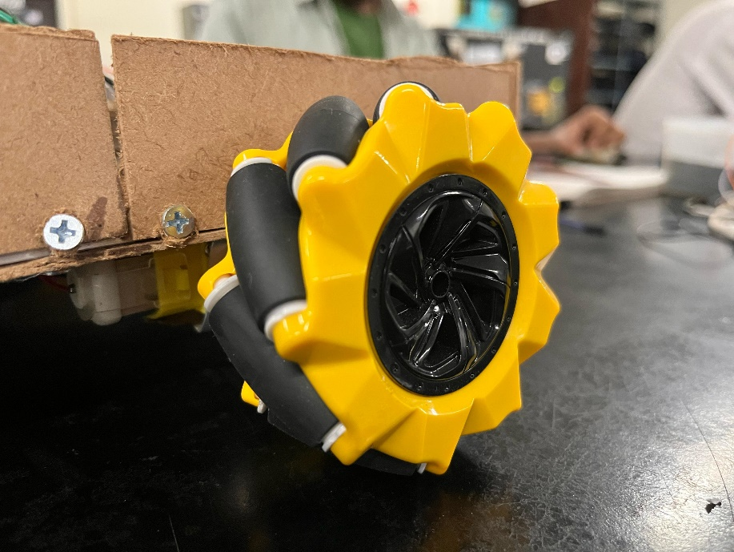

Fig5: Mecanum wheels

1. **FUTURE SCOPE**

The Omni EV Bot has a promising future in industrial warehousing, with numerous opportunities for expansion, enhancement, and integration into broader automated systems. Here are several potential avenues for its future development:

1. Integration with Advanced AI and Machine Learning

* Scope: In the future, the Omni EV Bot can be integrated with advanced AI and machine learning algorithms to enable smarter decision-making. This could include predictive maintenance, where the bot can self-diagnose potential issues before they occur, or enhanced navigation systems that adapt to changing warehouse environments.
* Benefit: Improves operational efficiency, reduces downtime, and allows for real-time optimization of tasks.

2. Collaborative Robotics and Human-Robot Interaction

* Scope: Future versions of the Omni EV Bot could be designed to collaborate even more closely with human workers. By integrating advanced sensors, AI, and real-time communication systems, the bot can work alongside humans in a more intuitive and cooperative manner, making tasks more flexible and efficient.
* Benefit: Increases productivity while ensuring safety in environments with both human and robot interaction.

3. Autonomous Fleet Management

* Scope: As the Omni EV Bot fleet grows, there is potential for creating a fully autonomous fleet management system. This system would coordinate multiple bots, ensuring that tasks like material transportation, sorting, and order fulfillment are handled efficiently across the warehouse without human intervention.
* Benefit: Maximizes warehouse throughput and minimizes human oversight, allowing for completely automated operations.

4. Edge Computing and Real-Time Data Processing

* Scope: Incorporating edge computing into the Omni EV Bot would allow it to process data locally, enabling faster decision-making and reducing reliance on cloud systems. This is particularly useful in large warehouses where data latency can be a concern.
* Benefit: Improves real-time responsiveness and reduces the risk of network disruptions affecting warehouse operations.

5. Energy-Efficient and Sustainable Design

* Scope: Future versions of the Omni EV Bot could be designed with sustainability in mind, utilizing energy-efficient motors, lightweight materials, and solar charging stations. Additionally, bots could be optimized to reduce energy consumption through AI-based algorithms that adapt their energy usage depending on the task.
* Benefit: Reduces operational costs and supports sustainability goals in industrial operations.

6. Expansion into New Industries

* Scope: The Omni EV Bot could be adapted for use in industries beyond warehousing, including manufacturing, logistics, healthcare, and agriculture. In these industries, the bot could perform tasks such as assembly line support, product inspection, and delivery of supplies.
* Benefit: Expands the bot’s utility, making it a versatile solution across various sectors.

7. Integration with Augmented Reality (AR) and Virtual Reality (VR)

* Scope: The Omni EV Bot could be enhanced with AR/VR systems, allowing warehouse operators to visualize the movement and tasks of bots in real-time. This could help in monitoring and directing tasks more efficiently, as well as improving training for operators.
* Benefit: Provides enhanced control and visibility for warehouse managers and workers, improving task execution and training processes.

8. Blockchain for Supply Chain Transparency

* Scope: Implementing blockchain technology could enhance the Omni EV Bot’s role in tracking goods, ensuring real-time traceability, and ensuring the security of data within the warehouse. The bot could automatically record its tasks on a blockchain, improving transparency in inventory management and order fulfillment.
* Benefit: Enhances security, data integrity, and transparency in supply chain operations.

9. Advanced Payload and Multi-Tasking Capabilities

* Scope: Future versions of the Omni EV Bot could feature enhanced payload capacities and multi-tasking capabilities, allowing it to handle larger and more complex items or perform several tasks simultaneously (e.g., moving multiple items while simultaneously scanning barcodes)

1. **CONCLUSION**

The Omni EV Bot for Industrial Warehousing represents a significant advancement in warehouse automation, offering a wide range of applications that improve efficiency, safety, and overall productivity. Its omni-directional movement, combined with its ability to seamlessly switch between autonomous and manual operation, makes it highly adaptable to the dynamic needs of modern warehouses.

By automating tasks such as material handling, inventory management, order fulfillment, and sorting, the Omni EV Bot helps streamline operations, reduce human error, and cut down on operational costs. Furthermore, its capacity for real-time monitoring, collaboration with human workers, and integration with IoT technologies ensures that warehouses can operate with maximum efficiency and flexibility.

In addition, the Omni EV Bot’s capability to handle hazardous materials, perform cross-docking, and offer multi-modal transport options makes it ideal for a variety of industries, including those requiring sensitive or time-critical operations. The autonomous charging feature ensures minimal downtime, enhancing its utility in environments where continuous operation is critical.

Ultimately, the Omni EV Bot is not just an enhancement in warehousing technology; it is a transformative tool that will shape the future of industrial logistics. As automation continues to evolve, robots like the Omni EV Bot will play a crucial role in optimizing warehouse operations and driving the efficiency of supply chains worldwide**.**