**VISVESVARAYA TECHNOLOGICAL UNIVERSITY**

**Jnana Sangama, Santhibastawad Road, Machhe**

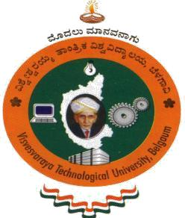**Belagavi - 590018, Karnataka, India**

**A SURVEY REPORT**

**ON**

*“***Survey on Space Technology***”*

**BACHELOR OF ENGINEERING**

**IN**

**INFORMATION SCIENCE AND ENGINEERING**

**For the Academic Year 2019-2020**

**Submitted by**

**Student Name: Pavan Kumar. P** **USN: 1JS18IS064**

**Under the Guidance of**

**Chayadevi ML**

**Associate Professor, Dept. of ISE, JSSATE**

**2019-2020**

**DEPARTMENT OF INFORMATION SCIENCE AND ENGINEERING**

**JSS ACADEMY OF TECHNICAL EDUCATION**

**JSS Campus, Dr. Vishnuvardhan Road, Bengaluru-560060**

**ABSTRACT:**

Space Technology is the technology constructed using space science and aeronautical study consisting of elements like spacecraft, rockets, satellite system etc. Software in Space technology plays a integral role in developing and launching of rockets, control of space shuttle system and also provides a major tools and techniques to the shuttle system to survive for longer missions etc. The basic software is constructed using high level languages such as Java, Python and also some object-oriented languages in Linux operating system. During late 90’s rockets were built using midrange computer aided design (CAD), this technology took more time to respond. Hence this made space industries to go for advanced technology called AI using softwares like NX, FEMAP and TEAMCENTER constructed using Siemens PLM software. Nastran developed by MacNeal-Schwendler is used as an algorithm to develop the code. These codes are stored in board dedicated computer, this is a dedicated server computer which can connect to the reserved network and share information. Using this AI technology robots, rovers are constructed and made to land on other planets to collect information on that planet.

**INTRODUCTION*:***

Space Technology was discovered during cold war between Soviet Union and USA which led to many developments in the present-day world. Innovations in automated (robotic) spacecraft are leading in a easy path explore space and its objects. Space crafts are most used software -intensive objects to support the remote sensing objects placed on the orbit, to gather information and also to analysis. A variety of software supports space exploration like – Flight software is used for planetary orbiters, lander spacecraft and for also space probes, Navigation and hazard avoidance software guides over Martian rover, the operational software that is used on Earth to monitor and to control the missions , software used to collect scientific data like weather forecasting. These helps the scientists to analyze, visualize and to interpret the results which gains knowledge on newly discovered objects in space and also may provide solutions to other problems on earth. Software also gives a better trouble shooting during the flight and accelerated understanding of our universe. Advancement in software also offers to improve the odds of the spacecraft to survive longer missions, contributing to their resilience to new environmental challenges. Apart from Siemens PLM softwares, Nastran softwares -the space industries like SPACEX, ESA also uses Taitus softwares for controlling the mission.

In this paper let us focus on software engineering for robotic space craft. Robotic spacecraft are mainly unmanned objects or vehicles which are remote controlled encoded with some software commands (programs). These robotic spacecrafts are like forward guard in human efforts to explore the space since they can go farther than manned missions, building knowledge or the memory units are beyond humans’ capacity. Also, because they can travel more and survive for longer period, they are used in the respective missions. Their software is highly fault tolerant to detect and to respond the anomalies that occur during the mission operation. Their software can also be updated in flight to adapt to the changes in the mission’s needs or to accommodate the failure of the certain components.

**SOFTWARE IN ROBOTIC SPACECRAFT:**

Software engineering plays a vital role by providing tools, techniques and a systematic approach to develop and service many different kinds of software needed for space exploration development. The technology in robotic spacecraft is basically based on Artificial Intelligence Technology. Advances in software engineering such as model based software development, formal verification and product line development help to ensure that the software built meets the need for exploring the mission and operates on each spacecraft safely and correctly according to the expectations. Software engineering goes step by step and in a planned version of software with system engineering on robotic spacecraft. A variety of software supports the scientific discovery in space exploration. Most of the satellites which are send to the space are unmanned satellites which run on a certain artificial intelligence technique, some programs to operate the spacecraft. Hence this engineering techniques plays a vital role not only in developing the programs but also in development of AI technology.

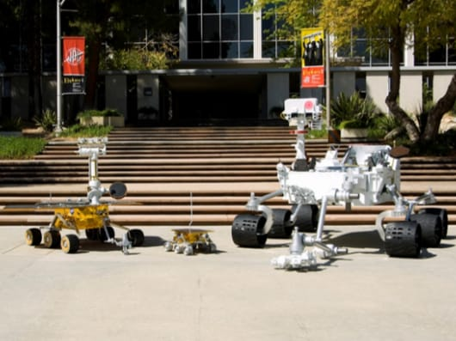

**Fig 1**: Automated rovers built using AI technology. (courtesy Google images)

The space company giants like NASA, ISRO etc use different types of softwares developed from multiple companies and agencies. Even some of the space craft parts programmed directly are taken from certain companies. These spacecrafts are programmed and designed in such a way that any external sources or gases present in the space can not affect the parts of that craft. Some of the softwares used and their working in these space industries are shown below.

**WORKING OF SOFTWARE:**

Most used softwares are as follows

**1.Nastran Software:** This software is the finite element analysis program that was developed for Nasa in late 1960’s under United states government. The MacNeal-Schwendler Corporation (MSC) was one the main and original developers of the available Nastran code. This is primarily written in Fortran language and it contains over millions of lines of code. These codes are compatible and operating systems ranging from small work stations to large super computers. These software tools also includes the functionality to import and simplify CAD geometry, use with finite elements, apply loads and restraints. For all these programs all inputs and outputs are given in the form of documents or files.

It was designed from the beginning to consist of several modules. A module is a collection of respective language that is Fortran subroutines designed to perform a specific task like processing model geometry, assembling matrices, calculating output quantities, conversing the data base, printing the solution, applying constraints, solving matrix problems and many more. These types of modules are controlled using an internal language called as Direct Matrix Abstraction Program (DMAP). Analysis of each codes of these software is known as a solution sequence. Nx Nastran is the famous algorithm used.

Use link <https://en.wikipedia.org/wiki/Nastran> for more details on codes used in this software.

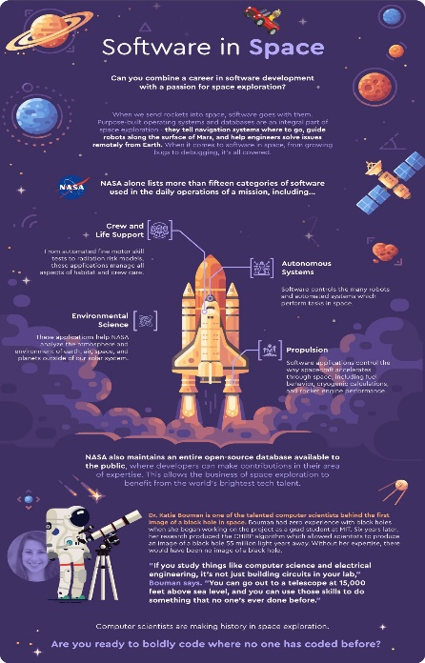

**Fig 2:** Software in Space. (Courtesy Googleimages- lighthouselabs.)

**2.Taitus Software:** This software was found in 2004 by Felipe Martin Crespo. This is specialized in advancement in mission analysis, planning and simulation tools for space applications, in particular focus on Earth observation. It is powered by in house-built technology that make extensive use of modern 3D computer graphics, integrated with advanced user interfaces. Taitus core competencies include:

* Particular focus on ground segment systems.
* Development of reusable software components for rapid application development.
* 3D graphics visualization software development.

For more information refer <https://www.taitussoftware.com/develpoment-company-for-space-applications/>

**3.Siemens PLM software:** This is a computer software specialized mainly in 3D and 2D product lifecycle management (PLM) software. There are three more softwares constructed using these softwares they are - Nx, Femap, Teamcenter. Nx is same as Nastran software. Femap plays a vital role in finite element models of complex engineering problems (“pre-processing”) and view solution results (“post-processing”), product simulation applications include basic strength analysis, frequency and transient dynamic simulation and for also the use of multi-physics engineering. It basically processes satellites in space shuttle system.

Teamcenter software is a modern, adaptable product lifecycle management (PLM) system that connects people and processes using the digital thread for innovation. Siemens PLM software provides software design management by integrating application lifecycle management’s (ALM) software engineering data and processes with the rest of product lifecycle management. The space industries like SpaceX mainly depend on this software -Teamcenter for launching of satellites to space for different explorations in space.

Link for this software is <https://www.plm.automation.siemens.com/global/en/>

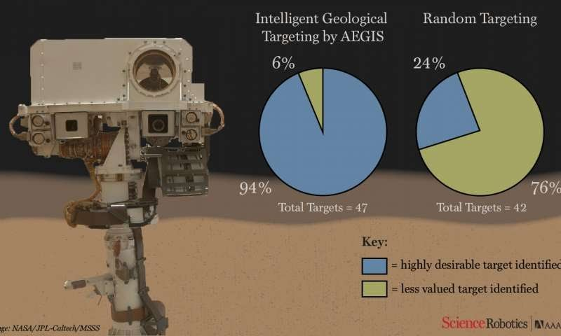

**Fig 3:** Software on Mars rover allows it to pick research targets autonomously. (courtesy Google images)

**SOFTWARE ISSUES IN SPACE EXPLORATION:**

There may be some issues in software while developing and sustaining the space craft. These shows the difficulties encountered in this domain and also illustrate the software engineering solutions used for them.

Software systems must be designed to accommodate it especially on long lived spacecraft travelling to distant planets. Space craft software can be and is updated during the flight and operations. Bugs are fixed in such a way that the object get adapted to the change in context as per enhancing the software of that spacecraft. On reaching the destination it is certain that the development of the softwares are developed according to the lateral surfaces of that planet. It allows the software to be updated consecutively and tailored to the next phase of the mission.

For example, consider two voyager spacecraft, launched in 1977 are the farthest human made objects from Earth. To get that far, Voyager 2 ground and flight software had to be updated during the flight. A new algorithm was designed and implemented so that prior to sending any software commands to the space craft.

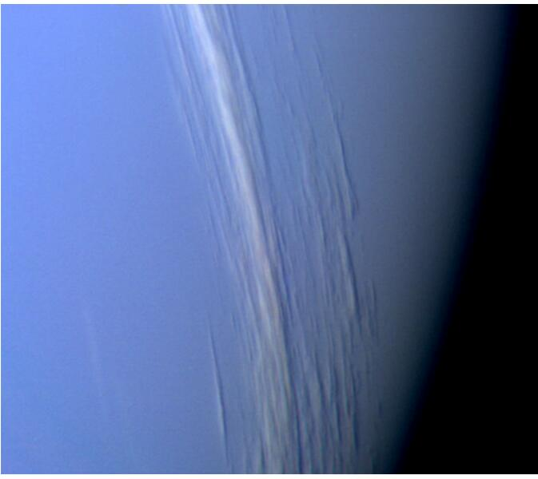

**Fig 4:** Neptune Clouds, taken by Voyager 2 before its closest approach. (courtesy NASA/JPL-Caltech)

**GROWTH OF SOFTWARE IN SPACE INDUSTRY:**

A simple software for a system is not only easier to understand but also easier to build precisely. As in the present-day world evolution of software is much more faster, so it is a challenging for the software engineers working for space industries to create an easier but also a smarter in terms of working and detecting the obstacles, objects for research etc of the spacecraft. The report of the recent analysis states that the space robotics market or its development is based on solution for the problems that occurred, application, end user and region. Based on these space robotics market has been divided into deep space segments. But when it comes to isolate the spacecraft and to recover the faults and also to make the system to take the decision itself while on its onboard without depending upon the human operations pushes it towards a bigger, challenging and more complicated software.

The growth of the software depends mainly on its size and its complexity. Specially for the space craft where it is once launched there is no way to pull the craft back to the earth and then repairing it and again sending it to space. Hence it requires more smarter and better fragile software to make the mission with this craft a successful one. 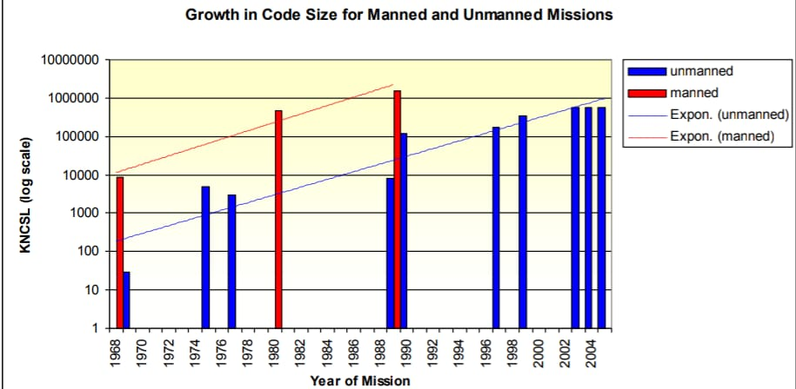

**Fig 5:** Software growth in from 90’s to 20’s. (courtesy Google images)

**CONCLUSION:**

As more digital technologies like mobile technology, broadcasting technology etc depends indirectly on the Space technology due to its fastness in transferring the information from one place to another, not only the fastness but also the quality of the information and much more, there is non stop research going on in this world to explore more things based on this technology. But this technology keenly depends on the software-based technologies like Artificial intelligence, digital twin technology etc plays a important role specially in this space explorations. Therefore, these technologies continue to rule and to grow in this competitive digital world.

**References:**

1. [www.google.com](http://www.google.com)
2. <https://www.isro.gov>
3. <https://www.nasa.gov>
4. Robyn Lutz. “Software engineering for Space Exploration”, Computer, 2011.