**INDEX**

* + - 1. Basic intro
      2. Creating Directory and Files
      3. Linux Components
      4. What is Script and Shell Scripting
      5. Command Execution flow in Linux
      6. Types of Users
      7. Basic Linux Commands
      8. Types of Files in Linux
      9. File System Navigation Commands
      10. Linux File System Hierarchy

**UNIX/LINUX**

**OS:** Operating System. By using OS user will communicate with HARDWARE.

**UNIX:** unix is the base version.

**LINUX:** linux is the updated version. It is multi user operating system.

**Flavour’s:** Ubuntu, RedHat Linux, CentOS, Fedora, etc…

**Creating Directory and Files:**

Command for to create Directory is “mkdir” => mkdir dir{1..50}

Command for to create File is “touch” => touch dir{1..50}/file{1..50} ===> each directory we are creating 50 files.

**Components in Linux:**

2 Components are used in Linux : a) shell b) kernel

Hardware

Shell Kernel

**Unix/Linux OS**

**Shell:** Shell acts as interface between User and Kernel.

**Function of shell:**

1. Checks the command is Valid or Not and gives error message when it is not found.
2. Checks the command is properly used or Not.
3. If everything is proper, then shell interprets/converts that command into Kernel understandable form and handover that to kernel.

**Kernel:** kernel acts as interface between Shell and Hardware Components.

**Function of Kernel:**

1. It is core Component in Unix OS.
2. Kernel execute our commands by using Hardware components.
3. Memory and Processor allocation will take care by kernel.

**Script:** Script is nothing but “we can write multiple commands in a file” and execute them by using function is called scripting.

**Shell Scripting:** it is nothing butgroup of commands.

**Command Execution Flow:**

End user types command

Again $ prompt will be displayed to the terminal, which indicates ready for the next command

Kernel execute that command and perform required action

If it is proper, shell interprets that command into kernel understandable form and handover to the kernel

If it is not proper display error message to the terminal

Shell checks whether this command is valid or not and whether it is properly used or not

Command will be submitted to the shell

**Types of Users:**

1. Normal User ===> $
2. Super User/root User ===> #

**Note:** for **every User** separate folder created in **Home** Directory. It is called as USER HOME Directory.

Ex: /home/pavan

**/ -> root directory**

**Website:** [**http://www.masswerk.at/jsuix**](http://www.masswerk.at/jsuix) **===> Online editor**

**Example Commands:**

Pwd -> print working directory

Whoami

Which <command>

sudo -i ===> To switch to super user

ls -> list of all files and directories

ls -a ===> a is all

ls -la

cal

date

mkdir

touch -> create an empty file

rmdir

rm

rm -r <directory-name>

clear

echo

hello -> brief system information

help

exit

file <file-name> ===> this tell the which type of file it is.

mv <source file> <destination file>

tty ===> this will display Terminal file

**Types of Files in Linux:**

**Note:**

* In Linux everything treated as a file.
* Based on the data in the file Linux will identify the file type.

There are 3 types of files in Linux. They are:

1. Normal/ordinary files
2. Directory files
3. Device files
4. **Normal/ordinary files(-rwxr-xr--):**

These files contain data. It can be normal text file or binary files (images, video files, audio files etc)

* abc.txt
* test.sh
* test.py
* test.java
* image.jpg
* video.mp4

1. **Directory files(drwxr-xr-x):**

* Those are similar like folders in Windows in Linux we have Directories.
* Inside the directories can have SUB DIRECTORIES and FILES.

1. **Device files:**

* In Linux every device is represented as a file.
* By using this file, we can communicate with that device.
* Inside **/dev** directory all device related files will be there.

**Note:**

The first letter represents the file type:

* ===> ordinary file

**d**  ===> directory file

**l** ===> link file

**c** ===> character special file

**b** ===> block special file

**s** ===> socket file

**File System Navigation Commands:**

* In every directory we have 2 hide directories. They are

**. ===>** present directory

**.. ===>** Parent directory

* **cd** ===> change directory to USER HOME directory
* **cd .** ===> change directory to present directory
* **cd ..** ===> change directory to parent directory
* **cd ~ or cd** ===> change directory to USER HOME directory
* **cd ../../..**
* **cd - ===>** change directory to Previous working directory.

**Linux File System Hierarchy:**

Linux file system has TREE like structure.

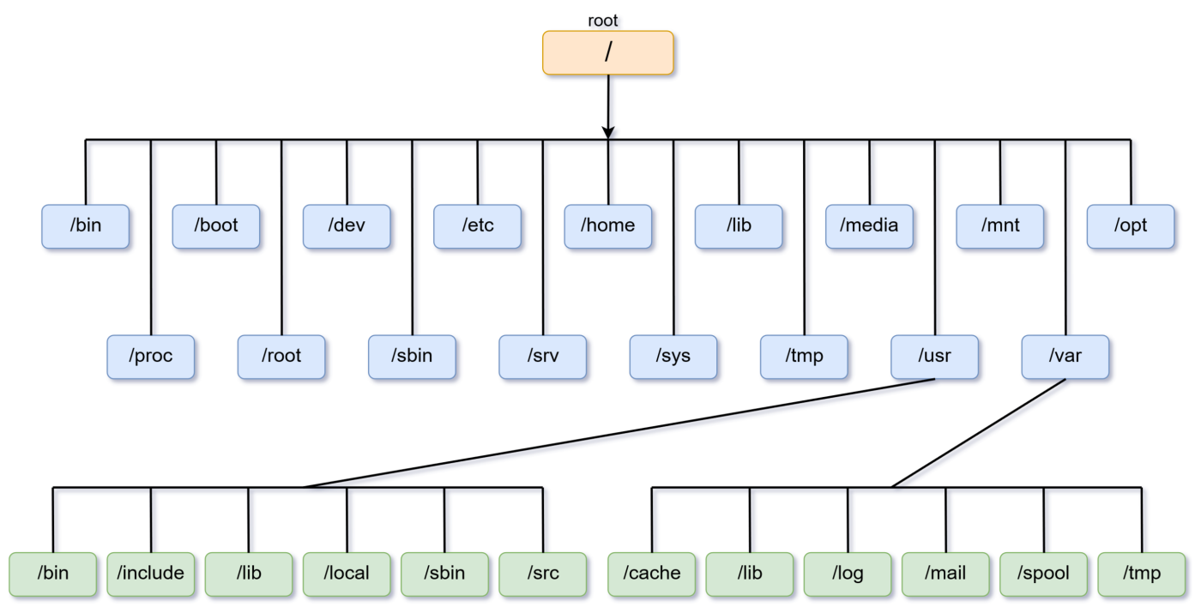

1. **bin directory ( cd /bin):** bin means binary.

To execute our command in Linux we need **Executable files**. Those files are available in this directory.

Simply It contains all binary executables related to our Linux commands.

1. **sbin directory (cd /sbin):** sbin means system bin/secondary bin.

* normal user used commands related binary executable files available in bin directory.
* Super user used commands related binary executable files available in sbin directory.

1. **etc directory (cd /etc):** etc directory contains all system configuration files. These configuration files can be used by operating system itself.

* **All user information ===>** cat /etc/passwd
* **All group information ===>** cat /etc/group
* **IP and DNS information ===>** cat /etc/hosts

1. **boot (cd /boot):** It contains boot loader files.
2. **dev (cd /dev):** it contains device files. Like terminal, monitor etc…
3. **home (cd /home):** it contains folders for every user.
4. **usr (cd /usr):** It contains binary executable files.
5. **tmp (cd /tmp):** It contains temporary files. If you restart the system those files will flush.
6. **var (cd /var):** it contains variable data files.
7. **opt (cd /opt):** optional add-on applications
8. **proc (cd /proc):** it contains process information. Like memory, CPU etc…
9. **lib (cd /lib):** system libraries.
10. **media (cd /media):** mount point for removable media.
11. **mnt (cd /mnt):** mount point for temporary file systems
12. **srv (cd /srv):** service data.
13. **lost+found (cd /lost+found):** misplaced data.

**Linux Installation:**

Step 1: Oracle virtual box installation (it is free, license not expired) (or) VMware (it is free for 1 month)

Step 2: Ubuntu installation

**Note:**

1. The need of Virtual Box?

**Ans:** To run virtual computers in our system without effecting original computer. That means it providing environment to run virtual computers.

V.M

OS Linux

V.M

OS Mac

Virtual Box

My Computer

Note: V.M = Virtual Machine

**Step 1:** Oracle virtual box installation

* Go to “virtualbox.org” -> click on “downloads” -> click on “Windows hosts”
* Go to downloads -> click on download file -> click on “next” to install

**Step 2:** Ubuntu installation

* Go to “ubuntu.com” -> click on “downloads” -> select “ubuntu desktop” (LTS Version) -> click on “download”

**Step 3:** Create Virtual Computer/Machine:

* Go to Virtual Box -> click on “new” ->type “name” , select “type”, “version”
* Select Memory Size
* Create hard disk -> select “dynamically allocate”

**Step 4:** Perform settings to that virtual machine:

* select virtual machine ->click on “settings” -> click on “system” -> click on “processor”-> modify value of processors =2
* click on “storage” -> click on “controller” and click on “empty” -> chose a disk file “you downloaded ubuntu file” (iso file)

**Step 5:**  Install Ubuntu Iso file:

* select “VM/VC” -> click on “start” -> select “Iso file” -> click on “install Ubuntu” ->select “minimal installation”
* Provide “Who are You?” details.
* rw-r--r-- 1 root root 20343 Jun 16 05:06 ansible.cfg

No.of link files

permissions

Type of file

User/owner name

group

Size of file

Created and modified time

Name of file