Debater Test 1
Conversation Record for a Security Deposit Dispute

Review Note
This record reproduces the supplied debate-practice exchange. Its legal statements have not been verified for the tenant’s jurisdiction. In the official Model Tenancy Act, section 11(2) provides for refund of a security deposit after due deductions for tenant liability. Section 15(3) addresses repair deductions and notice but does not expressly require itemised receipts. Section 24(2) concerns interest on certain unrefunded advance payments under section 24(1), not a general security-deposit interest rule. The Model Tenancy Act is a model framework for state and Union Territory adoption, so local law may differ. The transcript’s [S1], [S2], [S3], [S15(3)], [S15(1)], and [S24(2)] labels are retained as supplied; their underlying retrieved excerpts were not included.

Conversation Transcript
Each numbered entry is one speaker turn. Follow-up questions remain part of the debater’s reply.

Turn 01 User
I rented a flat and my landlord kept my security deposit after I moved out. I paid the rent and left the flat in good condition. I want to argue that the deposit should be returned.

Turn 02 Debater
Could you confirm that the dispute is about the return of a security deposit for a residential tenancy in India?

Turn 03 User
yes, that'r right

Opposing View The Deposit Need Not Be Returned in Full

Turn 04 Debater
1. Landlord’s right to deduct for repairs
Section 15 of the Model Tenancy Act expressly allows a landlord to deduct from the security deposit the cost of repairs that the tenant failed or refused to carry out. The deduction is lawful “after making due deduction of any liability of the tenant” [S2]. If the landlord can show that the tenant caused damage or neglected maintenance, the deposit may be reduced accordingly.
2. Refund only after deductions
Section 11(2) states that the security deposit is refunded “after making due deduction of any liability of the tenant” [S1]. Thus, the deposit is not automatically returned in full; it is returned only after lawful deductions have been made.
3. No requirement for full refund
The Act does not mandate a full refund of the deposit. It only requires that the landlord return the deposit “after due deduction” and, if the landlord fails to do so, pay interest on the amount withheld [S3]. Therefore, a partial refund is permissible if the landlord has a valid deduction.

Conclusion
Under the Model Tenancy Act, the landlord may retain part of the security deposit if the tenant has caused damage or failed to maintain the premises. The deposit is only fully refundable once all lawful deductions have been made.
Do you agree with this interpretation, or would you like to present additional facts that might affect the deduction?

Turn 05 User
The landlord says there were repair costs, but gave me no itemized list or receipts. Why should the deposit still be withheld?

Turn 06 Debater
Could you confirm whether the landlord has provided any evidence of the alleged repair costs?

Turn 07 User
yes, he didn't give any list or evidence

Opposing View The Landlord May Retain Part of the Deposit

Turn 08 Debater
1. Law allows deduction for repairs
Section 15 permits the landlord to deduct the cost of repairs that the tenant failed or refused to carry out, and to recover that amount from the security deposit [S2]. The Act does not require the landlord to provide an itemised list or receipts before making the deduction; it only requires that the deduction be “due” and that the tenant be notified [S2].
2. Deposit is refunded only after lawful deductions
Section 11(2) states that the security deposit is refunded “after making due deduction of any liability of the tenant” [S1]. Thus, the deposit is not automatically returned in full; it is returned only after any lawful deductions have been made.
3. No obligation to refund the entire amount
The Act does not mandate a full refund. If the landlord fails to refund the remaining balance, he must pay simple interest on the amount withheld, but the landlord is not required to return the full deposit if a lawful deduction has been made [S3].

Conclusion
Under the Model Tenancy Act, the landlord may retain part of the security deposit if the tenant has a liability for repairs, even without an itemised list or receipts. The deposit is only fully refundable once all lawful deductions have been satisfied.
Would you like to discuss how to challenge the landlord’s deduction or explore other remedies?

Turn 09 User
Coach me on my argument

Debate Coach Response

Turn 10 Coach

1. What’s Already Persuasive in Your Case
You paid rent in full and left the flat in good condition
The Act requires the landlord to refund the deposit after making due deduction of any liability of the tenant (S1). If there is no evidence that you caused damage, the “liability” clause is not triggered. Legal backing: S1.
Landlord gave no itemised list or receipts
Section 15(3) allows the landlord to deduct repair costs only after giving the tenant a notice and an itemised statement (the Act implies that the landlord must prove the cost). Without such proof, the deduction is unlawful. Legal backing: S15(3).
No written agreement to the contrary
Section 15(1) says that notwithstanding any agreement in writing to the contrary, the statutory rules apply. If your tenancy agreement does not expressly waive the statutory refund rule, the Act overrides it. Legal backing: S15(1).
You are entitled to interest if the landlord fails to refund
Section 24(2) obliges the landlord to pay simple interest on any amount withheld. Legal backing: S24(2).
These points already give you a solid legal footing: the landlord has no statutory basis to keep the deposit unless you can prove that you caused damage and that the landlord can substantiate the cost.

2. What Needs More Support
Proof that the flat was “in good condition”
The landlord could argue that “good condition” is subjective. How to strengthen it: gather evidence such as photos taken before you moved in, a written statement from a neighbour or a professional inspector, or a copy of the move-in inspection report (if any).
Absence of a written repair notice
The landlord might claim they sent a notice but you didn’t receive it. How to strengthen it: ask for a copy of the notice or the landlord’s proof of delivery. If you can show you never received it, the deduction is invalid.
Exact amount the landlord claims you owe
Even if the landlord had a legitimate claim, the amount must be reasonable and itemised. How to strengthen it: request a detailed invoice or receipts. If they refuse, point out that the Act requires the landlord to provide evidence before deducting.

3. Concrete Improvement and Rebuttal Strategy

Draft a Formal Letter to the Landlord
- State the facts – rent paid, move-out date, condition of the flat (attach photos).
- Cite the Act – “Under Section 11(2) of the Model Tenancy Act, the security deposit must be refunded after deducting any legitimate liability. Section 15(3) requires the landlord to provide an itemised statement of repair costs and receipts.”
- Demand the refund – “I request the full refund of my security deposit within 15 days, as prescribed by the Act. If you believe there are legitimate deductions, please provide the itemised list and receipts within 7 days.”
- Mention interest – “If the deposit is not refunded, I will seek the simple interest payable under Section 24(2).”
- State your next step – “If the matter is not resolved, I will file a claim with the Rent Tribunal under Section 21 of the Act.”

Why This Works
- Legal authority: You’re directly invoking the statutory provisions that protect you.
- Clear deadline: Gives the landlord a concrete timeframe, making it harder to delay.
- Interest threat: Adds a financial incentive for the landlord to comply.

4. Quick Rebuttal
Landlord’s claim
“I had to repair the kitchen sink; it was broken when I let you in.”
Your rebuttal
“Under Section 15(3), you must provide an itemised statement and receipts for any repair costs you wish to deduct. You have not supplied such evidence. Therefore, the deduction is unlawful, and I am entitled to a full refund of my security deposit.”

Bottom Line
You have a statutory right to a full refund because you paid rent, left the flat in good condition, and the landlord failed to provide proof of any legitimate deduction.
Use the Act’s language in your communication to make the landlord’s position legally untenable.
Document everything – photos, correspondence, and any third-party statements will strengthen your case if you need to go to the Rent Tribunal.
Good luck, and remember: the law is on your side as long as you can show that the landlord didn’t meet the statutory burden of proof for any deduction.

Sources for the Review Note
Ministry of Housing and Urban Affairs, Government of India. Model Tenancy Act, 2021, sections 11(2), 15(1)–(3), and 24(1)–(2).
https://www.mohua.gov.in/upload/whatsnew/60b7acb90a086Model-Tenancy-Act-English-02.06.2021.pdf
PRS Legislative Research. The Model Tenancy Act, 2021: summary of the model framework and state and Union Territory adoption.
https://prsindia.org/billtrack/the-model-tenancy-act-2021
The record preserves the AI response as supplied, including its assertions and citation labels. Check the applicable local law, tenancy agreement, and underlying source excerpts before relying on or filing any legal argument.

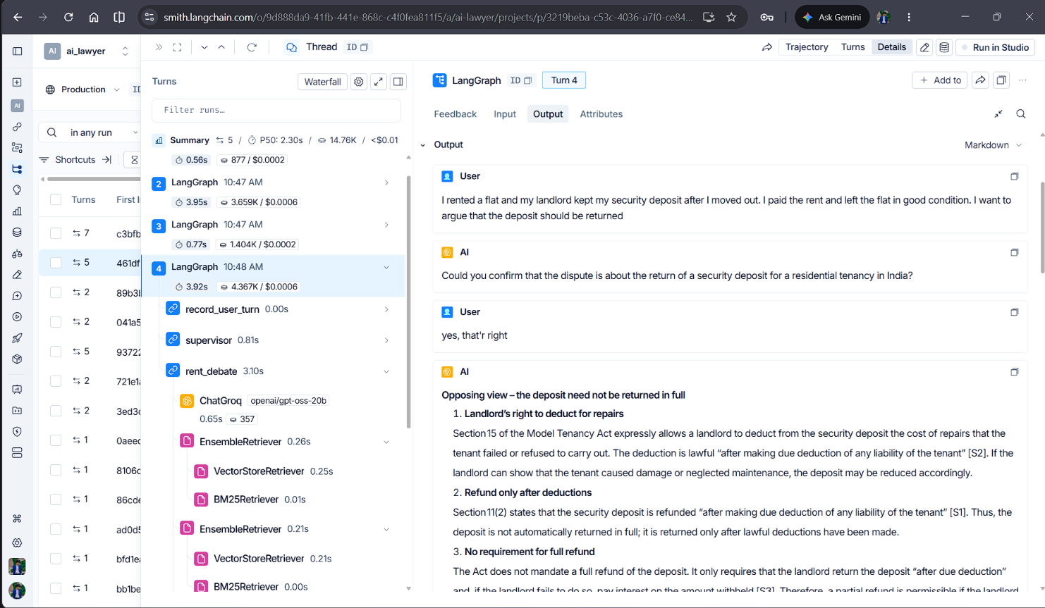
Langsmith Tracing

