*Hazardous Area Monitoring System For Industrial Plants*

Introduction :

*Safety and health management is one of the vital constituents of industrial activities because most of the operational conditions, chemicals and end products associated with industrial production are well-known to pose serious safety and health threats to the workers and environment. The problems related to air quality monitoring are important issues of the current research activity. In fact, a key component in many process controls, product development, environmental monitoring etc. is the measurement of concentration of one or the other gaseous components. The most polluting industries in the world are pesticides pollution from agriculture and storage, waste water treatment in industries, tanning industries, and coal mining. Industrial plants, such as chemical works and metal-smelting plants, release SO2, H2S, NO2, and CO into the atmosphere. Tall chimney stacks may be used to carry gases and particles to a high altitude and thus avoid local pollution, but the pollutants return to Earth, sometimes hundreds of kilometer from the original source. The identified hazardous gases are Hydrogen Sulfide (H2S), Carbon Monoxide (CO), Ammonia (NH3), and Methane (CH4) gas. The exposure to these gases gives a severe health hazards to the humans. Inorder to avoid high exposure a monitoring system should be developed.*

***Literature review :***

*Every day synthetic, toxic chemicals are released into the environment. It affects our water, land and air. These pollutants may cause serious health effects such as birth defects, development disorders, respiratory problems, cancer and in some cases can lead to death. Apart from this, it can also have adverse effect on wildlife and environment. The main polluting industries in India where hazardous gases evolve are waste water treatment plant, tanneries, coal mining industries, textile dye processing, and pesticide pollution. Consider few industries and their problem.*

***Existing Problem :***

*The existing methods uses various technology for identifying the hazardous gases and regular monitoring in an industry or for environment takes technologies such as GSM, ZigBee, WSN. Let us consider the different existing systems as follows.*

***Proposed Solution :***

*The proposed system is placed in an industry where the hazardous gases have to be monitored. The individual sensors are placed to read the range of gaseous concentration in ppm. Each sensor is sensitive to its own specific gas. These sensor values are read by the microcontroller, and then it is programmed to monitor the range of all gases. When the concentration of any gas exceeds its limit then the alarm is put on, simultaneously the concentration of all gases are displayed in the LCD display. This display gives a notification to workers working in the plant premises. A Local Area Network (LAN) port is also available in the Ethernet module which is connected to the controller so that the concentration of all gases are uploaded to a website constantly.*

***Theoritical Analysis :***

***Block Diagram :***

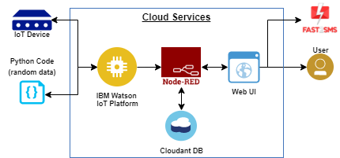

*Then create the Node red that is creating the App URL to connecting the flow chart in Node Red Flow,firstly downl;oad the IBM IOT NODE RED in the palate right side to the flow,after that connect the IBM IOT to the sensor from the flow. Then we should give the Temperature and humidity to the IBM IOT flow,connect the msg payload to the IBM IOT flow then Deploy by that we can know that IBM IOT is connected to the sensor.Now create the HTTPS so that we can give the data through the flow to the sensor by that URL web we can see the temperature and humidity by that UI is created.About block diagram, As we know that the message will recive to the mobile by Fast2sms web by using the web UI that I have given tpo the NOde Red flow chart by indicating the Temperature and Humidity and about clekage of gas.*

***Software Designing:***

***Create the IBM IOT Account to negotiate with the App,then create the IBM watson platform to know the temperature and humidity.Now to know the temperature and humidity open the watson sensor simulator and after creating the divice in the IOT platform service credentials will bbe given copy that credentials in the notepad, then copy your credentials in the Watson sensor simulator to connect the IOT platform to the sensor.***

***Then create the Node red that is creating the App URL to connecting the flow chart in Node Red Flow,firstly downl;oad the IBM IOT NODE RED in the palate right side to the flow,after that connect the IBM IOT to the sensor from the flow. Then we should give the Temperature and humidity to the IBM IOT flow,connect the msg payload to the IBM IOT flow then Deploy by that we can know that IBM IOT is connected to the sensor.Now create the HTTPS so that we can give the data through the flow to the sensor by that URL web we can see the temperature and humidity by that UI is created****.*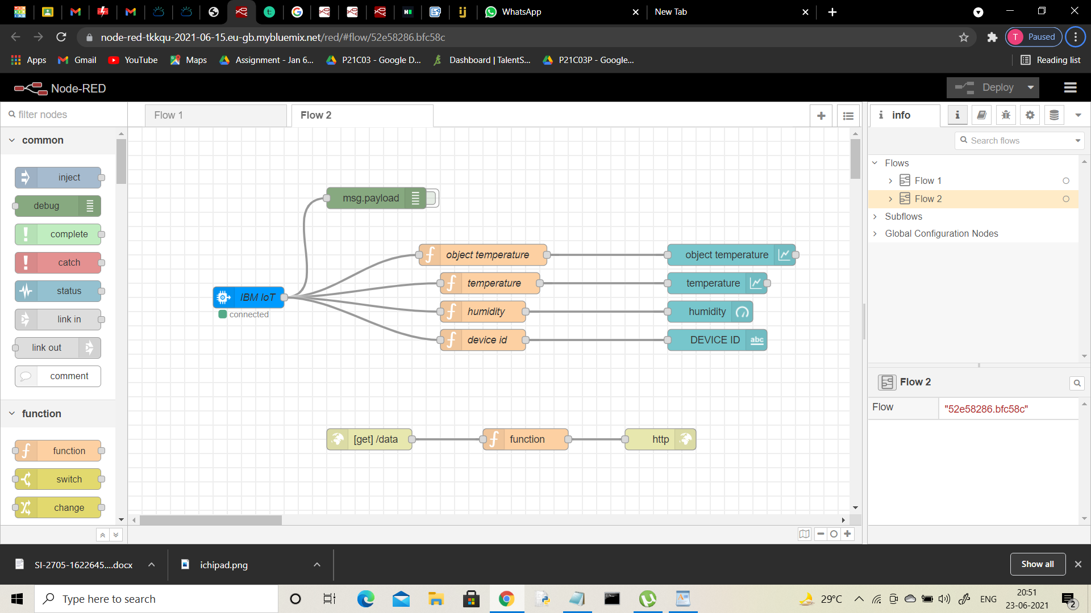

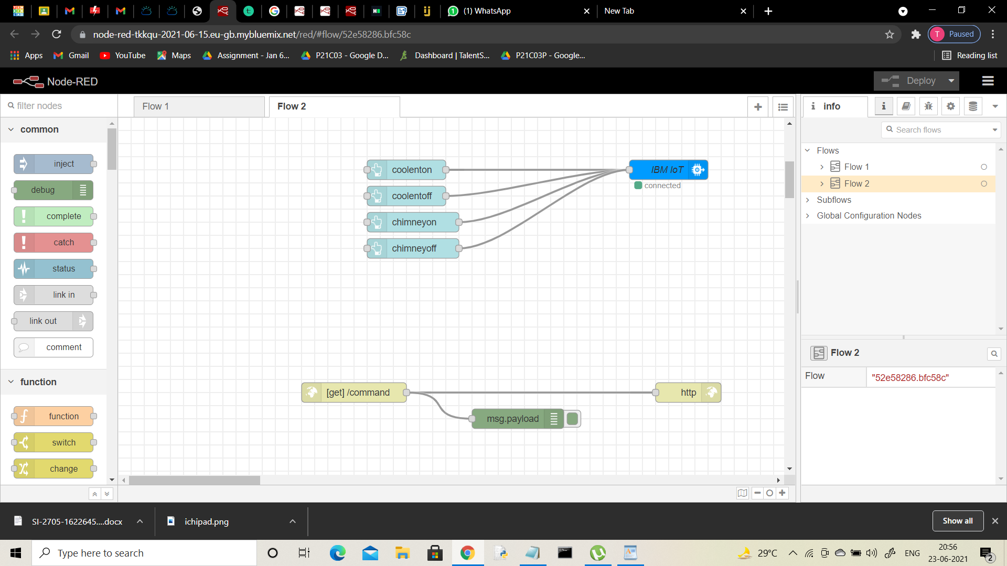

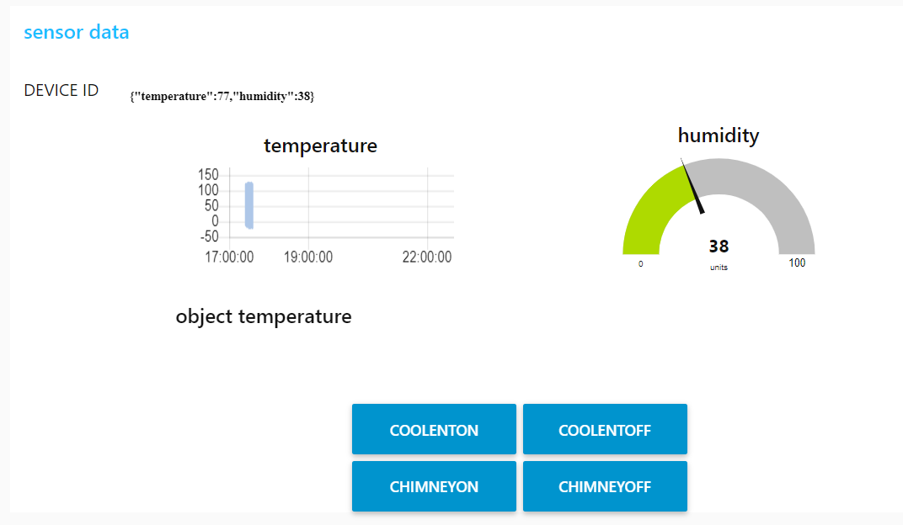

*By the creating of UI after that we should Run the code of temperature and humidity and regarding coolant is supplied and chimney ON and OFF****.***

*After that in the MIT App inventor we can create the buttons and by the web URL we can create the home automation things which will use for the industries to negotiate the coolent supply.*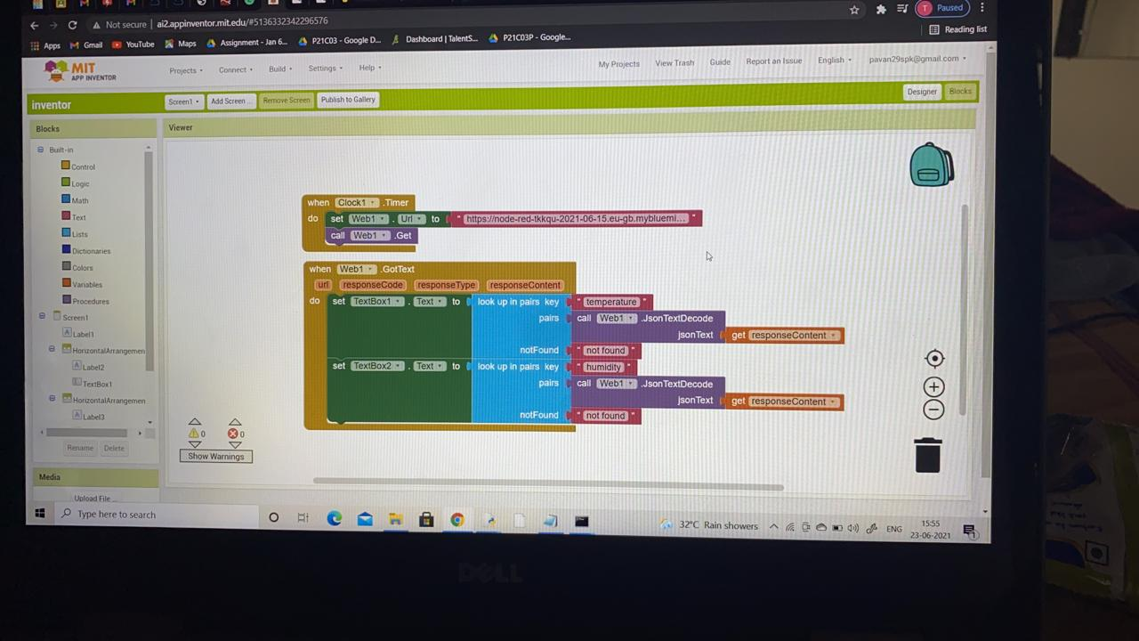

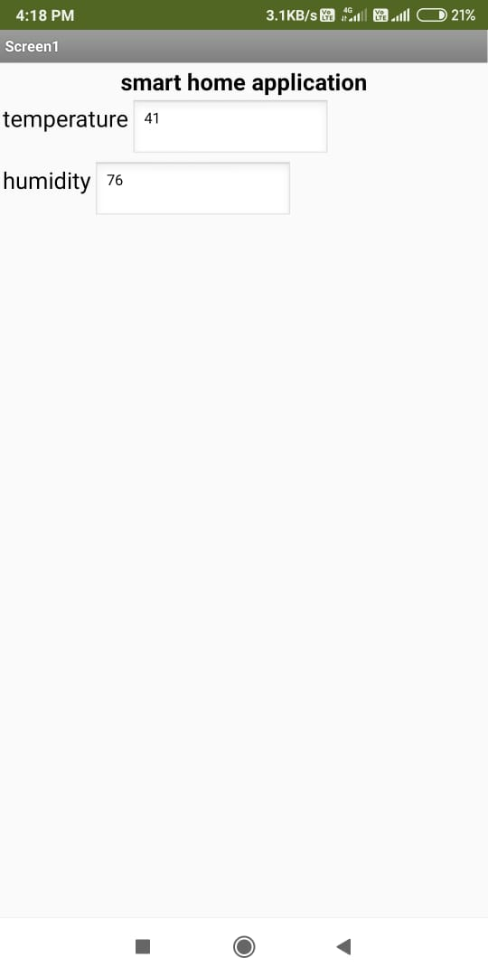

***Solution :***

*This the MIT app inventor which we can use in our mobile by installing the app in play store or google store. After installing the app in mobile scan the QR code or type the given given code in the place were they give. By that our created app will visiable in the mobile and can oparate from the mobile by that out put will show in the proggram that we will Run.*

***The code is given below :***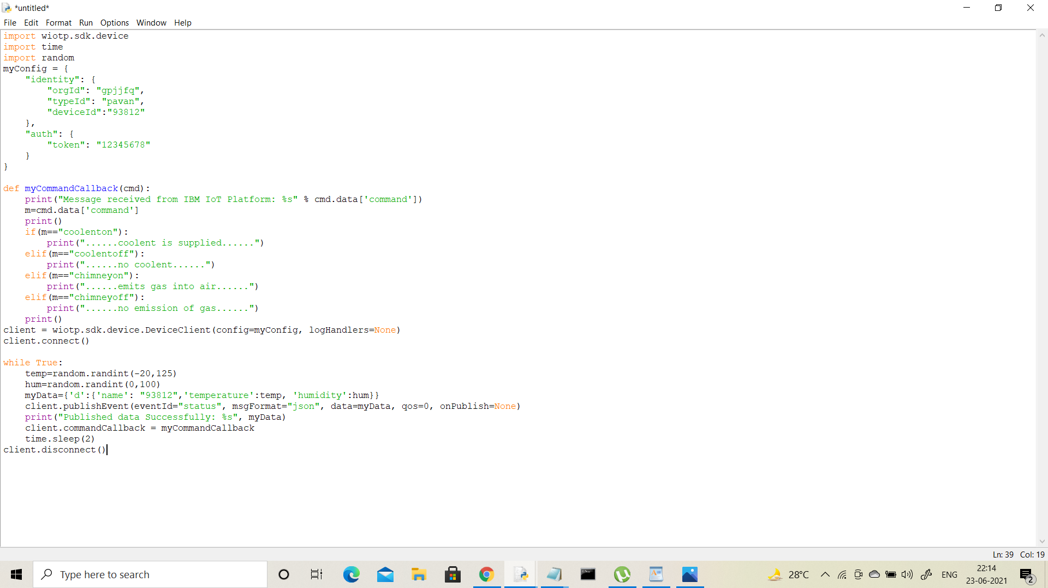 *:*

*By replacing the credentials with the device credentials & running the code by modifing specific data according to our sensors the condition statements will be displayed in the output with the data of the respestive appliances.*

*variables and notations and numericals has to be given carefully.*

*by making some process before the exegution in command prompt that is... install specific packages like wiotp-sdk.*

*after evrything is done the output will be as In the following manner:*

***Output of the above program :***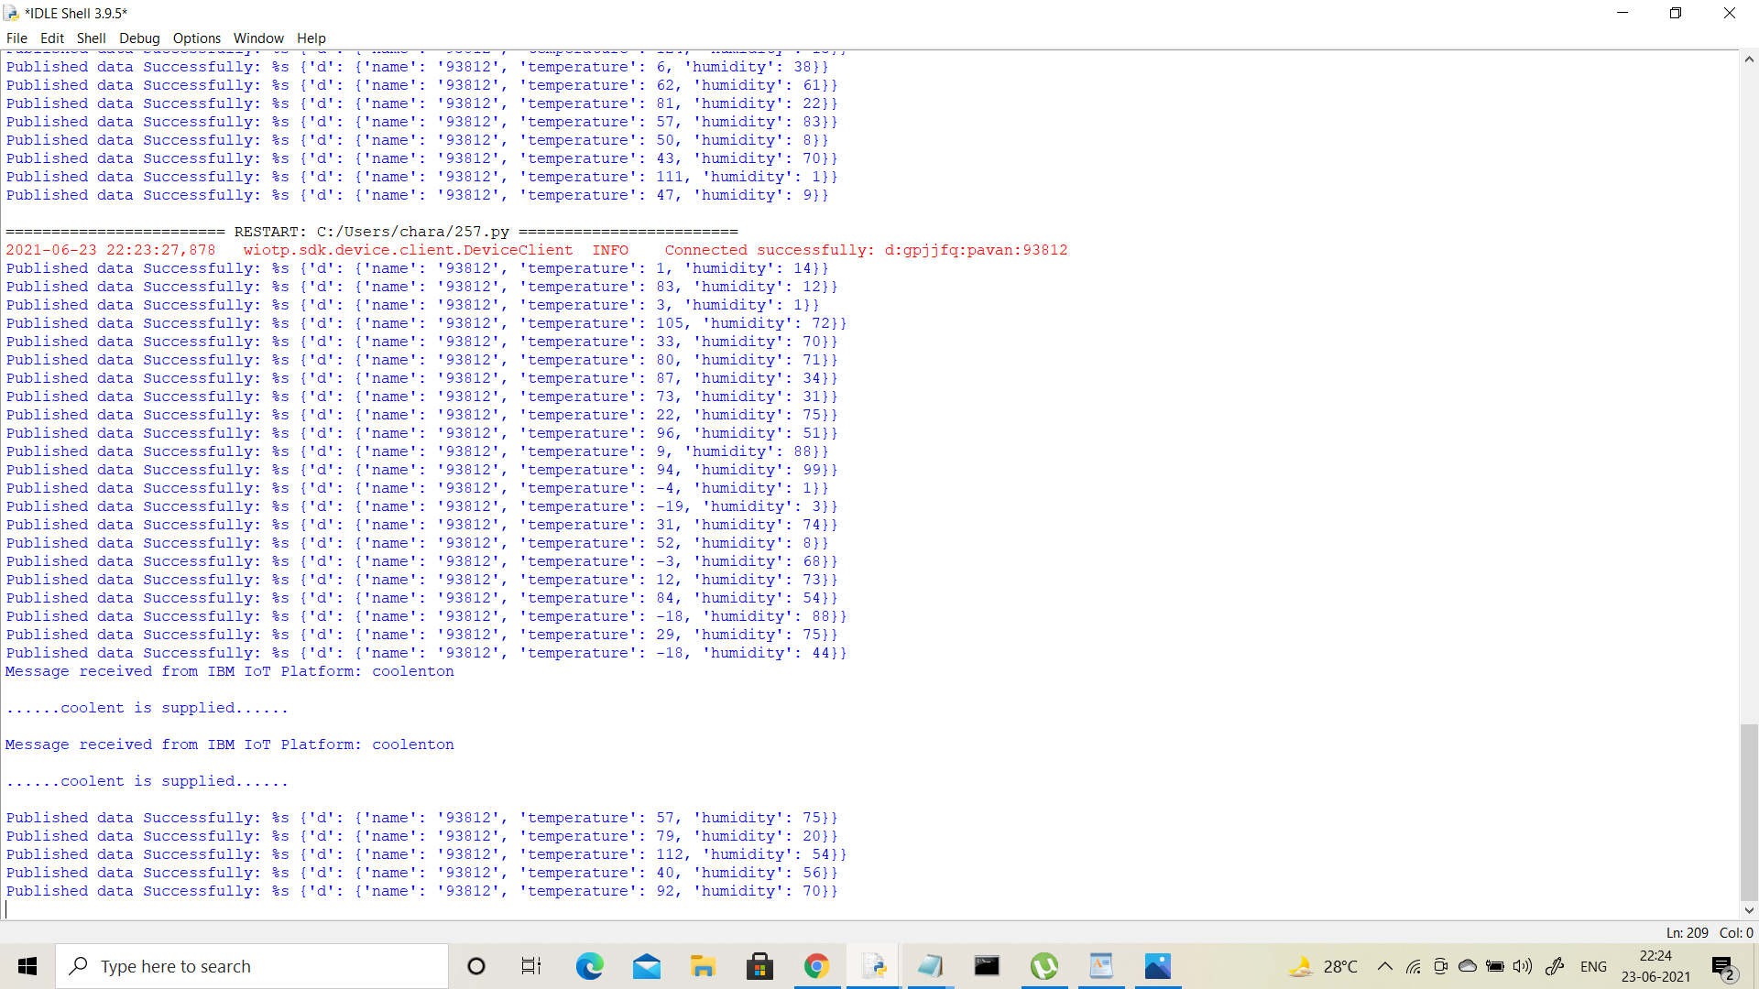

*By this we can know the out of the code*

Below the out put of the MIT app in the mobile has given, this is the process of the Hazardous Area Monitoring System For Industrial Plants by software using .

***Python,IBM Cloud,Node- RED,IBM IoT Platform,MIT App Inventor,IBM Cloudant DB.***

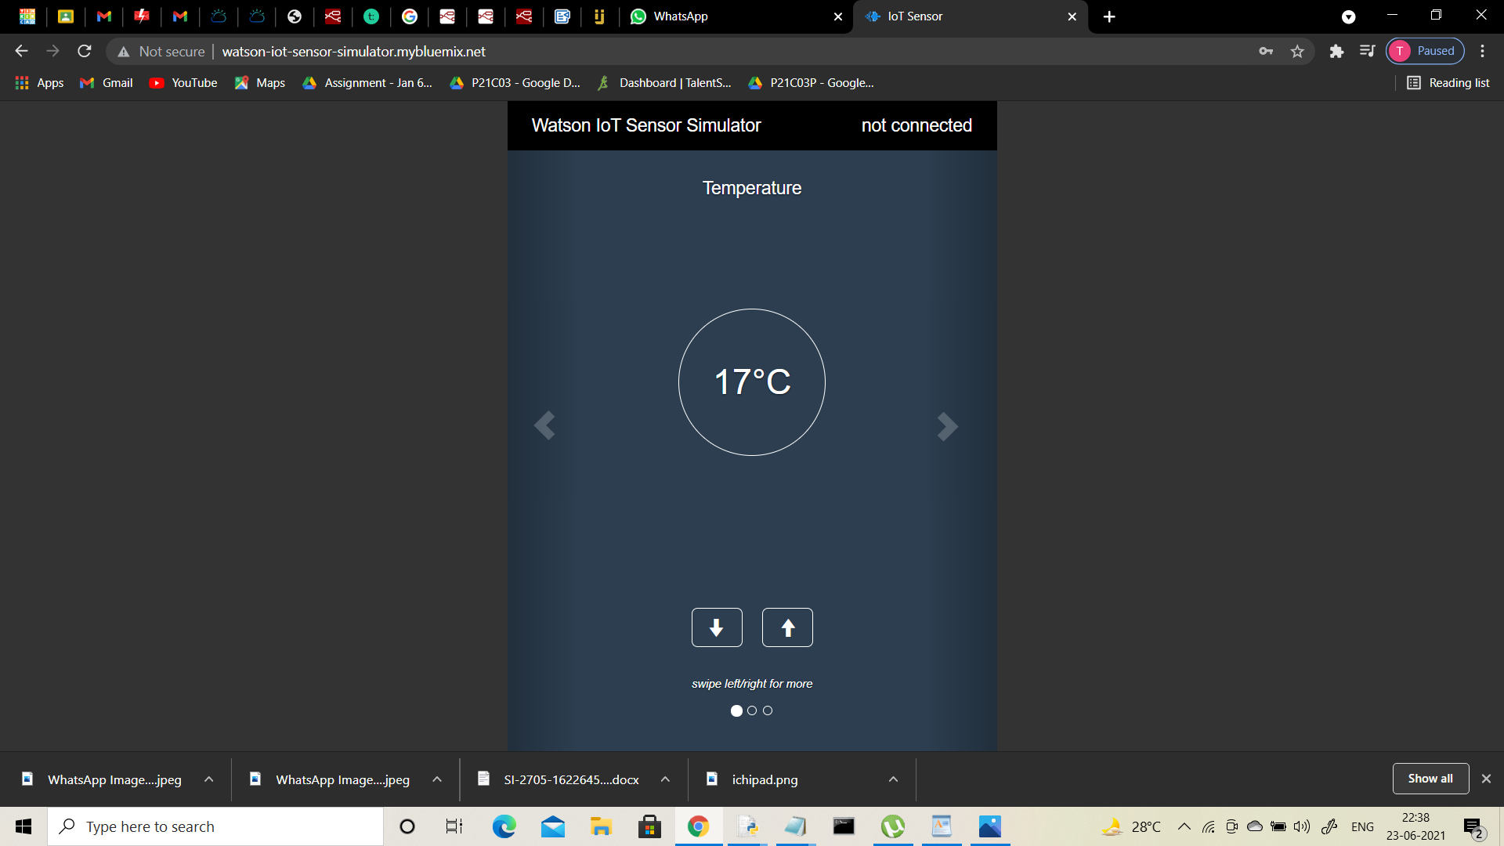

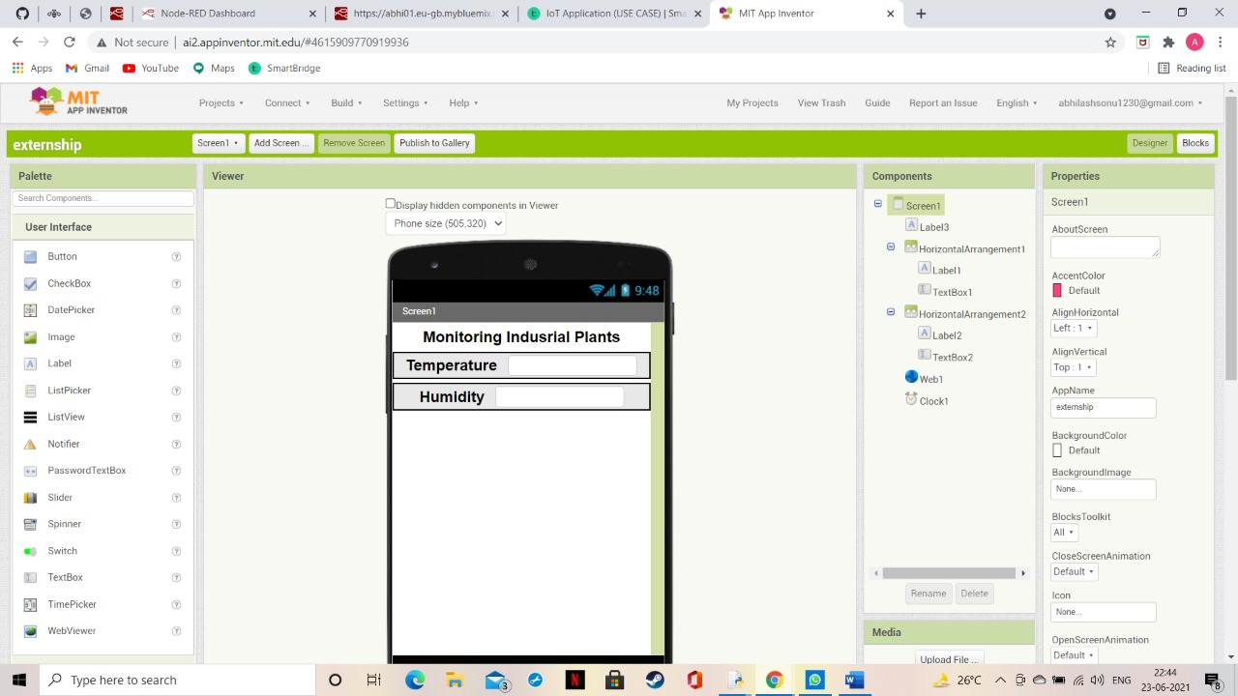

*The above is the designer pattern of the app.*

*It is built using the labels, text boxes, allighnments.*

*then the blocks has to be generated where we paste the url of node red's data.*

*these parameters - temperature,humidity are tracked by the iot sensors that is data & send it to the MIT app inventer*

*By using the AI Companion we can scan it's own Qr code or enter it's own unique code to get the data in our mobile.*

*In order to do that I have downloaded the MIT A12 Companion app in my android. By scanning the QR code of the AI companion values of the parameters are reviewed.*

***Abstract :***

*Monitoring is the first step for safety. In our dayto-day life there are many industries working with various hazardous chemical gases and the workers are often exposed to these gases. The unexpected accident cause a great impact to human lives and properties. To avoid these situations we need to develop an Automatic Toxic Gases Detection and Alerting System. The existing detection systems are available to sense only a particular gas and they use GSM technology to indicate the critical situations. The drawback is that the detection system can send a message to only one person. The proposed system is made up of monitoring and alerting system through Internet of Things (IoTs). In this the dangerous, toxic and flammable gases such as Hydrogen Sulfide gas, Carbon Monoxide gas, Ammonia gas, and Methane gas are sensed using individual gas sensors and an Arduino UNO controller. The concentration of all gases values are displayed in ppm using a Liquid Crystal display in the plant premises; when the value exceeds the limited range then an alarm is put on. The advancement in this project is the values are constantly uploaded to the internet by using Ethernet module with an Arduino controller. The Internet of Things (IoTs) provides a proper access to values by an authorized persons and governmental organization. A database is also maintained, this helps to know the status of an industry. The timely sensing of chemical toxic gases offers a quick response on an emergency situation and therefore leading faster diffusion of the critical situation*

***Keywords :***

*Hazardous gases, monitoring, IoTs, Arduino UNO, Ethernet module.*

***Conclusion :***

*In this proposed paper a hazardous gas monitoring embedded system designed using Internet of Things to detect toxic and flammable gases from industrial environment. The individual gas has its own range of risk, they are identified using advanced sensors. This system gives an instantaneous alarm during the excessive emission of hazardous gases. The current value of all gases in their concentration are display in an LCD display and in internet webpage. Hence the status of the process industries can be monitored and leads to the effective management of adverse condition. The system is more flexible and low cost so that it can be implemented in any of the process industries.*