For question and answering you need to prepare a context of sentences and whenever you ask any question than model will scan those sentences to answer your question. In below screen showing some context with sentences.
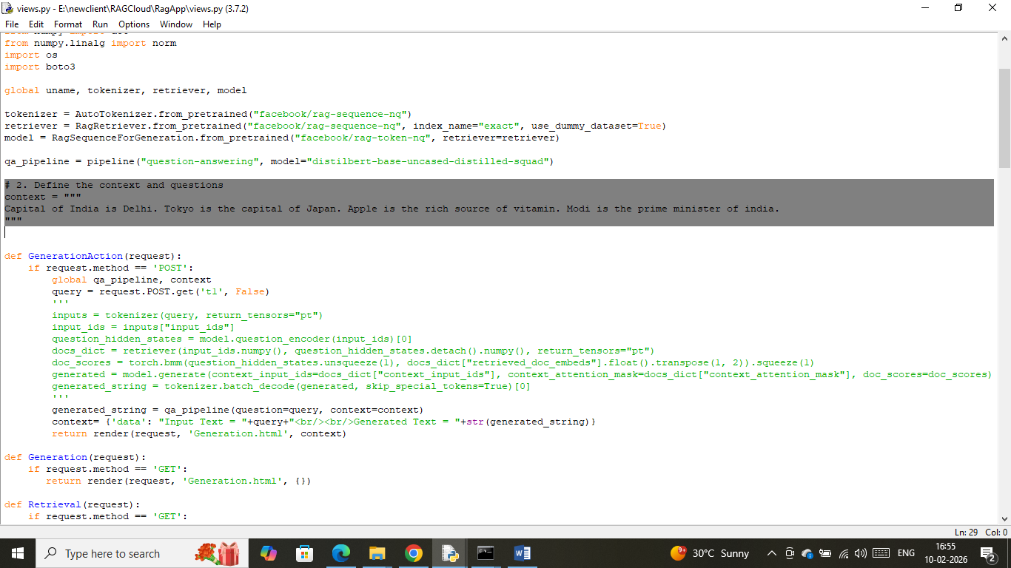
In above screen in gray text I gave some sentences as
Context = “Capital of India is Delhi. Tokyo is the capital of Japan. Apple is the rich source of vitamin. Modi is the prime minister of India.”
In above context each sentence is separated with dot and you can ask below questions
- who is the prime minister of India?
- capital of japan?
- what is the rich source of vitamin
- Capital of India
For above questions model will answer correctly and if you want you can some more sentences to that context

