**Modern Database Mini Project**

**Student Information**

|  |  |
| --- | --- |
| SRN | R21EF242 |
| Name | Pavan B N |
| Branch | CSE ‘E’ |
| Project Name | **Student Information System** |

**Tech Stack**

|  |  |
| --- | --- |
| Frontend | React |
| Backend | NodeJS |
| Database | MongoDB |

**AIM**

* Design a Student Information System Which is responsible for Managing basic details of student including their grades, program and course details
* Design a database to store student information, courses, grades, and attendance records.
* Include features like adding/editing students, enrolling in courses, and generating report cards.

**Database Design**

* Program Name
* Duration
* fee
* Email
* account Type – admin/student
* password

Program Detail Model

User Model

* courseName
* duration
* SRN
* Name
* Email
* Phone
* Address
* Residency status
* programID
* current Semester

Student Info Model

Course Detail Model

* SRN
* Course ID
* Status – active/completed
* CGPA
* SEM
* SRN
* SEM
* Details
* Num of backlogs
* result

Enrolled Course Model

Grade Model

**NodeJS API Endpoints**

app.use(“/auth”, AuthRoute)

app.use(“/program-detail”, ProgramDetailsRoute)

app.use(“/course-detail”, CourseDetailsRoute)

app.use(“/enrolled-courses”, EnrolledCoursesRoute)

app.use(“/grade-detail”, GradeDetailsRoute)

app.use(“/student-detail”, StudentDetailsRoute)

**API Endpoints Tested Using Postman**

**Application Interface Frontend React**

* Admin Dashboard

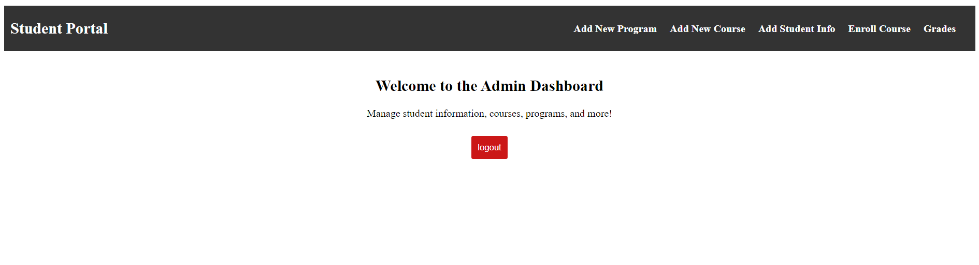

* Admin has access to add new program, courses and enrol new course to a student.

* Admin also have access to add and update basic student information and declare the student academics grades

* Student can access their information by logging in to the portal

