Assumptions

1. As the request is to only validate the columns structure in the file, I have not added validation for the rows. Here are my assumptions.
   1. Column Headers are the 1st row in the file
   2. Any number of rows (if their columns are as per the format) are allowed.
   3. Separator line “--------” can be on any row and would be ignored.
   4. Separator line has only “-“characters(at-least one) in the 1st column.
   5. The file would not have empty rows.
2. I have assumed that the request is to support both file extension types - .dat, .csv and have developed the application to support to both extension types.

Improvements that could have been made

While validating the structure of the file, if the file has more than 1 value that do not adhere to standard format(like string types in a columns expecting integer types), the application gives a feedback for the 1st format mismatch. One thing that could have been improved was to collate all the mismatches and present it on uploading a file with wrong formatting.

NuGet packages installed

1. **Moq** - **V4.8.3** – Installed on FootballExerciseService.Tests project. Attached is the screenshot below

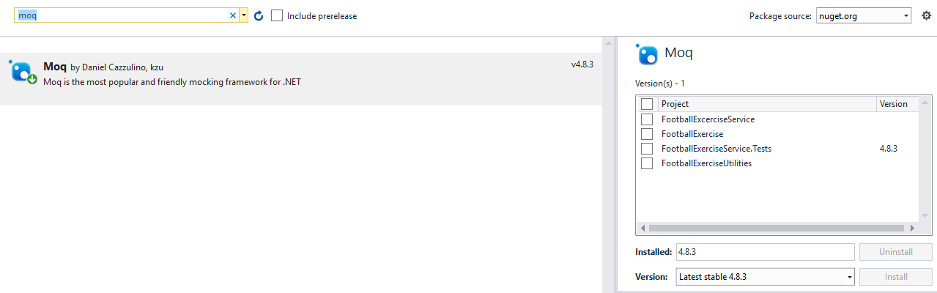

1. **Unity - V5.8.6 –** Installed on Solution. Attached is the screenshot.