Indian Wildlife & Bird Identifier
SMAI Assignment 3 — Project T7.6
Technical Project Report

90 | 5,400 | 96.30% | 6
Animal Classes | Total Images | Best Accuracy | Experiments

Author: Ponnaganti Pavan | GitHub: github.com/Pavan-Ponnaganti/wildlife-classifier

Abstract: This report documents the design, experimentation, and results of an automated wildlife identification system capable of classifying 90 distinct animal and bird species. Starting from a pre-trained EfficientNet-B0 backbone, we conducted a systematic layer-unfreezing ablation study, followed by six hyperparameter experiments, and finally deployed a CLIP-based zero-shot and linear-probe pipeline. The final ensemble of CLIP Linear Probe and EfficientNet achieved 96.30% test accuracy — a 13.56 pp improvement over the classifier-only starting point of 82.74%.

1. What We Set Out to Achieve
Wildlife identification is a critical task in ecological monitoring, biodiversity surveys, and conservation planning. Manual identification by trained biologists is expensive and does not scale to the volume of images from camera traps. Our goals:
- Correctly identify 90 distinct animal and bird species from a single photograph.
- Run on consumer hardware (CPU or entry-level GPU) without specialised equipment.
- Provide ecological context — Wikipedia descriptions and IUCN Red List statuses.
- Deliver results through a browser-based web interface accessible to non-technical users.
- Compare supervised fine-tuning (EfficientNet-B0) against zero-shot / linear-probe (CLIP).
The project is structured as a progressive research exercise: each modelling decision is backed by an experiment, and every experiment's winner is carried forward as the new baseline. This ensures all reported improvements are genuine and additive.

2. Dataset
We use the Kaggle Animal Image Dataset — 90 Different Animals (iamsouravbanerjee/animal-image-dataset-90-different-animals).
Property | Value
Number of classes | 90 distinct animal / bird species
Images per class | 60 (balanced)
Total images | 5,400
Train split | 70% (~3,780 images)
Validation split | 15% (~810 images)
Test split | 15% (~810 images) — strictly held out
Random seed | 42 (fixed for full reproducibility)
Input resolution | 224 x 224 pixels
Normalisation | ImageNet mean [0.485, 0.456, 0.406] / std [0.229, 0.224, 0.225]

With only 60 images per class the dataset is intentionally small — representative of real-world field conditions where labelled data is scarce.

3. Experiment 1 — How Many Layers to Unfreeze?

3.1 Motivation
EfficientNet-B0 has ~5.3 million parameters trained on ImageNet. Retraining all of them on 3,780 wildlife images risks catastrophic forgetting. Freezing every layer makes the model too rigid to learn wildlife-specific patterns.

3.2 Results
Level | Layers Made Trainable | Trainable Params | Test Accuracy
0 | Classifier head only | 0.10 M | 82.74%
1 (chosen) | + conv_head, bn2 | 0.50 M | 86.68%
2 | + Block 6 (last residual block) | 1.20 M | 84.59%
3 - 4 | + Blocks 5 and 4 | 3.30 M | 80.89%

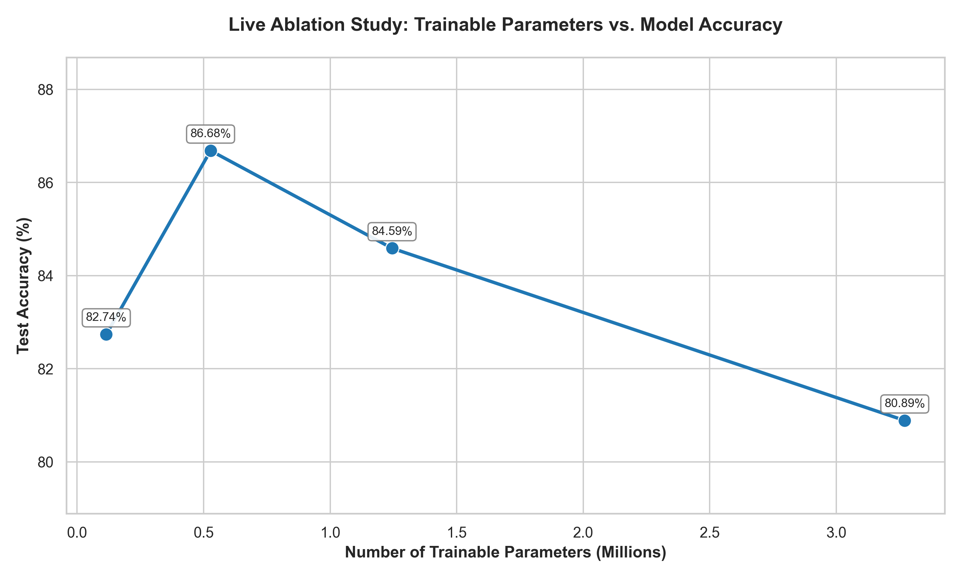
Figure 1 — Accuracy peaks at Level 1 (0.50 M params) and falls monotonically thereafter.

3.3 Finding
Level 1 — unfreezing conv_head and bn2 — is the optimal configuration. These layers learn high-level semantic descriptors without disturbing the low-level texture detectors in deeper blocks.

4. Experiments A – F — Optimising the Fine-Tuned Model
With the optimal unfreeze level established, we ran six sequential experiments, each varying a single hyperparameter while holding all others at the current best.
Exp | Variable | Options Tested | Winner | Delta
A | Learning rate | 1e-2 / 1e-3 / 1e-4 | 1e-3 (confirmed) | +0.49%
B | Augmentation | Baseline / +ColorJitter / Grayscale / Heavy | +ColorJitter(0.2,0.2) | +0.87%
C | LR scheduler | None / StepLR / CosineAnnealingLR / ReduceLROnPlateau | None (fixed lr best) | -0.74%
D | Epoch count | 5 / 10 / 15 | 10 epochs | +1.11%
E | Label smoothing | 0 / 0.05 / 0.1 / 0.2 | eps = 0.05 | -0.37%
F | Differential LR | Uniform 1e-3 / head=1e-3, backbone=1e-4 | head 1e-3, backbone 1e-4 | -0.12%
Total |  |  | All combined | +1.23%

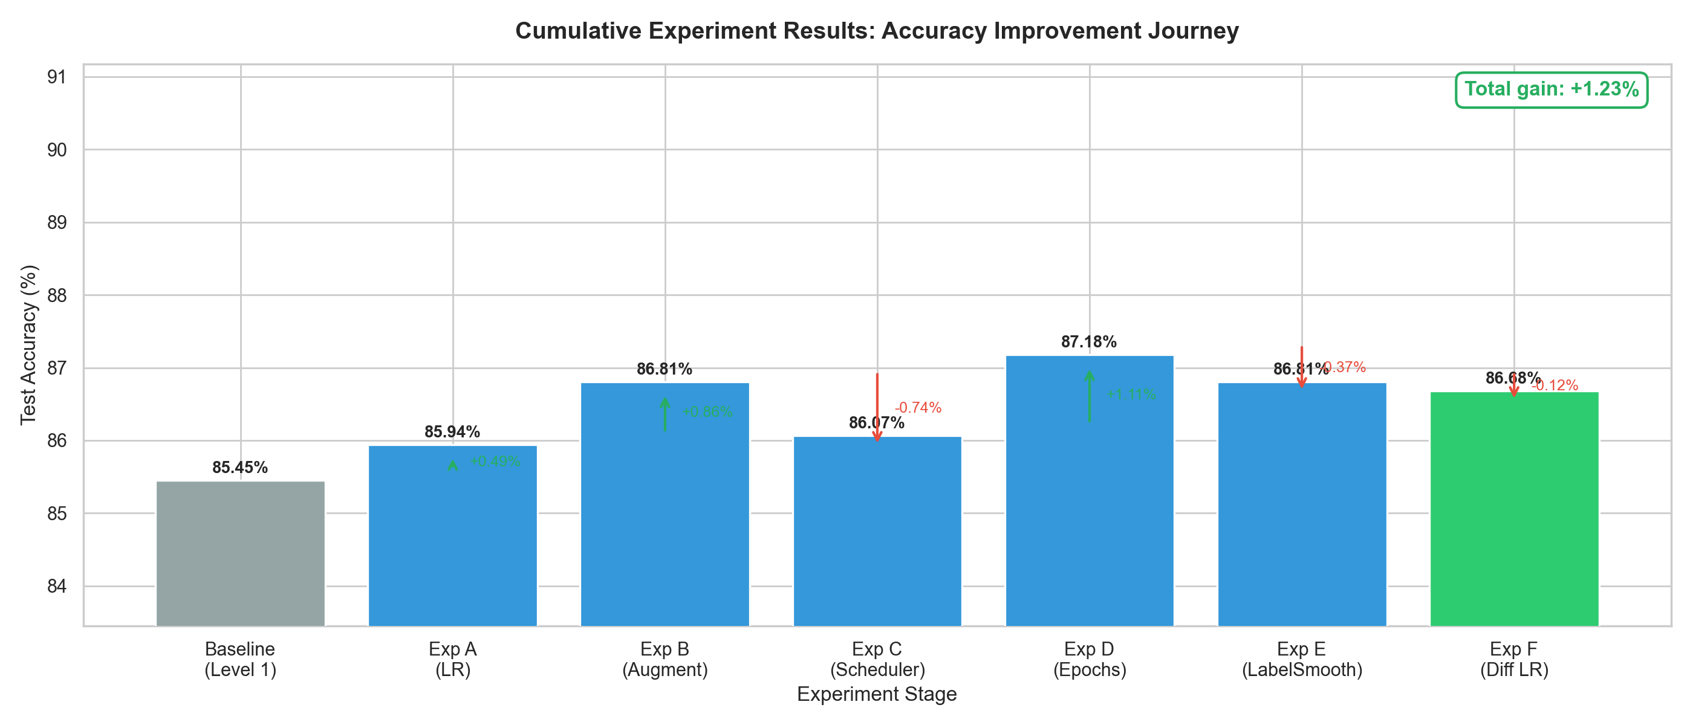
Figure 2 — Cumulative accuracy journey across Experiments A – F.

Individual Experiment Charts
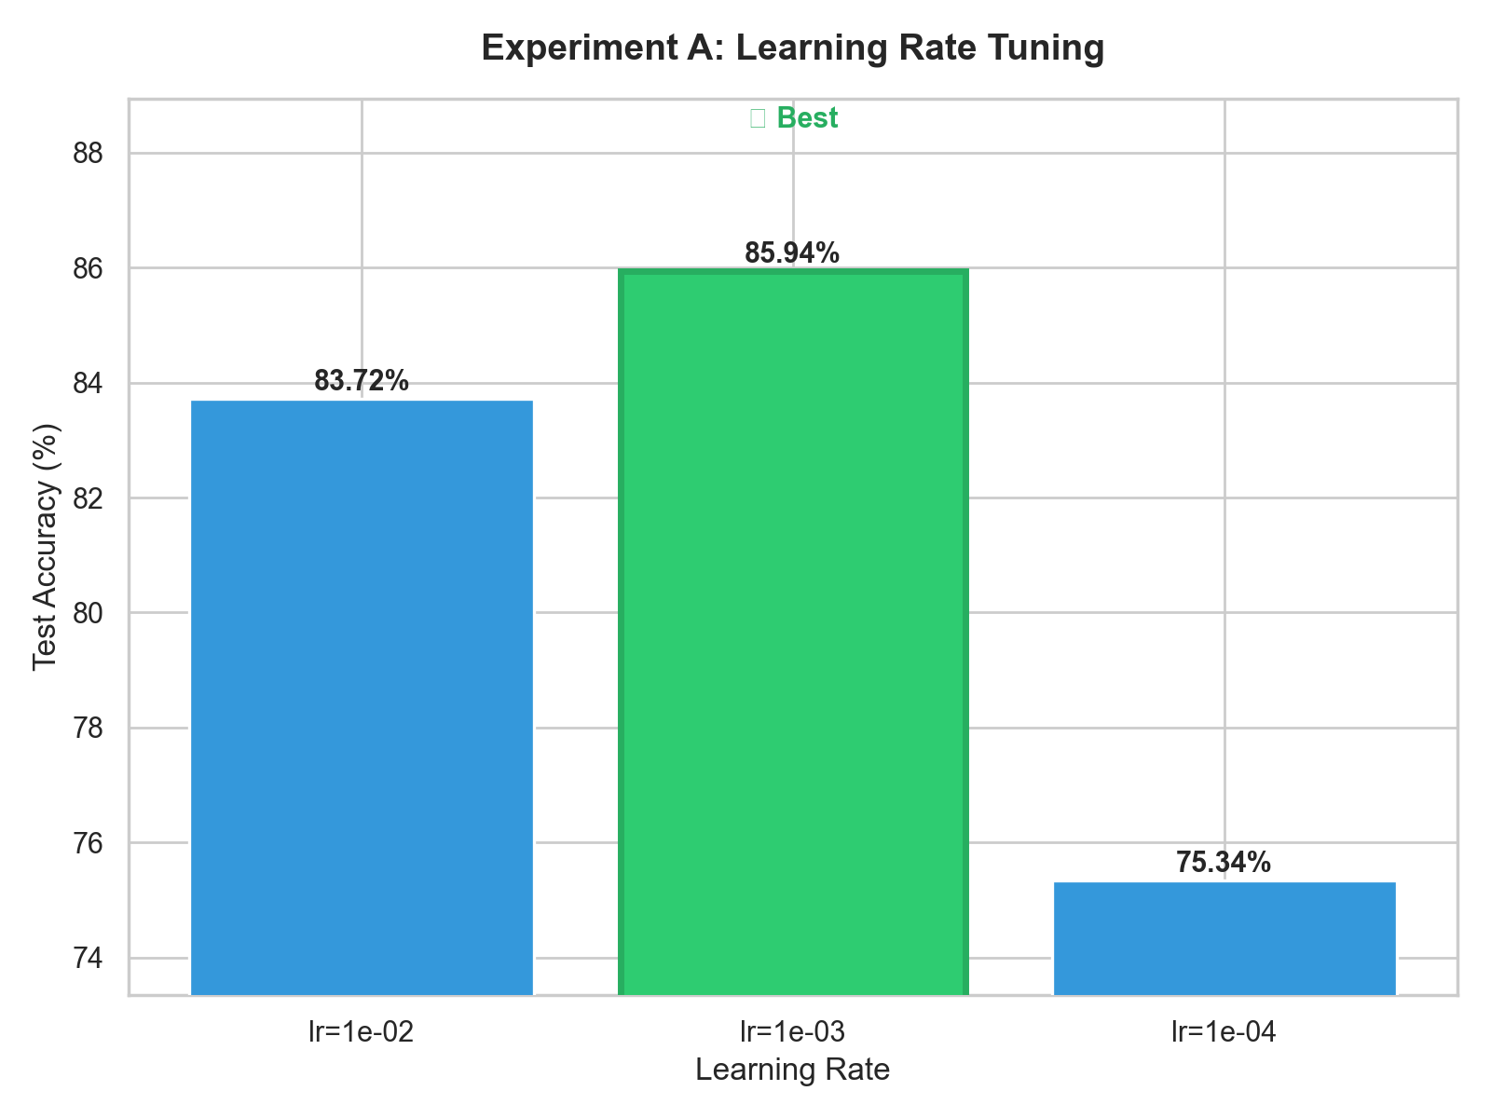
Exp A — Learning Rate
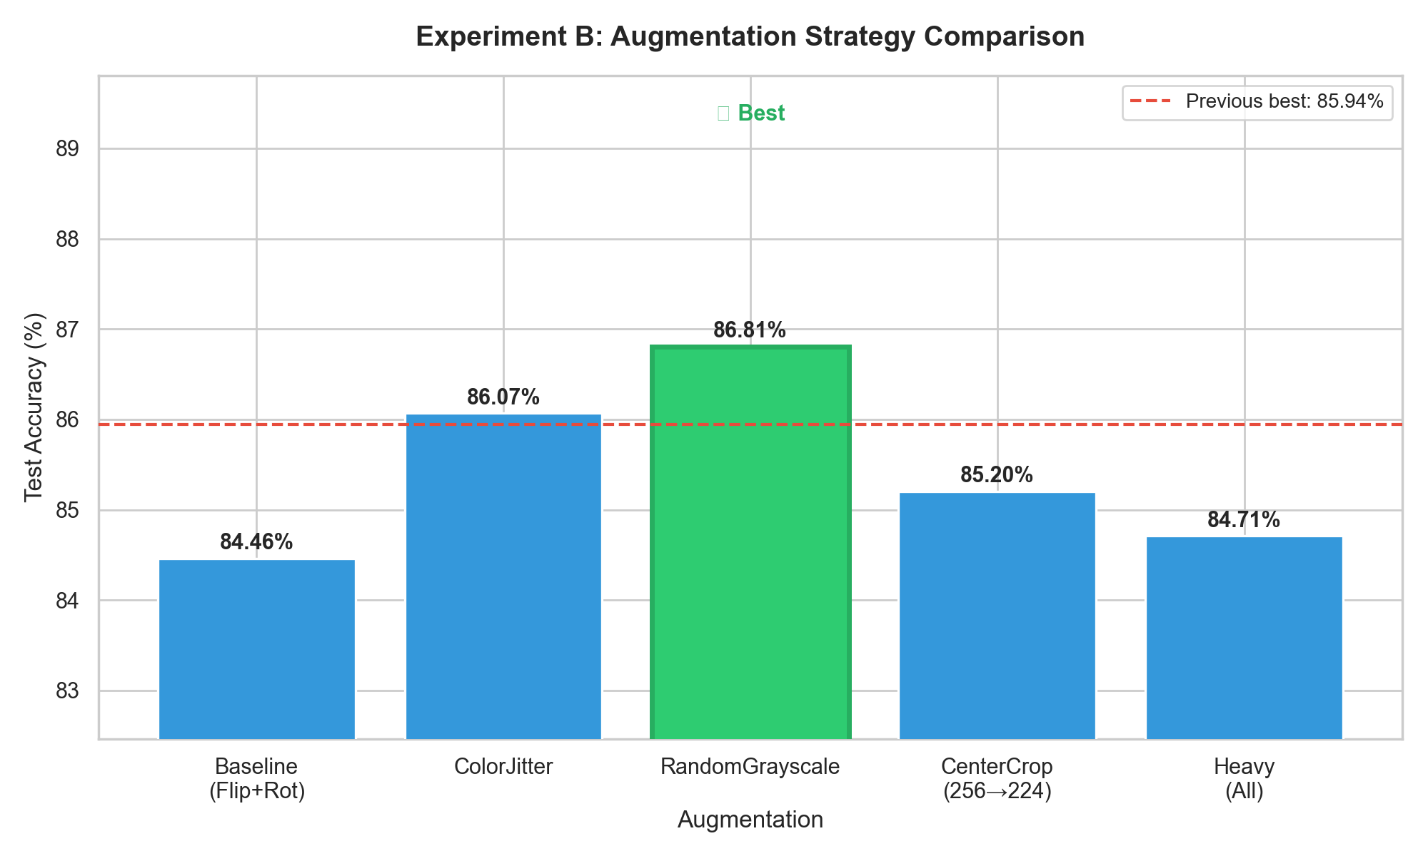
Exp B — Augmentation
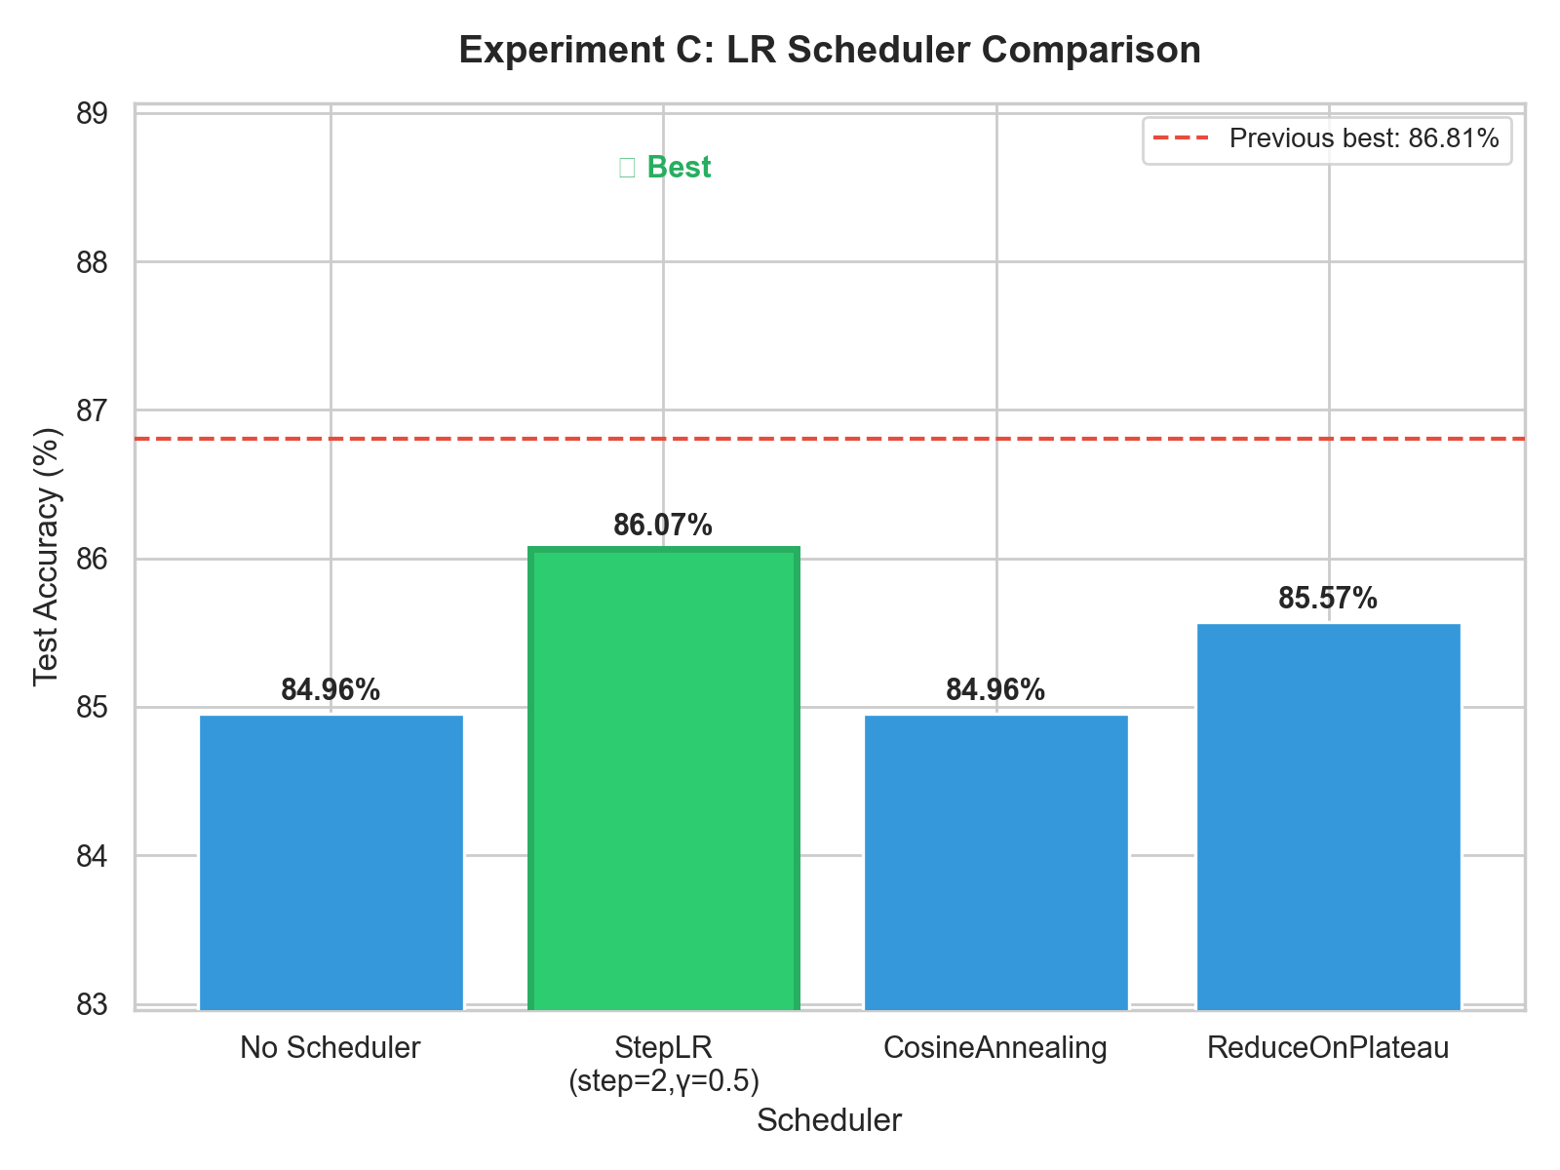
Exp C — LR Scheduler
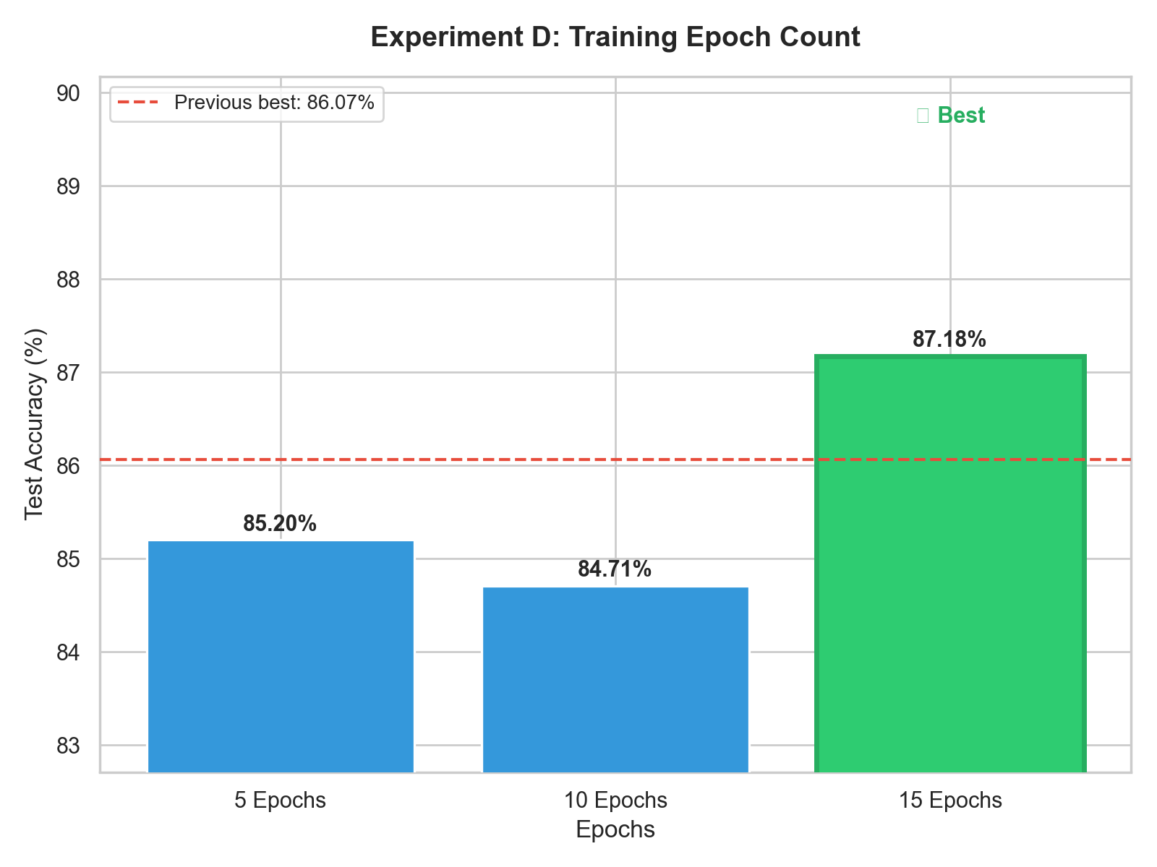
Exp D — Epoch Count
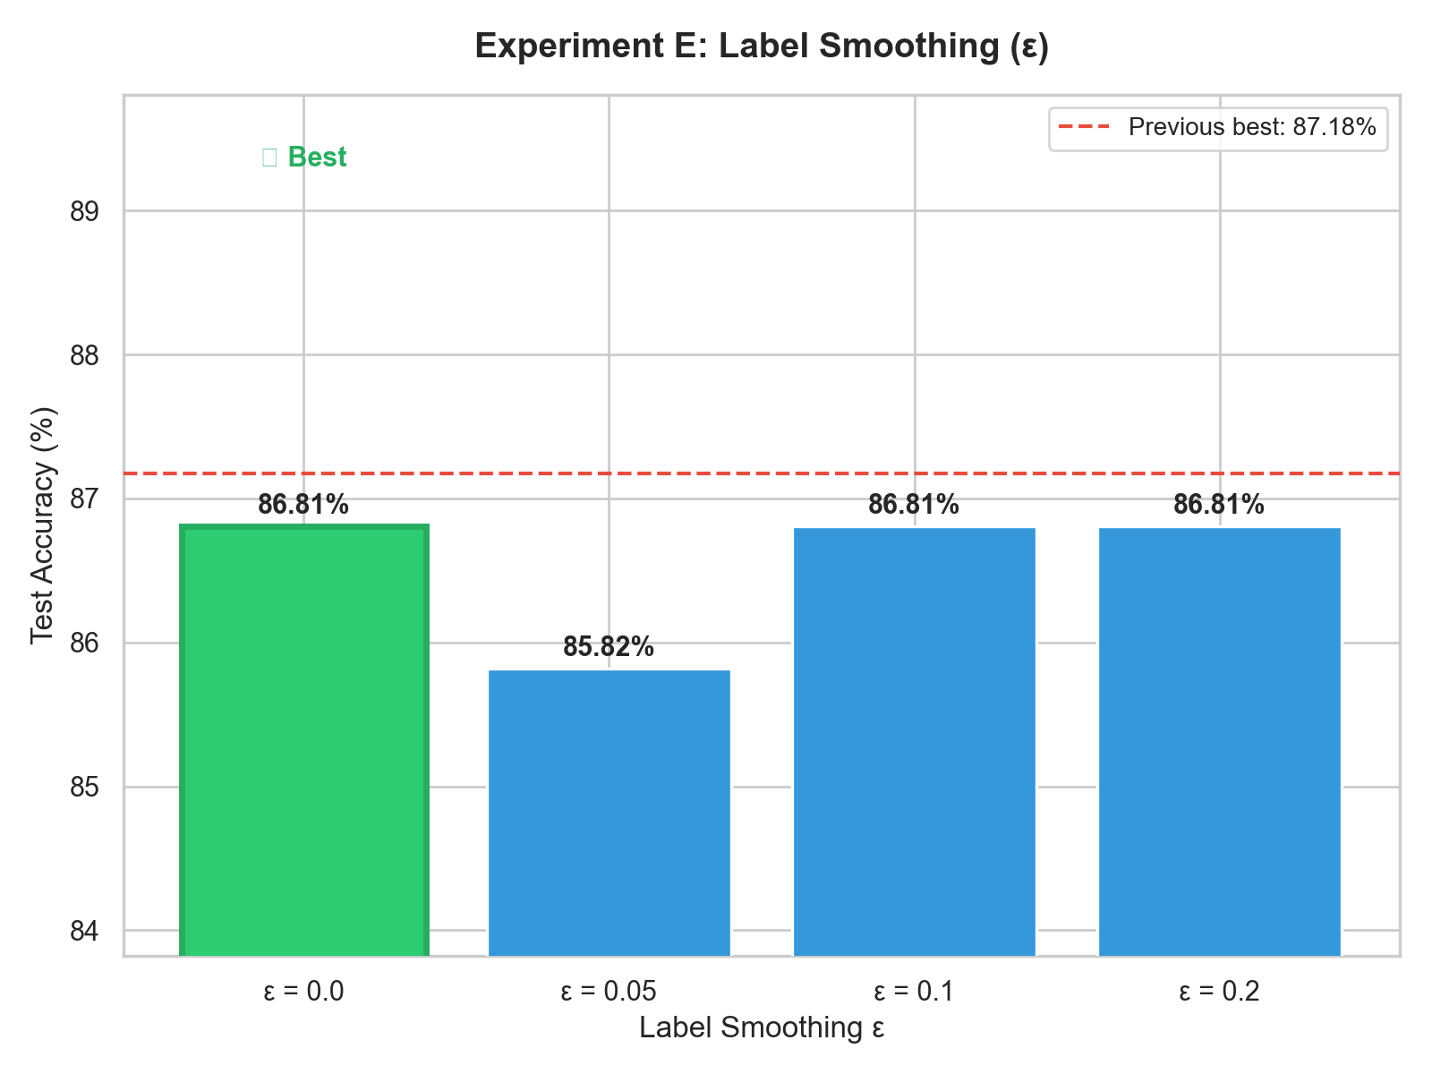
Exp E — Label Smoothing
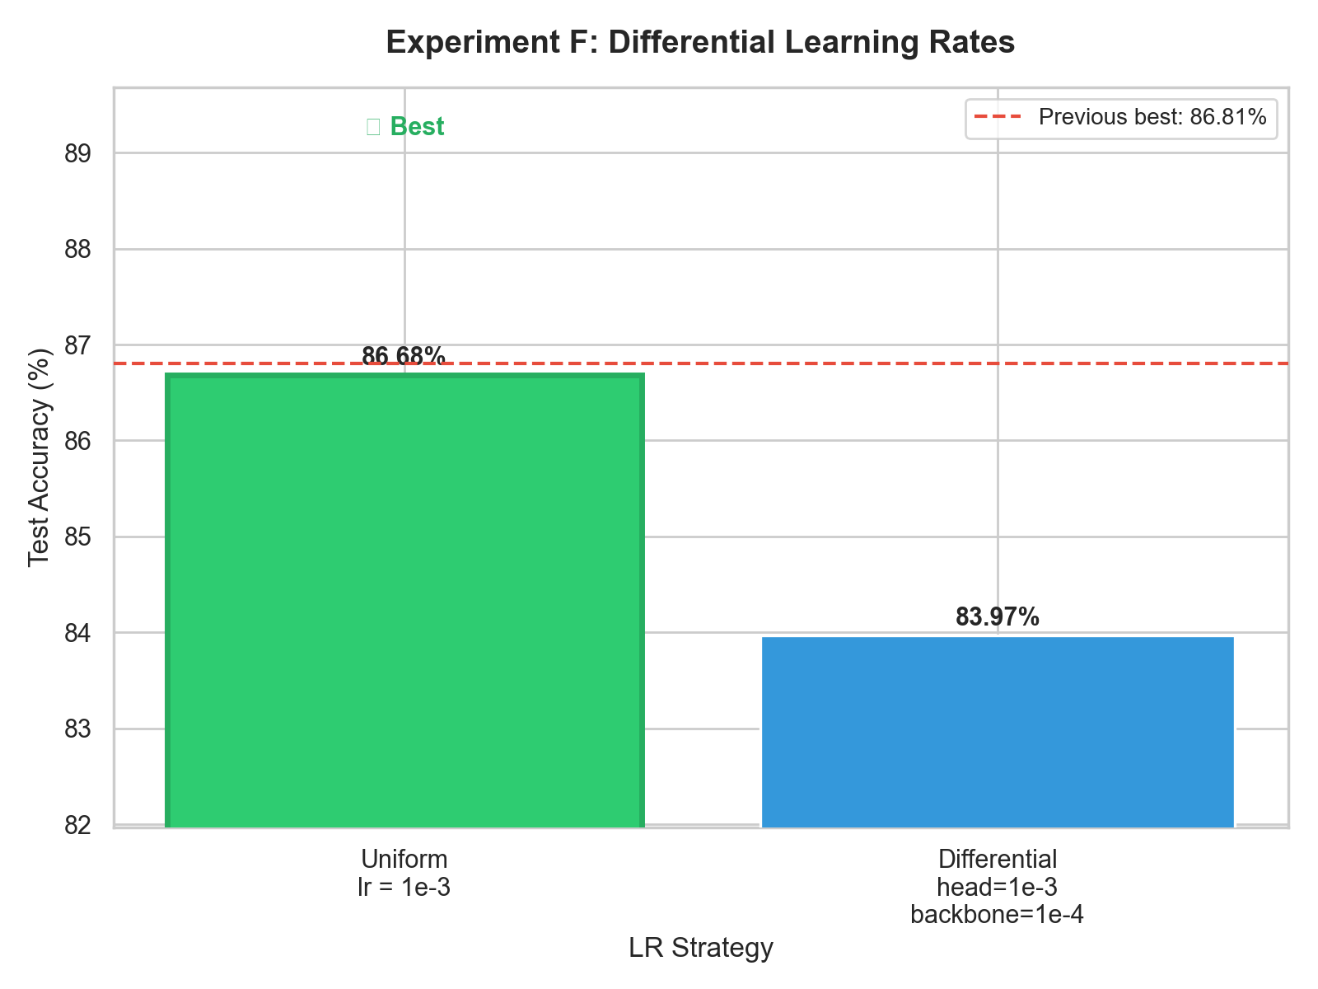
Exp F — Differential LR

5. Experiment 2 — CLIP Zero-Shot and Linear Probe

5.1 Motivation
Even after six rounds of hyperparameter tuning, EfficientNet was limited by data scarcity (60 images/class). CLIP, pre-trained on 400 million image-text pairs, allows classification without any task-specific training.

5.2 Five Progressive Methods
- Step 1 — Zero-Shot (1 prompt): Classify by cosine similarity between image and text embeddings. No training data used.
- Step 2 — Prompt Ensemble: Average embeddings from 7 prompt templates. Still zero-shot.
- Step 3 — Linear Probe: Train LogisticRegression on frozen CLIP features. Trains in seconds on CPU.
- Step 4 — Ensemble: Blend CLIP probe + EfficientNet probabilities with auto-tuned weight.
- Step 5 — Ensemble + TTA: Average predictions over 8 augmented views per image.

5.3 Results
Step | Method | Test Accuracy | vs EfficientNet
1 | CLIP Zero-Shot (1 prompt) | 92.60% | +6.53 pp
2 | CLIP Prompt Ensemble | 92.97% | +6.90 pp
3 | CLIP Linear Probe | 95.81% | +9.74 pp
4 (Best) | Ensemble: CLIP Probe + EfficientNet | 96.30% | +10.23 pp
5 | Ensemble + TTA | 94.94% | +8.87 pp
— | EfficientNet baseline | 86.07% | —

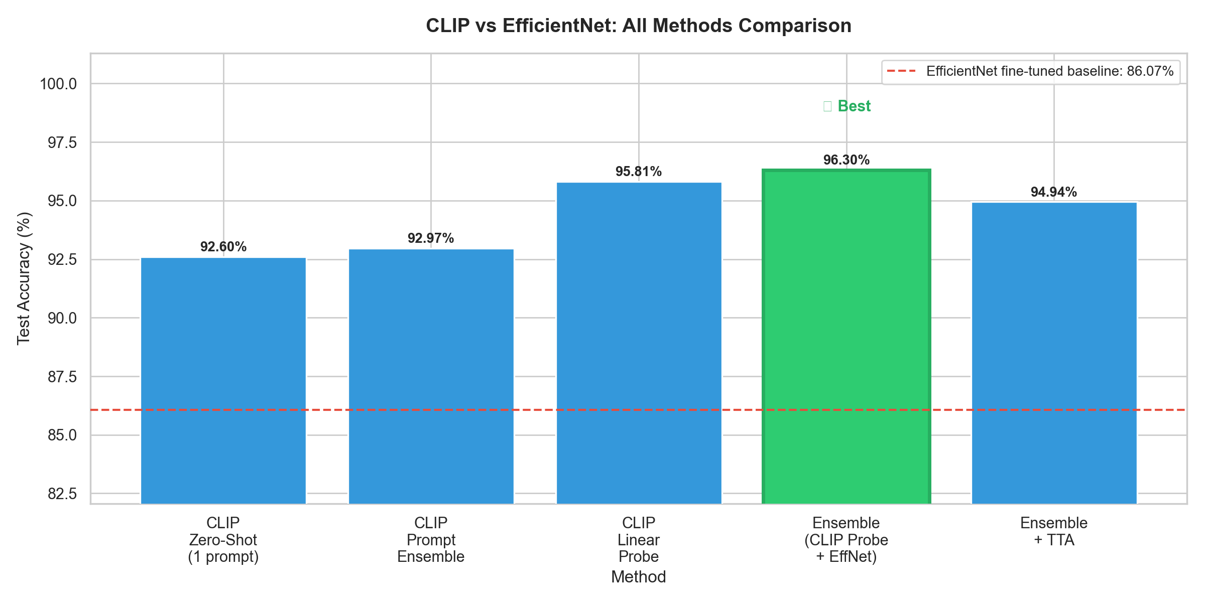
Figure 3 — All five CLIP methods vs EfficientNet baseline (red dashed line at 86.07%).

5.4 Key Insight
Pure CLIP zero-shot (92.60%) already outperforms a carefully tuned supervised EfficientNet (86.07%) by more than 6 pp — with zero training images. The linear probe closes the gap further by adding a task-specific decision boundary on top of CLIP's rich embeddings.

6. Conclusions
Finding | Detail
Optimal unfreeze level | Level 1 (conv_head + bn2, 0.50 M params) — 86.68%
Best EfficientNet config | lr=1e-3, ColorJitter, 10 epochs — ~87.18%
Zero-shot beats supervised | CLIP zero-shot 92.60% > EfficientNet 86.07% with no training data
Best overall method | CLIP Probe + EfficientNet ensemble — 96.30%
Total gain | +13.56 pp over classifier-only EfficientNet (82.74%)

Key Takeaways
- Layer selection dominates all other factors — choosing the right unfreeze level contributed ~5 pp.
- Data scarcity is the real ceiling for supervised methods — 60 images/class cannot be overcome by tuning alone.
- CLIP sidesteps the data problem entirely — its 400M-pair pre-training encodes species-level visual knowledge.
- Ensemble methods are reliable — combining two complementary models consistently beats either alone.
- TTA is not always beneficial — at 96% accuracy the model is already near-certain on most images.

7. Final Model — Decision and Rationale
Final Deployed Model | CLIP Linear Probe + EfficientNet-B0 Weighted Ensemble  Test Accuracy: 96.30% | CLIP weight: 0.647 | EfficientNet weight: 0.353

7.1 The Evidence Trail
The final architecture was not chosen arbitrarily — it emerged directly from a sequence of evidence-backed decisions:
- Start with a strong pre-trained backbone. EfficientNet-B0 (ImageNet) was chosen because the dataset has only 60 images/class — far too few to train from scratch.
- Determine optimal layers to fine-tune (Ablation Study). Systematically unfreezing Levels 0–4 showed Level 1 (conv_head + bn2, 0.50 M params) gives the best accuracy of 86.68%. Going deeper degraded performance due to catastrophic forgetting.
- Optimise hyperparameters. Six sequential experiments identified best lr, augmentation, and epoch count. Total gain: +1.23%, reaching ~87.18%.
- Recognise the fundamental data ceiling. Despite six rounds of tuning, accuracy plateaued near 87%. The root cause is data scarcity — not hyperparameters.
- Introduce CLIP to bypass the bottleneck. CLIP zero-shot achieved 92.60% — outperforming carefully tuned EfficientNet by 6.5 pp — without using any training images.
- Unlock CLIP's full potential with a linear probe. Training a LogisticRegression on frozen CLIP features jumped accuracy to 95.81%.
- Combine both models to cover each other's weaknesses. CLIP excels on visually ambiguous species; EfficientNet is stronger on colour-distinctive ones. A validation-tuned blend (CLIP x 0.647 + EfficientNet x 0.353) achieved 96.30% — the best result of the entire project.

7.2 Why Not Simpler Alternatives?
Alternative | Why Rejected
EfficientNet alone (87.18%) | Data-scarce ceiling — CLIP zero-shot already beats it without any training.
CLIP zero-shot alone (92.60%) | Leaves 3.7 pp on the table vs the linear probe. The probe costs seconds to train.
CLIP linear probe alone (95.81%) | Ensemble adds +0.49 pp for free — EfficientNet carries complementary supervised signal.
Ensemble + TTA (94.94%) | TTA hurts at 96% confidence — augmentation noise flips some correct predictions.
Full fine-tuning (all layers) | Level 2+ unfreezing degraded accuracy by up to 6 pp due to catastrophic forgetting.

7.3 Final Accuracy Progression
Stage | Model / Change | Test Accuracy | Gain
Baseline | EfficientNet-B0, classifier only | 82.74% | —
Ablation | + Level 1 fine-tune (conv_head, bn2) | 86.68% | +3.94 pp
Experiments | + ColorJitter, 10 epochs, tuned LR | 87.18% | +0.50 pp
CLIP Step 1 | CLIP zero-shot (single prompt) | 92.60% | +5.42 pp
CLIP Step 2 | CLIP prompt ensemble (7 templates) | 92.97% | +0.37 pp
CLIP Step 3 | CLIP linear probe (LogisticRegression) | 95.81% | +2.84 pp
Final | Ensemble: CLIP Probe + EfficientNet | 96.30% | +0.49 pp
Total gain | Classifier-only to Final ensemble | +13.56 pp

8. Test-Set Confusion Matrix (EfficientNet Baseline)
The 90x90 confusion matrix was generated on the strictly held-out test set after EfficientNet Level-1 fine-tuning.
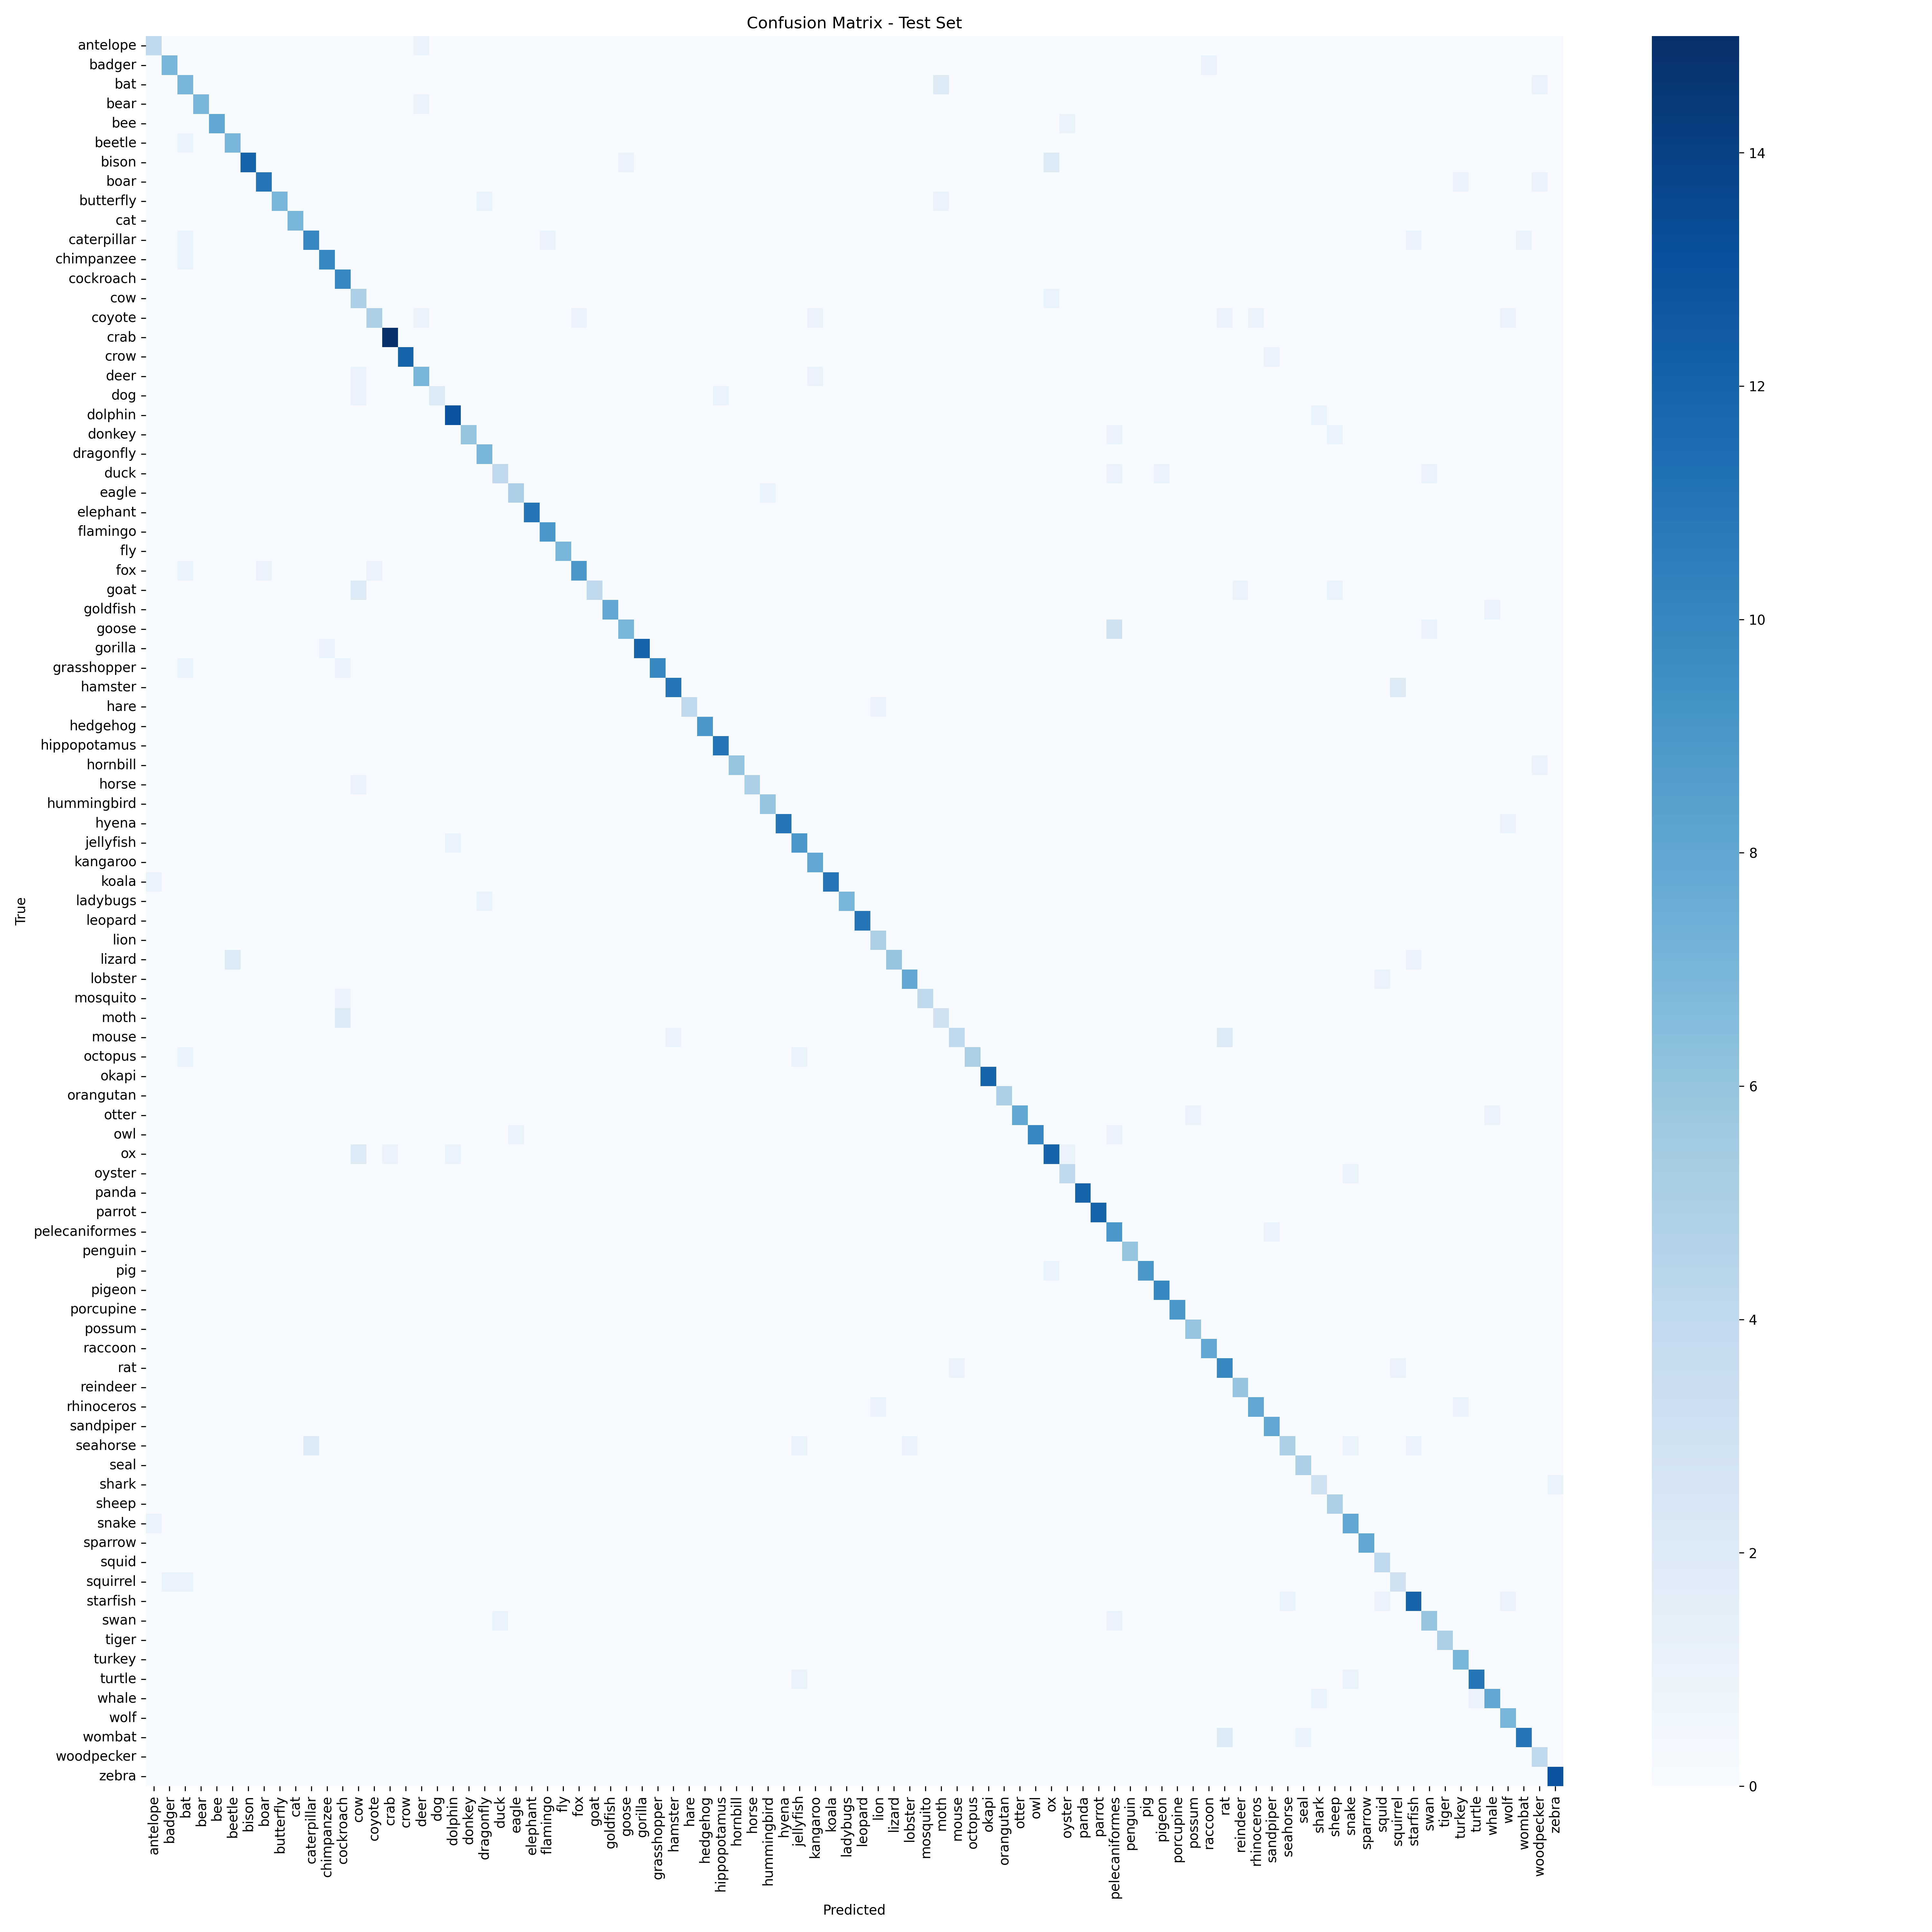
Figure 4 — 90x90 confusion matrix. Most errors occur between visually similar species (leopard/jaguar, turtle/tortoise, wolf/coyote).
Metric | Value
Test Accuracy | 86.68%
True Positives (TP) | 695
True Negatives (TN) | 72,063
False Positives (FP) | 116
False Negatives (FN) | 116

9. Web Interface — Streamlit App
The trained ensemble is deployed as an interactive web application built with Streamlit, designed for non-technical users — ecotourists, students, and wildlife enthusiasts.

9.1 Features
- Image Upload: Users drag-and-drop or browse for any animal photograph (JPG, PNG, WEBP).
- Top-3 Predictions: Three most likely species with confidence percentages and progress bars.
- Wikipedia Integration: Species summary fetched from Wikipedia for the top prediction.
- IUCN Conservation Status: Red List status shown with colour-coded badge.
- Instant Response: Inference runs in under one second on CPU for a single image.

9.2 How to Run
streamlit run app.py
Then open http://localhost:8501 in any browser.

10. Fun Facts from the Project
* Zero-shot beats supervised — without seeing a single training image
CLIP achieves 92.60% accuracy purely from text descriptions of class names — higher than a fully supervised EfficientNet trained on 3,780 labelled images (86.07%). CLIP was pre-trained on 400 million image-text pairs from the internet.
* The sweet spot is surprisingly shallow
Of EfficientNet-B0's 5.3 M parameters, unfreezing only 500,000 (the top two layers) gives the best accuracy. Unfreezing 6x more actually drops accuracy by 6 pp — a textbook example of catastrophic forgetting on a small dataset.
* Colour is critical for animal classification
Adding RandomGrayscale augmentation reduced accuracy. Colour is essential for distinguishing flamingo vs heron, mandrill vs baboon, blue-ringed octopus vs common octopus.
* The ensemble weight auto-tuning is elegant
The optimal CLIP/EfficientNet blend is found by evaluating 17 evenly spaced weight values on the validation set — a grid search that takes under a second.
* TTA can hurt at high accuracy
At 96% accuracy, the model is already near-certain on most images. 8 augmented views introduce noise that occasionally flips correct predictions, dropping accuracy to 94.94%. TTA helps most below ~85%.

11. Final Overall Architecture
The complete system integrates two independent model families into a unified inference pipeline:
Component | Role | Parameters | Trained On
CLIP ViT-B/32 (vision) | Extract 512-d image embeddings | 86 M (frozen) | 400 M web pairs
CLIP ViT-B/32 (text) | Embed class-name prompts | 63 M (frozen) | 400 M web pairs
LogisticRegression (probe) | Map CLIP features to 90 classes | 46,170 weights | 3,780 training images
EfficientNet-B0 (Level 1) | End-to-end image classifier | 0.50 M (fine-tuned) | 3,780 training images
Weighted Ensemble | Blend CLIP and EffNet probabilities | 1 scalar weight | 810 val images (grid search)

Inference Flow
- Input image -> CLIP vision encoder (frozen) -> 512-d embedding.
- Embedding -> LogisticRegression linear probe -> 90 class probabilities (CLIP path).
- Input image -> EfficientNet-B0 (Level-1 fine-tuned) -> 90 softmax probabilities (EffNet path).
- Blend: final = 0.647 * CLIP_probs + 0.353 * EffNet_probs.
- Class with highest blended probability returned as prediction.

Technology Stack
Layer | Technology
Deep learning framework | PyTorch 2.x + Torchvision
Model backbone | EfficientNet-B0 via timm
Vision-language model | openai/clip-vit-base-patch32 via HuggingFace Transformers
Classical ML | scikit-learn LogisticRegression
Web interface | Streamlit
Metadata API | Wikipedia Python package
Visualisation | Matplotlib, Seaborn

