AI-Enhanced Olympic Medal Analytics System

1. Problem Statement
Olympic data contains a vast amount of information about athletes, countries, sports, and medals earned across different years. Analyzing this data manually is difficult and time-consuming. There is a need for a system that can efficiently store, analyze, visualize, and predict Olympic medal outcomes while providing intelligent insights to users.
The objective of this project is to develop an AI-powered Olympic Medal Analytics platform that enables users to explore historical Olympic records, analyze medal trends, predict medal categories using machine learning, and generate AI-based performance summaries.

2. Approach
The project follows a data-driven approach:
- Collect and preprocess historical Olympic athlete-event datasets.
- Store processed medal records in a MySQL database.
- Build REST APIs using Flask to access and analyze data.
- Develop dashboards using HTML, CSS, JavaScript, and Chart.js.
- Train a Random Forest Machine Learning model to predict medal categories.
- Integrate AI-generated country insights using the Gemini API.
- Provide interactive visualizations and prediction features through a user-friendly web interface.

3. System Architecture

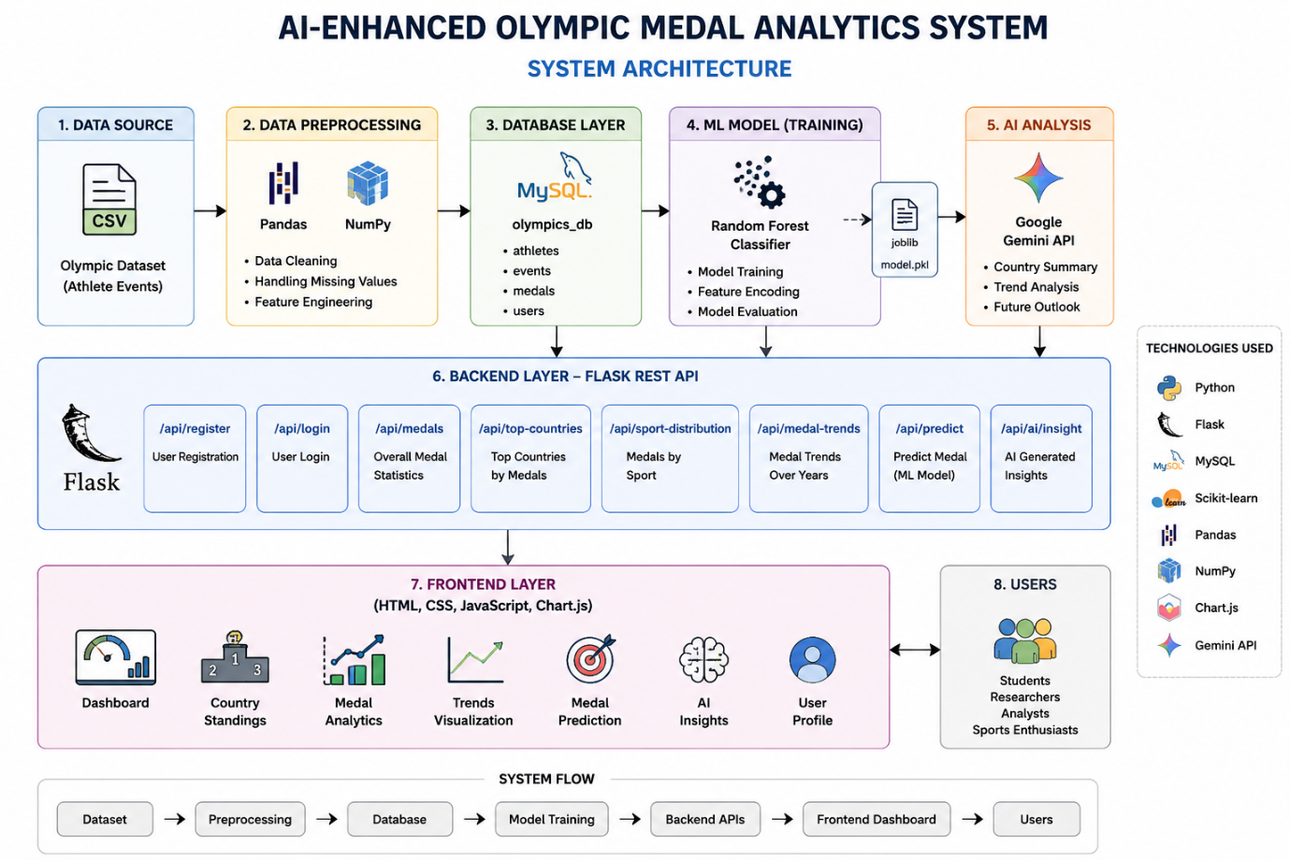
Frontend Layer
- HTML
- CSS
- JavaScript
- Chart.js
Provides:
- Dashboard visualization
- Medal standings
- Prediction interface
- AI insights page
- User authentication pages
Backend Layer
- Flask REST API
- Python
Handles:
- Data retrieval
- Analytics processing
- Authentication
- Prediction services
- AI insight generation
Database Layer
- MySQL
Stores:
- Olympic medal records
- User accounts
- Analytics data
Machine Learning Layer
- Scikit-learn
- Random Forest Classifier
Functions:
- Medal prediction
- Feature encoding
- Probability estimation
AI Layer
- Google Gemini API
Functions:
- Country performance summaries
- Trend analysis
- Future outlook generation
Data Flow
Dataset → Data Processing → MySQL Database → Flask API → Dashboard & Analytics → Machine Learning Prediction → AI Insights
4. Tools Used
Programming Languages
- Python
- JavaScript
- SQL
Frontend Technologies
- HTML5
- CSS3
- JavaScript
- Chart.js
Backend Technologies
- Flask
- Flask-CORS
Database
- MySQL
Machine Learning
- Scikit-learn
- Pandas
- NumPy
- Joblib
AI Integration
- Google Gemini API
Development Tools
- Visual Studio Code
- Git
- GitHub
- Postman
Dataset
- Historical Olympic Athlete Events Dataset

Project Outcome
The developed system successfully:
- Analyzes Olympic medal records.
- Displays country and sport-wise statistics.
- Visualizes historical trends.
- Predicts medal categories using machine learning.
- Generates AI-powered performance insights.
- Provides an interactive and user-friendly dashboard for Olympic analytics.

