***9 SE Lab Experiments***

***UNIT-1***

***Experiment-1***

***AIM: Assume that a software development company is already experienced in developing payroll software and has developed similar software for several customers (organizations). Assume that the software development company has received a request from certain customer (organization), which was still using manually processing of its pay rolls. For developing payroll software for this organization, which life cycle model should be used? Justify your answer.***

***DESCRIPTION:***

***Prototype model is used to develop a payroll software.***

***Payroll system:***

***Payroll is a document which contains the details of employees of a company or organization, like bonus, leaves, working days of the staff members,etc. It provides the information of the total money paid to the employees of a company based on their working days a payroll provides the functions like***

* ***It provides a detailed payslip***
* ***It is used to determine actual remuneration***
* ***It is used for paying salaries or wages***
* ***It is also providing a detailed breakdown of salary or wages***
* ***It also provides detailed information***

***Prototype model:***

***The Prototyping Model is one of the most popularly used Software Development Life Cycle Models (SDLC models). This model is used when the customers do not know the exact project requirements beforehand. In this model, a prototype of the end product is first developed, tested and refined as per customer feedback repeatedly till a final acceptable prototype is achieved which forms the basis for developing the final product.***

***In this process model, the system is partially implemented before or during the analysis phase thereby giving the customers an opportunity to see the product early in the life cycle. The process starts by interviewing the customers and developing the incomplete high-level paper model. This document is used to build the initial prototype supporting only the basic functionality as desired by the customer. Once the customer figures out the problems, the prototype is further refined to eliminate them. The process continues until the user approves the prototype and finds the working model to be satisfactory.***

***There are four types of models available:***

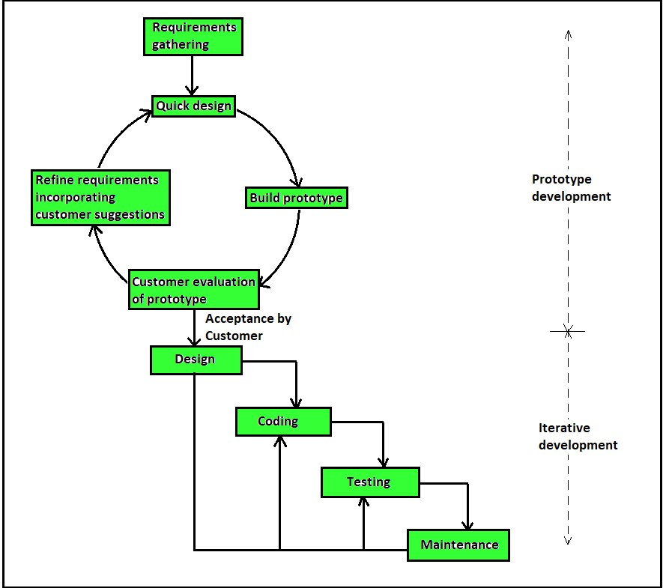

***Advantages of prototype model:***

* ***Reduce maintenance cost***
* ***Regular visible process aids management***
* ***Reduce the risk of incorrect user requirements***
* ***Good where requirements are changing***
* ***Errors can be detected much easier as the system is made is made side by side***

***WHY PROTOTYPE MODEL?***

* ***A prototype is a toy implementation of the system***
* ***The prototype model can be deployed when development of highly optimised and efficient software is required***
* ***It becomes easier to illustrate the input data formats, messages, reports, and the interactive dialogs to the customer***
* ***The prototype model requires that before carrying out the development of actual software a working prototype of the system should be built.***

***Experiment-2***

***AIM: Identify the criteria based on which a suitable life cycle model can be chosen for a given project development. Illustrate your answer using suitable examples***

***Library Management System:***

***An integrated library system also known as library management system, is an enterprise resource planning system for a library, used to track items owned, or books borrowed, fee paid.***

***Waterfall model is suitable for library management system.***

***Waterfall model:***

***It supports functions such as issue, return, the very basic functions of searching for a particular book etc. It also maintains data about books, teachers, students records that are required during various library operations. And in waterfall model, requirements were well known, clear and fixed. Also, the chances of ambiguity are less so the product definition is stable. Once the library management system is developed, we can add more features in futures in future releases.***

***Iterative model:***

***In consideration to the library management system and iterative life cycle model does not attempt to start with a full specification of requirements. Instead, development begins by specifying and implementing just part of the software, which is then received to identify further requirements. And in iterative model, more resources may be required. Although cost of change is lesser, but it is not very suitable for changing requirements.***

***Prototype model:***

***Prototype model is costly. It has poor documentation because of continuously changing the customer requirements. Prototype model is time- consuming process. Before developing the final product, multiple prototype are used for testing, which takes a lot of time. Poor decision making may affect the result of library management system.***

***Agile model:***

***While attempting to adopt an agile model for an entire organization, it’s easy for missteps to occur. Taking on two-week iterations and other experimental approaches to increase production can help inspire creativity and enthusiasm-but not without risk. And the level of collaboration can be difficult to maintain in agile model.***

***ATM application:***

***Automated teller machines (ATMs) is a computer based machine, connected to a network, that offers, as basic functions to users, access to bank account and retrieval of money. It allows consumers to perform quick self-service transactions.***

***Waterfall model is suitable for ATM application.***

***Waterfall model:***

***In case of ATM application, a waterfall model is easy in implementation. Early stage planning is done. Cost of waterfall model is low. Here, testing is done in waterfall model after completion of all coding phase. There is only one cycle is waterfall model. It helps to find errors earlier, and easy to understand and apply to build ATM application.***

***Iterative model:***

***For developing ATM application using iterative model, in this model user involvement is only at the beginning. It can’t handle large project. Generally, the cost of change is lesser, but it is not very suitable for changing requirements. Highly skilled resources are required for skill analysis.***

***Prototype model:***

***In prototype model, building this model is costly. It has poor documentation because of continuously changing customer requirements. There may be too much variation in requirements. And this prototype model, is time consuming in comparison to other life cycle models. There may be incomplete or inadequate problem analysis.***

***Agile model:***

***To build ATM application using agile model it requires more time and commitment. And also has greater demands on developers, and. clients. Lack of necessary documentation. Here the resource requirements and effort are difficult to estimate.***

***Banking System:***

***A banking System is a group or network of institution that provide financial services for us. These institutions are responsible for operating a payment system, providing loans, taking deposits, and helping with investments.***

***Agile model is suitable for banking system.***

***Agile model:***

***The agile software development process is characterized by iterative sprints lasting from two to four weeks. Each system release differs from the previous one by small changes. At each, the system is tested. This model works best if you want to detect issues before they appear or mature into more significant challenges. Throughout the process, developers ask all the stake holder for feedback.***

***Waterfall model:***

***In accordance with the waterfall model, developers proceed to the next phases only once the pervious one is completed. Each phase has its plan and takes into account the information from the previous phase. The issues can’t be fixed until developers proceed to maintenance.***

***Iterative model:***

***Here, this model depends on the iterations model. The next iteration depends on the pervious iteration. Highly skilled resources are required for skill analysis. Although cost of change is lesser, but it is not very suitable for changing requirements. In iterative model, building and improving is done step by step, which is time consuming.***

***Prototype model:***

***In prototype model, there is misconcepting regarding the arrival of the final product. And also has high up front cost. Illusfficient analysis which may lead to developer overtook better solutions, incomplete details, and the whole project may be poorly engineered, leading to complex maintenance.***

***UNIT-2***

***Experiment-3***

***AIM: Compute the FP value for the grade calculation of students. Assume that it is an average complexity size project. The information domain values are as follows:***

***Number of user inputs = 13***

***Number of user outputs = 4***

***Number of user inquiries = 2***

***Number of files = 5***

***Number of external interfaces = 2***

***The total value of complexity adjustment attribute is 13.***

***Solution:***

***FP=UFP*TCF***

***Where FP=Function Point***

***UFP= Unadjusted Function Point***

***TCF = Technical Complexity factor***

***TCF=0.65+0.01*DI***

***Where DI= Degree of Influence***

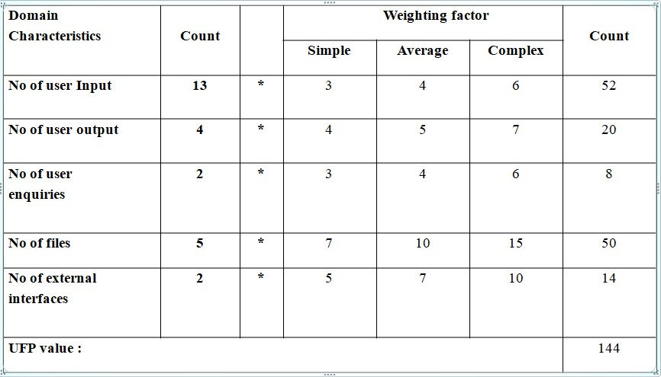

***Given CAA value = 13***

***DI=13*3=39***

***TCF=0.65+0.01*(DI)***

***= 0.65+0.01*39***

***= 1.04***

***FP = UFP * TCF***

***=144*1.04***

***= 149.76***

***Experiment-4***

***AIM: Assume that a system for simple student registration in a course is planned to be developed and its estimated size is approximately 10,000 LOC. The organization proposed to pay 25,000 per month to software engineers. Computethe development effort, development time, and the total cost for product development.***

***Solution:***

***Development Effort = a1 × (KLOC)a2 PM***

***Development Time (Tdev) = b1 × (Effort)b2 months***

***Where a1,a2,b1,b2 are constants***

***KLOC=Kilo Lines of Code***

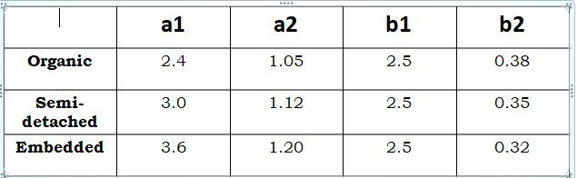

***Let the project can be considered an organic project.***

***From basic COCOMO Model***

***Development effort (E)=2.4*(10)1.05***

***=26.93PM***

***Development effort (Tdev)=2.5*(26.93)0.38***

***=8.74months***

***Total product development cost= Development time *salaries of engineers***

***=Rs 2,18500***

***Experiment-5***

***AIM: Suppose a lib management system (LMS) is to be designed for an academic institution. From the project proposal, the following five major components are identified:***

|  |  |  |
| --- | --- | --- |
| ***online data entry*** | ***-*** | ***1.0 kloc*** |
| ***data update*** | ***-*** | ***2.0 kloc*** |
| ***file input and output*** | ***-*** | ***1.5 kloc*** |
| ***library reports*** | ***-*** | ***2.0 kloc*** |
| ***query and search*** | ***-*** | ***0.5 kloc*** |

***The database size and application experience are very important in this project. The use of the software tool and the main storage is highly considerable. The virtual machine experience and its volatility can be kept low. All other cost drivers have nominal requirements. Use the COCOMO model to estimate the development effort and the development time .***

***Solution:***

***Let the project can be considered an organic project.***

***From Intermediate COCOMO Model***

***Development effort (E): Ei× EAF***

***Initial effort (Ei) = a1 × (KLOC) a2***

***Effort Adjustment Factor (EAF) = EAF1× EAF2×... × EAFn***

***Development time (T) = b1 × (E) b***

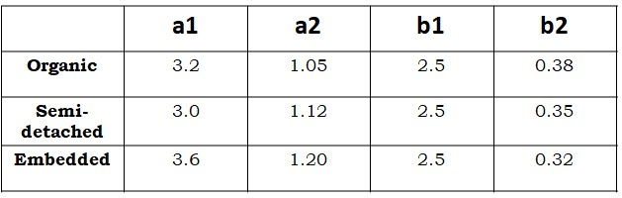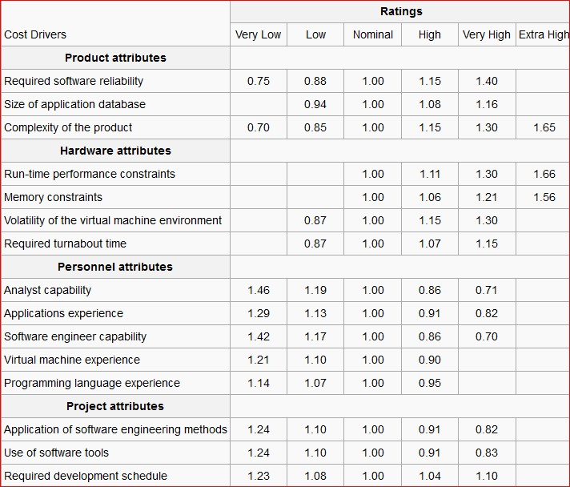

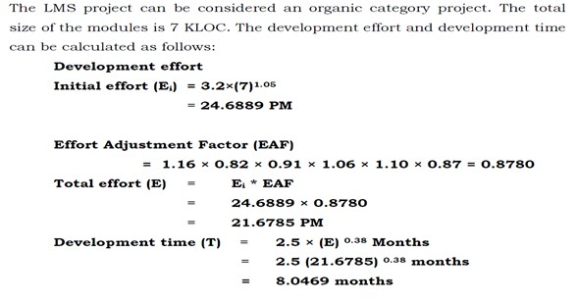

***UNIT-3***

***Experiment-6***

***Aim:***

***Suppose you have been appointed as the analyst for a large software development project. Discuss the aspects of the software product you would document in the software requirement specification (SRS) document? What would be the organization of your SRS document? (Take any real time problem and prepare SRS document?***

***Description:***

***Automated teller machines (ATMs) are electronic banking outlets that allow people to complete transactions without going into a branch of their bank. Some ATMs are simple cash dispensers while others allow a variety of transactions such as check deposits, balance transfers, and bill payments.***

***Introduction***

***Purpose:***

* ***This document describes the software requirements and specification (SRS) for an automated teller machine (ATM) network. The document is intended for the customer and the developer (designers, testers, maintainers).***
* ***The reader is assumed to have basic knowledge of banking accounts and account services. Knowledge and understanding of Unified Modeling Language (UML) diagrams is also required.***

***Scope***

* ***The software supports a computerized banking network called 'Bank24'. The network enables customers to complete simple bank account services via automated teller machines (ATMs) that may be located off premise and that need not be owned and operated by the customer's bank.***

* ***The ATM identifies a customer by a cash card and password. It collects information about a simple account transaction (e.g ., deposit, withdrawal, transfer, bill payment), communicates the transaction information to the customer's bank, and dispenses cash to the customer. The banks provide their own software for their own computers. The 'Bank24' software requires appropriate record keeping and security provisions. The software must handle concurrent accesses to the same account correctly***

***Documentation Conventions***

***Account:***

* ***A single account at a bank against which transactions can be applied.***
* ***Accounts may be of various types with at least checking and savings. A customer can hold more than one account.***

***Max Daily Withdrawal:***

***The maximum amount of cash that a customer can withdraw from an account in a day (from 00:00 AM to 23:59 PM) via ATMs.***

***PIN:***

***It Refers to Personal Identification Number. Used to identify and validate the login of an ATM user.***

***Intended Audience***

***The intended audience of this SRS consists of:***

* ***Software designers***
* ***Systems engineers***
* ***Software developer***
* ***Software testers***
* ***Customers***

***Additional information***

* ***The ATM network does not work independently. It works together with the banks' computers and the software run by the network's banks***
* ***The actors of the system are:***

1. ***User***
2. ***ATM Machine***
3. ***Bank***

***Product Perspective***

* ***The ATM network doesn't work independently***
* ***It has to work together with the computer software owned by banks. There are clearly denied interfaces for the different system.***

***Product Functions***

* ***The software should support a computerized banking network***
* ***Each bank provides its own computer to maintain its own accounts and process transactions against them***
* ***Automatic teller machines communicate with the banks, computers An automatic teller machine accepts a cash card and interacts with the user communicates with the bank computer to carry out the transaction dispenses cash and prints receipts***
* ***The system requires appropriate record keeping and security provisions The system must handle concurrent access to the same account correctly***
* ***The banks will provide their own software for their own computers The cost of the shared system will be apportioned to the banks according to the number of customers with***

***User Characteristics***

* ***There are several users of the ATM network***
* ***Customer***
* ***ATM network***
* ***The customer interacts with the ATM network via the ATM***
* ***It must be very easy for them to use the ATM***
* ***They should be supported by the system in every possible way***
* ***Maintainer***
* ***It should be easy to maintain the whole system***
* ***The maintainer should be the only person that is allowed to connect a new ATM to the network***

***External Interface requirements***

|  |
| --- |
| ENTER  **9**  **8**  **7**  **6**  **5**  **0**  **1**  **2**  **3**  **4**    ***Card Slot Receipts Cash Slot*** |

***Functional Requirement***

* ***Insert atm card***
* ***Validate atm card***
* ***Enter product task***
* ***Enter pin***
* ***Validate pin***
* ***Validate for account type if the task is banking***
* ***Ask for amount to be withdrawn***
* ***Amount is debited if sufficient balance is available***
* ***Error message is displayed otherwise***
* ***Ask for printing advice if the task is balance enquiry***

***Product function***

1. ***Login***
2. ***Get Balance Information***
3. ***Withdraw Cash***
4. ***Transfer Funds***

***Hardware Interface***

* ***The ATM network has to provide hardware interfaces to various printers and various ATM machines***
* ***Ability to read the ATM card***
* ***Ability to count the currency notes***
* ***Touch screen for convenience***
* ***Keypad (in case touchpad fails)***
* ***Continuous power supply***
* ***Ability to connect to bank's network***
* ***Ability to take input from user***
* ***Ability to validate user***

***Non-Functional Requirements***

* ***Performance Requirements : Error message should be displayed at least 6 sec.***
* ***If there is no response from the bank computer after a request within minutes the card is rejected with an error message.***
* ***The ATM dispenses money if and only if the withdrawal from the account is processed and accepted by the bank.***
* ***Each bank may be processing transactions from several ATMs at the same time.***

***Security Requirements***

* ***Users accessibility is censured in all the ways***
* ***Users are advised to change their PIN on first use***
* ***Users are advised not to tell their PIN to anyone***
* ***The maximum number of attempts to enter PIN will be three***

***Software Interface***

* ***The ATM network has to provide software interfaces to the software used by di-erent banks***
* ***Different network software***
* ***The exact detailed specification of the software interfaces is not part of this document***

***Safety Requirements***

* ***Must be safe kept in physical aspects, say in a cabin***
* ***Must be bolted to floor to prevent any kind of theft Must have an emergency phone outside the cabin***
* ***There must be an emergency phone just outside the cabin***
* ***The cabin door must have an ATM card swipe slot***
* ***The cabin door will always be locked, which will open only when user swipes his/her ATM card in the slot & is validated as genuine***

***Attributes***

* ***Availability***
* ***Security***
* ***Maintainability***
* ***Transferability Conversions***
* ***Data Bases***

***Assumptions***

* ***Hardware never fails***
* ***ATM casing is impenetrable***
* ***Limited number of transactions per day i.e. sufficient paper for receipts***
* ***Limited amount of money withdrawn per day i.e. sufficient money***

***Conclusion***

* ***Owing to the above mentioned assumptions this ATM Net Banking Software is working as fit to customer needs.***
* ***Result is verified accordingly***

***UNIT-4***

***Experiment-7***

***UML Diagrams for ATM Application***

***Class Diagram:***

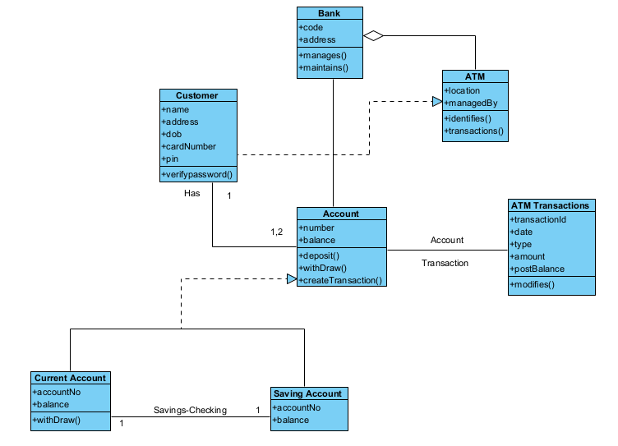

***Use case diagram:***

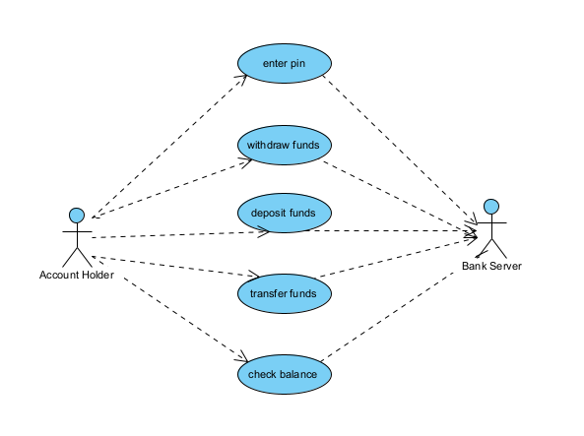

***State Chart:***

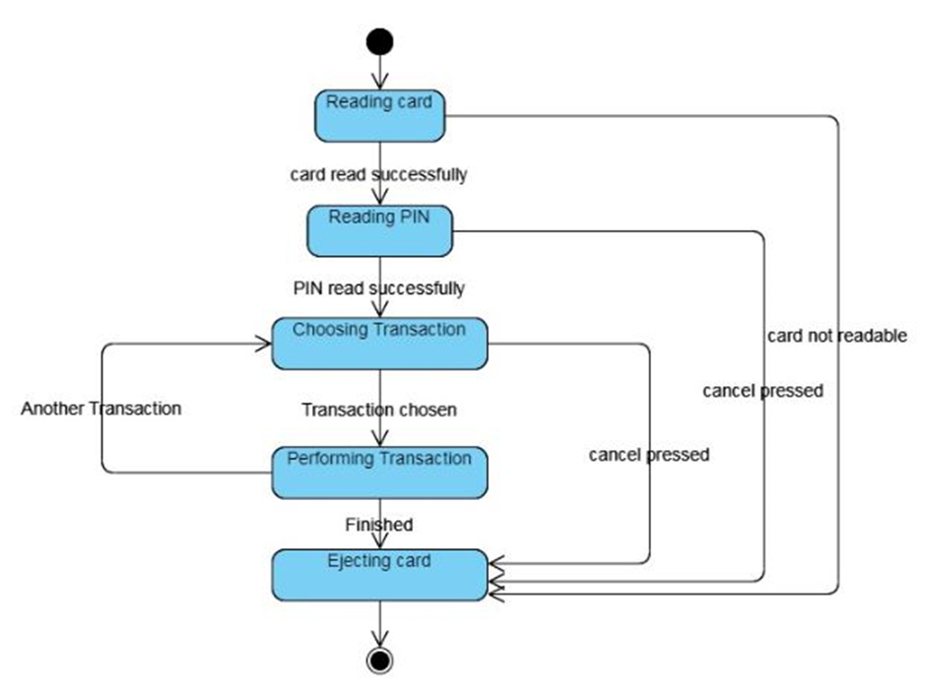

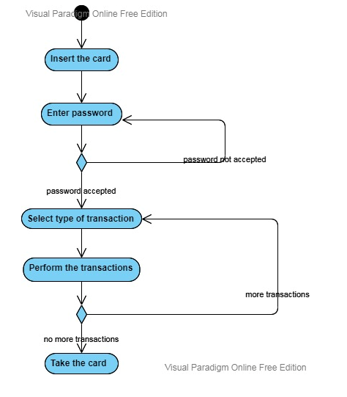***Activity Diagram:***

***Sequence Diagram:***

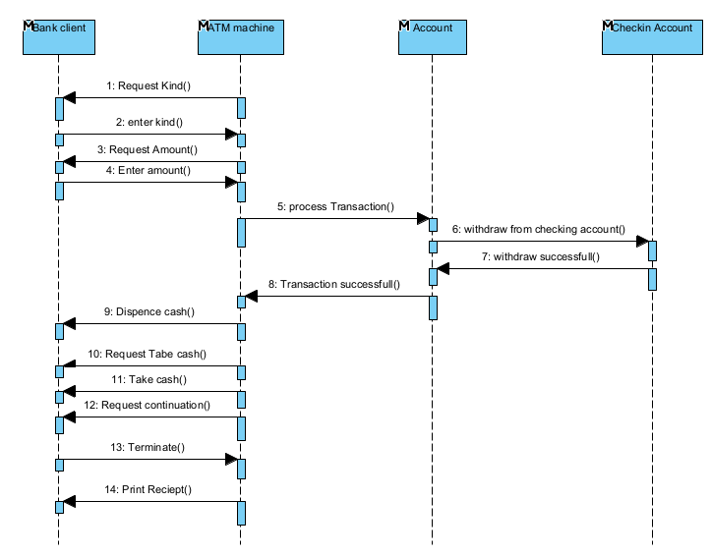

***Collaboration Diagram:***

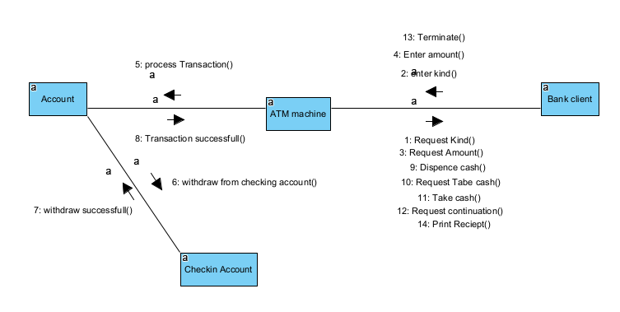

***Component diagram:***

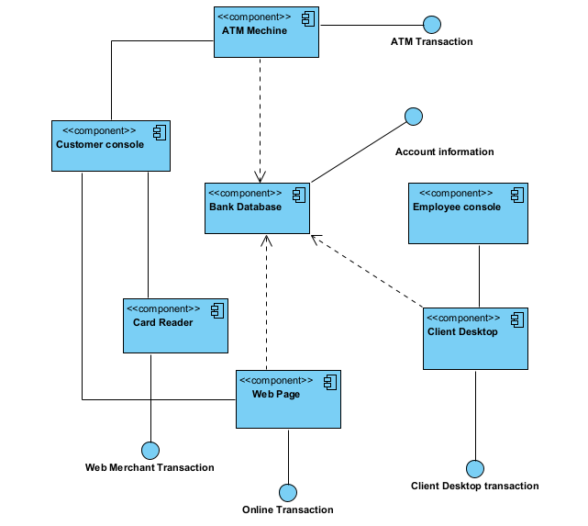

***Deployment diagram:***

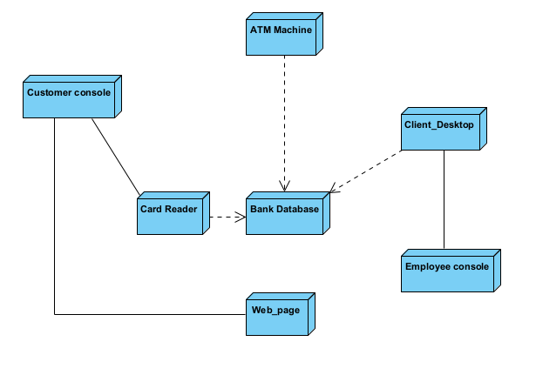

***Experiment-8:***

***AIM: To create a UML diagram of BANKING SYSTEM.***

***Class Diagram***

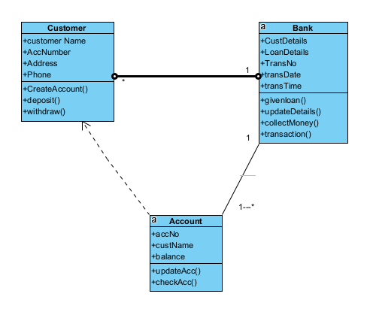

***Use Case Diagram:***

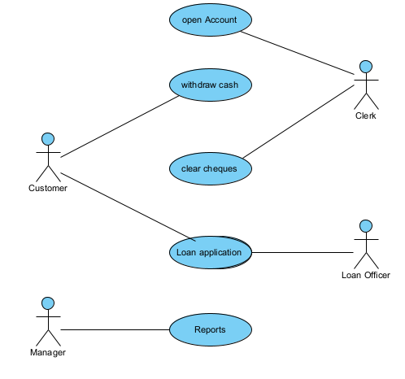

***State Chart diagram***

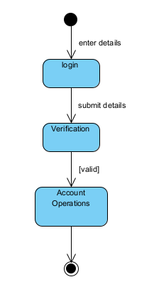

***Activity Diagram***

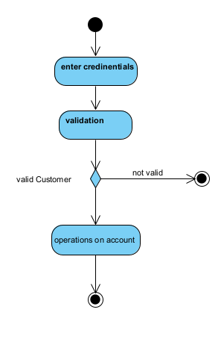

***Sequence Diagram***

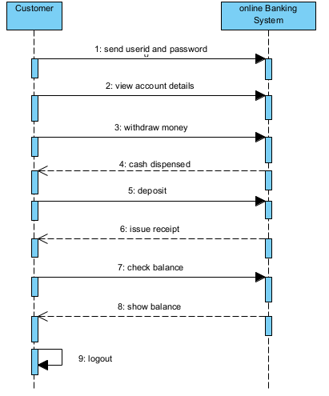

***Collaboration diagram***

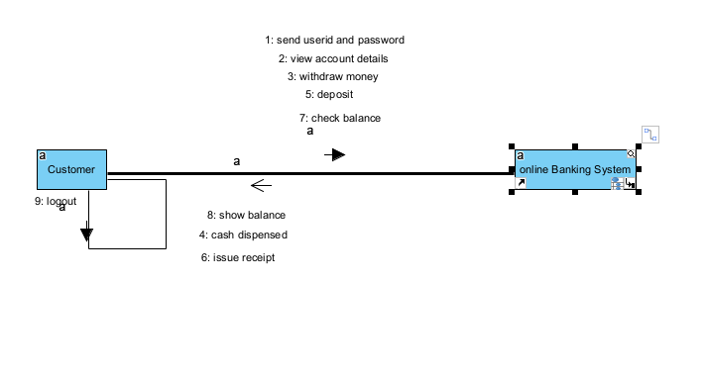

***Component Diagram:***

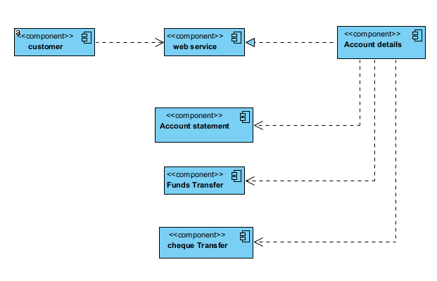

***Deployment Diagram***

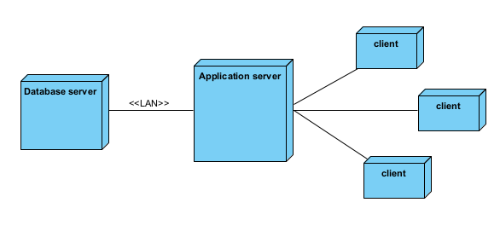

***Experiment-9***

***AIM: UML Diagrams for Library Management System***

***Class Diagram:***

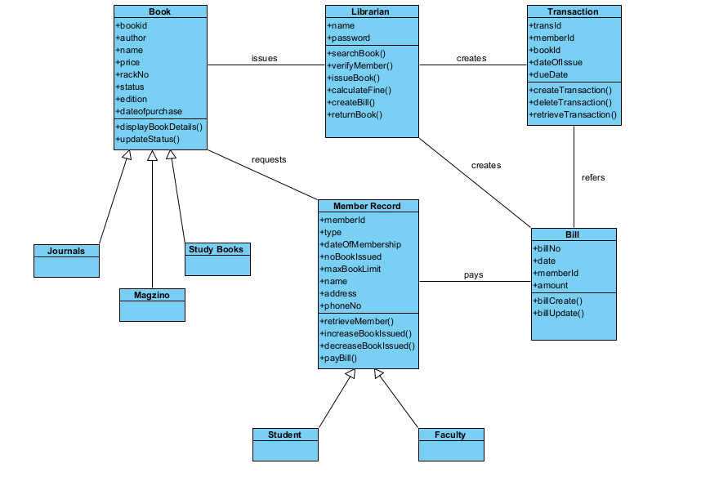

***Use Case Diagram:***

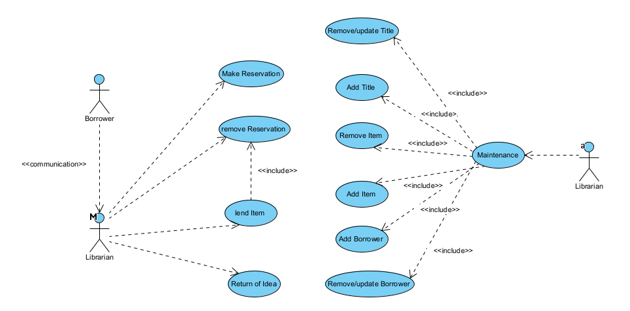

***State Chart:***

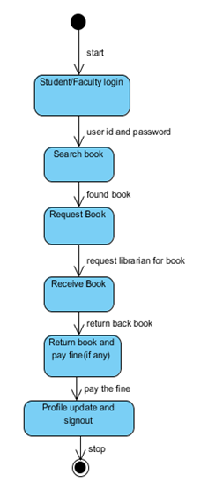

***Activity Diagram:***

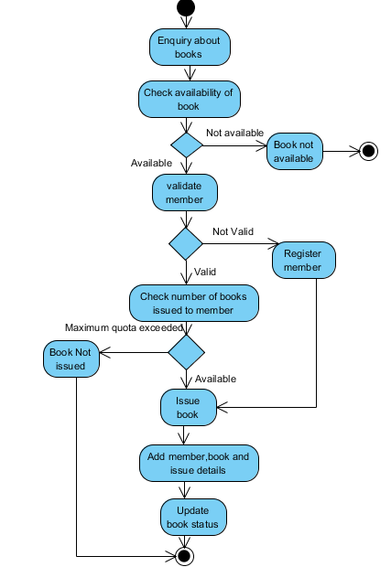

***Sequence Diagram:  
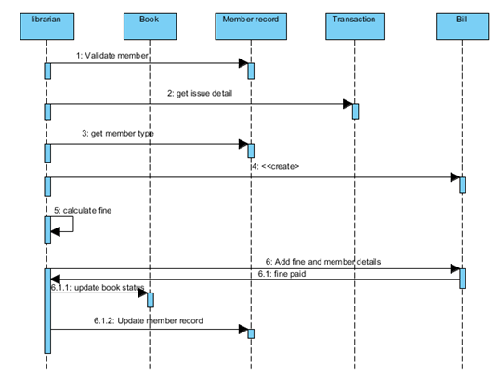  
Collaboration diagram:***

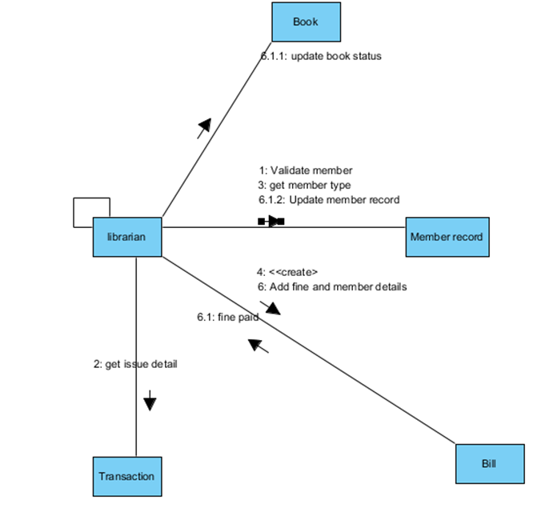

***Component diagram:***

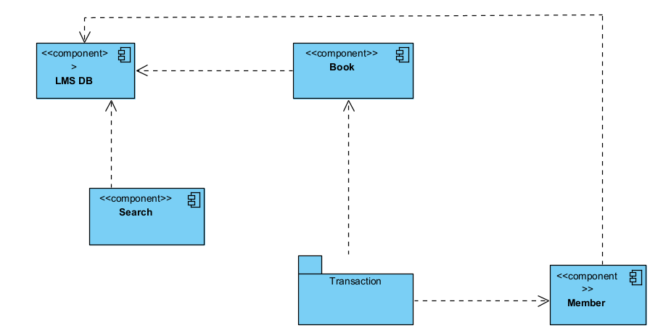

***Deployment:***

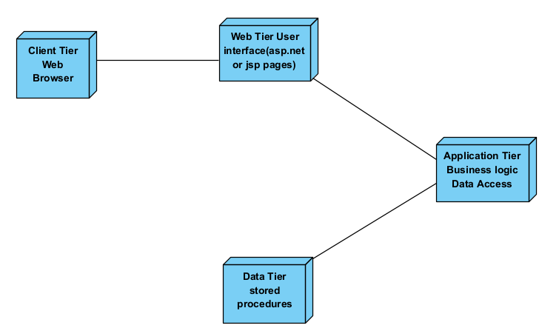

***UNIT-5***

***EXPERIMENT-10***

***AIM: Design of Test cases based on requirements and design.***

***Test case to issue a book to the student member***

***Test plan ID TP-001***

***Test case ID LTC-01***

***Feature to be tested Issue a book to the member of library***

***Preconditions 1. Library membership is compulsory***

***2. Book quota limit should not exceed 5 for a studentmember***

***Test Script:***

1. ***Verify library membership***
2. ***Check book availability***
3. ***Check the issue limits of books***
4. ***Issue book***
5. ***Add book in the account of member***
6. ***Update library catalog***

***Test data :***

* ***Valid membership: 'CS-5Jan12-30Jun12-MS-10'***
* ***Invalid membership: 'CS-4Jan12-30Jun 12-MS-00'***
* ***Valid book limit: 1, 4***
* ***Invalid book limit: -1, 5, 6***

***Expected results***

* ***Book should be issued if there is valid membership and valid book limit***
* ***Display "renew membership" for invalid membership***
* ***The book limit is "over" for invalid book limit***

***Test status Pass***