Cyberbullying Detection Across Social Media Platforms: A Two-Tier Hate Speech Detection System Using SVM and BERT with Confidence-Based Routing.

V. Dadi Naga Siva Sai Pavan department of IT
Seshadri Rao Gudlavalleru Engineering College
Gudlavalleru,India
dadisaipavan1514@gmail.com

N. Teja
department of IT
Seshadri Rao Gudlavalleru Engineering College
Gudlavalleru,India
tejanadella28@gmail.com

- Nithya Sri
department of IT
Seshadri Rao Gudlavalleru Engineering College
Gudlavalleru,India
nithyayeduruvada@gmail.com

T. P. Santhosh
department of IT
Seshadri Rao Gudlavalleru Engineering College
Gudlavalleru,India
santhoshkumartadiboyina@gmail.com

A.Koteswaramma
Assistant Professor
department of IT
Seshadri rao Gudlavalleru
Engineering College
Gudlavalleru, India Koteswari.1201@gmail.com

Abstract—Automatic identification of harmful content on social platforms requires systems that maintain classification precision without sacrificing processing speed. In real-world moderation pipelines, this balance is critical because large-scale user-generated content must be filtered in near real time while preserving contextual understanding. Deep learning architectures such as BERT deliver superior accuracy but demand extensive computing resources, whereas conventional algorithms like SVMs execute rapidly yet fail to capture semantic context adequately. We introduce a dual-stage classification framework employing confidence-based decision routing to optimize the trade-off between computational efficiency and detection performance. Our methodology begins with an SVM utilizing TF-IDF representations for initial assessment, then forwards uncertain predictions to a fine-tuned BERT module for comprehensive semantic evaluation. By restricting intensive processing to ambiguous cases only, this strategy minimizes unnecessary computational expense. Evaluation was conducted on the Davidson et al. benchmark dataset containing three categories: hate speech, offensive but non-hateful language, and neutral messages. Our experimental findings demonstrate that the proposed framework achieves 93.2% classification accuracy with 30 ms mean inference time, approximating BERT's performance while operating approximately five times faster than standalone transformer implementations. Analysis of prediction confidence levels, processing time distributions, and misclassification patterns validates the architectural design. Results indicate that hybrid systems with adaptive routing offer a practical solution for deploying sophisticated hate speech detectors under real-world operational constraints.
Keywords—Hate Speech Detection, Natural Language Processing, Hybrid Classification Systems, Confidence-Aware Routing, Support Vector Machines, BERT, Low-Latency Inference, Content Moderation
I. INTRODUCTION
Online platforms have transformed the way people share information and communicate across the world, but this rapid growth has also accelerated the spread of harmful content such as hate speech and abusive language. The widespread circulation of such material can lead to serious real-world consequences, including psychological harm, reinforcement of social biases, and increased hostility toward vulnerable communities. As a result, automated content moderation has become a necessity, since manual review alone cannot scale to the volume of online interactions generated every day.
Early moderation systems relied heavily on keyword lists and rule-based pattern matching, which proved insufficient for handling subtle or context-dependent expressions such as sarcasm, implicit threats, or indirect harassment. Traditional machine learning models improved detection accuracy by using handcrafted features and statistical classifiers, offering a reasonable balance between performance and efficiency. However, these methods still struggle to capture deeper semantic meaning, particularly when distinguishing explicit profanity from targeted hateful intent.
Recent advances in transformer-based models, most notably BERT, have significantly improved text classification by leveraging bidirectional context and attention mechanisms. While these models achieve high accuracy by understanding linguistic nuance, their computational demands pose practical challenges. High memory usage and slow inference times make it difficult to deploy such models at scale, especially in environments that must process millions of messages per hour.
Based on this idea, we propose a hierarchical detection framework that combines rapid SVM-based screening with context-aware BERT evaluation. The SVM component quickly handles straightforward cases using TF-IDF features, while predictions with low confidence are selectively passed to a fine-tuned BERT model for detailed semantic assessment. Experimental results on benchmark datasets demonstrate that this approach significantly reduces inference latency with only a marginal loss in accuracy, addressing a key obstacle in deploying advanced hate speech detection systems in real-world moderation pipelines. The main contributions of this work are summarized as follows:
- A confidence-guided hybrid framework that combines fast, lightweight classifiers with transformer-based models to enable accurate and efficient hate speech detection.
- A dynamic decision-routing strategy that selectively forwards only uncertain inputs to computationally intensive models, thereby avoiding unnecessary processing overhead.
- An extensive experimental study conducted under realistic deployment conditions, evaluating not only classification accuracy but also latency, confidence thresholds, and error behavior.
- Empirical evidence demonstrating that the proposed system achieves performance comparable to BERT while substantially reducing inference time, making high-quality hate speech detection practical for large-scale, real-time moderation.
II. LITERATURE REVIEW
Research on the automatic detection of abusive language has intensified in recent years as harmful interactions have become increasingly common on online platforms. Early studies in this domain primarily relied on traditional supervised learning techniques, such as margin-based classifiers and probabilistic models, coupled with frequency-oriented text representations that capture word occurrence patterns and relative importance [1][10]. While these methods offered computational efficiency and scalability, they were heavily dependent on shallow lexical cues, making them unreliable when handling nuanced language phenomena such as sarcasm, implicit hostility, or culturally specific expressions.
The introduction of transformer-based architectures marked a major shift in natural language processing research [3][4][5][12]. By learning rich contextual representations with minimal manual feature engineering, these models substantially improved classification performance. Despite these gains, several challenges remained unresolved, including the detection of subtle or implicit hate, interpretation of sarcasm, handling long-range contextual dependencies, and managing skewed class distributions. In particular, dataset imbalance continued to cause misclassification of less frequent but critical hate speech instances.
To address the trade-off between accuracy and efficiency, a number of studies explored ensemble and hybrid approaches [6][11]. These methods typically combine traditional features with deep semantic embeddings or employ voting-based mechanisms to improve robustness. However, most existing solutions process all inputs using identical pipelines, resulting in unnecessary computational overhead and limited suitability for latency-sensitive applications.
More recent work has begun to emphasize deployment-oriented concerns such as scalability and response time [7][8]. Even so, systems that dynamically adjust computational effort based on input complexity remain relatively rare. In contrast, our approach places prediction confidence at the core of the decision process. By routing inputs according to certainty levels, the system allocates resources more effectively, achieving efficient inference without compromising accuracy—an approach that aligns well with the practical constraints of real-world moderation environments.
III. EXISTING WORK
Content moderation systems are required to maintain a delicate balance between classification accuracy and response speed. Modern social media platforms process millions of user-generated posts every hour, making near-instantaneous detection of harmful content a critical operational requirement. Even small increases in processing latency can significantly reduce system throughput at this scale, directly affecting moderation effectiveness.
In this work, we formulate harmful content detection as a three-class text classification problem, where inputs are categorized as hate speech, offensive but non-hateful language, or neutral content. Real-world datasets are highly imbalanced, with explicitly hateful content forming only a small portion of overall traffic. Misclassification in such settings has uneven consequences: failing to detect hate speech allows harmful material to spread, while excessive false positives can lead to unwarranted censorship and erode user trust in the platform.
Most existing moderation pipelines rely on a single, uniform classification strategy. Lightweight models offer fast inference but lack the semantic depth required to capture subtle or implicit hate, whereas deep contextual models provide stronger language understanding at the cost of high computational overhead. This creates a persistent trade-off between performance and efficiency that limits large-scale deployment.
Our key insight is that computational effort should be proportional to input complexity. A large share of user-generated content is either clearly benign or overtly abusive and can be classified with high confidence using simple methods. Only a smaller subset of ambiguous cases demands deeper semantic reasoning. Applying the same processing pipeline to all inputs therefore leads to unnecessary resource consumption.
Motivated by this observation, our research focuses on designing classification systems that adapt their computational investment dynamically based on input characteristics. By selectively applying intensive analysis only where it is truly needed, such systems can preserve detection accuracy while significantly improving efficiency—an essential requirement for real-world content moderation at scale.
IV. PROPOSED WORK
We propose a confidence-driven, two-tier classification framework that dynamically allocates computational resources based on prediction certainty. Inputs that exhibit clear and unambiguous characteristics are processed rapidly using lightweight models, while instances with lower confidence are selectively routed to more advanced semantic analysis for refined decision-making.
A. Dataset Overview
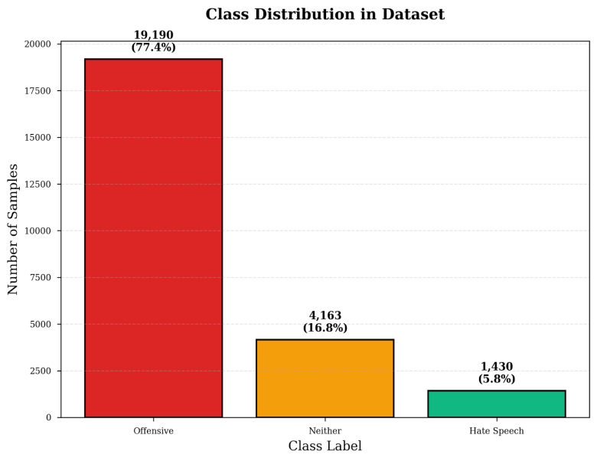
The proposed framework is evaluated using the Davidson et al. hate speech dataset [1], a widely adopted benchmark in social media moderation research. The dataset consists of English-language tweets that have been manually annotated into three categories: hate speech, offensive but non-hateful content, and neutral language. It reflects the inherent class imbalance and linguistic ambiguity found in real-world user-generated data, making it well suited for assessing both the effectiveness and practicality of moderation systems under realistic deployment conditions.

Fig. 1. Frequency of instances per category in the dataset
The dataset consists of 24,783 manually annotated samples and exhibits a pronounced class imbalance, with hateful content representing only a small fraction compared to offensive and neutral categories. This skewed distribution closely reflects real-world social media data and provides a challenging testbed for evaluating the system’s ability to correctly identify minority classes without introducing excessive false positives. To ensure fair and realistic evaluation, the dataset is divided using a stratified splitting strategy, preserving the original class proportions across both training and testing sets.
B. System Overview
The proposed framework follows a sequential, multi-tier processing pipeline. Most inputs are handled by a fast, lightweight classification stage, while only predictions with lower confidence are forwarded to a more detailed semantic analysis stage. This design achieves high computational efficiency while maintaining strong classification performance, making it suitable for large-scale, real-time content moderation.
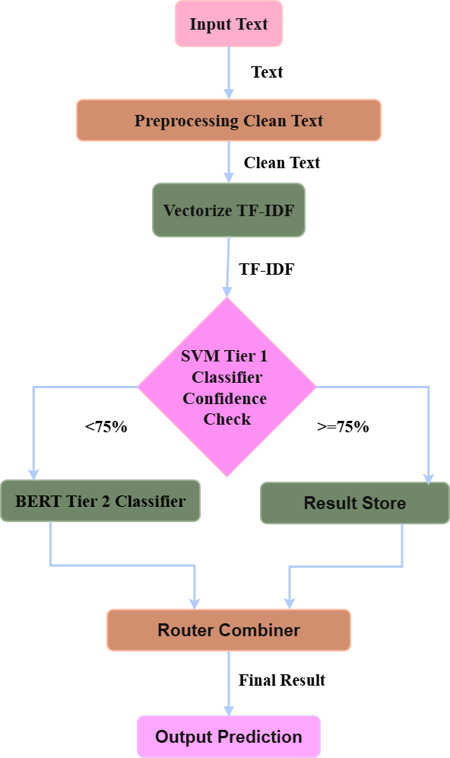

Fig. 2. Architecture of the proposed confidence-aware two-tier hate speech detection system.
The proposed processing pipeline follows a structured, confidence-driven workflow. Raw social media text is first preprocessed to reduce noise while preserving essential semantic information. In the first tier, a lightweight SVM classifier produces an initial class prediction along with an associated confidence score. Predictions exceeding a predefined confidence threshold are accepted immediately as final outputs, enabling rapid decision-making. Inputs with lower confidence are selectively escalated to the second tier, where a fine-tuned BERT model performs deeper contextual analysis to resolve semantic ambiguity.
C. Text Processing and Feature Extraction
Text collected from social media platforms is often informal and noisy, requiring careful normalization before classification. Our preprocessing pipeline includes lowercasing, tokenization, selective removal of stopwords, and lemmatization to standardize word forms while retaining semantic meaning. Elements such as URLs, user mentions, and non-informative special characters are removed, as they do not contribute meaningfully to content interpretation. Negation terms are handled explicitly, since they play a critical role in altering sentiment and intent. For feature extraction, word-level tokenization is used to support TF-IDF representations in the SVM-based tier, while the BERT model relies on its internal subword tokenization mechanism. Lemmatization is preferred over stemming, as it preserves meaningful base forms and improves generalization across linguistic variations.
In the first-tier classifier, preprocessed text is transformed into numerical features using TF-IDF vectorization, a widely adopted approach for representing sparse textual data. Term frequency captures how often a word appears within a document, while inverse document frequency adjusts this value based on the word’s importance across the entire corpus.
$$\text{TF}\text{ (}\text{t}\text{,}\text{d}\text{)=}\frac{\text{No}\text{. }\text{of} \text{occurrences} \text{of} \text{term} \text{t} \text{in} \text{document} \text{d}\text{​}}{\text{Total} \text{number} \text{of} \text{terms} \text{in} \text{document} }$$
$$\text{IDF(t)=log}\left(\frac{\text{N}}{{\text{n}}_{\text{t}}}\right)$$
Here, N refers to the total number of documents in the corpus, while nₜ represents the number of documents in which the term t appears. The final TF–IDF score for each term is then obtained by combining its normalized frequency within a document with its inverse document frequency across the corpus, as defined by the following expression:

$$TF−IDF(t,d)=TF(t,d)×IDF(t)$$

To capture meaningful phrase-level patterns that single tokens often fail to represent, we incorporate unigram to trigram features, enabling the detection of multi-word expressions such as compound insults and abusive phrases. To control feature dimensionality and limit sparsity, document frequency thresholds are applied, which improves both computational efficiency and model stability.
D. Tier-1: Lightweight SVM Classification
The first processing tier employs a linear Support Vector Machine (SVM) trained on TF-IDF feature representations [9]. SVMs are well suited for high-dimensional and sparse textual data, as they efficiently learn maximum-margin decision boundaries with minimal computational overhead. This makes them particularly effective for rapid initial screening in large-scale moderation pipelines.
In addition to producing class predictions, the Tier-1 classifier outputs confidence scores that reflect the reliability of each decision. When the confidence score exceeds a predefined threshold τ\tauτ, the prediction is accepted immediately. Such cases typically correspond to inputs containing explicit lexical cues or clearly distinguishable semantic patterns. Processing these instances entirely within Tier-1 maximizes throughput and reduces unnecessary reliance on more expensive models.
E. Tier-2: BERT-Based Contextual Classification
Inputs that receive low-confidence predictions from Tier-1 are selectively forwarded to Tier-2, which consists of a fine-tuned, domain-adapted BERT model. By leveraging bidirectional self-attention and large-scale pretraining, BERT captures deep contextual dependencies within text. This capability allows it to effectively differentiate between hate speech and non-hateful offensive language, particularly in cases involving sarcasm, implicit intent, or subtle contextual cues. By escalating only ambiguous inputs, the framework ensures that BERT’s computational cost does not dominate overall system latency. Predictions generated at Tier-2 are treated as final decisions for these challenging cases.
F. Confidence-Aware Routing Strategy
The routing mechanism serves as the core decision logic of the proposed system. Let f1(x) denote the Tier-1 classifier applied to input xxx, and let c(x) represent its associated confidence score. The routing decision is governed by the following rule:
$$\text{Prediction}\left(\text{x}\right)\text{=}\left\{ \begin{aligned}{\text{f}}_{\text{1}}\text{(}\text{x}\text{), & }\text{if} \text{c}\text{(}\text{x}\text{) ≥ }\text{τ} \\ {\text{f}}_{\text{2}}\text{(}\text{x}\text{), & }\text{if} \text{c}\text{(}\text{x}\text{) < }\text{τ}\end{aligned}\right.$$

This formulation provides direct control over the balance between classification accuracy and inference latency. Smaller threshold values favor faster processing by resolving more inputs at the first tier, whereas larger values emphasize accuracy by routing a greater number of cases to Tier-2 for deeper semantic analysis.
V. RESULTS
We assess the proposed framework using the Davidson et al. dataset, examining both classification effectiveness and overall system efficiency. With real-world deployment as the primary objective, the evaluation extends beyond accuracy to include practical performance measures such as inference latency, system throughput, and the behavior of the confidence-based routing mechanism.
- SVM Classification Performance
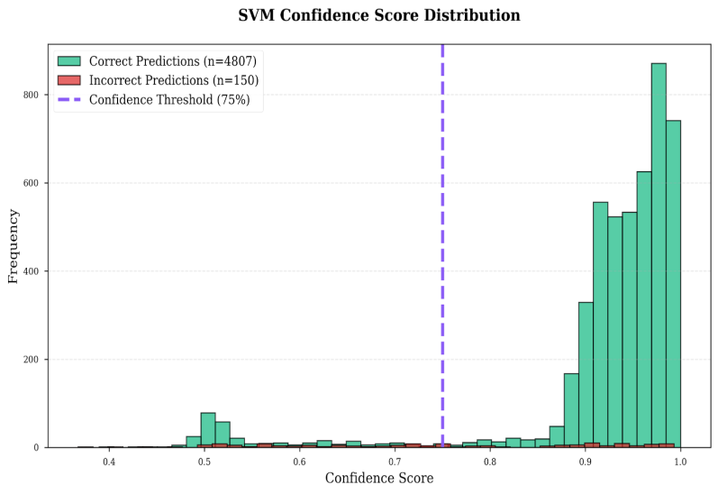
Fig. 3. Distribution of SVM Confidence Scores for Correct and Incorrect Predictions with the Selected Confidence Threshold
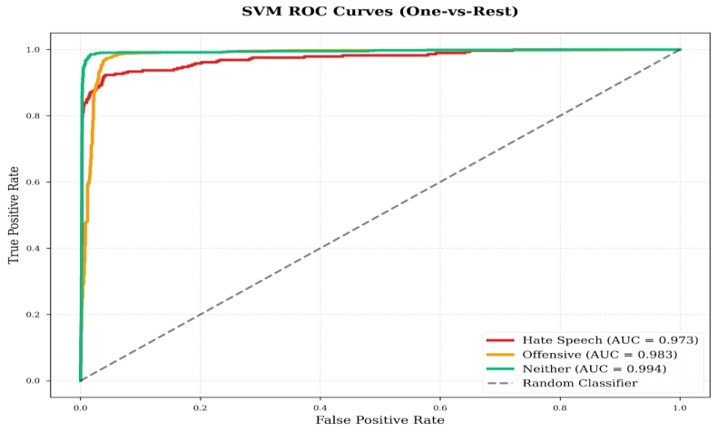
Fig. 4. One-vs-Rest ROC Curves for the Tier-1 SVM Classifier Across Hate Speech, Offensive, and Neutral Classes
Tier-1 functions as the primary decision layer in the proposed framework, rapidly handling straightforward inputs while forwarding only uncertain cases to Tier-2 for deeper analysis. As a result, both its classification accuracy and confidence estimation play a critical role in determining the overall effectiveness of the system.
The one-vs-rest ROC curves shown in Fig. 4 demonstrate the strong class-separation ability of the SVM classifier. In particular, the curves for the offensive and neutral categories reach high true positive rates with only minor increases in false positives, indicating that explicit offensive language and non-harmful content are reliably identified using TF-IDF-based features. The hate speech class shows comparatively weaker separation, reflecting the inherent difficulty of detecting subtle, implicit, or context-dependent hateful expressions when relying mainly on surface-level lexical information. Nevertheless, the ROC analysis confirms that the SVM provides stable and consistent performance, making it an effective and efficient first-stage filter within the hierarchical pipeline.
Further evidence of the SVM’s suitability for confidence-driven routing is provided by the confidence score distribution illustrated in Fig. 3. Correct predictions are predominantly associated with high confidence values, whereas misclassifications are largely concentrated in the lower-confidence range. This clear separation indicates that the confidence estimates produced by the SVM are reliable indicators of prediction uncertainty, supporting their use as the basis for selective escalation to Tier-2.
- BERT Classification Performance
Threshold | Accuracy | Average Latency | BERT Usage
60% | 92.1% | 19 ms | 12.3%
70% | 92.9% | 26 ms | 22.1%
75% | 93.2% | 30 ms | 26.6%
80% | 93.6% | 38 ms | 34.5%
90% | 94.8% | 89 ms | 72.8%

Table 1: Impact of confidence threshold on accuracy, latency, and BERT utilization
The confidence threshold plays a central role in balancing accuracy and inference efficiency. Higher threshold values result in a larger number of inputs being routed to the BERT-based Tier-2 classifier, which improves overall accuracy but also increases system latency. At moderate threshold settings, particularly in the 70–80% range, the system achieves an effective balance: straightforward inputs are resolved efficiently by Tier-1, while genuinely ambiguous cases benefit from deeper semantic analysis in Tier-2. When the threshold is raised further to around 90%, the gains in accuracy become marginal, while latency increases sharply. This behavior highlights the strength of the adaptive design—BERT is highly effective for difficult cases, but applying it indiscriminately significantly undermines system efficiency.
C. Two-Tier System Performance Analysis
As shown in Fig. 5, setting the confidence threshold to τ = 75% allows Tier-1 to handle the majority of inputs, with only a small portion escalated to Tier-2. This selective routing strategy ensures efficient use of computational resources. The benefits of this design are further confirmed in Fig. 6, where the two-tier framework achieves a five-fold reduction in latency compared to a BERT-only system, while incurring only a 3% decrease in accuracy. When compared with an SVM-only approach, the proposed system delivers a 6% improvement in accuracy at the cost of a six-fold increase in latency, a trade-off that is justified by the substantially better detection of subtle and context-dependent hate speech.

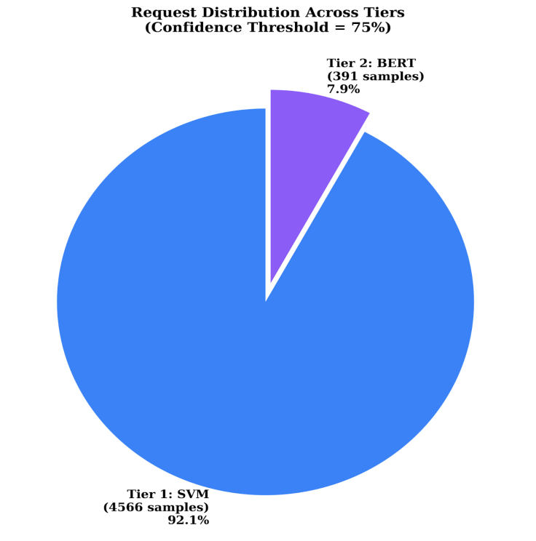
Fig. 5. Distribution of input samples across Tier-1 and Tier-2 classifiers at a confidence threshold of 75%.
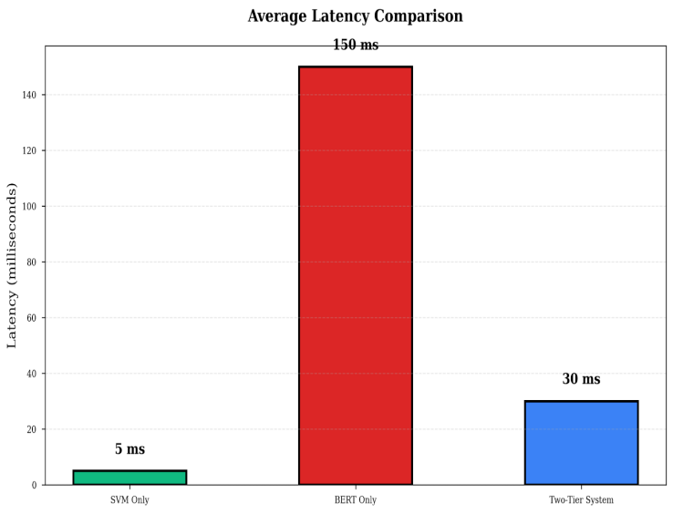
Fig. 6. Average inference latency comparison across SVM-only, BERT-only, and two-tier systems.
System | Accuracy | Average Latency | Throughput
SVM Only | 87.2% | 5 ms | 200 req/s
BERT Only | 96.1% | 150 ms | 6.7 req/s
Two-Tier | 93.2% | 30 ms | 33 req/s

Table 2: System-Level Comparison
Table 2 compares our two-tier system against single-model baselines. SVM-only runs fast (5ms, 200 req/s) but achieves only 87.2% accuracy. BERT-only hits 96.1% accuracy but crawls at 150ms per sample (6.7 req/s)—unacceptable for production. Our two-tier approach achieves 93.2% accuracy at 30ms (33 req/s), splitting the difference intelligently.
VI. CONCLUSION
This work presents a confidence-aware, two-tier hate speech detection framework that addresses the practical challenge of balancing classification accuracy with low inference latency in real-time moderation systems. By integrating a fast SVM-based classifier with a transformer-based BERT model through confidence-driven routing, the system ensures that computationally intensive semantic analysis is reserved only for uncertain inputs. Experimental evaluation shows that the proposed approach achieves performance comparable to a BERT-only model while significantly reducing inference time and increasing overall throughput, making it well suited for deployment at scale. Further analysis of confidence distributions and tier utilization reveals that the majority of inputs can be handled reliably by the lightweight classifier, while selective escalation enhances detection of ambiguous and minority-class hate speech. By jointly optimizing predictive accuracy and system efficiency, this study demonstrates that adaptive hybrid architectures offer a practical pathway for deploying high-quality hate speech detection models within the operational constraints of real-world content moderation pipelines.
REFERENCES
[1] Davidson T, Warmsley D, Macy M, Weber I. Automated systems for identifying offensive vs hateful language. Proc ICWSM. 2017:512-515.
[2] Waseem J, Hovy D. Identifying hate speech on social platforms: Predictive characteristics. NAACL Student Res Workshop. 2016:88-93.
[3] Zhang Z, Robinson D, Tepper J. Detecting harmful social content via neural networks. Eur Semantic Web Conf. 2018:745-760.
[4] Liu Y, et al. Enhanced optimization for bidirectional encoder representations. arXiv:1907.11692. 2019.
[5] Devlin J, et al. Bidirectional transformer pretraining for language comprehension. Proc NAACL-HLT. 2019:4171-4186.
[6] Schmidt A, Wiegand M. Computational approaches for abusive language: A review. Int Workshop NLP Social Media. 2017:1-10.
[7] Fortuna P, Nunes S. Computational methods for detecting harmful textual content: A survey. ACM Comput Surv. 2018;51(4):1-30.
[8] Vidgen N, Derczynski T. Dataset quality for training abusive language classifiers. PLoS ONE. 2020;15(12):1-26.
[9] Cortes C, Vapnik V. Support-vector networks for pattern recognition. MLJ. 1995;20(3):273-297.
[10] Salton G, Buckley C. Term-weighting strategies in automatic text retrieval. IP&M. 1988;24(5):513-523.
[11] Qian K, et al. User-level representation learning for harmful content. Proc NAACL-HLT. 2018:118-123.
[12] Ruder S. Transfer learning in computational linguistics [Dissertation]. National Univ Ireland; 2019.
[13] Ribeiro M, Singh S, Guestrin C. Interpretability of machine learning classification. Proc ACM SIGKDD. 2016:1135-1144.
[14] Guo A, et al. User requirements for interpretable AI. CHI Conf Human Factors. 2019:1-12.
[15] Hochreiter S, Schmidhuber J. Long Short-Term Memory architectures. Neural Comput. 1997;9(8):1735-1780.
[16] Kim Y. Sentence classification using convolutional neural networks. EMNLP. 2014:1746-1751.

