Simple RAG
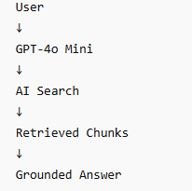
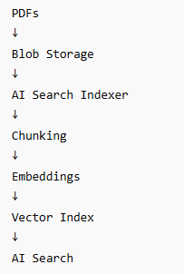
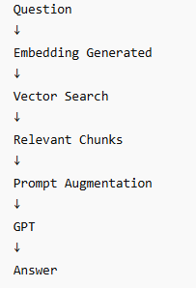

AI Search can store:
- vectors
- chunks
- metadata
- keywords
- semantic indexes
Traditional Open Source Architecture
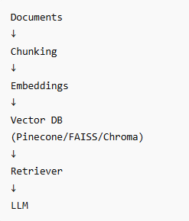

Azure Architecture

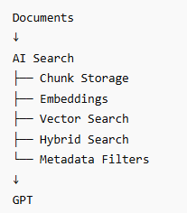

Enterprise RAG Architecture

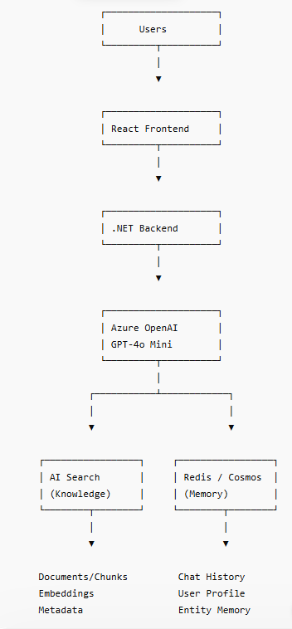

What Azure AI Search Replaces
Open Source World | Azure World
Pinecone | AI Search
Chroma | AI Search
FAISS | AI Search
Elasticsearch | AI Search
Vector Store | AI Search
Semantic Search | AI Search
Metadata Filters | AI Search

What AI Search Does Internally
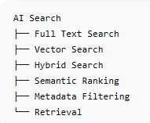

Real Enterprise RAG + Agent Architecture

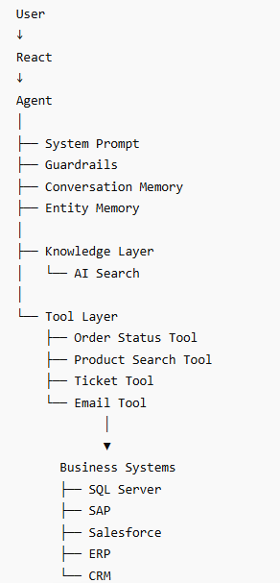

Blob Storage = Document Storage
AI Search = Knowledge Retrieval Layer

GPT = Reasoning Layer

Redis/Cosmos = Memory Layer
Azure Functions = Action Layer

Custom mapping for RAGS
======================
Field | Select
Content Data | ✅ snippet
File Name | ✅ id (or empty if optional)
Title | ✅ snippet
URL | ✅ id

What We Are Building
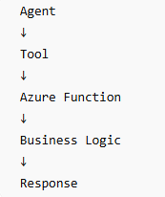

Example:
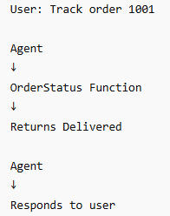

Enterprise Architecture Diagram
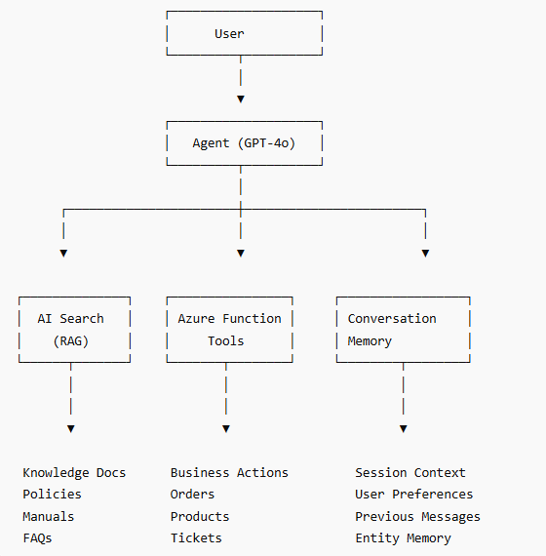

Memory is NOT AI Search.

RAG Memory
Company documents
Stored in:
- Azure AI Search

Conversation Memory
Previous chat messages
Stored in:
- Redis
- Cosmos DB
- SQL

Entity Memory
Example:
{
"preferred_brand": "HP",
"budget": 70000,
"category": "gaming laptop"
}
Stored in:
- Redis
- Cosmos DB

Enterprise Version

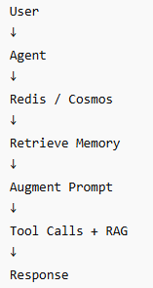

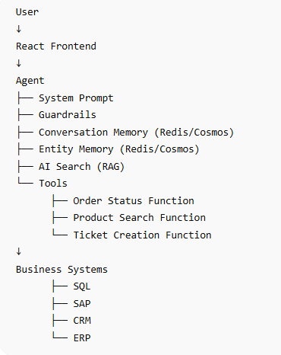

Framework | Status | Role
Semantic Kernel | Maintenance mode | Enterprise connectors, observability — absorbed into MAF
AutoGen | Maintenance mode | Multi-agent research patterns — absorbed into MAF
Azure AI Foundry Agents | Active | The cloud hosting/runtime that MAF deploys to
MAF | GA (v1.0) | The unified pro-code SDK that wraps everything above

MAF unifies research from Semantic Kernel (enterprise connectors and observability) and AutoGen (experimental multi-agent orchestration) into a single open-source SDK, allowing teams to experiment locally and deploy to Azure AI Foundry with built-in observability, durability, and compliance

Quick Summary: When to Use What?
Requirement | Use Copilot Studio | Use MAF + Azure AI Foundry
Primary User | Business Analysts / Low-Code Devs | Software Engineers / Data Scientists
Interface | Visual Drag-and-Drop | Python / .NET Code
Logic Type | Straightforward, linear conversation | Complex, autonomous, multi-agent loops
Integration | Native to Teams, M365, SharePoint | Custom APIs, Databases, Legacy Backend Systems

Real-World Enterprise Applications
- Use Copilot Studio for: An Internal IT Helpdesk Bot. It authenticates the employee via Microsoft 365, checks their SharePoint for troubleshooting guides, and automatically creates a ticket if it can't solve the issue.
- Use MAF + Foundry for: A Supply Chain Disruption Manager. An automated MAF agent constantly monitors weather and shipping data APIs. If a storm hits, it kicks off a workflow: Agent 1 calculates shipping delays, Agent 2 crawls inventory databases for alternative suppliers, Agent 3 drafts new supplier contracts, and a final step pings a human manager via email for approval.

One-Line Summary
Foundry = the cloud platform you deploy to · MAF = the pro-code SDK you build with · Copilot Studio = the low-code UI anyone can use

Azure AI Foundry
Cloud Platform
What it is
The cloud RUNTIME and STUDIO. Hosts agents, manages deployments, provides dashboards, RAG pipelines (AI Search), content safety, and model management. You deploy TO Foundry.
Who uses it
DevOps / MLOps — anyone needing managed cloud hosting without orchestration code.
Use when
→Deploy agents without writing orchestration logic
→RAG via AI Search + managed dashboards
→Usage tracing, model management, content safety
→Your Azure Functions already live here as tools
Not for
Not a programming framework. You deploy TO Foundry, not build IN it.

MAF (Agent Framework)
Pro-Code SDK
What it is
The .NET + Python SDK for building, orchestrating, and deploying agents. The code that drives what Foundry runs. Unified successor to Semantic Kernel + AutoGen (both now maintenance-only).
Who uses it
Software engineers needing full control — your students.
Use when
→Complex multi-agent orchestration (handoff, parallel, sequential)
→Durable workflows that survive restarts
→Human-in-the-Loop approvals in code
→Custom middleware, observability, safety logic
→.NET backend integration with agents

Requires real coding skills.

Copilot Studio
Low-Code / No-Code
What it is
Visual drag-and-drop builder for agents and chatbots on top of Microsoft 365 and Power Platform. Can call MAF agents as custom connectors. Outputs to Teams, SharePoint, websites.
Who uses it
Business analysts, citizen developers, Power Platform users — no coding required.
Use when
→Business user needs a chatbot without code
→Agents embedded in Teams, SharePoint, Dynamics
→Power Automate flows triggered by agent actions
→Expose a MAF agent to non-technical users via UI
→Rapid conversational experience prototyping
Not for
Not for complex orchestration logic, custom code, or high-performance backends.

How They Connect — E-Commerce Scenario
Foundry hosts
your Azure Functions as tools + your AI Search RAG index
MAF calls
those Foundry-hosted tools from .NET / Python code
MAF deploys to
Foundry runtime for monitoring, scaling, dashboards
Copilot Studio wraps
your MAF agents as custom connectors → exposed in Teams

5 Core Primitives
ChatClient
Model abstraction — swap Azure OpenAI / OpenAI / Anthropic with 1 line
AgentSession
Persistent memory across turns — like HttpSession for agents
ContextProvider
Injects dynamic context (RAG results) before each agent turn
Middleware
Intercept execution — logging, safety, rate limiting, tracing
MCP Client
Tool protocol — connects to external tools including your AZ Functions

