Exercise-1:

1. Open Power BI Desktop.
2. In the **Data** section of the **Home** ribbon, select **Excel**.
3. Navigate to where you saved the sample workbook, and select **Open**.
4. Select the **Financials** table, and choose **Transform Data**
5. Select the **Units Sold** column. On the **Transform** tab, select **Data Type**, then select **Whole Number**. Then Choose **Replace current** to change the column type.
6. Select the **Segment** column. On the **Transform** tab, select **Format**, then select **UPPERCASE**.
7. Double-click the **Month Name** column, and rename to just **Month**.
8. Montana product was discontinued last month, so we want to filter this data from our report to avoid confusion. In the **Product** column, select the dropdown and uncheck **Montana.**
9. Back on the **Home** tab, select **Close & Apply**. Our data is almost ready for building a report.

Sigma symbol 🡪 Power BI has detected that those fields are numeric.

calendar symbol 🡪 Power BI indicates the date field

Writing measures and creating tables in the DAX formula language is super powerful for data modeling.

1. Create Measure:

* On the **Home** ribbon, select **New measure**.
* Type this expression to add all the numbers in the Units Sold column.

Total Units Sold = SUM(financials[Units Sold])

* Select the check mark to commit.

1. Create Table:

* Now select the **Table** view on the left.
* On the **Home** ribbon, select **New table**.
* Type this expression to generate a Calendar table of all dates between January 1, 2013, and December 31, 2014.

Calendar = CALENDAR(DATE(2013,01,01),Date(2014,12,31))

* Select the check mark to commit.
* Here is the single-column table you just created.

1. Now select **Model** view on the left.
2. Drag the **Date** field from the financials table to the **Date** field in the Calendar table to join the tables, and create a relationship between them.
3. Build Report:

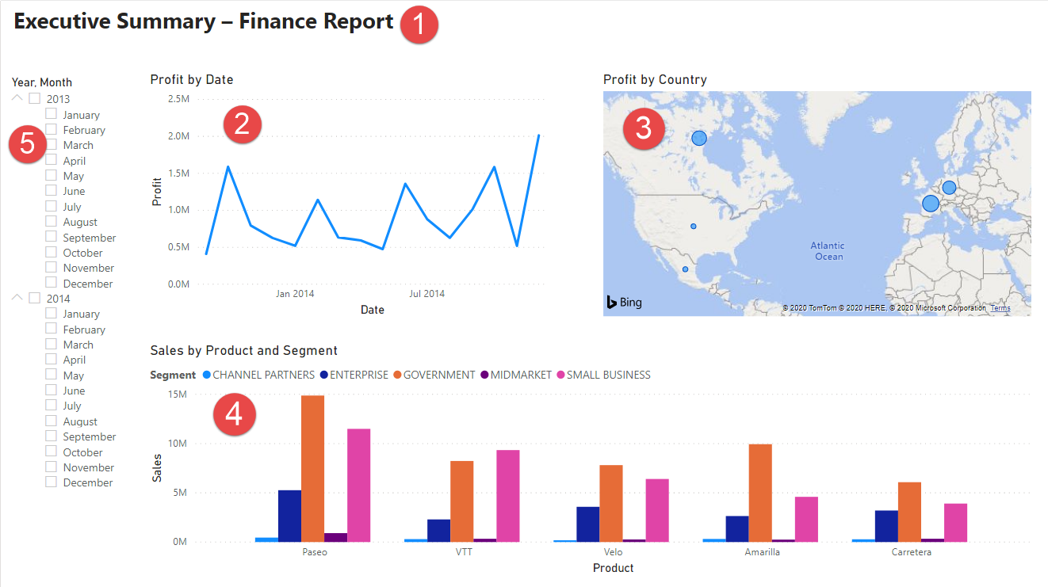

Visual 1: Add a title

1. On the **Insert** ribbon, select **Text Box**. Type “Executive Summary – Finance Report”.
2. Select the text you typed. Set the **Font Size** to 20 and **Bold**.
3. Resize the box to fit on one line.

Visual 2: Profit By Date

1. From the Data pane, drag the **Profit** field to a blank area on the report canvas. By default, Power BI displays a column chart with one column, Profit.
2. Drag the **Date** field to the same visual.
3. In the **Add data to your visual** section of the Visualizations pane, select the drop-down in the **X-axis** value. Change **Date** from **Date Hierarchy** to **Date**.
4. Power BI updates the column chart to show profit for each month.
5. In the Visualizations pane, change the visualization type to **Line chart**. Now you can easily see that December 2014 had the most profit.

Visual 3: Profit By Country / Region

1. From the Data pane, drag the **Country** field to a blank area on your report canvas to create a map.
2. Drag the **Profit** field to the map. Power BI creates a map visual with bubbles representing the relative profit of each location.

Visual 4: Sales by Product and Segment

1. Drag the two charts you've created to be side by side in the top half of the canvas. Save some room on the left side of the canvas.
2. Select a blank area in the lower half of your report canvas.
3. In the Data pane, select the **Sales**, **Product**, and **Segment** fields.

Power BI automatically creates a clustered column chart.

1. Drag the chart so it's wide enough to fill the space under the two upper charts.

Visual 5: Year Slicer

Slicers are a valuable tool for filtering the visuals on a report page to a specific selection.

**Date slicer using the original table**

1. In the Data pane, select the **Date** field in the Financials table. Drag it to the blank area on the left of the canvas.
2. In the Visualizations pane, choose **Slicer**.

**Date slicer using the DAX table**

1. In the Data pane, select the **Date** field in the Calendar table. Drag it to the blank area on the left of the canvas.
2. In the Visualizations pane, choose **Slicer**.
3. In the Data section of the Visualizations pane, select the drop-down in **Data**. Remove Quarter and Day so only Year and Month are left.
4. Expand each year and resize the visual, so all months are visible.

**Format the Report:**

1. **Theme**

* On the **View** ribbon, change the theme to **Executive**.

1. Make the following changes on the **Format** tab in the Visualizations pane.

* Select Visual 2. In the **Title** section, change **Title text** to “Profit by Month and Year” and **Text size** to **16 pt**. Toggle **Shadow** to **On**.
* Select Visual 3. In the **Map styles** section, change **Theme** to **Grayscale**. In the **Title** section, change title **Text size** to **16 pt**. Toggle **Shadow** to **On**.
* Select Visual 4. In the **Title** section, change title **Text size** to **16 pt**. Toggle **Shadow** to **On**.
* Select Visual 5. In the **Selection controls** section, toggle **Show "Select all" option** to **On**. In the **Slicer header** section, increase **Text size** to **16 pt**.

**Add a background shape for the title**

1. On the **Insert** ribbon, select **Shapes** > **Rectangle**. Place it at the top of the page, and stretch it to be the width of the page and height of the title.
2. In the **Format shape** pane, in the **Border** section, change **Transparency** to **100%**.
3. In the **Fill** section, change **Fill color** to **Theme color 5 #6B91C9** (blue).
4. On the **Format** tab, select **Send backward** > **Send to back**.
5. Select the text in Visual 1, the title, and change the font color to **White**.

**Add a background shape for visuals 2 and 3**

1. On the **Insert** ribbon, select **Shapes** > **Rectangle**, and stretch it to be the width and height of Visuals 2 and 3.
2. In the **Format shape** pane, in the **Border** section, change **Transparency** to **100%**.
3. In the **Fill** section, set the color to **White, 10% darker**.
4. On the **Format** tab, select **Send backward** > **Send to back**.

**Finished Report:**

In summary, this report answers your manager’s top questions:

* Which month and year had the most profit?
* Which country/region is the company seeing the most success in?
* Which product and segment should the company continue to invest in?