# ITChamps Software Private Limited

# Performance Appraisal

# Employee/Manager End User Manual

**1. Login to iEmpPower**

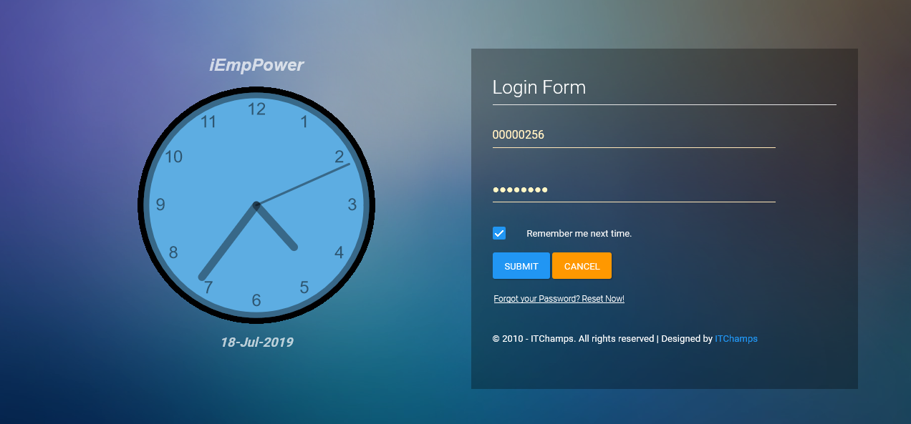

**2. Click on Employee Performance** **Menu**

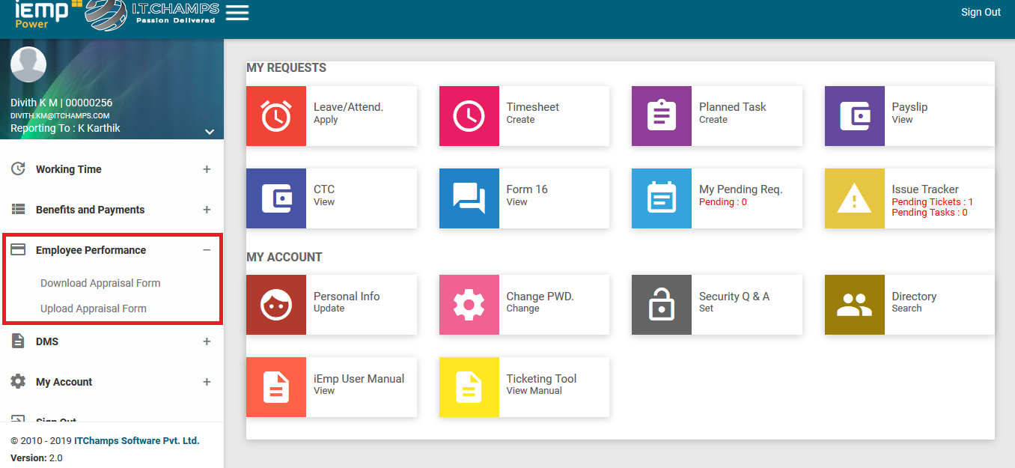

2.1 Navigate to Download Appraisal Form -> Click on Self-Appraisal TAB

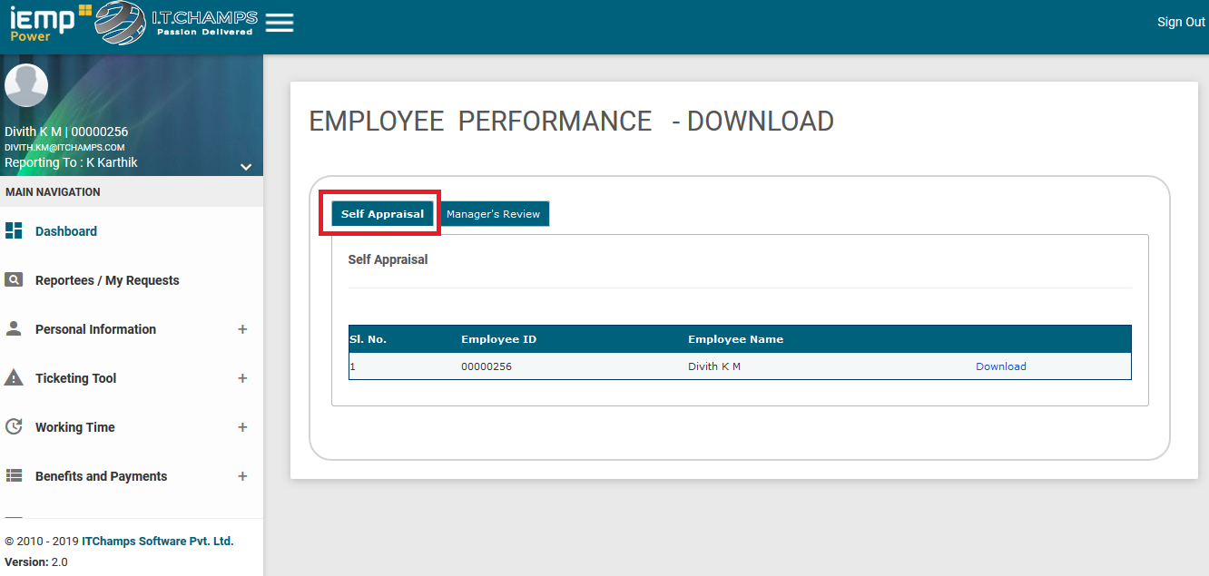

2.2 Click on the download option against the file.

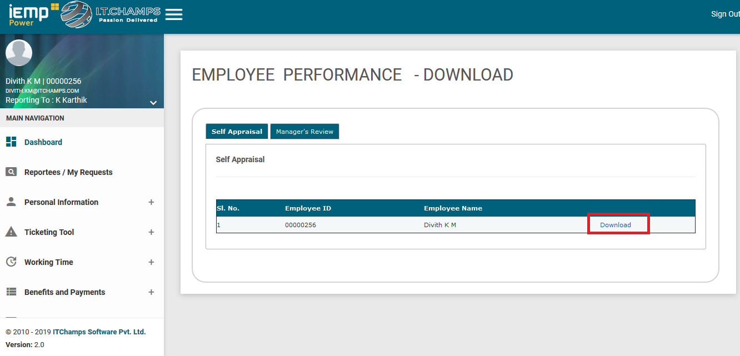

2.3 Save or download the pdf to your local drive (Eg. Desktop).

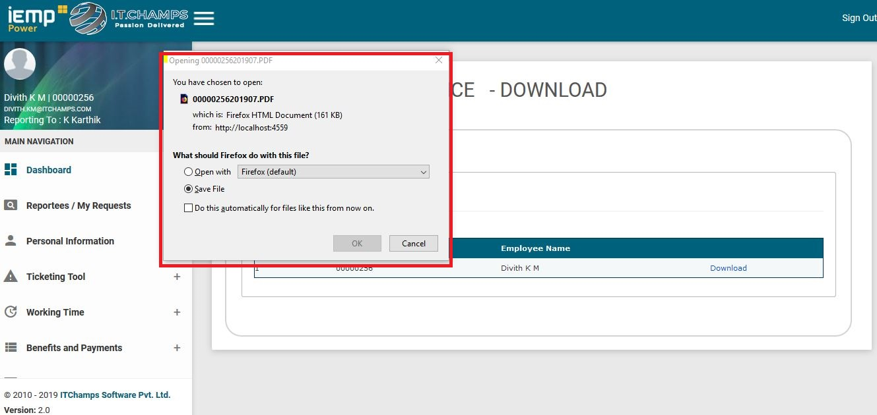

2.4 Navigate to Upload Appraisal Form -> In Self-Appraisal TAB, **Upload the employee rating filled PDF file**.

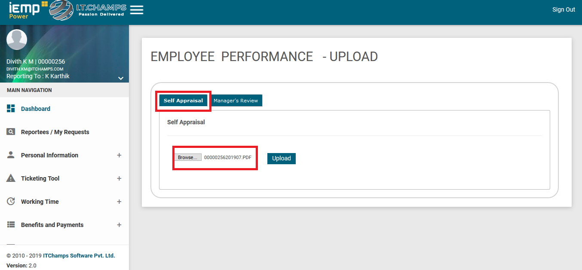

Note: **If file already uploaded error will be displayed (only 1 file can be uploaded).**

**3. Manager Process**

3.1 Navigate to Download Appraisal Form -> In Manager’s Review TAB

* Download all your subordinate’s form available.

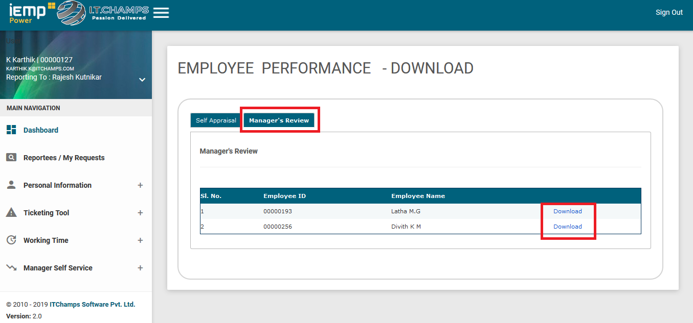

3.2 Navigate To Upload Appraisal Form - > In Manager’s Review TAB

* Upload each subordinate form.

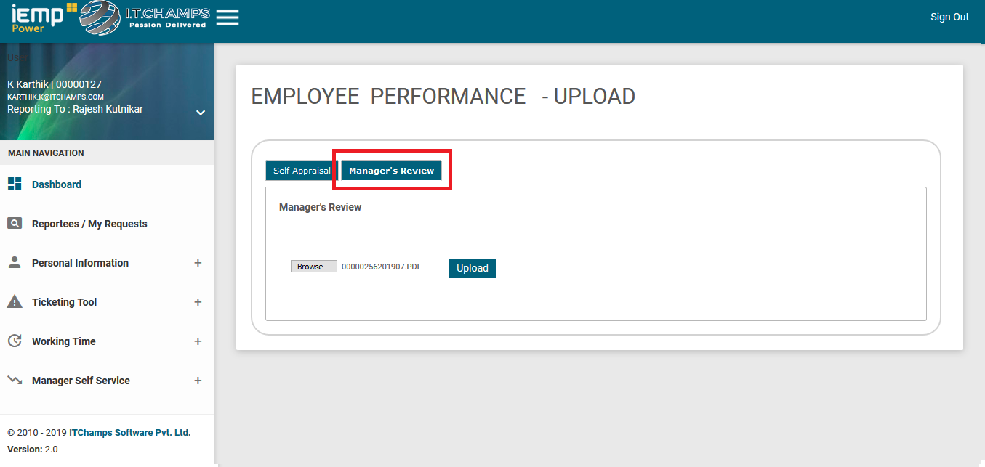

Note: **Only one form can be uploaded at a time,**

**For every form uploads, mail will be sent.**