Rangsons Electronics

A CYIENT COMPANY

**Travel Management**

**End User Manual**

**Travel Management Process for RANGSONS ELECTRONICS**

* The Travel Process in Rangsons Electronics consists of 2 types, which are as follows:

1. Domestic Travel Request & Travel Claims

* Domestic Travel Request has Functional Head Approval
* Domestic Travel Claims has Functional Head & Travel Administrator Approval

1. International Travel Request & Travel Claims

* International Travel Request has Functional Head & CEO Approval
* International Travel Claims has Functional Head & Travel Administrator Approval

**Accessing the Travel Management through IEMPPOWER**

* Employee would access Travel Request by logging into the IEMPPOWER at **iemppower.rangsons.com** and selection “**Travel Management** “ 🡪 “**Travel Requests**” 🡪 “**Requisitions**”
* Manger would access the Employee Travel Request sent for approval by logging into the IEMPPOWER at **iemppower.rangsons.com** and selection “**Travel Management** “ 🡪 “**Travel Requests**” 🡪 “**Required For Approval**”
* Employee would access Travel Claims by logging into the IEMPPOWER at **iemppower.rangsons.net** and selection “**Travel Management** “ 🡪 “**Travel Claims**” 🡪 **“Claim Requests”**
* Manger would access the Employee Travel Claim sent for approval by logging into the IEMPPOWER at **iemppower.rangsons.com** and selection “**Travel Management** “ 🡪 “**Travel Claim**” 🡪 “**Approve Claim Requests**”

**Domestic/International Travel Request - Employee**

* Employee Logs in to the **IEMPPOWER** Portal using his Login Credentials



* Employee to create Travel Requests (Domestic & International ) Selects “**Travel Management**” 🡪 “ **Travel Requests**” 🡪 “**Requisitions**”

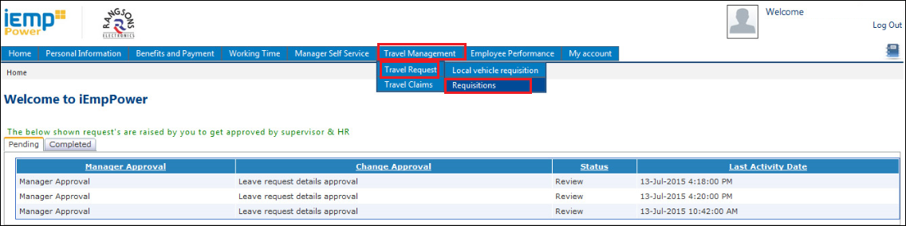

* Click on **Requisition** below screen appears.
* Employee would be able to create both Domestic & International Request as shown below.

**Domestic Request screen** 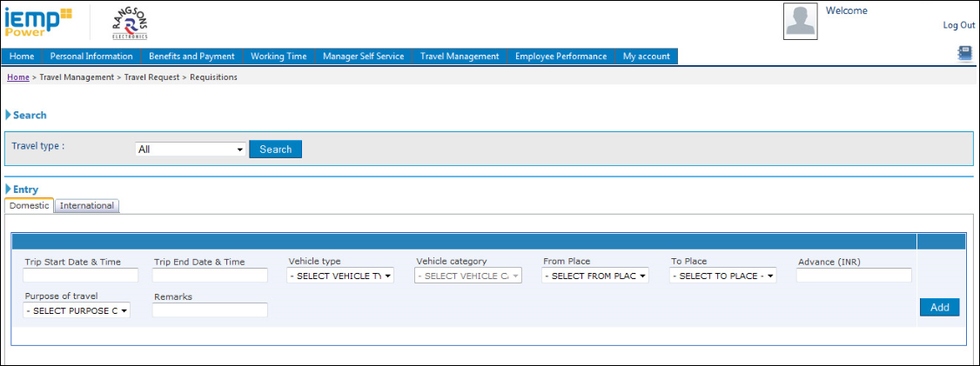

**International Request Screen**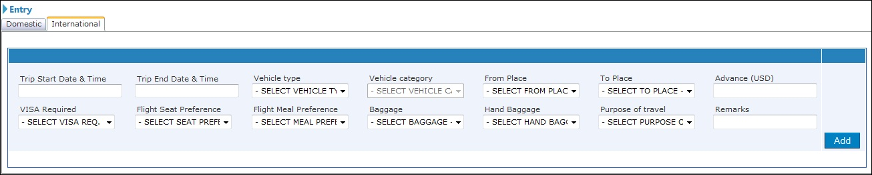

* Employees enter all the Travel Details in the screen shown below and click on 
* Once added where Employees are able to request for the Vehicle & Accommodation for the same Request before he sends for approval as shown below .

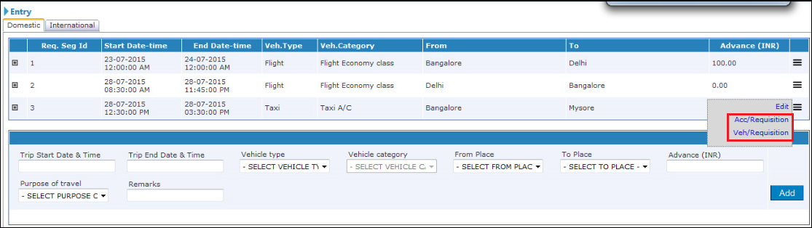

* Select the Type of Requests (Vehicle/Accommodation) below screen as shown.

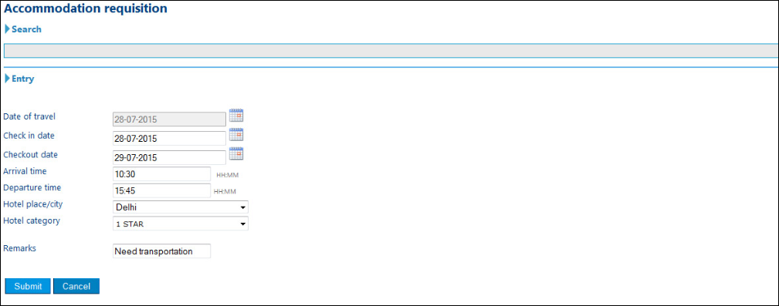

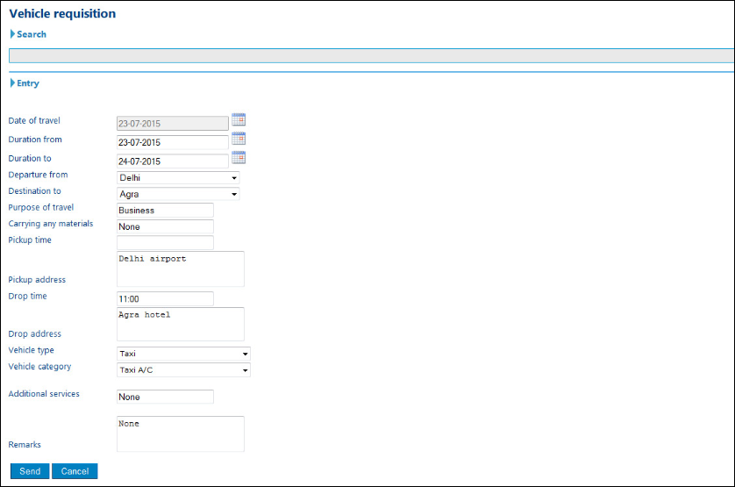

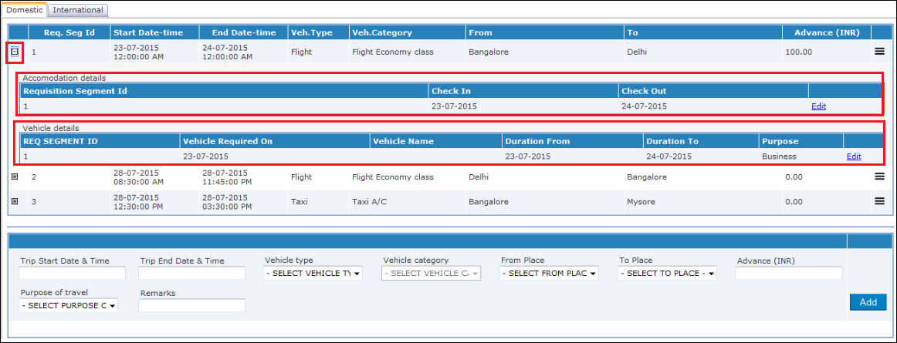

* Once Entered all the details by employee he Send for Approval to “**Functional** **Head**” by selecting the corresponding option as highlighted below.

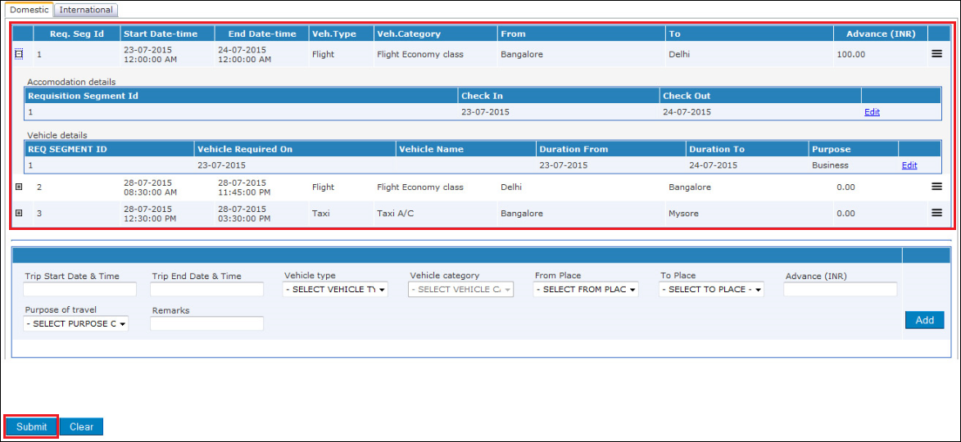

* As Highlighted above together called as One Trip , where it consists of all the ways of the Trip. Once SUBMIT it goes to his/her Reporting Manager as shown below.

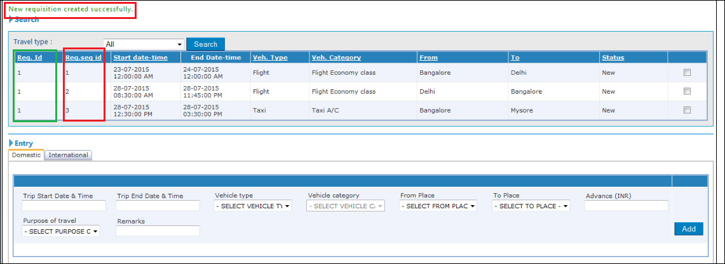

* As highlighted in Green shows the One Travel Request Number where it consists of segments of Trips (Additional Destinations)in one Trip.

**Domestic/International Travel Request Approval – Functional Head**

* Functional Manager logs into the IEMPPOWER using his login credentials and selects “**Travel Management**” 🡪 “ **Travel Requests**” 🡪 “**Required For Approval**” as shown below



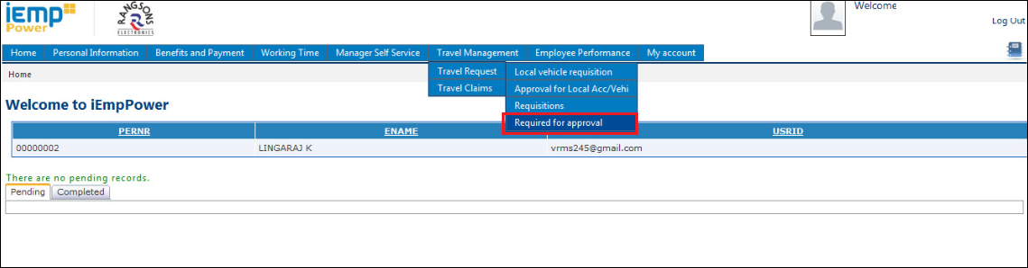

* Functional Head select the particular Trip Segment and by selecting the **View Details** he/she will be able to see the submitted Travel Requested details of the Trip as shown below.

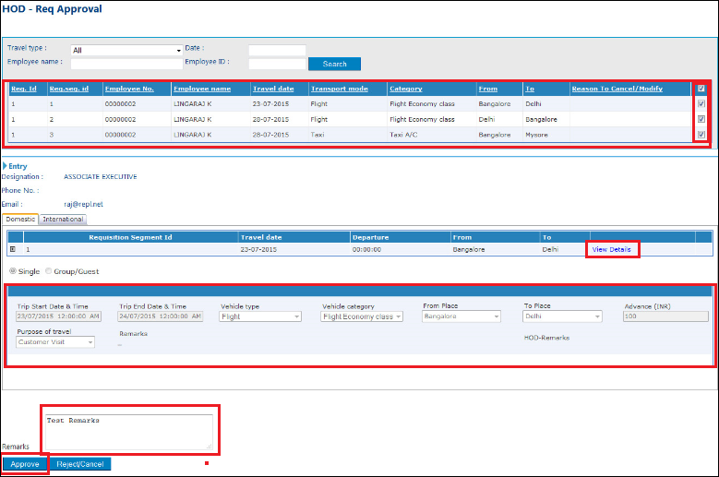

* Once the review and the Remarks are completed by the Functional Head, the Functional Head has the option to “**Approve**” or “**Reject/Cancel**” the Travel Request Submitted by the Employee.
* Once Approved by the Functional Head, Employee will be Notified.
* If any Advance Requested – FI Administrator will be Notified to do the Payment Settlement.

**Domestic/International Travel Claim Request - Employee**

* Employee Logs in to the **IEMPPOWER** Portal using his Login Credentials to create the Travel Claim against the Trip which approved by his/her Functional Head.



* Employee to create Travel Claims (Domestic & International ) Selects “**Travel Management**” 🡪 “ **Travel Claim**” 🡪 “**Claim Request**”

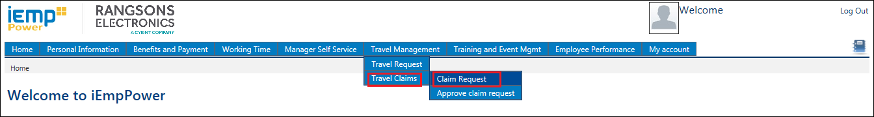

* Click on **Claim Request** below screen appears.
* Employee should select the Trip for which the Claims to be requested, once selected he should be Entering the feedback Form of the Travel as shown below.

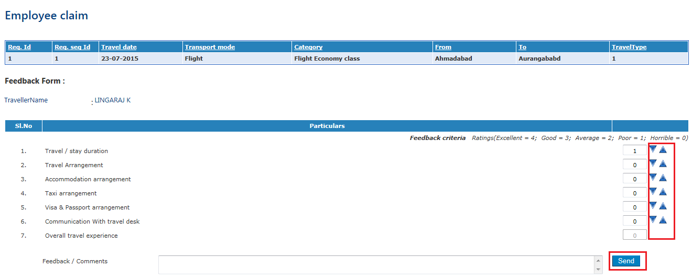

* Maintain the Ratings for the Feedback Form with comments and click on **SEND**



* Once sent he will be able to Enter the Travel Claims against the Trip as shown below.

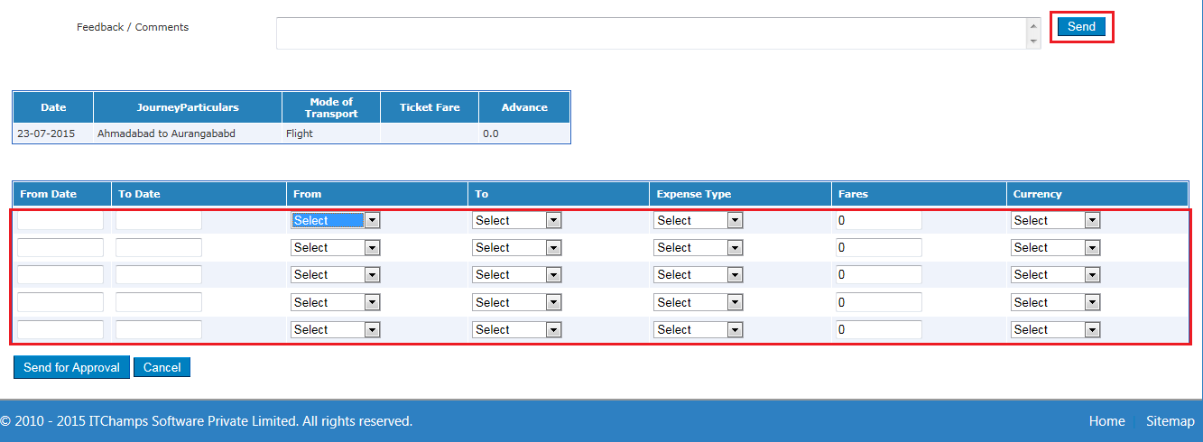

* Once Maintained with all the details it should be sent to his/her Functional Head for the approval by clicking on the **SEND FOR APPROVAL.**

**Domestic International Travel Claim Approval – Functional Head & Travel Admin**

* Functional Head Logs in to the **IEMPPOWER** Portal using his Login Credentials to Approve Travel Claim sent by the Employee.



* Functional Manager selects “**Travel Management**” 🡪 “ **Travel Claims**” 🡪 “**Approve Claim Requests**” as shown below.

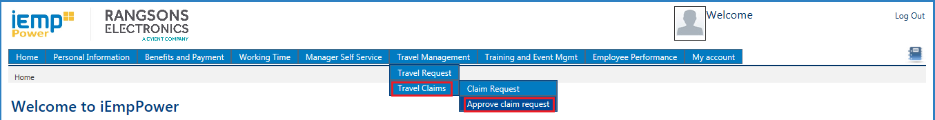

* Once selected **Approve Claim Request** belowscreen appears.
* Functional Head will able to view the complete details of the Travel Claim against each Travel Segment he/she sent for approval.

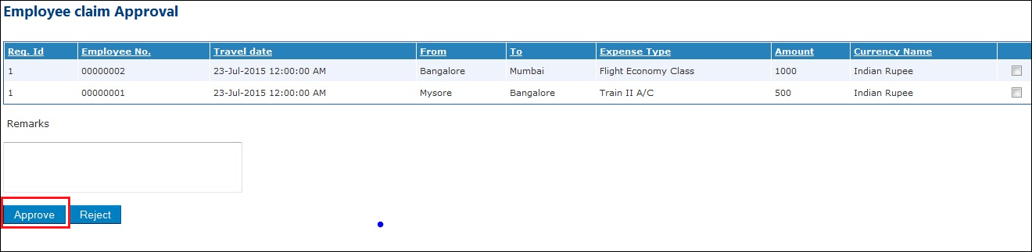

* Once confirmed Functional Head can **Approve** or **Reject** the Travel Claim submitted by Employee.
* On Approval, Employee will be notified on the approval
* FI admin will be notified to do the Payment.