USER MANUAL

TRAVEL MANAGEMENT FI POSTING

**(Travel Advance & Travel Expenses Posting)**

Settlement of Advance& Claims

* Once the Travel Request with advance approved by Functional Head.
* Advance has to be settled before it can be posted to **FI**
* Transaction Code : **PREC**

**Menu Path:** From the SAP Easy Access screen, choose Human Resources 🡪 Travel Management 🡪 Travel Expenses🡪Periodic Processing🡪Settle Trips

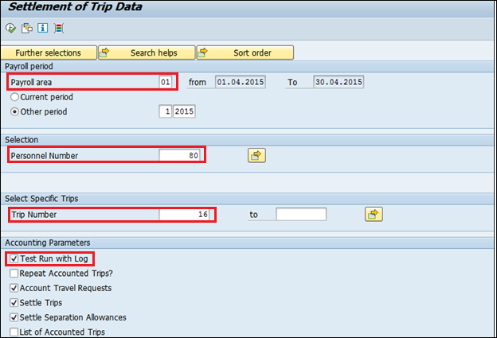

Select Payroll Area as **01** for **RANGSONS**

Check Test Run with Log and execute.

Once the Settlement run is successful, remove the check and execute live run.

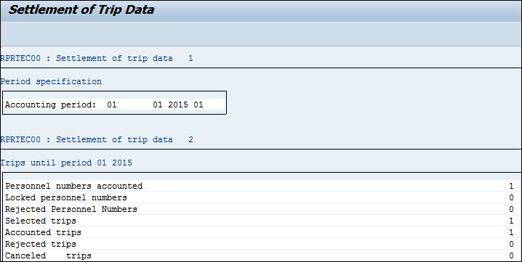

Create Posting Run for Advance

* In a posting run, the results of travel expense settlement are collected as trip transfer documents for [transfer to Accounting](http://help.sap.com/saphelp_erp60_sp/helpdata/en/b6/cd9ea249e911d189060000e8322f96/content.htm).
* After the advance has been settled, posting run including trip documents are created
* Transaction Code **PRFI**
* **Menu Path:** From the SAP Easy Access screen, choose Human Resources 🡪 Travel Management 🡪 Travel Expenses 🡪Periodic Processing🡪Transfer to Accounting🡪Create Posting Run

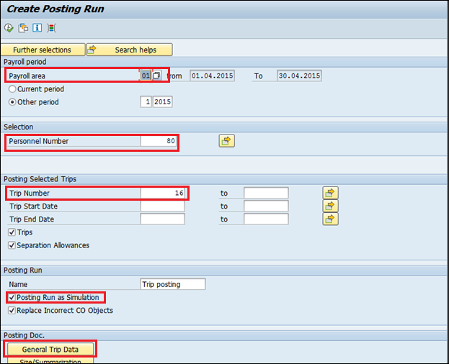

Select Payroll Area as 01 for **RANGSONS**

* Enter the Personnel Number, Trip Number, to be included in the Posting Run.
* Check the Posting Run as Simulation
* In General Trip Data maintain the Document Type **TR** as shown Below

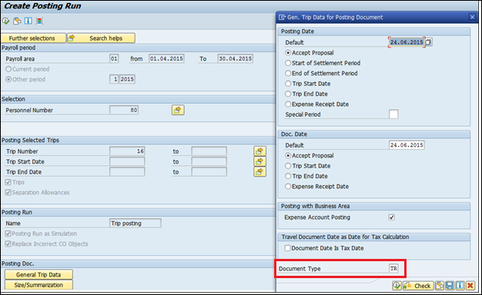

* Execute  once maintained the document type **TR**.
* And Execute  the Report with all the data maintained.
* Once executed it says that it has Included in posting run as shown below.

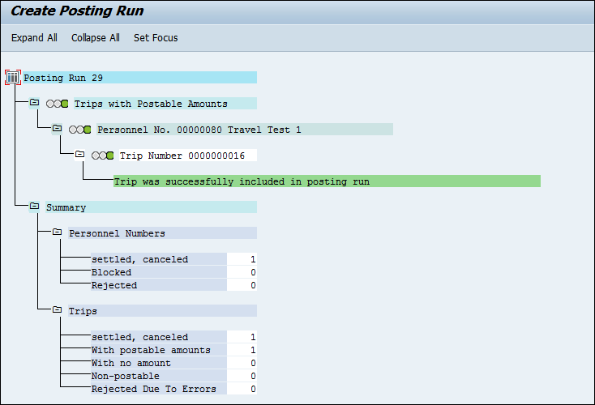

* Once confirmed, remove Posting Run as simulation checkbox from the previous run and run the Live Run to include in posting run

Manage Posting Run for Advance

* Trip documents created as part of Posting Run have to be posted to FI so that payment can be made through FI.
* Transaction Code – **PRRW**

**Menu Path:** From the SAP Easy Access screen, choose Human Resources 🡪 Travel Management 🡪 Travel Expenses🡪Periodic Processing🡪Transfer to Accounting🡪Manage Posting Run

* Click on Execute  icon as below

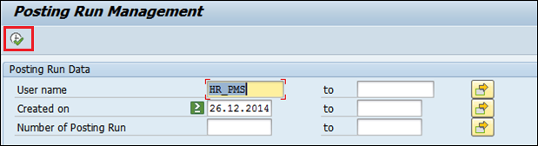

* Once Executed the following screen is displayed:

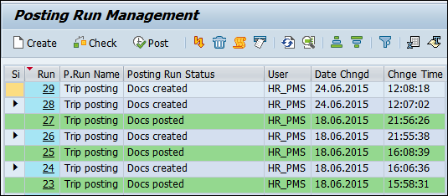

**Important:-**Posting run marked as  is the document created as part of Simulation Posting run. This cannot be posted to FI. As shown below

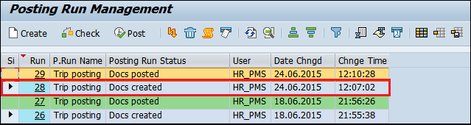

Double Click on the Live Posting Run 29. Following below screen is displayed:

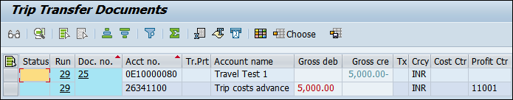

Select the Posting run 29 as below and click on  & 

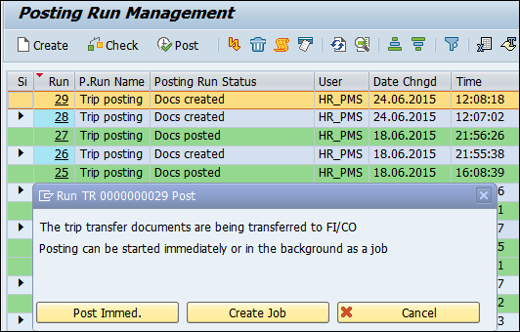

Following Screen is displayed as below: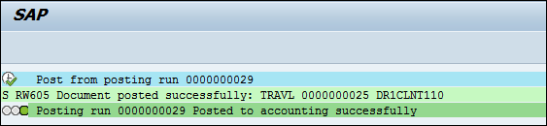

Click on the “Back” . Following screen is displayed:

The green color indicates that the documents have been successfully posted to FI. The status of the posting run is now “Docs Posted”.

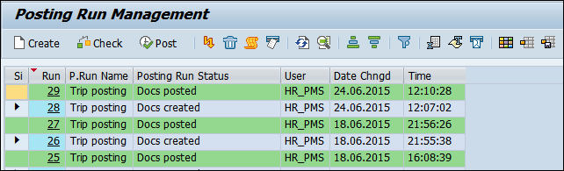

* FI Entry in **FBL1N.**

Following Screen is displayed as below

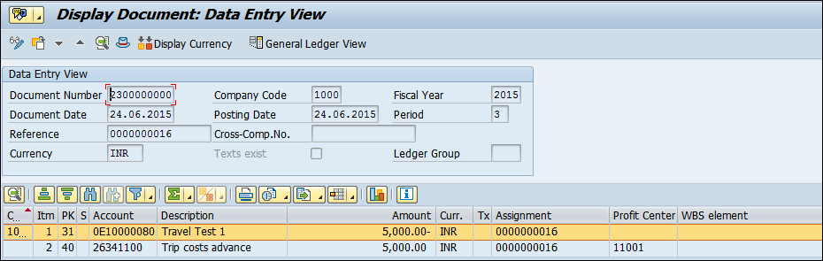

Report-Travel Advance& Travel Claim

* Report is used to get the Employee Travel Expenses & FI Posted details.
* Report Name : **ZHR_TRV_TOTAL_EXPENSES**
* Transaction Code **: ZHR_TRV_EXP**

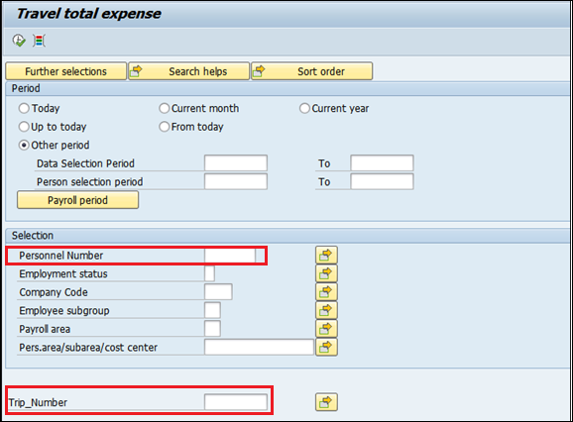

* Enter the Personnel Number and Trip Number as highlighted above and then Execute .
* Once Executed whereas u get the completed details of the Employee Travel details for the particular Trip number which was passed on the selection screen.
* To get the employee complete travel details of all the trip, enter the Personnel Number and then execute  to get the details.
* Once executed Employee Travel Details with FI posting date & vendor details are displayed as shown below.

