**Amrita Assistant Telegram Bot Documentation**

Bot available at: // Online address.

Bot designed for: users to save time and to help them for their needs in campus.

Bot was designed using: Telegram bot API and Mongo Database.

Bot can help you in: Knowing about faculty of any branch, local bus timings, locations, events in campus, workshops being conducted in campus, exam time table, auto rickshaw driver contact numbers, helpline numbers.

**Note:** Our team is working on many services to serve users comfort; you will be notified if there are any new services being implemented. You can request for a service by contacting our team through mail, if we feel that service would be helpful or useful to students we would surely try to bring that service into use.

**How to use bot:**

**🡪** When you are using bot for the first time you have this type of image on your screen.

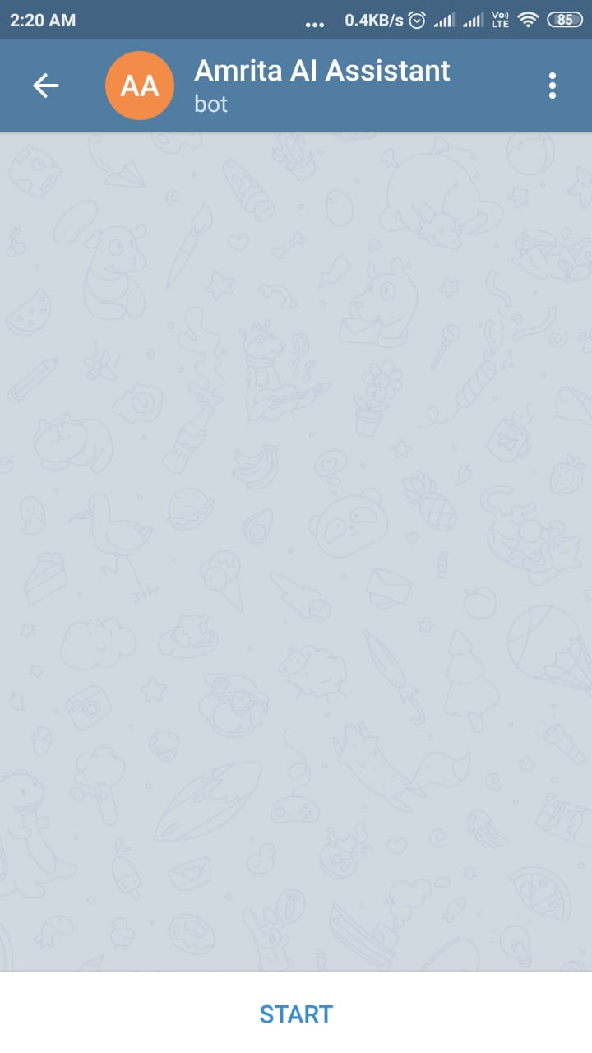

**Just click on START to use the bot.**

**You get this on your screen**

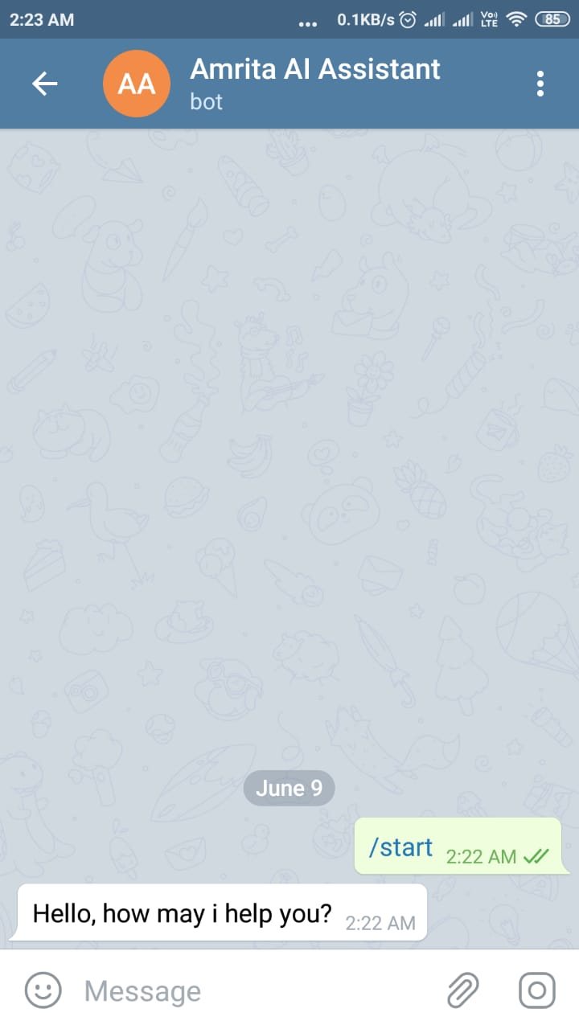

* You get the same reply even if you say hi or hello ☺
* If you are not getting any reply from it means that either you are not connected to internet or there’s a server issue which needs to be modified by our team. Just contact your team if bot is not responding for your commands so that we can check the problem and start the service again.

Bot replies instantaneously for your search queries.  
To use services you need to send your requirement as a message to bot, it processes the data and replies you immediately.

INPUTS:   
For bus service:  
* Send ksrtc `to place which you want to reach` to know government bus service details. [Example: ksrtc karunagappally]

* You need to type ksrtc first and then give space enter the place you wanted to reach.

*Are you feeling still confused?   
No problem I will show you demo.

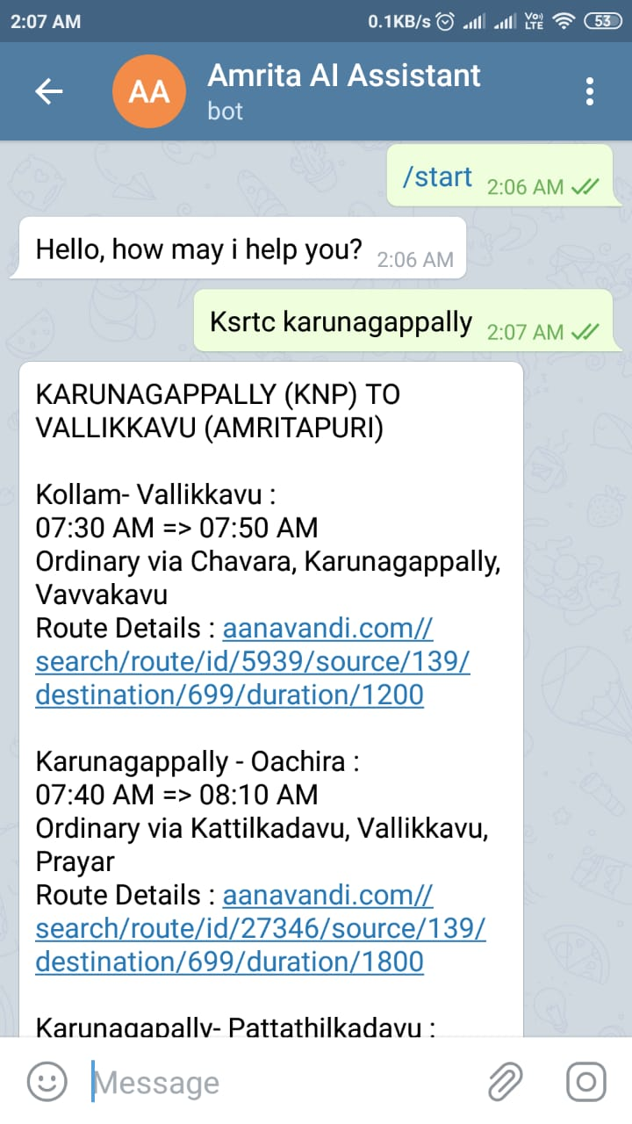

In the same way you can use the service for places giving mentioned input to bot.

* Karunagappally or kply or knp   
[To know bus details that reach out to Karunagappally]  
  
* Kayamkulam or kylm or kym or kyj  
[ To know bus details that reach out to Kayamkulam]

What if you need private services?

Just give bus and place name which you want to reach.  
For example: bus oachira or bus Karunagappally

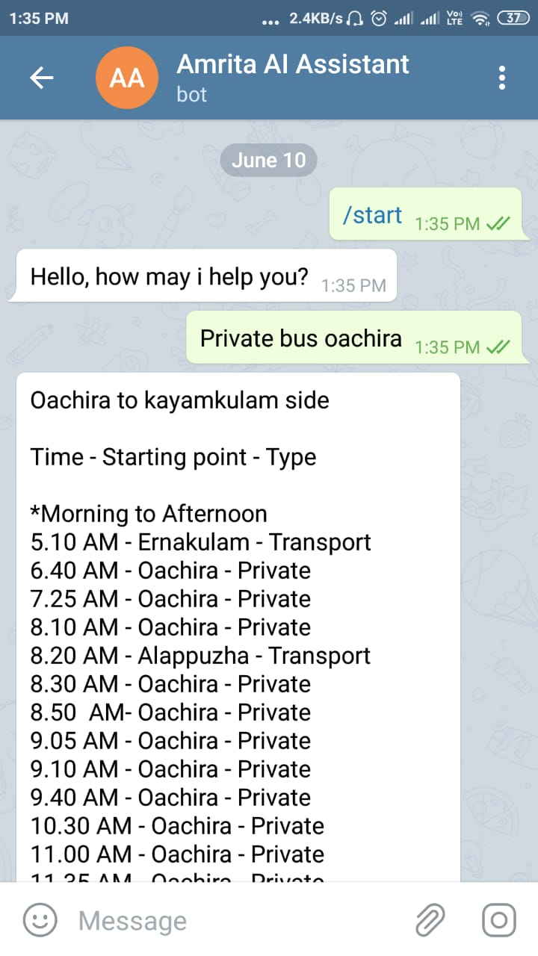

What if you want to know faculty details?  
Use this command

* Faculty branch that faculty belongs to.  
  Example: faculty ece  
  [You will be message with all the faculty details of branch ECE]

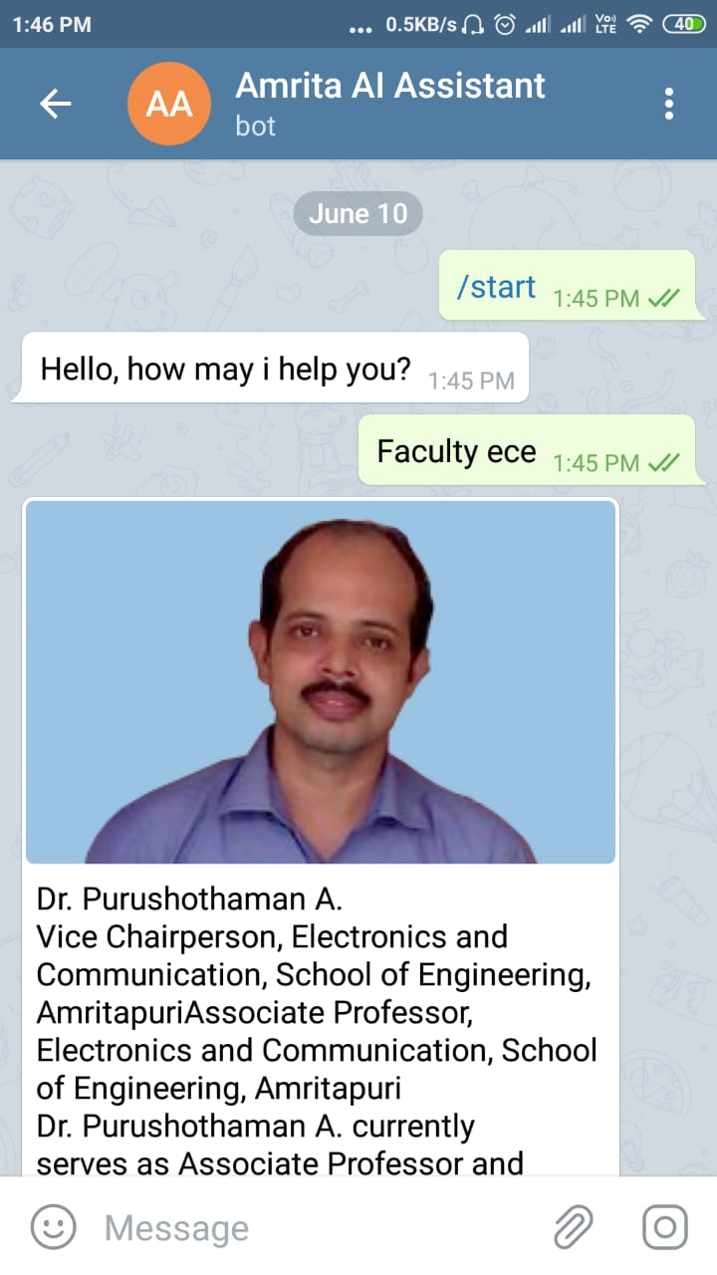

Similarly you can use this service for

CSE, MECH, EEE, ENGLISH, CHEMISTRY, PHYSICS, ASAS, MATHEMATCIS, BIOTECH and BBA.

Exam Time table for all branches and all semesters

* To use this service first select ASE or ASAS,
* Next select any of them either p1 exam time table or p2 exam time table or sem exam time table,
* Select the required semester either s1 or s2 or s3 …….
* You will be provided with file to view online or download the file  
    
  Example:  
    
  For ASE  
  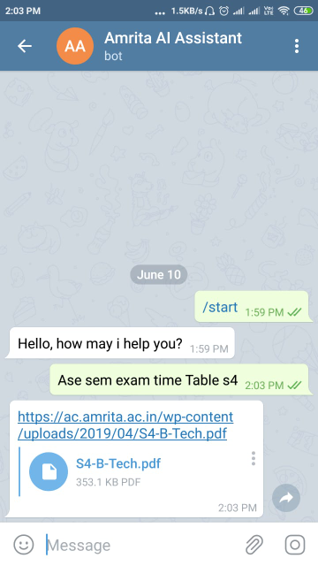

For ASAS

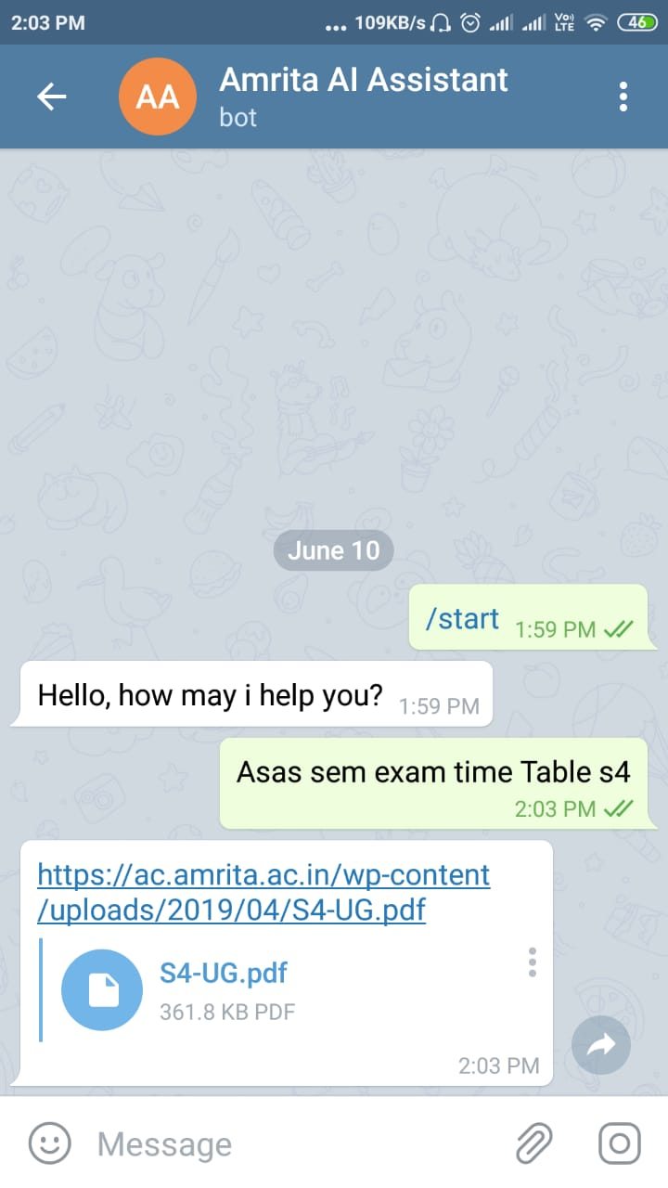

Using commands like:

* Auto - [ Lets you the contact details of auto rickshaw drivers]
* Helpline - [ lets you the contact details]
* Event or workshop - [ lets you know the events and workshop being conducted in the campus]
* Quote - [Lets you the AMMA’S [Mata Amritanandamayi Devi] quotes]
* Bug - [Provides you with email details of our team so that you can mail us if you find a bug]