**REPORT**

**Project Overview:**

The Shopping Assistant is a full-stack application developed using **Flask** on the backend, with a client-side interface built in **HTML** and **JavaScript**. The application enables users to interact conversationally to manage an online shopping experience, allowing them to search for products, add/remove items from a cart, track orders, get product recommendations, and perform various other shopping-related tasks. It leverages the **Ollama model** for natural language processing, facilitating realistic, human-like responses to user queries.

**Features and Capabilities:**

**Flowchart:**

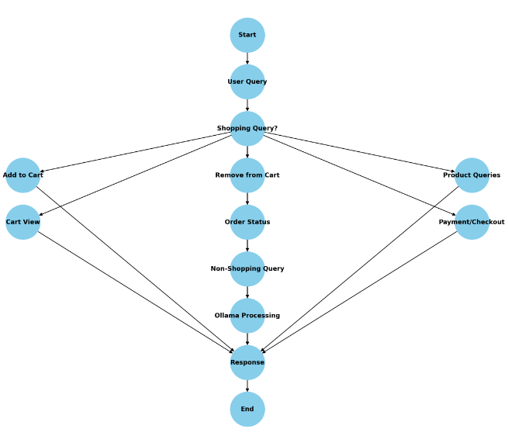

**Test cases:**