KARNATAK LAW SOCIETY’S

GOGTE INSTITUTE OF TECHNOLOGY

UDYAMBAG, BELAGAVI-590008

(An Autonomous Institution under Visvesvaraya Technological University, Belagavi)

**(APPROVED BY AICTE, NEW DELHI)**

Department of Electronics and Communication Engineering



*An Internship Report on*

**Configuration and testing of RTC, on ARM7 LPC2148 Processor**

*Submitted in the partial fulfillment for the award of the degree of*

**Bachelor of Engineering**

**In**

***Electronics and Communication Engineering***

*Submitted by*

**Pavan v. Kulkarni**

**2GI17EC416**

Internship Carried Out

at

Vayavya Labs Pvt.Ltd, Tilakwadi, Belagavi

**Internal Guide** **External Guide**

Deepak Kulkarni Veeresh Ambe

(Asst. Professor)

**2019–2020**

KARNATAK LAW SOCIETY’S

GOGTE INSTITUTE OF TECHNOLOGY

UDYAMBAG, BELAGAVI-590008

(An Autonomous Institution under Visvesvaraya Technological University, Belagavi)

**(APPROVED BY AICTE, NEW DELHI)**

Department ofElectronics and Communication Engineering

 

**CERTIFICATE**

Certified that the internship entitled **Configuration and testing of RTC, on ARM7 LPC2148**

**Processor**done at **Vayavya Labs Pvt.Ltd, Tilakwadi, Belagavi** is a bona-fide work carried out by **Mr. Pavan V. Kulkarni**,**USN 2GI17EC416**, in partial fulfillment for the award of **Bachelor of Engineering**in Electronics and Communication of the Visvesvaraya Technological University, Belagavi during the year 2019- 2020.

It is certified that all corrections/suggestions indicated have been incorporated in the report. The internship report has been approved as it satisfies the academic requirements in respect of Internship prescribed for the said Degree.

Signature of the Guide        Signature of the HOD    Signature of the Principal

**External Viva-Voce**

|  |  |  |  |
| --- | --- | --- | --- |
|  | **Name of the examiners** | **Date of Viva -voce** | **Signature** |
| **1.** |  |  |  |
| **2.** |  |  |  |

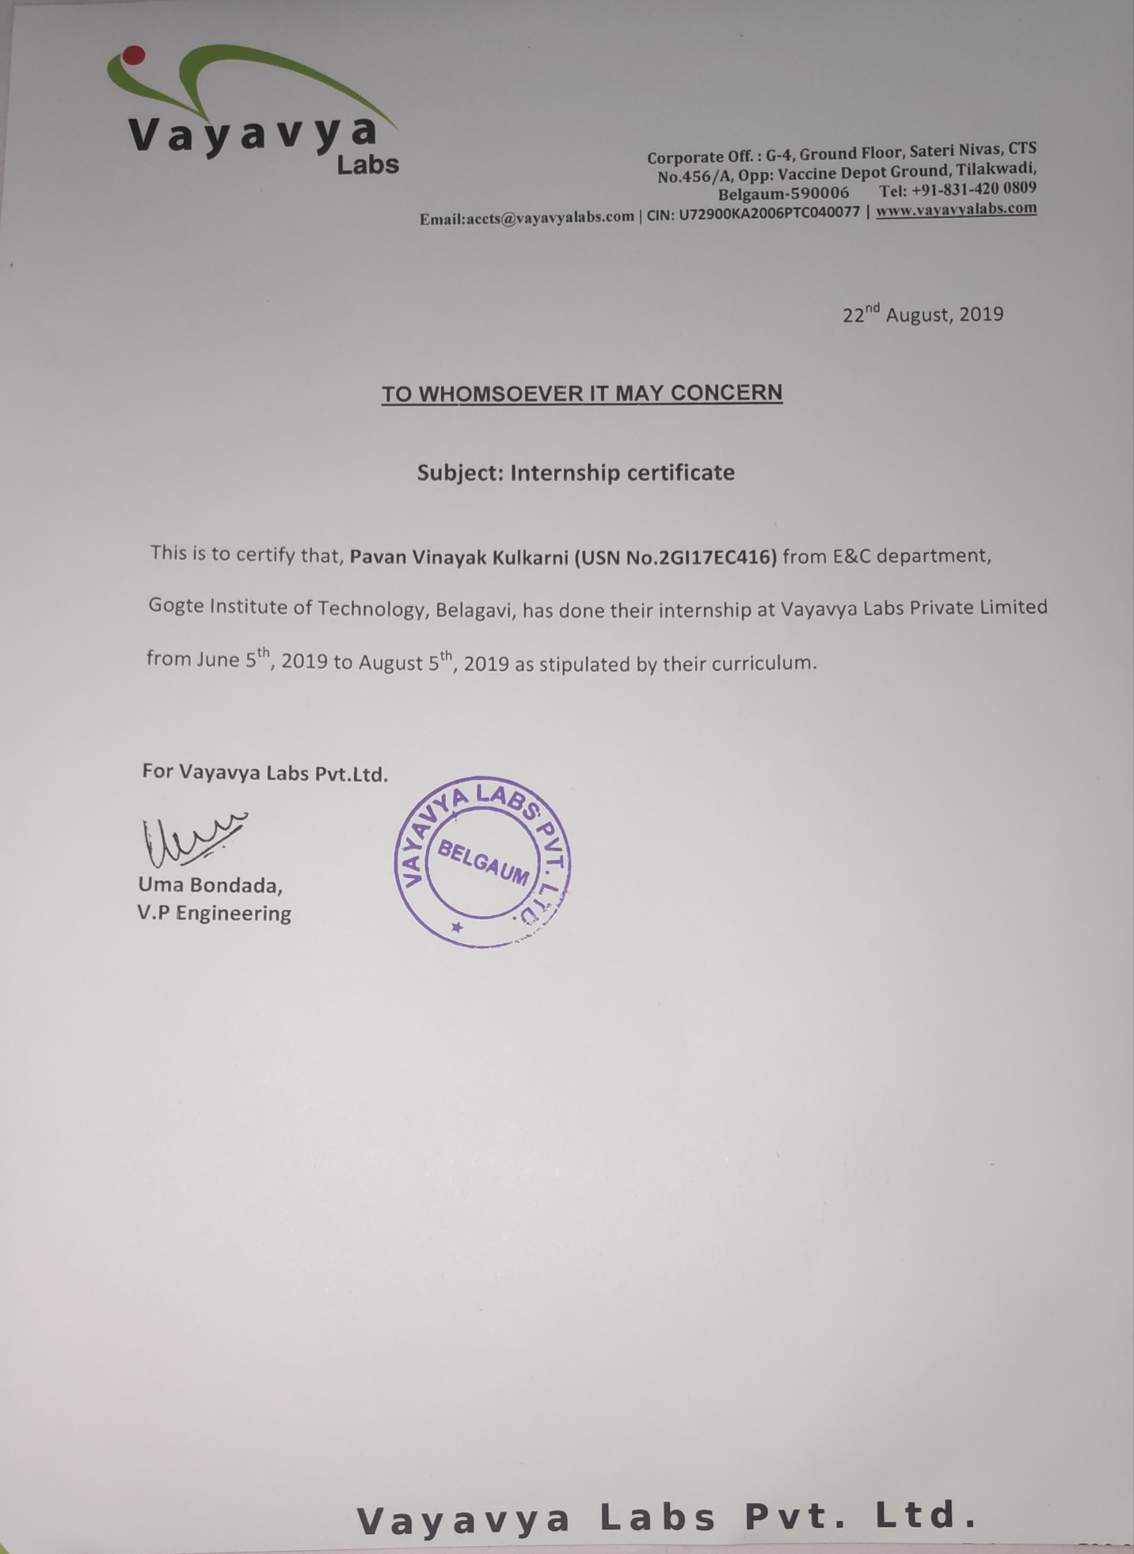**DECLARARTION BY THE STUDENT**

I, **Pavan V .Kulkarni**, hereby declare that the internship report entitled Configuration and testing of RTC, on ARM7 LPC2148 Processor submitted by me to KLS Gogte Institute of Technology, Belagavi, in partial fulfillment of the Degree of Bachelor of Engineering in Electronics and Communication is a record of the internship carried out at **Vayavya Labs Pvt.Ltd**, Tilakwadi, Belagavi. This report is for the academic purpose.

I further declare that the report has not been submitted and will not be submitted, either in part or full, to any other institution and University for the award of any diploma or degree.

Place: Belagavi Name of the student: Pavan v. Kulkarni

Date: 30/09/2019 USN: 2GI17EC416

Signature of the student

Acknowledgement

This internship work consumed huge amount of work, research and dedication. The internship would not have been possible if I did not have received support of many individuals and organizations for their incredible knowledge. Therefore I would like to extend my sincere gratitude to all of them. In particular, I would like to take this opportunity to express my honor, respect, deep gratitude & genuine regards to the staff of**Department of Electronics and Communication Engineering** of**KLS’s Gogte Institute of Technology, Belagavi** for providing me all the guidance required for the completion of the internship.

I sincerely would like to thank my guide **Deepak Kulkarni**for guiding me throughout this internship and also would like to thank my **Head of DepartmentDr. S. S. Saraf**for giving an opportunity for the completion of internship work and giving me a platform to showcase it.

I sincerely would also like to express my deep gratitude and thankfulness to **Veeresh Ambe** for providing me an excellent opportunity of internship at **“Vayavya Labs Pvt.Ltd”**without which my work would not have been completed.

My Sincere thanks to **Prop D AKulkarmi**, Principal, KLS’s GIT, Belagavi who have given me opportunity of the completion of this internship.

Last but not the least I would like to thank all the people who have helped me directly and indirectly for making my internship work successful.

**(Pavan V. Kulkarni)**

**Executive Summary**

Vayavya Labs is a growing Embedded software Tools & Services firm. My project was based on Arm7 LPC2148, to configure and test the inbuilt RTC of LPC2148 processor.

A real-time clock (RTC) is a computer clock (most often in the form of an integrated circuit) that keeps track of the current time.

Major activities carried out during the internship:

* Firstly, I learnt, about the embedded systems software that is used in the industry
* A detailed view on building the Driver code was showcased by the company
* The whole process was divided into different sections

1. Developing APIs
2. Generating the required files using DDGEN Tool
3. Verification of the files generated by DDGEN
4. Creating a Test file which can be modified as and when required
5. Testing the software on ARM7 LPC2148 processor using 16x2 Alpha-Numeric LCD Display

**Table of Contents**

|  |  |  |  |
| --- | --- | --- | --- |
| **Chapter No.** |  | **Content** | **Page No.** |
|  |  | Declaration | i |
|  |  | Acknowledgement | ii |
|  |  | Executive Summary of the Internship | Iii |
|  |  | Table of Contents | iv |
|  |  | List of Figures | v |
|  |  | List of Tables | vi |
| **1.** |  | **Description of the company** |  |
|  | 1.1 | Introduction and history of the company | 1 |
|  | 1.2 | Basic Information | 1 |
|  | 1.3 | Partners and Associates | 1 |
|  | 1.4 | Services | 2 |
| **2.** |  | **Internship activities** |  |
|  | 2.1 | What is RTC | 3 |
|  | 2.2 | About Arm7 LPC2148 Processor | 3 |
|  | 2.3 | About RTC of LPC2148 | 4 |
|  | 2.4 | Embedded Systems software approach | 5 |
|  | 2.5 | RTC Registers | 6 |
|  | 2.6 | APIs | 8 |
|  | 2.7 | Testing and Validation | 9 |
| **3.** |  | **Internship Outcomes** | 10 |
| **4.** |  | **Conclusions of the report** | 11 |
| **5.** |  | **References** | 12 |

**List of Figures**

|  |  |  |
| --- | --- | --- |
| **Fig. No** | **Name of the Figure** | **Page No** |
| 2.1 | ARM7 LPC2148 Micro-controller | 3 |
| 2.2 | Block diagram architecture of RTC | 4 |
| 2.3 | Testing on LCD display | 9 |
| 2.4 | Testing from command prompt | 9 |
|  |  |  |
|  |  |  |
|  |  |  |

**Chapter 1: Description of the company**

1.1Introduction and history of the company

“Vayavya Labs” are pioneers & industry leaders in Hardware-Software Interface™ (HSI™) Tools & Methodologies. We provide embedded software expertise across Automotive, EDA, Semiconductors, and Communications verticals. We hold 11 patents covering EDA/ESL, Embedded SW and SW Automation domains. We have been delighting customers for the past 12 years by our work, our dedication, focus and desire to excel, to be the best we can, delivering solutions that not only meet but also exceed their expectations.

1.2Basic Information

Vayavya Labs is a growing Embedded software Tools & Services firm. The firm is known for its technology & R&D initiatives to differentiate from the competition. With 11 patents in the field of Embedded software, Automation Tools, Domain Specific Languages, Compiler Tech we are also driving industry standards to realize Software-Driven Verification to solve complex problems of EDA, ESL and Semiconductor domain.

1.3 Partners and Associates

Vayavya Labs is a member of Accellera’s Portable Stimulus Specification Working Group.

 Vayavya Labs is a member of Synopsys ARC access program. Vayavya labs help customers to accelerate ARC based product design.

Vayavya Labs is pleased to be working with Synopsys for further acceleration of software development.

Vayavya Labs is now part of the Cadence System realisation alliance. Vayavya Labs is collaborating to combine its software driver generation technology with the Cadence HW/SW functional verification solution.

 1.4 Services

**Product Development and Management**

We have decades of experience in building products and taking them to the market. With our holistic approach, we ensure your product development process is efficient and uses all the right tools and technologies.   
  
For custom hardware design we act as a liaison partner, right from helping you pick the right set of IPs, to facilitating the hardware design, to managing the interactions with hardware (reference board) designers and application development teams.

**Porting, Bring-up and Optimisation**

We offer customisation and porting of Board Support Packages (BSP) for Linux, Android & Automotive Grade Linux. Having several years of experience in development of custom embedded software across ARM, x86, etc., we understand the hardware, OS and software well.   
Leveraging this knowledge we offer customised solutions in the areas of Board Bring-up, BSP Customisation, Porting and Firmware, Driver Development.   
  
We also provide performance optimisation in the areas of Boot time, Graphics and Power.

**Protocol Stack Development**

We specialise in MANET (Mobile Ad-hoc NETwork) Technology. We provide services including stack development & enhancements, V&V in simulation environment and boards, platform integration, field readiness testing, maintenance and support.   
  
We have experience in developing Test frameworks for V&V teams for feature validation, performance & load evaluation of the developed network components by simulating ‘real-world’ scenarios.

**Virtual Platforms & Modelling**

A Virtual Platform (VP) models behaviour of a SoC at a level of detail that enables development and testing of software (including device drivers and operating systems).   
  
We have worked on modelling complex peripherals in SystemC/C++. We provide SoC modelling services using C, C++, SystemC, TLM, and IP-XACT.

**Chapter 2: Internship activities**

2.1 What is RTC (Real Time Clock)

* A real-time clock (RTC) is a computer clock (most often in the form of an integrated circuit) that keeps track of the current time.
* Although the term often refers to the devices in personal computers, servers and embedded systems, RTCs are present in almost any electronic device which needs to keep accurate time.
* Although keeping time can be done without an RTC, using one has benefits:
* Low power consumption
* Frees the main system for time-critical tasks
* Sometimes more accurate than other methods

2.2 About Arm7 LPC2148 Processor

The NXP (founded by Philips) LPC2148 is an ARM7TDMI-S based high-performance 32-bit RISC Microcontroller with Thumb extensions 512KB on-chip Flash ROM with In-System Programming (ISP) and In-Application Programming (IAP), 32KB RAM, Vectored Interrupt Controller, Two 10bit ADCs with 14 channels, USB 2.0 Full Speed Device Controller, Two UARTs, one with full modem interface. Two I2C serial interfaces, Two SPI serial interfaces Two 32-bit timers, Watchdog Timer, PWM unit, Real Time Clock with optional battery backup, Brown out detect circuit General purpose I/O pins. CPU clock up to 60 MHz, On-chip crystal oscillator and On-chip PLL.

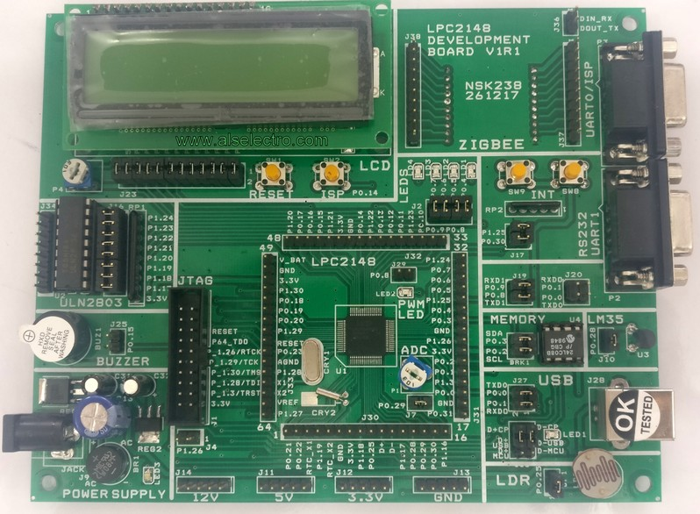

2.3 About RTC of LPC2148

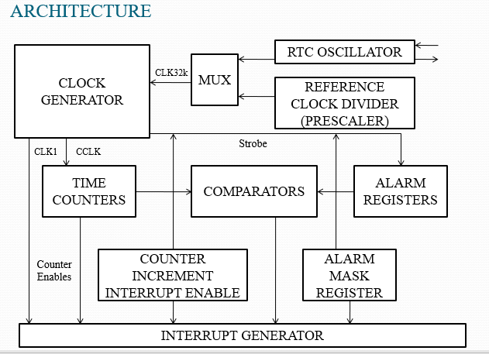

Features:

* LPC2148 has an inbuilt RTC. LPC2148RTC can be clocked by a separate 32.768 KHz oscillator or by a programmable prescale divider based on the APB clock.
* It maintains a calendar and clock and provides seconds, minutes, hours, month, year, day of week, day of month and day of year.
* It has power supply pin that can be connected to a battery or to the main 3.3V.
* It uses little power in power down mode.
* And most important, it has Alarm functionality.
* The purpose of an RTC is to provide precise time and date which can be used for various applications like digital clock, attendance system, digital camera etc.

2.4 Embedded Systems Software Approach:

DDGen (Device Driver Generator) is a software tool for anyone wanting to write software device drivers. Our target audiences are typically Embedded System Developers wanting to implement a software driver for a hardware platform or IC design engineers looking to develop software/firmware as part of post-silicon validation process. DDGen tool and methodology encourages device driver developers to think about the problem-domain rather than the implementation-domain. The tool provides a high-level mechanism to specify.

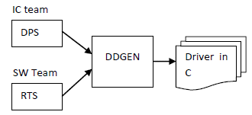

Fig2.2: DDGen

Vayavya Labs has proposed a domain specific language (DSL) called DPS (Device Programming Sequence) to capture the device attributes and behavior. Similarly, the various software architecture and run-time considerations are captured in another specification called RTS (Runtime Specification). A corresponding tool, DDGEN compiles this DPS specification and generates the device driver after analyzing the RTS input. DPS formalizes the communication between the hardware and software team. It essentially captures all the relevant aspects (registers, interrupts, fifo’s, programming sequence etc.) of a given device. The RTS captures the operating system, the driver model and other software aspects like synchronization, software buffering, interrupt handling mechanism etc.

Keil uvision 5

The MDK (Microcontroller Development Kit) Tools include all the components that you need to create, build, and debug an embedded application for ARM based microcontroller devices. MDK-Core consists of the genuine Keil µVision IDE and debugger with leading support for Cortex-M processor-based microcontroller devices

2.5 RTC Registers

1.  **ILR (Interrupt Location Register)**

* It is an 8-bit register.
* It specifies which blocks are generating an interrupt.

**Bit 0 – RTCCIF**  
When this bit is 1, it means that the counter increment interrupt block generated an interrupt.  
Writing a 1 to this bit clears the counter increment interrupt. Writing a 0 has no effect.

**Bit 1 – RTCALF**  
When this bit is 1, it means that the alarm registers generated an interrupt.  
Writing a 1 to this bit clears the alarm interrupt. Writing a 0 has no effect.

2.  **CTCR (Clock Tick Counter Register)**

* It is a 16-bit register.
* It is a read only register.
* It can be reset through the Clock Control Register (CCR).
* It consists of the bits of the clock divide counter.

**Bits 14:1 – Clock Tick Counter**  
Prior to the seconds counter, the CTC counts 32,768 clocks per second. Due to RTC Prescalar, these 32,768 time increments may not all be of the same duration.

3.  **CCR (Clock Control Register)**

* It is an 8-bit register.
* It controls the operation of the clock divide circuit.

**Bit 0 – CLKEN (Clock Enable)**  
0 = Timer counters are disabled. They should be initialized in this condition.  
1 = Timer counters are enabled

**Bit 1 – CTRST (CTC Reset)**  
When 1, elements in CTC (Clock Tick Counter) are reset. The elements remain reset until this bit is changed to 0.

**Bit 3:2 – CTTEST (Test Enable)**  
These bits should always be 0 during normal operation.

**Bit 4 – CLKSRC**  
0 = CTC takes clock from Prescalar  
1 = CTC takes clock from 32.768 kHz oscillator

4.  **CIIR (Counter Increment Interrupt Register)**

* It is an 8-bit register.
* It provides the option to generate an interrupt every time a counter is incremented.
* This interrupt remains valid until it is cleared by writing a 1 to RTCCIF bit in ILR.

5.  **PREINT (Prescalar Integer Register)**

* When PCLK acts as the clock source for RTC, then, this Prescalar allows generation of 32.768 kHz reference clock from any PCLK greater than 65.536 kHz (2 * 32.768).
* This allows RTC to run at proper rate irrespective of the PCLK.
* PREINT is the integer portion of the prescale value.
* **PREINT** = int (PCLK/32768) – 1
* PREINT must be greater than or equal to 1.

6.  **PREFRAC (Prescalar Fraction Register)**

* This is the fractional part of the prescale value.
* **PREFRAC** = PCLK – ((PREINT+1) * 32768)
* **PREFRAC (Prescalar Fraction Register)**

2.6 IMPLEMENTATION USING APIS

1. **void rtc_clock_source (int clksrc**)

Function name: rtc_clock_source

Parameter: clksrc (integer type)

Return type: void

Functionality: Option to choose internal prescalar or external crystal.

For internal prescalar, pass 0 as parameter

For external crystal, , pass 1 as parameter

{

CCR= clksrc<<4; //4th bit of Clock Control Register is modified

return;

}

1. **void rtc_enable(int en**)

Function name: rtc_enable

Parameter: en (integer type)

Return type: void

Functionality: Enable RTC

0 = DISABLE

1= ENABLE

{

CCR= en<<0; //0th bit of Clock Control Register is modified

return;

}

1. **int rtc_read_time()**

Function name: rtc_read_time

Parameter: no input parameter

Return type: int

Functionality: Reads date and time within the following range from respective registers:

SEC: 0 to 59

MIN: 0 to 59

HOUR: 0 to23

DOM: 1 to 28, 29, 30 or 31

DOW: 0 to 6

DOY:1 to 365 or 366

MONTH: 1 to 12

YEAR: 0 to 4095

**{**

sec = SEC;

min = MIN;

hour = HOUR;

dom = DOM;

dow = DOW;

doy = DOY;

month = MONTH;

year = YEAR;

return(sec, min, hour, dom, dow, doy, month, year );

**}**

Steps to Implement:-

**Initialize RTC**

* Select the Clock source Internal/external(32k).
* Enable the clock for RTC

**Set Date and Time**

* Feed the separate Time Counter registers for each time parameter(hour, min, sec and date) with required values.

**Read Date and Time**

* The values of date and time can be read from associated Time Counter registers. Alternately, date and time can also be read from Consolidated Time registers.

Time Counter registers are used for both reading and writing.

2.7 Testing the RTC

1. By using LCD:

Time and date can be displayed in hh:mm:ss and dd/mm/yyyy format.

2. By using indicators:

GPIOs such as LED and Buzzer can be programmed for particular time interval.

***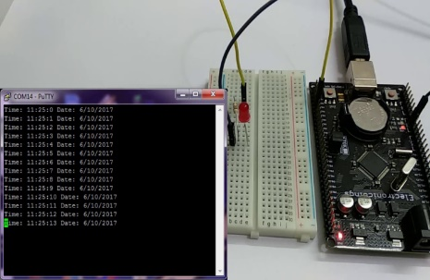****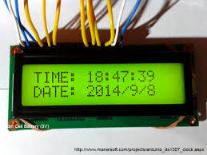*

**Chapter 3. Internship Outcomes**

The Internship helped me to develop industry-specific skills which are essential for an embedded career field and are often called “hard skills.” For instance:

* The ability to read and understand datasheets, and produce driver code for a given device based on the information contained in its datasheet.
* Ability to read and understand schematics.
* Competency in the ‘C’ programming language.
* A good understanding of microprocessor internals (mostly registers).
* Ability to use a debugger to perform simple operations such as setting breakpoints, single stepping, examining variable values, examining memory, examining registers.
* A good understanding of device drivers.

Acquired new learning through challenging and meaningful activities. Linked academic theory to practice.

The Internship Program helped me to evolve my soft skills. For instance: Interpersonal, Problem solving, Team work, Analytical skills, Strong work ethic, Organizational skills, Initiative.

**Chapter 4: Conclusions of the report**

Device Driver acts as a translator between the hardware device and the programs or operating systems that use it. Without the required device driver, the corresponding hardware device fails to work

I have Successfully built, verified, validated and tested the Driver built to initialize the RTC of LPC2148

Building Stage: In this stage we have successfully obtained the driver code by using DDgen Tool for generating the driver

Verifying stage: In this stage error debugging the previously built driver was carried out efficiently

Validation stage: By using Kiel Uvision 4 validation of the driver was carried out.

Testing stage: Working of RTC was tested on 16x2 LCD display.

At the end I would say that I got a broader view on how a Device Driver is developed at an industry and how its release package is built by allowing, the end user to make flexible amount of modification according to his necessity.

**References**

1. DDGen Vayavya Labs Pvt Ltd, https://www.vayavyalabs.com/
2. DDGEN: An Automated Device Driver Generation Tool for Embedded Systems https://www.design-reuse.com/articles/23316/automated-device-driver-generation- tool.html.
3. Device driver-Wikipedia, https://en.wikipedia.org/wiki/Device_driver.
4. Device driver- https://embedkari.com/2019/07/27/device-drivers/
5. LPC2148 reference manual from nxpsemiconductors.