Intelligent OTT Platform System Leveraging Advanced Machine Learning Techniques

MS P. RENUKA (Assistant professor)
Artificial Intelligence and Data Science Department
Annamacharya University
Rajampet, India
pasupuletirenuka805@gmail.com
S.ARIF HUSSIAN
Artificial Intelligence and Data Science Department
Annamacharya Institute of Technology and Sciences
Rajampet, India
arifhussainshaik24@gmail.com
K. PAVAN KUMAR
Artificial Intelligence and Data Science Department
Annamacharya Institute of Technology and Sciences
Rajampet, India
pavankumarkundeti237@gmail.com
Y.DHANUSH KUMAR RAJU
Artificial Intelligence and Data Science Department
Annamacharya Institute of Technology and Sciences
Rajampet, India
rajdhanush020@gmail.com
MS.MAHAMMAD YOUSUF
Artificial Intelligence and Data Science Department
Annamacharya Institute of Technology and Sciences
Rajampet, India
msmahammadyousuf@gmail.com

Abstract— Over-the-top (OTT) service providers are expanding at a rapid pace, which calls for sophisticated systems that can provide efficient content management and individualized user experiences. This paper presents an intelligent over-the-top (OTT) platform solution that maximizes user engagement, content suggestion, and operational efficiency by utilizing cutting-edge machine learning algorithms. Using streamlit as the UI, the system applies cosine and TF-IDF similarity techniques on a large movie dataset in order to produce precise movie recommendations. By combining collaborative filtering with content-based recommendation algorithms, the system's hybrid approach improves customization by taking into account contextual elements, user preferences, and viewing history. To further improve content recommendations, the platform also uses NLP (natural language processing) to examine user sentiment and comments.
Keywords— Content Management, Collaborative Filtering, Cosine Similarity, Machine Learning, Movie Recommendations, Natural Language Processing (NLP), Real-Time Analytics and TF-IDF.

Introduction
The way people consume media has changed dramatically with the rise of over-the-top (OTT) video streaming services [1], which offer a wide variety of material available for on-demand viewing. Offering a highly tailored user interface has become essential for platform distinction and user retention as the competition in this sector heats up. As a result, sophisticated machine learning methods have been adopted, which are able to customize content suggestions by analyzing user actions, preferences, and contextual data. Platforms may improve their recommendation algorithms by using techniques like cosine similarity and TF-IDF (Term Frequency-Inverse Document Frequency), which provide users with more interesting and relevant material [2] based on their viewing habits and preferences.
The increasing need for customized media experiences may be seen in the rise in demand for tailored material suggestions in recent years. Personalized suggestions have a big influence on user happiness and retention, according to industry surveys. Studies show that platforms with sophisticated recommendation systems [3] may experience up to 30% more user engagement. Using sophisticated algorithms for machine learning to improve content recommendations is turning into a crucial tactic for OTT companies looking to preserve their competitive edge and enhance customer satisfaction as the industry grows. Several important issues with user engagement and content management are addressed by the incorporation of artificial intelligence techniques into over-the-top (OTT) systems. Platforms may offer more precise and pertinent suggestions by employing hybrid models [4] that blend collaborative filtering with content-based algorithms. This improves user satisfaction and promotes extended platform usage.
In addition, platforms may adjust to shifting user trends and tastes by using natural language processing (NLP) for mood and feedback monitoring. This guarantees that content recommendations stay interesting and relevant. Our research offers a clever OTT platform solution [5] that makes use of these cutting-edge methods to provide efficient content management and optimal content suggestion. Using streamlit as the UI, this system makes customized movie suggestions based on a movie dataset that has been examined using TF-IDF and cosine similarity. Real-time analytics features of the system allow for proactive modifications to content offering and marketing tactics by providing insights into user behavior. Our platform hopes to raise the bar for tailored content distribution by putting these advances into practice, increasing user happiness and engagement [6] in the cutthroat OTT market.

literature survey
Many methods have been developed in the past to improve systems for recommending content, especially in the context of over-the-top (OTT) platforms. The majority of early work concentrated on collaborative filtering methods [7], which employ user activity data to suggest products based on the tastes of users who are similar to one another. Although this approach was successful in producing pertinent recommendations, it frequently encountered challenges with scalability and cold start concerns. In order to overcome these constraints, scientists started using content-based filtering, which makes suggestions based on item attributes and user profiles. By combining the best features of the two approaches, this hybrid strategy aimed to provide suggestions that were more precise and tailored to the individual. Goyani et al. proposed a system that provide recommendations are well-liked instruments [8] for decision-making. They employ content-based and collaborative filtering in the movie recommendation context to find comparable users. Combining these techniques can increase the system's efficacy. Recommendation systems are used by businesses like Facebook, LinkedIn, Pandora, Netflix, and Amazon to boost revenue and provide benefits to its users. In order to investigate further, this study analyzes a variety of approaches and strategies for movie selection. Agrawal et al. proposes a hybrid technique to enhance the performance of recommendation systems for movies [9].
Neural networks and matrix factorization are two techniques that have been used to improve recommendation accuracy and tackle issues like sparse data and changing consumer preferences. Furthermore, it is now standard procedure to analyze texts using TF-IDF and measure item similarity using cosine similarity [10]. By using these techniques, platforms are able to better match user preferences with content that is accessible, which enhances the quality of recommendations as a whole. Kumar et al. introduces MOVREC, a collaborative filtering method [11] movie recommendation system that analyzes user data and suggests movies based on user ratings. Rajarajeswari et al. proposed the way websites and e-commerce apps interact with users is changing as a result of recommender systems and information filtering tools [12] that utilize big data to suggest users' interests and preferences.
Recommendation systems have been greatly enhanced by developments in machine learning and natural language processing, which have made use of sophisticated models and algorithms. Two methods that have been utilized to address problems like sparse data and shifting customer preferences and increase recommendation accuracy are neural networks and matrix factorization [13]. Wang et al. suggests a mixed model-based movie suggestions system [14] that divides user space using evolutionary algorithms and K-means clustering. In order to densify the movie population space, principal component analysis (PCA) reduction of information is used. By tackling the issue of information overload in online interactive movie suggestions, the methodology offers high accuracy and more dependable, individualized movie recommendations than previous approaches. Reddy et al. proposed a recommendation system is a technology that makes data-driven recommendations for media such as songs, movies, and books. Users' choices are predicted by movie recommendation algorithms [15] using criteria such as director, actors, and genre.

DATA COLLECTION & PREPROCESSING

The quality and completeness of the data gathered form the basis of any successful recommendation system. The OTT platform's recommendation algorithm is developed using a varied movie dataset that includes comprehensive details on movies, such as titles, genres, ratings, explanations, and user interactions. Typically, this information contains movie metadata, watching history, and user reviews. User-generated content platforms, streaming service logs, and publicly accessible movie databases might be the main sources of this information. Building a strong recommendation engine that can serve a broad audience requires making sure the dataset is sizable and reflective of different genres and user preferences. To make processing easier, once gathered, data from diverse sources is combined into a single format. To get a full perspective of user tastes and movie qualities, this entails combining several datasets, such as user conversations with movie metadata.
Transformation of data entails transforming unprocessed data into an analysis-ready format. This frequently entails normalizing numbers, encoding categorical factors, and transforming text input into numerical representations in the context of systems for recommendation. For instance, one-hot encoding is used to encode film genres and user preferences, while TF-IDF vectorization is used to alter text data, such as movie descriptions. These modifications enable efficient analysis and model training while also making the data suitable with machine learning techniques. Finding and choosing pertinent characteristics from the dataset that the recommendation model will employ is known as feature extraction. Features including user ratings, movie genres, and written descriptions are retrieved and given in a way that can be analyzed in this study. To represent the relevance of terms in movie descriptions in relation to their frequency over the full dataset, for example, feature vectors derived from text data are created using TF-IDF. These characteristics are essential for figuring out how relevant and comparable movies are to user preferences.

PRINCIPLES AND METHODS
The purpose of recommendation systems is to offer consumers tailored material according to their interests and actions. Recommendation systems work on the fundamental tenet of using past data and user interactions to forecast and propose content that users are likely to find interesting or relevant. Usually, these systems work on the assumption that comparable users or objects have comparable tastes or traits. Recommendation systems seek to improve user experience by providing personalized suggestions that correspond with individual preferences and interests by examining trends in user behavior and item characteristics. Presenting information that speaks to each user's individual interests will ultimately boost user happiness and engagement.
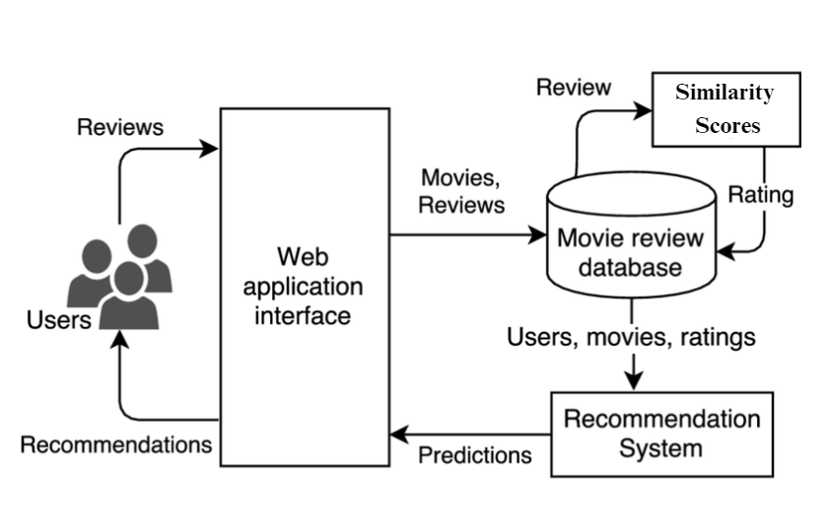
Fig.1 Architecture of the System
Cosine similarity is used in the system for suggestions for comparing the TF-IDF vectors of various films. Cosine similarity measures how similar two vectors are to one another in terms of content by computing a cosine of the angle across them. A greater cosine similarity between two movies suggests that they have more characteristics in common and will probably appeal to the same audience. This technique works very well for finding related material, which makes it a useful tool for producing pertinent suggestions based on the written examination of movie synopses. Hybrid techniques, which integrate several recommendation algorithms, are utilized to augment the efficacy of the recommendation system. A hybrid approach in this system combines collaborative filtering methods with content-based filtering.

TF-IDF
A statistical metric called Term Frequency-Inverse Document Frequency (TF-IDF) is employed to assess a word's significance in a document in relation to a corpus, or group of documents. Weighing words according to their rarity throughout the corpus and their frequency inside a text is the basic principle of TF-IDF. This method aids in locating terms that are both uncommon and often appearing in a certain text as opposed to others. Words that are common in one document but uncommon in others receive a higher TF-IDF score, emphasizing terms that are important for comprehending the contents of the document. TF-IDF is frequently used in text analysis for problems related to text mining and information retrieval. Finding essential phrases that accurately convey the substance of papers is much easier with its assistance.
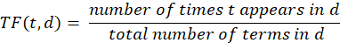
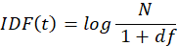
Where, N is the entire amount of documents, df is the total amount of documents that include the phrase t, and d denotes the number of documents.

It doesn't take into consideration the semantic significance of words or how they relate to one another in the text. Because of this, it could overlook subtle meanings and not fully convey the context of words. In order to overcome these drawbacks, TF-IDF can be used in conjunction with additional methods that offer more complex semantic comprehension, such word embedding or deep learning models. Even with these drawbacks, TF-IDF is still a useful tool for recommendation systems and text analysis, especially when combined with more recent methods. Through the integration of TF-IDF with cutting-edge techniques like natural language processing (NLP) models, text-based applications may be made more effective overall.

COSINE SIMILARITY
By computing a cosine of the angle that separates two vectors in a multidimensional space, one may determine the degree of similarity between them using the cosine similarity metric. The idea is based on vector space models, in which things or documents are represented as multi-dimensional vectors that stand in for various attributes or phrases. Cosine similarity measures the degree of directionality between two vectors by computing the cosine of the angle that separates them. This method works especially well in situations where finding things with comparable content or attributes is the main objective, such text analysis and recommendations. Cosine similarity is frequently used in text analysis to assess how similar two documents are to one another based on their vector renderings. For instance, word embeddings and TF-IDF are used to turn documents into vectors while processing textual data.
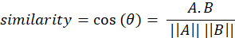
The ability to quantify resemblance based on the orientation of the vectors not their magnitude is one of the main benefits of cosine similarity. Because of this, it handles changes in document length or component count especially well. Cosine similarity is a popular option for many applications since it is also easy to implement and computationally efficient. Cosine similarity does have certain restrictions, though. Since it doesn't take into consideration the vectors' absolute magnitude, concepts or characteristics with high frequencies could not be properly captured in terms of their relevance. Furthermore, cosine similarity could have trouble comprehending complex word meanings or context, especially in situations where semantic links are crucial.

RESULTS

The movie recommendation system's outcomes show how successful it is to offer individualized content recommendations by utilizing cutting-edge machine learning algorithms. Through the use of cosine similarity for resemblance measurement and TF-IDF for textual analysis, the system is able to identify and suggest movies that closely match user tastes. The system offers a carefully selected list of films that are pertinent to the user's interests and makes suggestions based on the user's input choices, including genres, keywords, and ratings (as shown in Fig.2 & 3). By providing highly tailored recommendations that take into account each user's unique interests and tastes, this method improves the user experience. To guarantee the caliber and applicability of the suggestions, the recommendation system's performance is assessed using a number of indicators. Recall, F1-score, and precision are common assessment measures that gauge how relevant and accurate the suggestions are.
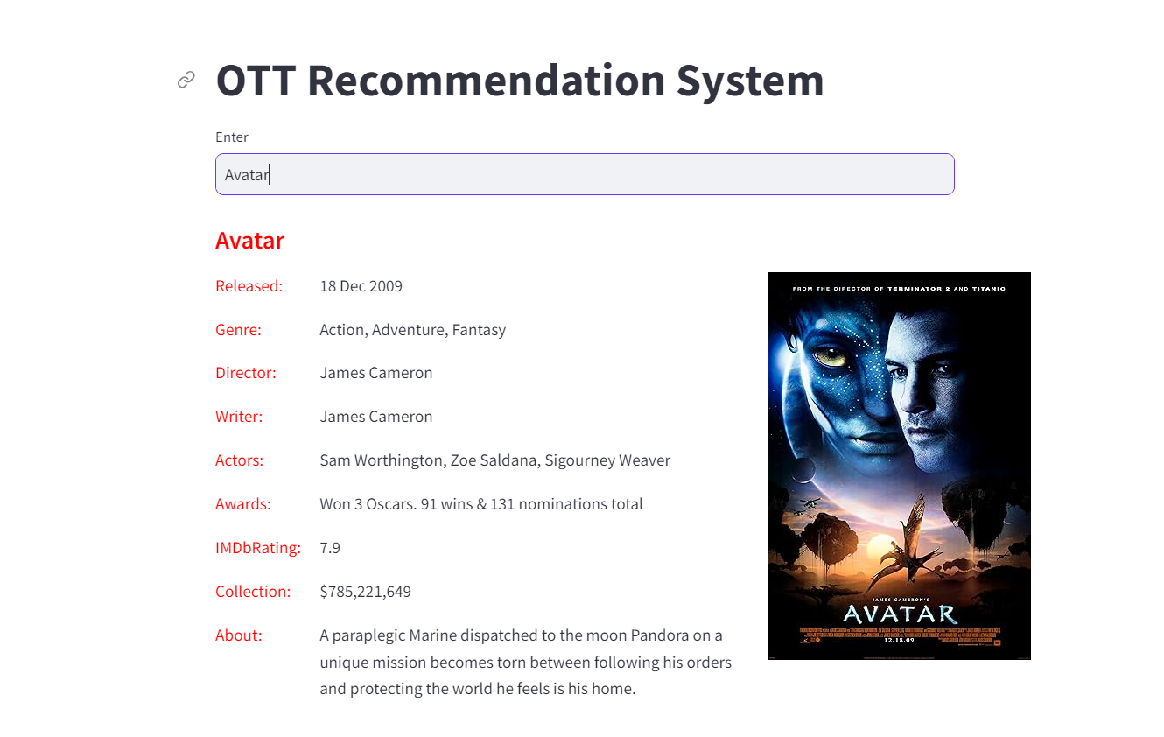
Fig.2 OTT User Interface
Recall gauges the system's capacity to recognize every relevant movie, whereas precision evaluates the percentage of suggested films that are pertinent to the user. The F1-score offers a thorough evaluation of the system's performance by providing an adequate measure of recall and accuracy. In addition, feedback from customers and engagement measures are employed to evaluate how well the suggestions work and how satisfied users are. Based on how users engage with the interface, the system is intended to offer recommendations in real-time. The recommendation engine takes user input when they choose genres or enter keywords, for example, and produces a list of movies that meet the requirements. Users are given current and accurate recommendations since TF-IDF and cosine similarity are used to make sure that suggestions are based on the most relevant and comparable movies. The suggestions' real-time nature improves the user encounter by providing timely feedback and tailored material.
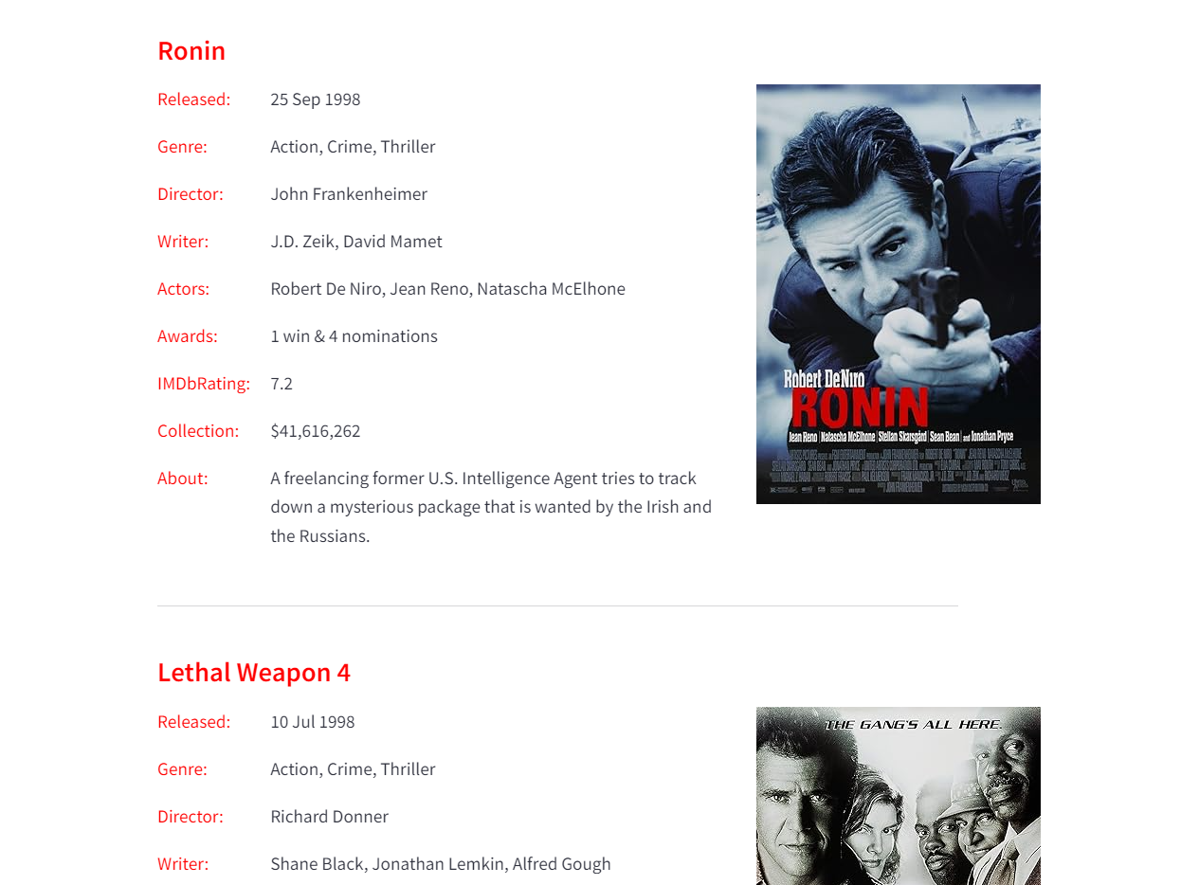
Fig.3 Predictions on User Interface
Users may engage with the recommendation algorithm on an easy-to-use and interactive platform thanks to the streamlit-developed user interface. Users may quickly enter their choices and view suggestions because to the interface's user-friendly design. Users may select their choices, such as movie genres, search terms, and ratings, using a variety of interactive components, such as dropdown menus, sliders, and text inputs. The user interface facilitates the exploration and selection of material by presenting suggested films in an aesthetically pleasing style that includes movie names, posters, and descriptions. The user interface allows users to engage and submit their preferred movie suggestions. Users may rate previously seen movies, add keywords relating to their interests, and choose genres from the menu that appears on the site. The recommendation engine uses these inputs to provide a list of movies that suit the user's tastes. Additionally, the system offers filtering options that let users focus upon suggestions based on other factors like movie ratings or release year.
The user interface presents the recommendations in an eye-catching way. Important details about every suggested film are provided, such as the title, advertisement, genre, and a synopsis. Users are able to evaluate the recommendations' relevancy quickly and make well-informed decisions because to this structure. Users may also access extra information about each movie, like trailers, evaluations, and ratings, through the user interface, which gives them more context and helps them make better decisions. There is need for improvement even if the user experience and suggestion mechanism as it is now implemented offer insightful analysis and helpful suggestions. Subsequent enhancements can involve integrating sophisticated machine learning methods, such deep learning models or collaborative filtering, to augment the precision and customization of suggestions. Furthermore, by merging user profiles with past data, more personalized recommendations based on personal watching habits and histories may be made. The recommendation system will be continuously improved and optimized with input from users and engagement analysis to make sure it stays useful and relevant to users.

CONCLUSION

The movie recommendation engine efficiently makes use of cutting-edge machine learning methods, such as cosine similarity to measure similarity and TF-IDF for textual analysis, to provide consumers with tailored and pertinent content recommendations. The system offers a live and interactive platform for users to enter preferences, explore recommendations, and make educated watching choices by incorporating these approaches into a straightforward streamlit-based user interface. The user experience is improved overall because of the real-time processing capabilities, which guarantee that consumers receive the most recent ideas based on the parameters they have chosen. The system's ability to effectively identify and propose movies that fit individual likes is demonstrated by evaluation metrics and user comments, indicating its usefulness in enhancing user pleasure and content discovery. In addition to streamlining the recommendation process, the combination of complex algorithms and an intuitive interface lays the groundwork for future improvements, like the addition of more machine learning methods and user data for recommendations that are even more accurate and customized. All things considered, the system is a major step forward in personalized content distribution, providing insightful information and a customized viewing experience that caters to consumers' changing demands.

References

- Nagaraj, Samala, Soumya Singh, and Venkat Reddy Yasa. "Factors affecting consumers’ willingness to subscribe to over-the-top (OTT) video streaming services in India." Technology in Society 65 (2021): 101534.
- Sutcliffe, Alistair. Designing for user engagment: Aesthetic and attractive user interfaces. Springer Nature, 2022.
- Ko, Hyeyoung, et al. "A survey of recommendation systems: recommendation models, techniques, and application fields." Electronics 11.1 (2022): 141.
- Burke, Robin. "Hybrid recommender systems: Survey and experiments." User modeling and user-adapted interaction 12 (2002): 331-370.
- Chakraborty, Debarun, et al. "Watching is valuable: Consumer views–Content consumption on OTT platforms." Journal of Retailing and Consumer Services 70 (2023): 103148.
- O'Brien, Heather L., and Elaine G. Toms. "What is user engagement? A conceptual framework for defining user engagement with technology." Journal of the American society for Information Science and Technology 59.6 (2008): 938-955.
- Koren, Yehuda, Steffen Rendle, and Robert Bell. "Advances in collaborative filtering." Recommender systems handbook (2021): 91-142.
- Goyani, Mahesh, and Neha Chaurasiya. "A review of movie recommendation system: Limitations, Survey and Challenges." ELCVIA: electronic letters on computer vision and image analysis 19.3 (2020): 0018-37.
- Agrawal, Shreya, and Pooja Jain. "An improved approach for movie recommendation system." 2017 international conference on I-SMAC (IoT in social, mobile, analytics and cloud)(I-SMAC). IEEE, 2017.
- Yunanda, Gisela, Dade Nurjanah, and Selly Meliana. "Recommendation system from microsoft news data using TF-IDF and cosine similarity methods." Building of informatics, technology and science (BITS) 4.1 (2022): 277-284.
- Boddapati, Mohan Sai Dinesh, et al. "Creating a Protected Virtual Learning Space: A Comprehensive Strategy for Security and User Experience in Online Education." International Conference on Cognitive Computing and Cyber Physical Systems. Cham: Springer Nature Switzerland, 2023.
- Rajarajeswari, S., et al. "Movie recommendation system." Emerging Research in Computing, Information, Communication and Applications: ERCICA 2018, Volume 1. Springer Singapore, 2019.
- Wu, Hao, et al. "Dual-regularized matrix factorization with deep neural networks for recommender systems." Knowledge-Based Systems 145 (2018): 46-58.
- Wang, Zan, et al. "An improved collaborative movie recommendation system using computational intelligence." Journal of Visual Languages & Computing 25.6 (2014): 667-675.
- Reddy, S. R. S., et al. "Content-based movie recommendation system using genre correlation." Smart Intelligent Computing and Applications: Proceedings of the Second International Conference on SCI 2018, Volume 2. Springer Singapore, 2019.

