SmartServe: An AI-powered Virtual Assistant Designed to Streamline Task Management, Boost Productivity &Enhance Everyday Efficiency

Dr. K. UDAY KUMAR REDDY ¹
Associate Professor
Artificial Intelligence and Data Science Department
Annamacharya University, Rajampet, India
Pranith.dwh@gmail.com
G. LAKSHMIPATHI⁴
Artificial Intelligence and Data Science Department
Annamacharya Institute of Technology and Sciences
Rajampet, India
gownilakshmipathi@gmail.com
Dr. S. FAHIMUDDIN²
Associate Professor
Electronics and Communication Engineering Department
Annamacharya University, Rajampet, India
fahimaits@gmail.com
N. MAHAMMAD ASKAR⁵
Artificial Intelligence and Data Science Department
Annamacharya Institute of Technology and Sciences
Rajampet, India
nagarurumahammadaskar@gmail.com
K. HARINATH NAIDU ³
Artificial Intelligence and Data Science Department
Annamacharya Institute of Technology and Sciences
Rajampet, India
hari850040@gmail.com

Abstract— This study introduces Smart-Serve, a cutting-edge artificial intelligence (AI) virtual assistant designed to improve productivity and optimize job management using cutting-edge natural language processing (NLP) and AI technologies. Smart-Serve combines state-of-the-art NLP and speech recognition algorithms to convert written and spoken instructions into meaningful insights, facilitating seamless voice and text communication between users. Performing intricate mathematical calculations, automating web surfing chores (such opening Google and YouTube), and time management with integrated timer and reminder capabilities are some of the virtual assistant's primary functions. Smart-Serve uses natural language processing (NLP) to handle a wide variety of instructions accurately, responding in real time and adjusting to user demands. In-depth information about Smart-Serve's architecture, algorithmic methodology, and integration with several productivity tools are provided in this paper. The study demonstrates how Smart-Serve greatly improves user productivity and effectiveness in daily activities in addition to making regular chores simpler. The study illustrates how Smart-Serve may transform job administration and performance solutions in personal as well as commercial situations by combining mathematical modeling and practical assessment.
Keywords— AI-powered Virtual Assistant, Mathematical Operations, Natural Language Processing (NLP), Productivity Enhancement, Speech Recognition, Task Management, Timer and Reminders, and Web Browsing Automation

Introduction
Artificial intelligence (AI) and natural language processing (NLP) are now essential for improving human-computer interactions in the modern digital era [1]. NLP is a branch of artificial intelligence that focuses on giving robots the ability to meaningfully comprehend, interpret, and produce human language. Smart-Serve is an AI-powered artificially intelligent assistant that simplifies job management and increases productivity. It is built on this theoretical foundation. Smart-Serve turns spoken and written directions into actionable insights by utilizing cutting-edge voice recognition and natural language processing (NLP) technology. It can accomplish a broad range of tasks, including timer scheduling, web surfing automation, and mathematical computations [2]. The assistant's capacity to manage intricate language tasks highlights its contribution to closing the comprehension gap between humans and machines. As society grows more dependent on digital tools for task and information management, the insertion of AI-powered virtual assistants such as Smart-Serve into everyday life is becoming more and more significant.
AI assistants are becoming more and more common in personal as well as professional settings, according to recent data, and this has a big influence on efficiency and productivity. For example, research indicates that AI-powered virtual assistants can improve decision-making, expedite task management, and cut administrative workload by as much as 30%. In our more hectic and technologically-driven world [3], Smart-Serve meets the need for more effective and intuitive solutions by automating repetitive tasks and enabling seamless voice and text interactions. Smart-Serve, which combines cutting-edge natural language processing (NLP) algorithms with useful applications, marks a major development in virtual assistant technology. Beyond simple command execution, the assistant's capabilities includes advanced features like automatic online interactions and real-time mathematical computations.
With its versatile approach, Smart-Serve can handle a wide range of user requirements, from handling time-sensitive operations to executing intricate queries. The study examines the fundamental algorithms and design ideas that underpin Smart-Serve's performance and highlights its contributions to productivity improvement and the larger area of artificial intelligence. Smart-Serve, which combines cutting-edge natural language processing (NLP) algorithms with useful applications, marks a major development in virtual assistant technology [4]. Beyond simple command execution, the assistant's capabilities includes advanced features like automatic online interactions and real-time mathematical computations. With its versatile approach, Smart-Serve can handle a wide range of user requirements, from handling time-sensitive operations to executing intricate queries. The study examines the fundamental algorithms and design ideas that underpin Smart-Serve's performance and highlights its contributions to productivity improvement and the larger area of artificial intelligence.

literature survey
In order to prepare the way for more sophisticated systems, initial studies in the field of augmented assistants concentrated on simple speech recognition and command execution. Originally intended mainly to automate monotonous operations and enhance user comfort, first implementations were frequently restricted to predetermined instructions and basic interactions. Although these early systems showed promise for voice-activated assistance, they were not very good at interpreting the subtleties of real language or carrying out intricate tasks. Hoy et al. proposed that artificial voices are used by voice assistants [5], including Cortana, Alexa, Siri, and Google Assistant, to interpret human speech and provide a response. They are often utilized in home speakers and cellphones for calendar management, to-do lists, and email. This column examines their features, security, privacy, and possible applications in the future. Ammari et al. suggested in homes nowadays, voice assistants (VAs) such as Alexa, Siri, Google Assistant, and Cortana are commonplace [6]. The most often used requests for Alexa and Google Home devices, according to a research with 19 users and 82 devices, were for music, search, and Internet of Things usage. The study also looked at privacy issues and the function VAs play in Internet of Things control.
Natural language processing (NLP) and machine learning advances have greatly expanded the capabilities of virtual assistants throughout time. More advanced algorithms that can process a variety of language inputs, comprehend context, and produce correct results have been created by researchers. Thanks to this advancement, virtual assistants can now do more duties, such as information retrieval, scheduling, and even simple math calculations. With these advancements, rule-based systems gave way to AI-driven solutions that are more dynamic and adaptive. McLean et al. study is to investigate why people utilize AI voice assistants at home. It integrates ideas of technology with theory to comprehend the forces behind their uptake [7]. According to the study, consumers are motivated by utilitarian, symbolic, and social advantages; smaller families are predominantly motivated by hedonic rewards. The usage of voice assistants is also influenced by privacy problems. Terzopoulos et al. proposed that the advancement of AI in Natural Language Processing (NLP) has resulted in the creation of voice assistants that converse naturally using cloud computing [8]. The growing usage of these gadgets smart speakers in particular in homes and classrooms underscores the potential educational uses for them.
By incorporating cutting-edge features like contextual insight extraction, online surfing automation, and real-time language translation, recent efforts have expanded the potential of virtual assistants. To increase their functionality and adaptability, modern virtual assistants today use large training datasets and deep learning algorithms. The development of virtual assistants as a result of this study has greatly increased productivity and efficiency across a range of industries. These assistants can easily communicate with users via text and speech, handle challenging jobs, and offer tailored advice. Feng et al. proposed that voice assistants, such as Google Now, Alexa, and Siri, are widely used in home automation systems [9], smart cars, and wearable technology. They are susceptible to security risks, nevertheless, because of their open nature. V-Auth is a wearable technology solution that matches speech signals with user body-surface vibrations to continuously authenticate users for voice assistants. In an evaluation including 18 users and 30 commands, V-Auth prevented realistic assaults with less than 0.1% false positive rate and 97% detection accuracy, all while having modest energy and latency overheads. Malodia et al. proposed the "theory of consumption values" (TCV) serves as the theoretical foundation for this article's exploration of the consumption values related to voice assistants. It discovers that usefulness and playfulness are favorably correlated with task function and information search through personification and social identity. The relationship [10] between voice assistant functionality and utilization is tempered by trust and usage frequency. The results may be used by marketers and technology suppliers to create voice-activated products that improve user engagement and experience.

DATA COLLECTION & PREPROCESSING

For the purpose of training the virtual assistant's machine learning and natural language processing (NLP) models, a thorough data collecting procedure is part of the development of Smart-Serve. Obtaining a variety of sample datasets covering a broad spectrum of text and audio inputs is the first step in the data collecting process. These datasets usually contain text-based instructions, voice recordings, and contextual data pertinent to different activities that a virtual assistant is supposed to perform. Such data can be obtained via user-generated inputs, corporate collections, and open databases. To ensure strong model performance, the objective is to amass a rich corpus [11] that matches real-world use scenarios, spanning various dialects, accents, and linguistic styles. Audio data is gathered for speech recognition from a variety of sources, including user interactions, publicly accessible speech datasets, and conversation recordings. In order to train the speech-to-text models and make sure the assistant can properly transcribe spoken commands, this audio data is essential. User inquiries, instruction logs, and text-based interactions provide text data that is used to construct and improve the language comprehension components. Furthermore, online scraping and interaction from user logs provide the data that web surfing automation features need, such as web page architecture and popular search terms [12].
One of the most important preprocessing steps to guarantee the accuracy and dependability of the data gathered is data cleansing. This entails eliminating background noise from audio recordings, adjusting loudness levels, and dividing them into digestible segments [13]. Text data is subjected to many procedures, including standardizing formatting, eliminating unnecessary information, and fixing spelling mistakes. By removing abnormalities and ensuring consistency, this cleaning process protects the data from having a detrimental effect on model training. Training automated learning models requires annotating data. This entails marking audio clips with text transcriptions that correspond to them and associating text instructions with the activities or meanings that they are supposed to accomplish within the framework of Smart-Serve. Annotations for NLP tasks might involve naming things, grammatical structures, and sections of speech [14]. For the purpose of correctly training models to comprehend and interpret user commands, this annotated data constitutes the ground truth (as shown in Fig.1).
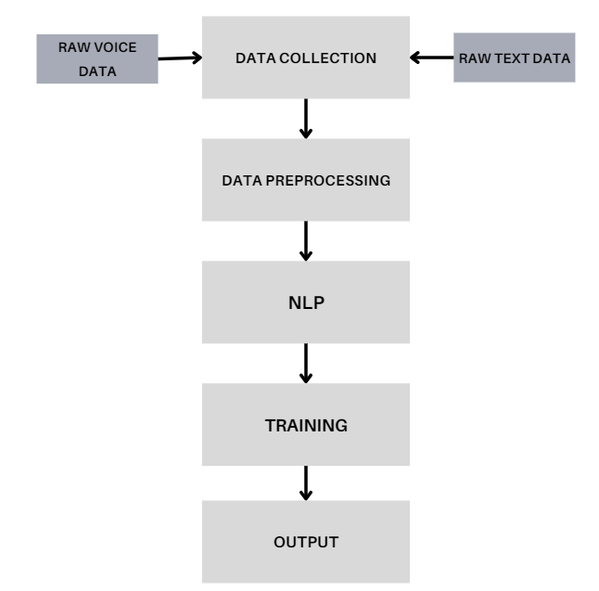
Fig.1 Architecture of the System
Raw data is transformed into a format that machine learning algorithms can use through feature extraction. To extract pertinent acoustic properties from audio data, features like spectrogram representations and Mel-frequency cepstral coefficients (MFCCs) are used. Tokenization, stemming, and the gathering of n-grams to symbolize textual information are examples of features in text data. These characteristics support the models' ability to identify trends and forecast outcomes depending on human input. Data augmentation strategies are used to increase the generality and resilience of the model. When it comes to audio data, this might entail creating artificially created versions of recordings through the use of alterations like speed adjustments, pitch shifts, or background noise additions. Augmenting text data might involve changing phrase patterns, adding synonyms, or rewriting instructions. These methods improve the model's capacity to manage various input conditions and mimic a variety of user interactions.
Integrating multiple sources of data and formats into a single, processable dataset for the virtual assistant is known as data integration. In this stage, text and speech data are combined, annotations and matching recordings are matched, and all data types are checked to make sure they meet the model's specifications. When integration is done correctly, the virtual assistant can manage text and speech inputs with ease and offers a smooth user experience. To make sure the data is accurate and within the anticipated range for machine learning models, data normalization and scaling are carried out. Normalization for audio characteristics entails modifying amplitude levels and guaranteeing constant sample rates. Scaling for text data may involve normalizing feature values and encoding text into quantitative representations. These procedures aid in enhancing model performance and stabilizing the training process.

PRINCIPLES AND METHODS
Natural Language Processing (NLP), which enables the virtual assistant to comprehend, interpret, and produce human language, is the fundamental component of Smart-Serve's functioning. Semantic comprehension, contextual inference, tokenization, and syntactic analysis are some of the fundamental elements of NLP concepts. Tokenization divides the text into smaller, more digestible chunks, such words or phrases, and syntactic analysis parses these chunks to figure out the grammar. Contextual inference enables the system to comprehend commands based on the surrounding context, whereas semantic comprehension concentrates on the significance behind the words and phrases. Together, these ideas allow Smart-Serve to properly interpret and respond to both oral and written user input. Smart-Serve uses sophisticated speech recognition algorithms to translate spoken language into text in order to handle voice requests.
In order to extract features from audio signals and capture the phonetic properties of speech, methods like spectrogram analysis and Mel-frequency cepstral coefficients (MFCCs) are employed. After being trained to identify phonemes and words, these characteristics are subsequently input into acoustic models, which are frequently built on algorithms for deep learning like Recurrent Neural Networks (RNNs) or Convolutional Neural Networks (CNNs). Following transcription into text, Natural Language Understanding (NLU) analyzes the text to ascertain the user's intention. On the other hand, text-to-speech (TTS) synthesis systems use techniques like concatenative synthesis or neuronal network-based synthesis to transform text replies back into spoken language and generate speech that sounds natural.
Smart-Serve uses a number of advanced techniques to power its job management and automation capabilities. The assistant utilizes algorithms for planning and prioritizing tasks in accordance with user instructions and contextual data. Reminders, rule-based systems, and reinforcement learning are a few of the techniques that may be used to manage to-do lists, resolve scheduling conflicts, and establish schedules. Browser automation frameworks such as Selenium or Puppeteer enable Smart-Serve for interacting with web components, conduct searches, and get data from websites, hence facilitating online surfing automation. In order to carry out operations like opening apps, performing instructions, and interacting with other digital tools and services, the system also incorporates scripting and APIs.
Smart-Serve uses customization and contextual awareness to improve user experience. Understanding the context of the communication, including past exchanges and user preferences, is necessary for contextual comprehension. Context-aware methods and state approaches to management that monitor active processes and user preferences help achieve this. In order to customize replies and recommendations, machine learning algorithms that examine user behavior and past data are used to create personalization. Collaborative filtering, content-based filtering, and profile building are some of the techniques used to enhance the relevance of interactions and offer customized recommendations. These procedures guarantee that Smart-Serve adjusts to the specific requirements of each user, resulting in more efficient and natural interactions.

NLP
Smart-Serve and other intelligent virtual assistants are developed with the use of natural language processing, or NLP. NLP is the umbrella term for a variety of approaches and procedures designed to give robots the ability to comprehend, interpret, and produce meaningful, contextually relevant human language. NLP's main goal is to close the knowledge gap between computer understanding and human communication so that consumers can engage with virtual assistants in a natural way. This entails handling and evaluating speech and text data in order to extract knowledge, carry out instructions, and provide relevant output (as shown in Fig.2). NLP combines computer techniques and linguistic concepts to carry out tasks including machine translation, sentiment analysis, text categorization, and entity recognition. Text processing, or being ready to analyze unprocessed text data, is the initial stage in natural language processing (NLP). A basic text processing method called tokenization divides a continuous text into distinct parts like words or phrases. This segmentation is necessary for further analysis and enables the computer to handle text in digestible bits.
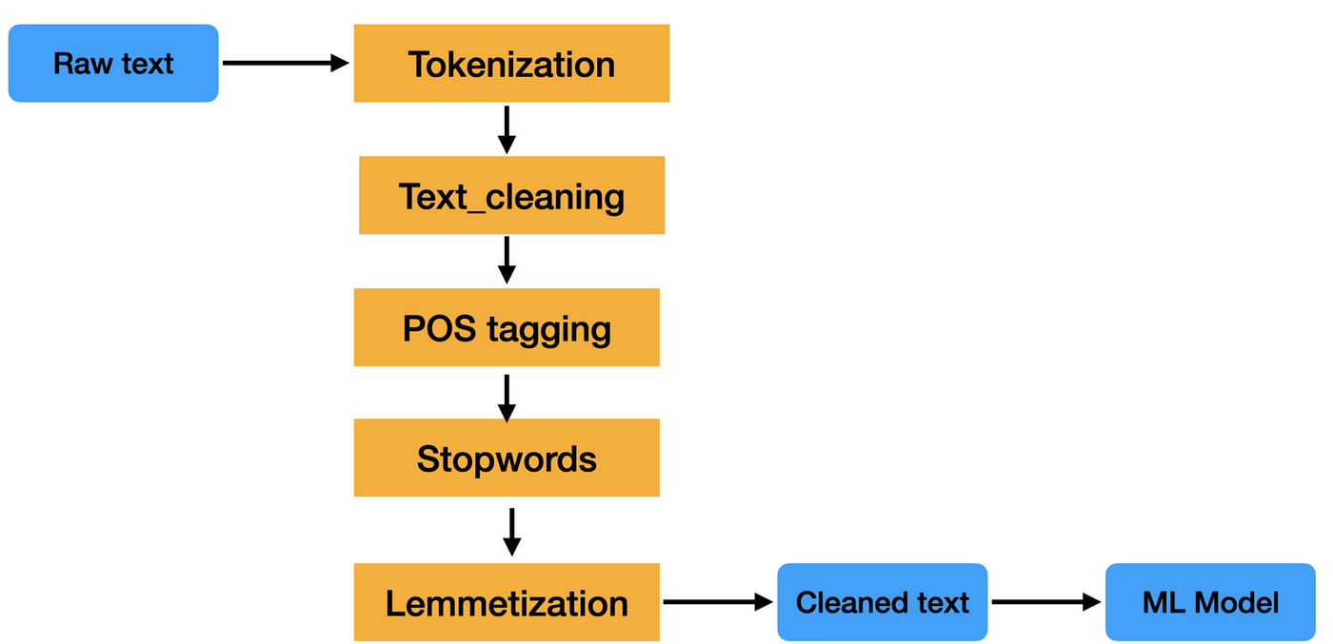

Fig.2 NLP Process
Techniques like punctuation-based splitting, whitespace splitting, and more sophisticated approaches incorporating statistical models that take into consideration linguistic quirks can all be used for tokenization. Following tokenization, the text is further processed to handle text normalization (standardizing spelling and grammar), eliminate stop words (frequent words with little significance), and conduct stemming or the lemmatization (reducing words to their root forms). Following tokenization, natural language processing (NLP) systems analyze the text's meaning and grammatical structure using syntactic and semantic analysis. In syntactic analysis, the text is parsed using methods like constituency and dependency parsing to determine the grammatical connections between tokens. This aids in recognizing the various elements of speech and comprehending sentence structure. Semantic analysis interprets words and phrases in context in a way that goes beyond grammar. Semantic role labelling is a technique that helps identify the roles of various parts inside a phrase, whereas Named Entity Recognition (NER) is used to recognize entities like names, dates, and locations. Smart-Serve can efficiently extract pertinent information and understand user requests thanks to the syntactic and semantic analysis [15] combined with this method.
Accurately interpreting user input, particularly in conversational circumstances, requires contextual comprehension. Context-aware models are used by NLP systems to keep track of past exchanges and the current engagement. To capture the meaning of words depending on their context, methods including transformer model-generated contextual embeddings and context windows [16] where the model takes into account a predetermined number of surrounding words are used. By taking into account the context in which phrases are employed, disambiguation techniques assist in clearing up ambiguities in language. Contextual understanding enables the system to infer the right meaning from surrounding text, such as when the word "bank" refers to a financial institution or the side of a river. NLP techniques are used in Smart-Serve to enable various functions, such as comprehending customer inquiries, producing answers, and carrying out requests. The system combines voice recognition components to translate spoken words into text. NLP techniques are then used to the text to determine the user's intent. Context-aware models are used by the assistant to manage multi-turn discussions and preserve coherence during exchanges. For tasks like intent categorization, entity identification, and response production, machine learning models are used. Furthermore, Smart-Serve uses customization strategies to customize interactions according to user preferences and past information. Smart-Serve provides a powerful and user-friendly virtual assistant experience that efficiently attends to user demands and boosts productivity by integrating various approaches.

VOICE ASSISTANTS
Smart-Serve's core function is to translate spoken words into text by utilizing cutting-edge voice recognition technology. The assistant records audio input and runs it via a speech recognition engine when a user speaks a command or question. This engine translates spoken speech into written text using models like Deep Neural Networks (DNNs) and Hidden Markov Models (HMMs) [17]. This procedure must be accurate since it establishes the foundation for all other NLP activities. The system ensures that the written output correctly matches the verbal input from the user by accommodating changes in accents, intonations, and background noise. After the voice is converted to text, Smart-Serve uses Natural Language Understanding (NLU) methods to decipher the text's meaning. NLU entails text parsing to determine entities and intentions. The NLU component recognizes that the user intends to create a timer, for instance, if they say, "Set a timer for 10 minutes," and it extracts the duration as a relevant entity. With this knowledge, Smart-Serve can react to user requests in an appropriate manner. The text is dissected and analyzed using methods including intent categorization, slot filling, and semantic role labeling to guarantee appropriate interpretation.
One important element of Smart-Serve is its task automation capabilities, which enable users to carry out a variety of operations using voice commands. This covers launching web browsers, sending messages, and establishing timers. Say a user instructs Google Chrome to "open and search for 'best restaurants nearby,'" for example. To carry out the command, Smart-Serve communicates with the automation scripts and APIs of the system. Users benefit from a hands-free experience as a result of the integration with task management and system control functions, which guarantee these tasks are completed precisely and effectively. Based on voice input, Smart-Serve's voice assistant [18] is capable of carrying out a variety of mathematical calculations. Smart-Serve uses mathematical library and functions (as shown in Fig.3) that are built into the system to process user requests for computations, such as "What is 23 times 47?" or "Calculate the square root of 144." The assistant does the necessary computations, parses the mathematical equations from the spoken language, and provides the user with the results. Parsing approaches that recognize operands and mathematical operators in user input offer this feature.
Users may conduct online searches and get information using voice commands thanks to Smart-Serve's integration with web surfing features. Users might ask to "Show me reviews for the new iPhone" or "Find the latest news on artificial intelligence," for instance. The assistant sends questions, processes the answers, and communicates with web browsers and search engines. It can also carry out operations like scrolling and clicking on search results, as well as open certain websites. To properly manage web interactions, this activity entails integrating with web automation technologies and APIs. Another essential feature of Smart-Serve is the ability to set alerts and reminders. Commands such as "Set an alarm for 6 AM" or "Remind me to call John at 3 PM" can be given by users. The assistant creates and controls alerts and reminders [19] by interacting with the scheduling features of the system (as shown in Fig.4). It entails processing user input to extract the time and event data, establishing reminders in calendars or alarm systems, and alerting users as necessary. Language translation is supported by Smart-Serve, allowing users to converse in several languages. For example, the assistant uses translation models or APIs to handle a user's request to translate "Good morning" into French. The assistant examines user behavior, preferences, and previous exchanges using machine learning models. For instance, it may adapt its replies and recommendations based on its memory of a user's favorite news outlets [20] or regularly visited websites (as shown in Fig.5 & 6).

RESULTS
The high accuracy real-time voice to text conversion is one of the main results of the Smart-Serve project. Spoken language is efficiently processed by the system to produce written text that faithfully represents user orders and inquiries. The use of sophisticated speech recognition algorithms guarantees that the transcription will continue to be accurate despite changes in speech patterns, accents, and background noise. The usefulness of the virtual assistant in comprehending and carrying out user requests is directly impacted by the correctness of this conversion, which also affects the performance of future natural language processing activities. The accuracy of Smart-Serve's Natural Language Understanding (NLU) is a noteworthy accomplishment. The system uses advanced neural language understanding (NLU) algorithms to reliably understand user intents and extract pertinent items from text and speech inputs. For instance, Smart-Serve recognizes the user's desire to create a timer and extracts the duration as an object when they say, "Set a timer for 15 minutes."
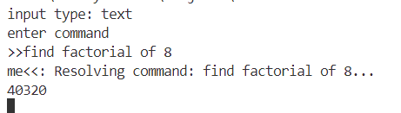
Fig.3 Performing Mathematical Operations
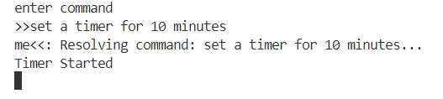
Fig.4 Setting Timer

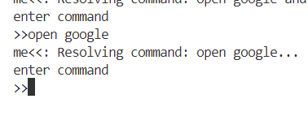
Fig.5 Command to open browser

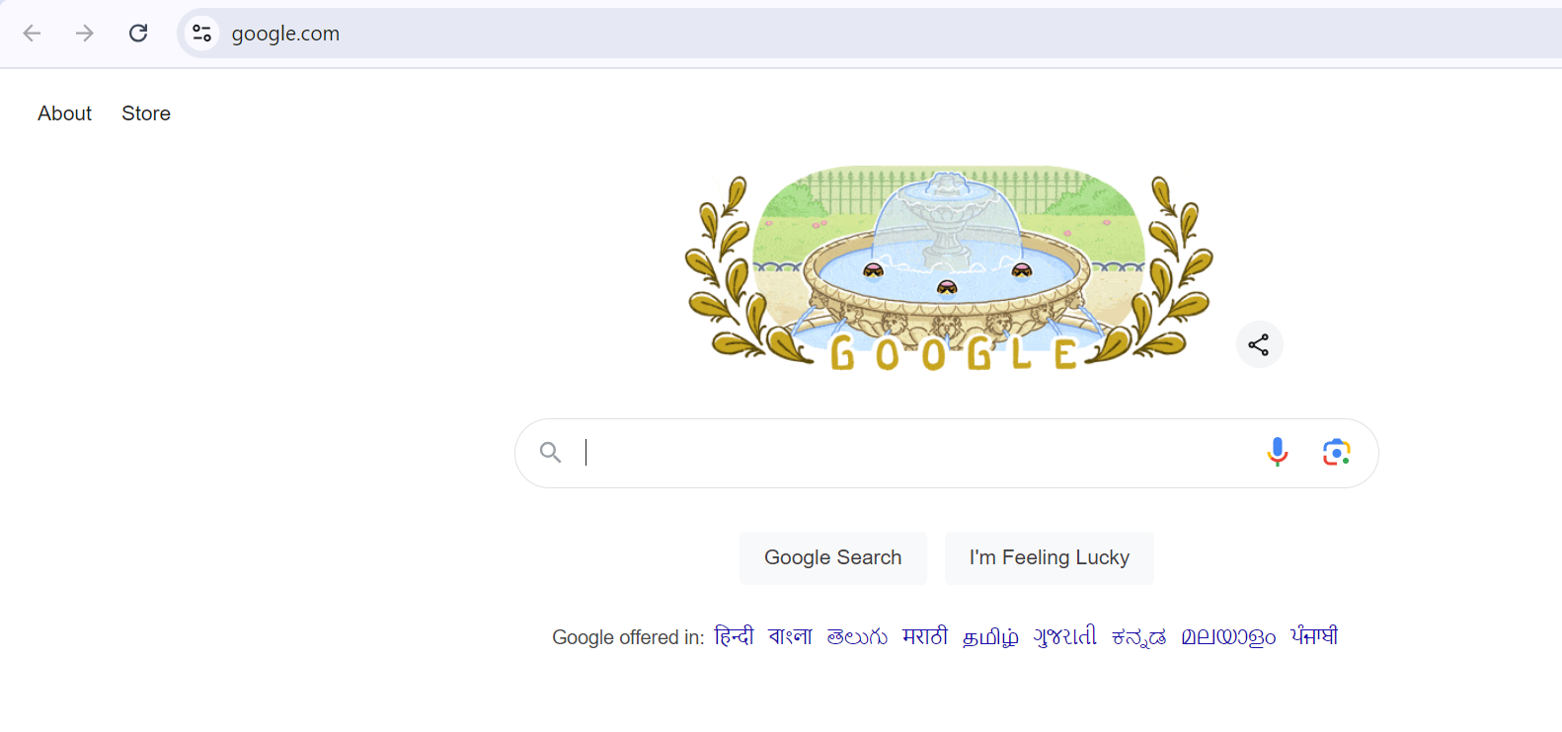
Fig.6 Output for open browser command

Strong task execution capabilities are displayed by Smart-Serve, which executes commands in a variety of domains with ease. Reminders, math computations, and online search management are among the tasks that are carried out precisely and efficiently. When a user asks the assistant to "Calculate the square root of 256," for example, the system receives the request, executes the calculation, and instantly returns the right answer. The accomplishment of these tasks successfully demonstrates the system's versatility and improves user experience. An additional noteworthy accomplishment of Smart-Serve is the incorporation of online surfing functionality. Voice commands, such as "Open YouTube and play the latest music video" or "Search for recent news on AI," let users to access web material in real-time.

Fig.7 Output for Youtube Play Music

The success of Smart-Serve is critically dependent on personalization. In order to customize replies and recommendations, the system gains knowledge from user interactions and preferences. In the event that a user consistently requests updates on particular subjects, like technology news, the assistant will give precedence to pertinent material in subsequent conversations. By tailoring interactions to each user's unique tastes and needs, this personalized approach improves the user experience. Because Smart-Serve has capabilities for ongoing learning and adaptation, it can get better over time. Through the examination of interaction patterns, performance statistics, and user input, the assistant upgrades its functionality and improves its algorithms. This constant process of modification guarantees that Smart-Serve can continue to handle new jobs, adapt to changing user needs, and keep up with technology developments. For Smart-Serve, the ability to manage jobs in real-time with text and voice inputs is a noteworthy accomplishment.

CONCLUSION
The completion of the Smart-Serve project highlights the noteworthy progress made in fusing Natural Language Processing (NLP) with real-time voice recognition to create a virtual assistant that is both extremely responsive and adaptable. The system has shown remarkable performance in text-to-speech conversion, understanding user goals, and carrying out a wide variety of activities, such as online surfing, controlling smart homes, and doing real-time mathematical computations. Smart-Serve offers a smooth and intuitive experience, improving convenience and efficiency by efficiently handling both speech and text inputs. The assistant demonstrates its strong capability and versatility by successfully doing tasks including translating, making reminders, and managing smart devices. In addition, the system's capacity for ongoing learning and adaptation in response to user interactions guarantees that it will always be applicable and efficient in addressing changing demands. All things considered, Smart-Serve is a prime example of how AI-driven virtual assistants can simplify everyday chores, enhance user engagement, and expand the possibilities of digital assistants in contemporary technology.

References

- Dix, Alan. "Human–computer interaction, foundations and new paradigms." Journal of Visual Languages & Computing 42 (2017): 122-134.
- Andresen, Daniel, et al. "Adaptive partitioning and scheduling for enhancing WWW application performance." Journal of Parallel and Distributed Computing 49.1 (1998): 57-85.
- Humphreys, Patricia. Office technology: bridging to the future. Diss. Lethbridge, Alta.: University of Lethbridge, Faculty of Education, 1994, 1994.
- Khurana, Diksha, et al. "Natural language processing: state of the art, current trends and challenges." Multimedia tools and applications 82.3 (2023): 3713-3744.
- Hoy, Matthew B. "Alexa, Siri, Cortana, and more: an introduction to voice assistants." Medical reference services quarterly 37.1 (2018): 81-88.
- Ammari, Tawfiq, et al. "Music, search, and IoT: How people (really) use voice assistants." ACM Transactions on Computer-Human Interaction (TOCHI) 26.3 (2019): 1-28.
- McLean, Graeme, and Kofi Osei-Frimpong. "Hey Alexa… examine the variables influencing the use of artificial intelligent in-home voice assistants." Computers in Human Behavior 99 (2019): 28-37.
- Terzopoulos, George, and Maya Satratzemi. "Voice assistants and smart speakers in everyday life and in education." Informatics in Education 19.3 (2020): 473-490.
- Feng, Huan, Kassem Fawaz, and Kang G. Shin. "Continuous authentication for voice assistants." Proceedings of the 23rd Annual International Conference on Mobile Computing and Networking. 2017.
- Malodia, Suresh, et al. "Why do people use Artificial Intelligence (AI)-enabled voice assistants?." IEEE Transactions on Engineering Management 71 (2021): 491-505.
- Turski, Michał, et al. "Ccpdf: Building a high quality corpus for visually rich documents from web crawl data." International Conference on Document Analysis and Recognition. Cham: Springer Nature Switzerland, 2023.
- Srivastava, Jaideep, et al. "Web usage mining: Discovery and applications of usage patterns from web data." Acm Sigkdd Explorations Newsletter 1.2 (2000): 12-23.
- Winer, Ethan. The audio expert: everything you need to know about audio. Routledge, 2017.
- Joshi, Aravind K. "Natural language processing." Science 253.5025 (1991): 1242-1249.
- Tur, Gokhan, and Renato De Mori. Spoken language understanding: Systems for extracting semantic information from speech. John Wiley & Sons, 2011.
- Yu, Wenhao, et al. "Generate rather than retrieve: Large language models are strong context generators." arXiv preprint arXiv:2209.10063 (2022).
- Li, Longfei, et al. "Hybrid deep neural network--hidden markov model (dnn-hmm) based speech emotion recognition." 2013 Humaine association conference on affective computing and intelligent interaction. IEEE, 2013.
- Poushneh, Atieh. "Humanizing voice assistant: The impact of voice assistant personality on consumers’ attitudes and behaviors." Journal of Retailing and Consumer Services 58 (2021): 102283.
- Jacobson, Daniel, Greg Brail, and Dan Woods. APIs: A strategy guide. " O'Reilly Media, Inc.", 2012.
- Billsus, Daniel, and Michael J. Pazzani. "User modeling for adaptive news access." User modeling and user-adapted interaction 10 (2000): 147-180.

