EXP 18: Demonstrate Infrastructure as a Service (IaaS) by creating a resources group using a Public Cloud Service Provider (Azure), configured with minimum CPU, RAM, and Storage.

AIM: To demonstrate Infrastructure as a Service (IaaS) by creating a resources group using a Public Cloud Service Provider (Azure), configure with minimum CPU, RAM, and Storage.

PROCEDURE:

STEP 1: CREATE AN ACCOUNT IN MICROSOFT AZURE.

STEP 2: GO TO RESOURCE GROUP AND CREATE A RESOURCE GROUP. STEP 3: GIVE NECESSARY THINGS FOR RESOURCE GROUP.

STEP 4: CREATE A VIRTUAL NETWORK FOR TO CREATE A VIRTUAL MACHINE.

STEP 5: NOW CREATE A VIRTUAL MACHINE WITH UR IP ADDRESS AN USERNAME AND PASSWORD FOR YOUR VIRTUAL MACHINE.

STEP 6: AND YOUR VIRTUAL MACHINE IS DEPLOYED.

STEP 7: NOW CONNECT THE VIRTUAL MACHINE AND DOWNLOAD THE RDP FILE TO OPEN YOUR WINDOWS VIRTUAL MACHINE.

STEP 8: CREATED A NEW WINDOWS VIRTUAL MACHINE.

IMPLEMENTATION:

STEP 1: CREATE AN ACCOUNT IN MICROSOFT AZURE.

STEP 2: GO TO RESOURCE GROUP AND CREATE A RESOURCE GROUP.

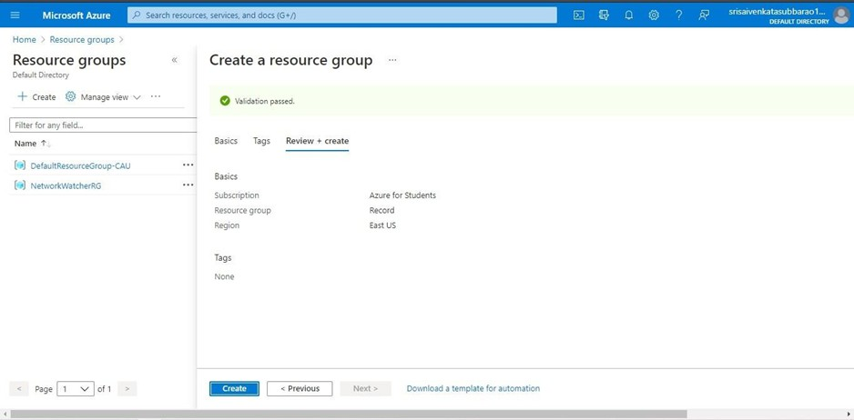

STEP 3: GIVE NECESSARY THINGS FOR RESOURCE GROUP.

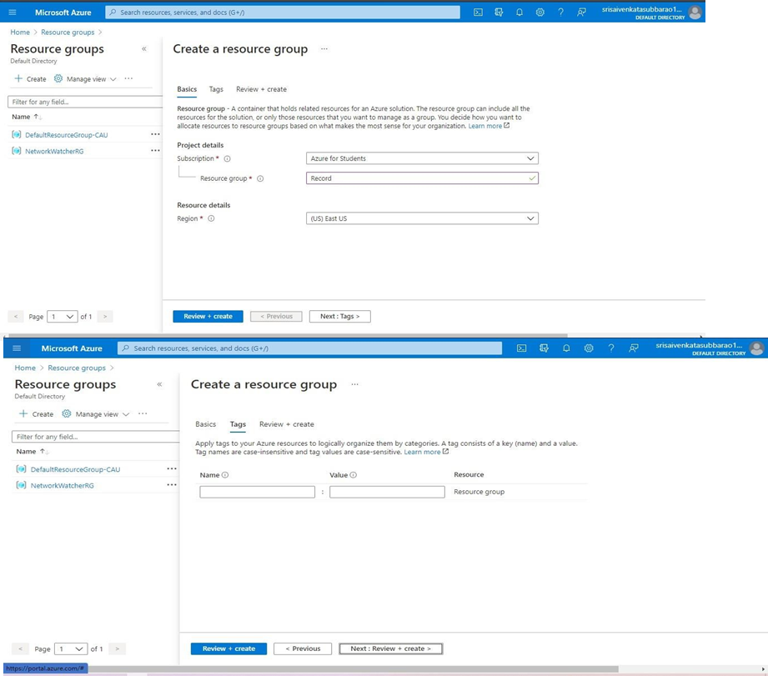

STEP 4: CREATE A VIRTUAL NETWORK FOR TO CREATE A VIRTUAL MACHINE.

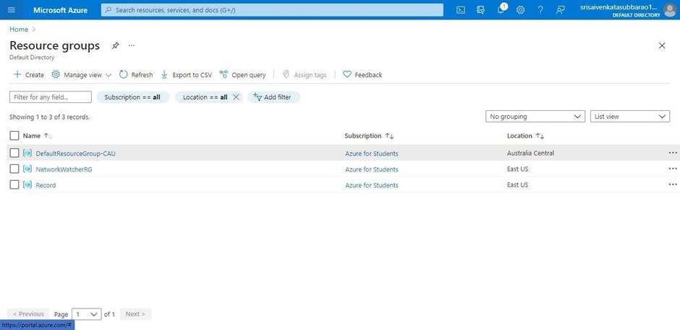

STEP 5: NOW CREATE A VIRTUAL MACHINE WITH UR IP ADDRESS AN USERNAME AND PASSWORD FOR YOUR VIRTUAL MACHINE.

STEP 6: AND YOUR VIRTUAL MACHINE IS DEPLOYED.

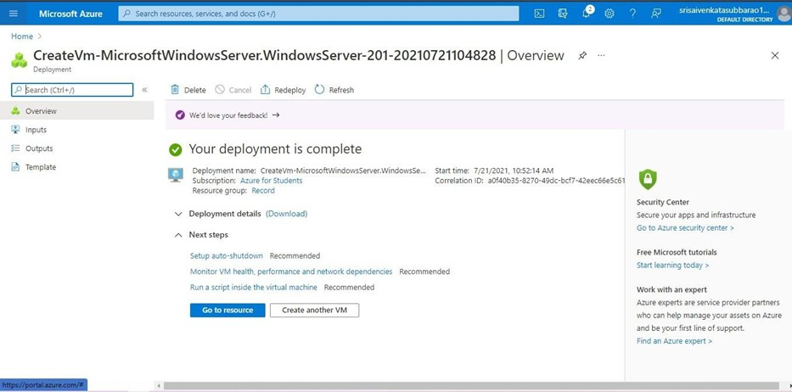

STEP 7: NOW CONNECT THE VIRTUAL MACHINE AND DOWNLOAD THE RDP FILE TO OPEN YOUR WINDOWS VIRTUAL MACHINE.

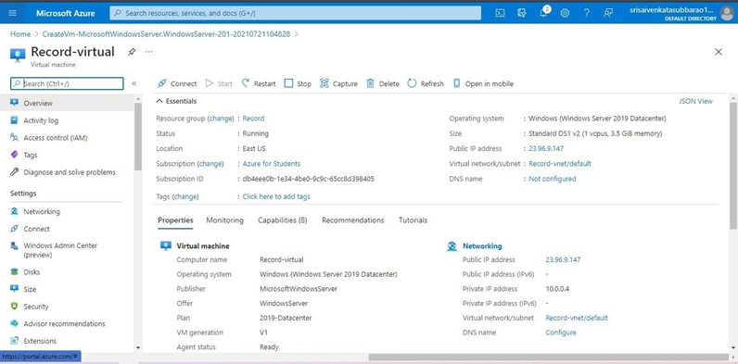

STEP 8: CREATED A NEW WINDOWS VIRTUAL MACHINE

