EXP 22: Create a Simple Web Application using Java or Python and host it in any Public Cloud Service Provider (Azure/GCP/AWS) to demonstrate Platform as a Service (PaaS).

AIM: To create a Simple Web Application using Java or Python and host it in any Public Cloud Service Provider (Azure/GCP/AWS) to demonstrate Platform as a Service (PaaS).

PROCEDURE:

STEP 1: FIRSTLY, GO TO APPSERVICE TO CREATE AN WEBAPP.

STEP 2: ENTER THE RESOURCE GROUP AND WEBAPP NAME AND REGION AND SELECT THE LINUX OS.

STEP 3**:** AFTER ENTER THE ALL THE NECESSARY THINGS CLICK THE REVIEW AND CREATE AND CLICK THE CREATE THE WEB APP.

IMPLEMENTATION:

STEP 1: FIRSTLY, GO TO APPSERVICE TO CREATE AN WEBAPP.

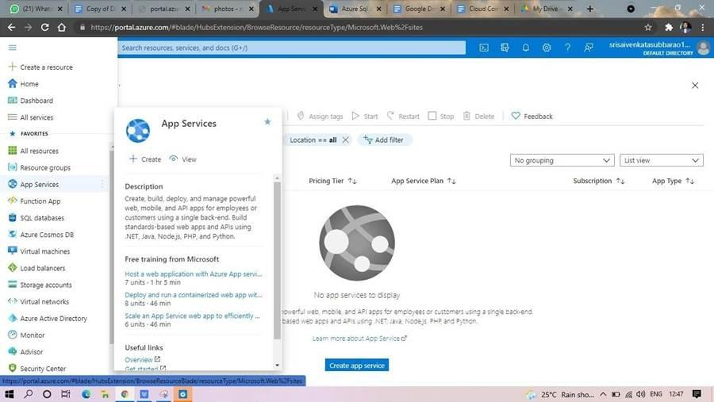

STEP 2: ENTER THE RESOURCE GROUP AND WEBAPP NAME AND REGION AND SELECT THE LINUX OS.

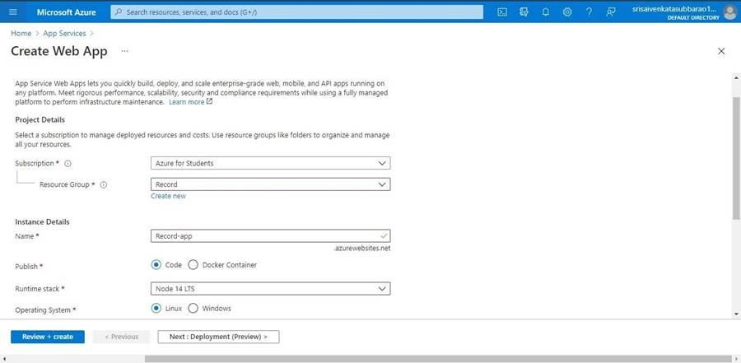

STEP 3: AFTER ENTER THE ALL THE NECESSARY THINGS CLICK THE REVIEW AND CREATE AND CLICK THE CREATE THE WEB APP.

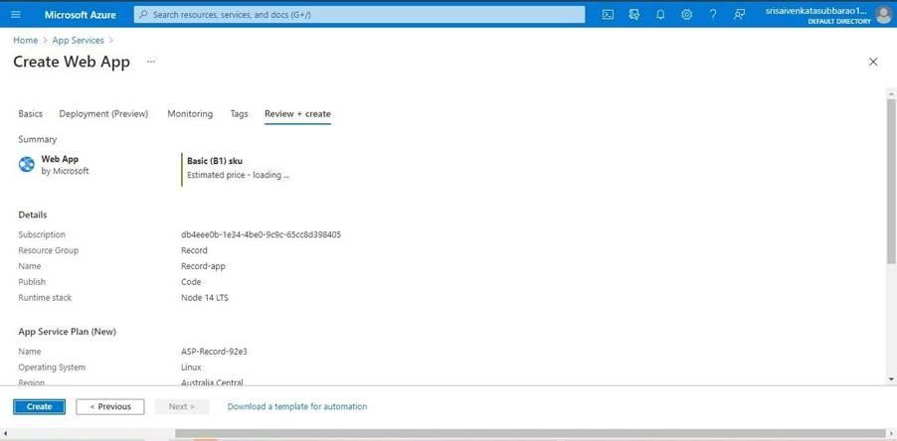

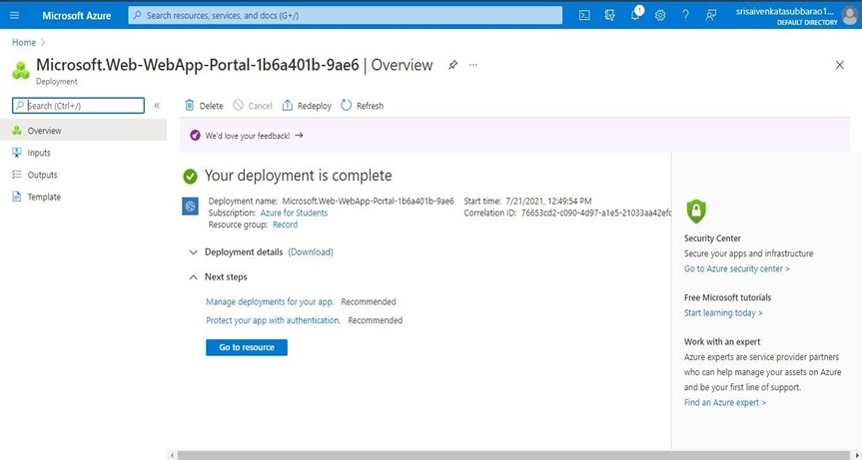

STEP 4: AND OUR DEPLOYMENT IS COMPLETED. STEP 5: GO TO WEBSITE URL LINK.

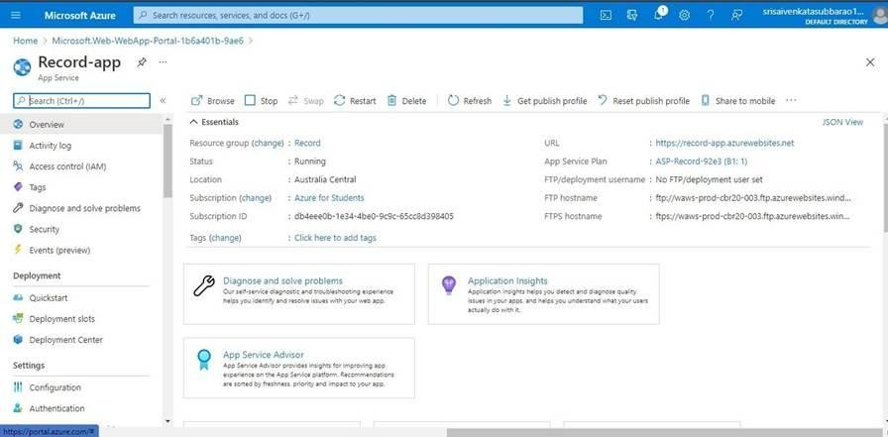

STEP 6: THIS IS OUR WEBAPP SERVICE.

