EXP 24: Create a Storage service using any Public Cloud Service Provider (Azure/GCP/AWS) and check the public accessibility of the stored file to demonstrate Storage as a Service.

AIM: To create a Storage service using any Public Cloud Service Provider (Azure/GCP/AWS) and check the public accessibility of the stored file to demonstrate Storage as a Service.

PROCEDURE:

STEP 1: OPEN AZURE AND GOTO STORAGE ACCOUNTS AND CREATE STORAGE ACCOUNT

STEP 2: ENTER THE RESOURCE GROUP AND AND STORAGE ACCOUNT NAME AND REVIEW AND CREATE AND CLICK THE CREATE AND YOUR STORAGE ACCOUNT WILL BE DEPLOYED SUCCESSFULLY.

STEP 3: OUR STORAGE ACCOUNT IS CREATED. STEP 4: GOTO STATIC WEBSITE

STEP 5: AND ENABLE AND ENTER YOUR INDEX AND ERROR HTML FILES

NAMES.

STEP 6: AND GOTO STORAGE EXPLORER(REVIEW) AND AND GOTO BLOB CONTAINERS AND WEB AND UPLOAD THE TWO HTML FILES INIT

STEP 7: AND AGAIN RETURN TO STATIC WEBSITE AND OPEN THE PRIMARY LINK AND YOUR WEB PAGE IS CREATED

IMPLEMENTATION:

STEP 1: OPEN AZURE AND GOTO STORAGE ACCOUNTS AND CREATE STORAGE ACCOUNT

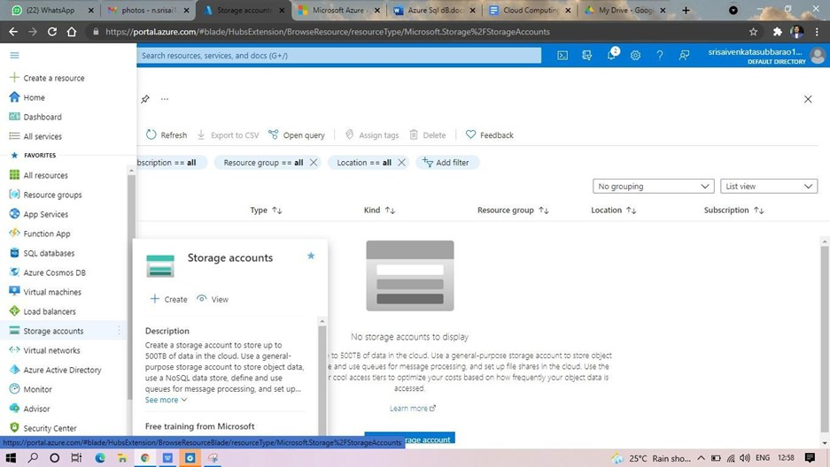

STEP 2: ENTER THE RESOURCE GROUP AND AND STORAGE ACCOUNT NAME AND REVIEW AND CREATE AND CLICK THE CREATE AND YOUR STORAGE ACCOUNT WILL BE DEPLOYED SUCCESSFULLY.

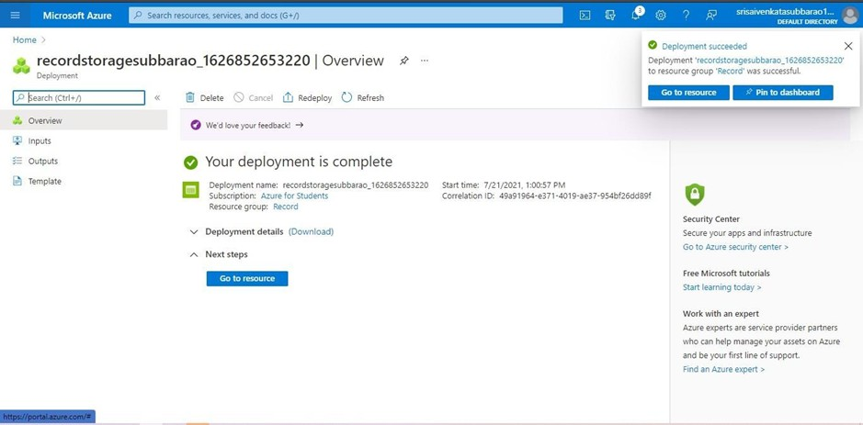

STEP 3: AND OUR STORAGE ACCOUNT IS CREATED.

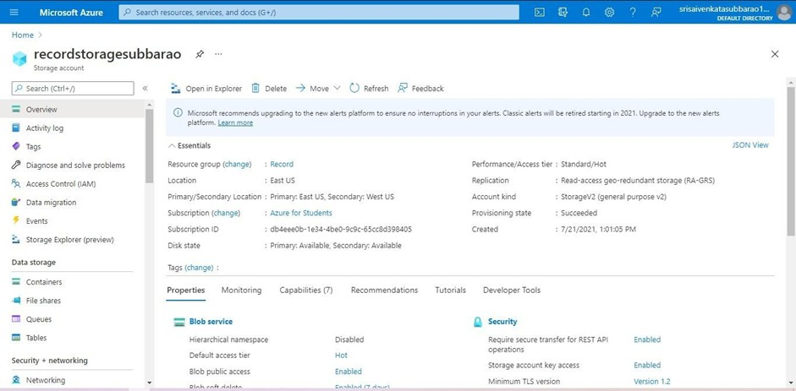

STEP 4: GO TO STATIC WEBSITE

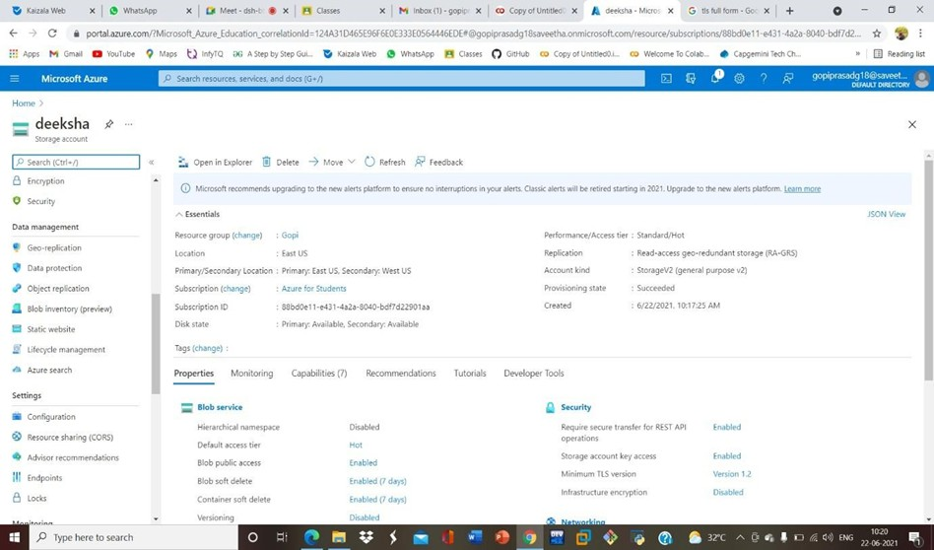

STEP 5: AND ENABLE AND ENTER YOUR INDEX AND ERROR HTML FILESNAMES.

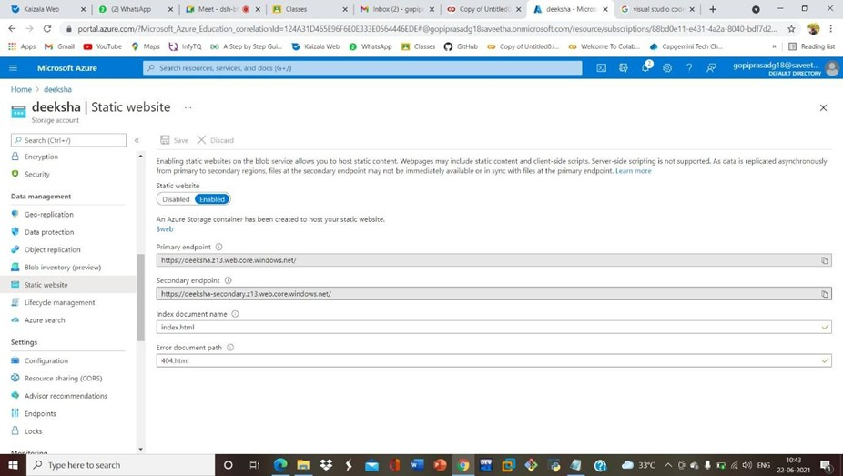

STEP 6: AND GO TO STORAGE EXPLORER(REVIEW) AND AND GOTO BLOB CONTAINERS AND WEB AND UPLOAD THE TWO HTML FILES IN IT.

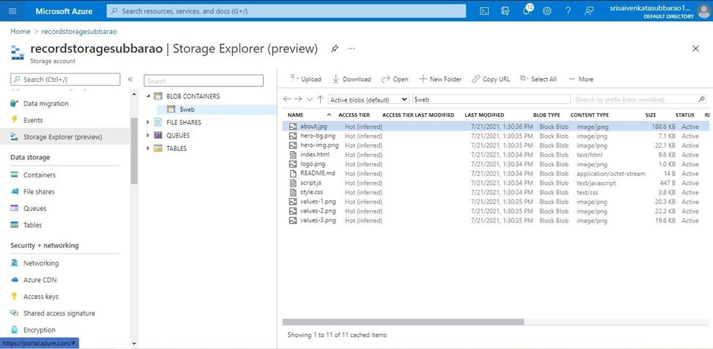

STEP 7: AND AGAIN RETURN TO STATIC WEBSITE AND OPEN THE PRIMARY LINK AND YOUR WEB PAGE IS CREATED

